Title | Employee Recognition
Meta Description
— Page content begins below. Please do not edit the table above. —
Employees at Bemidji State University are recognized and honored for their hard work they do through the BSU employee recognition ceremony and the granting of emeriti status to faculty who have exemplified great contributions to BSU.
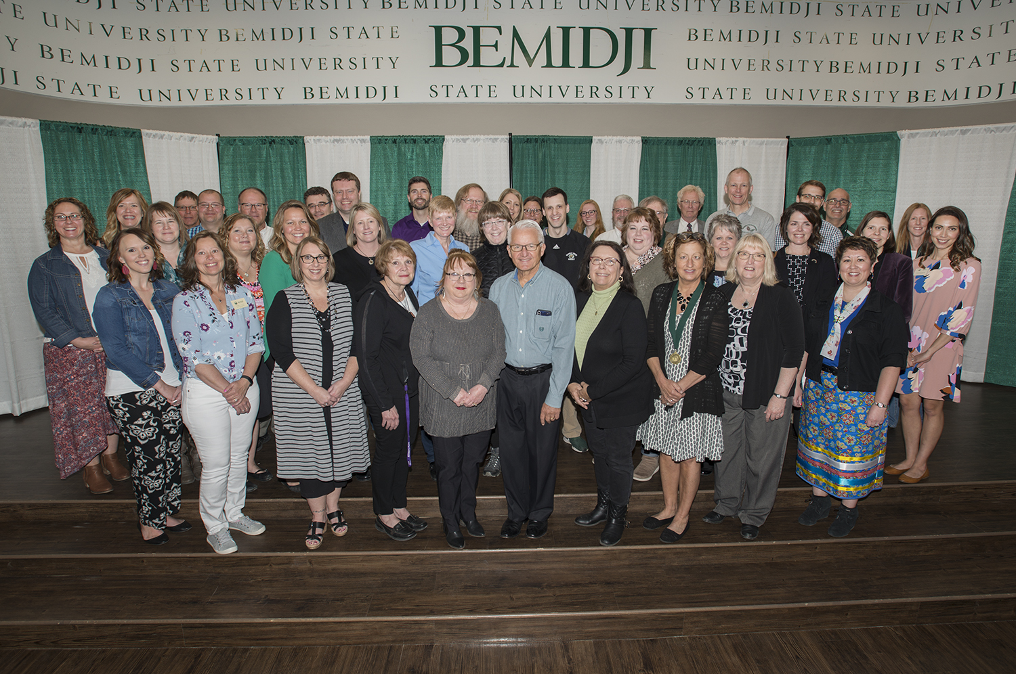
[[IMAGE REF 0000]] Image reference -- not directly editable; the original page reference is preserved automatically. Source: https://www.bemidjistate.edu/offices/president/wp-content/uploads/sites/86/2023/01/19EmployeeRecognition_YearsOfService_0022.jpg

