Title | Students for the Environment
Meta Description
— Page content begins below. Please do not edit the table above. —
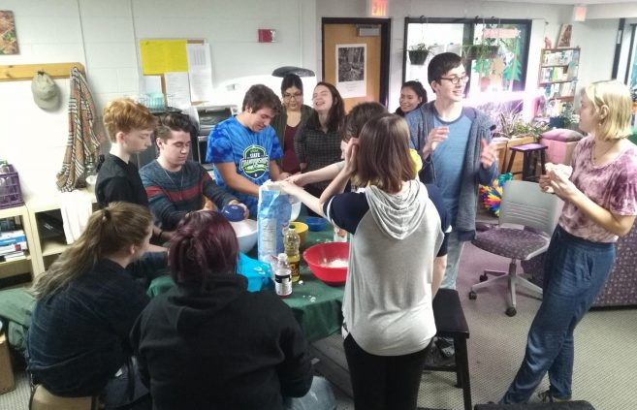
[[IMAGE REF 0000]] Image reference -- not directly editable; the original page reference is preserved automatically. Source: https://www.bemidjistate.edu/offices/sustainability/wp-content/uploads/sites/59/2020/07/SFE-1-5-657x423.jpg
SFE making play-dough for distribution during BSU Homecoming Parade
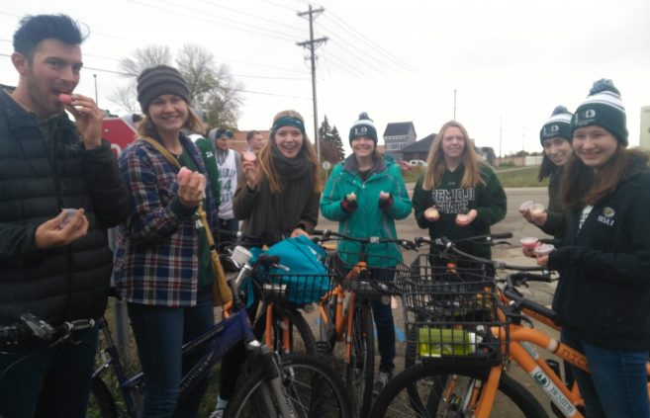
[[IMAGE REF 0001]] Image reference -- not directly editable; the original page reference is preserved automatically. Source: https://www.bemidjistate.edu/offices/sustainability/wp-content/uploads/sites/59/2020/07/SFE-11-657x423.jpg
SFE riding Bucky’s Bikes and leading the homecoming parade.
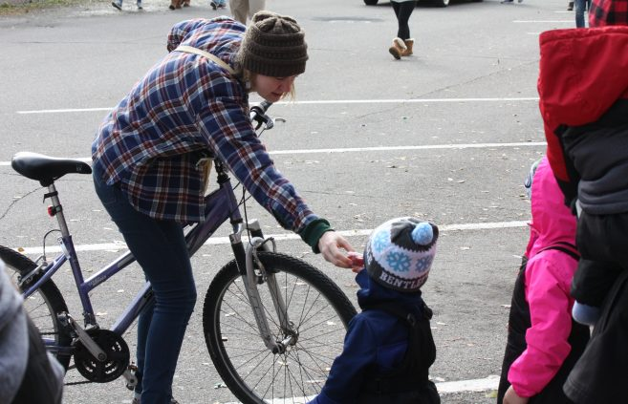
[[IMAGE REF 0002]] Image reference -- not directly editable; the original page reference is preserved automatically. Source: https://www.bemidjistate.edu/offices/sustainability/wp-content/uploads/sites/59/2020/07/SFE-3-6-657x423.jpg
SFE distributing homemade play-dough at BSU Homecoming Parade
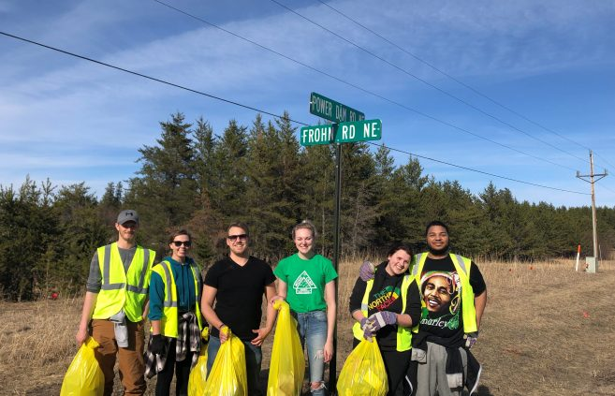
[[IMAGE REF 0003]] Image reference -- not directly editable; the original page reference is preserved automatically. Source: https://www.bemidjistate.edu/offices/sustainability/wp-content/uploads/sites/59/2020/07/2019-3-657x423.jpg
SFE members cleaning the group’s section of highway east of Lake Bemidji
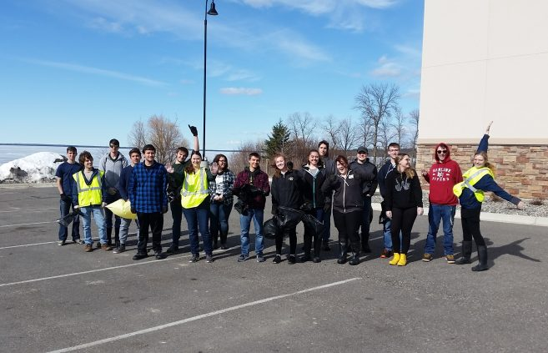
[[IMAGE REF 0004]] Image reference -- not directly editable; the original page reference is preserved automatically. Source: https://www.bemidjistate.edu/offices/sustainability/wp-content/uploads/sites/59/2020/07/20190418_163255-3-657x423.jpg
SFE members cleaning the southwest corner of Lake Bemidji
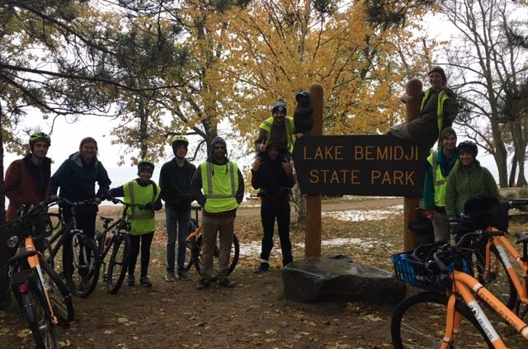
[[IMAGE REF 0005]] Image reference -- not directly editable; the original page reference is preserved automatically. Source: https://www.bemidjistate.edu/offices/sustainability/wp-content/uploads/sites/59/2020/07/IMG_2968-2-640x423.jpg
SFE at Lake Bemidji State Park on their loop of the lake bike ride
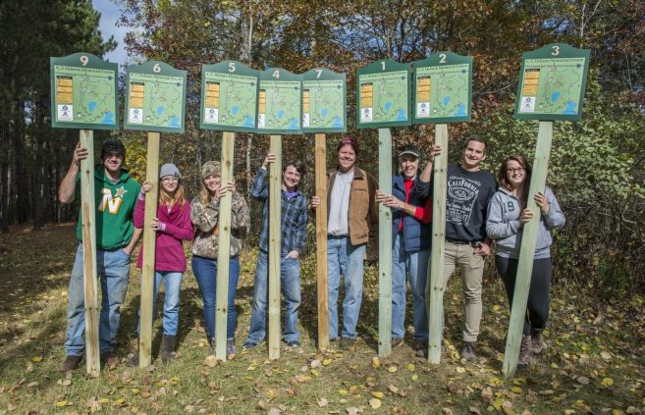
[[IMAGE REF 0006]] Image reference -- not directly editable; the original page reference is preserved automatically. Source: https://www.bemidjistate.edu/offices/sustainability/wp-content/uploads/sites/59/2020/07/Signage-at-Hobson-Forest-1-657x423.jpg
Members of Students for the Environment assisting local area Ski Club to install new trail signs in Hobson Forest.
Students for the Environment is a student-run organization that focuses on environmental issues on and off campus.
Through volunteer work, campaigns and projects, we seek to educate students on campus and advocate for a healthier planet. We’re always open for ideas and love new faces. Join us for a fun time and create interesting experiences. Send us an email to get involved!

1052021-22 Leadership Team

Kevin Krantz
Kevin.Krantz@go.minneapolis.edu

Bonnie O’Neal
Savannah.Mangels@live.bemidjistate.edu

Events SFE supports
- Lake-shore clean-up (fall and spring)
- Highway clean-up (fall and spring)
- Homecoming recycling (fall)
- Back to Basics (spring)
- Do it in the Dark (February)
- Earth Month Activities (April)
- Traditional Skills Workshops
- Documentary Screenings
- Snowshoeing, kayaking, hiking, and enjoying the outdoors together

Awards SFE has won
- 2012 Outstanding Student Organization Program (Earth Week)
- 2012 Outstanding Student Organization
- 2012 Outstanding Advisor (Erika Bailey-Johnson)
- 2010 Outstanding Student Organization Program (Do It In the Dark)
- 2009 Outstanding Student Organization Program (Do In In the Dark)

Advisors
Jordan Lutz Sustainability Project Manager jordan.lutz@bemidjistate.edu 755-2979 Sustainability Office | Carl Carl Isaccson Environmental Studies Professor carl.isaacson@bemidjistate.edu 755-4104 S109

