Title | Projects
Meta Description
— Page content begins below. Please do not edit the table above. —
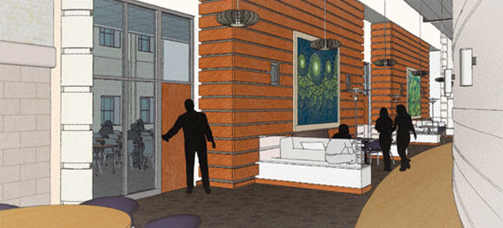
[[IMAGE REF 0000]] Image reference -- not directly editable; the original page reference is preserved automatically. Source: https://www.bemidjistate.edu/offices/sustainability/wp-content/uploads/sites/59/2015/03/118.png
Memorial Hall is BSU’s first LEED Certified building and will set the standard for all new buildings on campus.
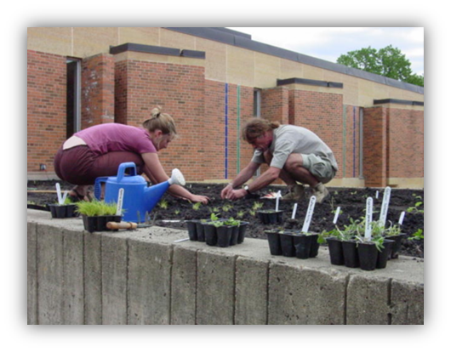
[[IMAGE REF 0001]] Image reference -- not directly editable; the original page reference is preserved automatically. Source: https://www.bemidjistate.edu/offices/sustainability/wp-content/uploads/sites/59/2015/03/114.png
Students and Faculty planting BSU’s first native butterfly garden.

[[IMAGE REF 0002]] Image reference -- not directly editable; the original page reference is preserved automatically. Source: https://www.bemidjistate.edu/offices/sustainability/wp-content/uploads/sites/59/2015/03/115-657x423.png
Reusable to-go containers are for sale at Lakeside and Wally’s for just $5.25 Bring in your dirty container and change it out for a clean one at no extra charge.
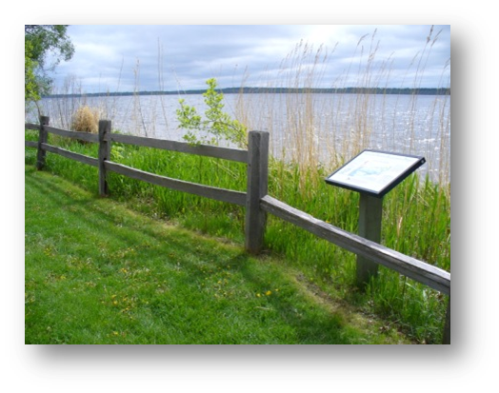
[[IMAGE REF 0003]] Image reference -- not directly editable; the original page reference is preserved automatically. Source: https://www.bemidjistate.edu/offices/sustainability/wp-content/uploads/sites/59/2015/03/116.png
Being on the lake is a privilege as well as a responsibility. That’s why BSU went through and restored its shoreline with a native buffer zone.
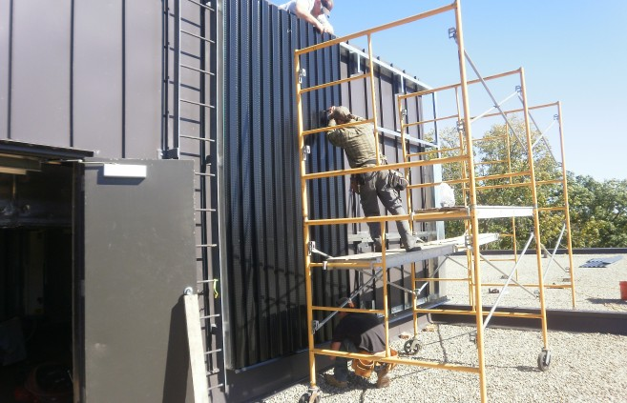
[[IMAGE REF 0004]] Image reference -- not directly editable; the original page reference is preserved automatically. Source: https://www.bemidjistate.edu/offices/sustainability/wp-content/uploads/sites/59/2015/03/117-657x423.jpg
Rural Renewable Energy Alliance (RREAL) staff installing BSU’s first solar technology; a Solar Transpired Air system on the Lower Union.
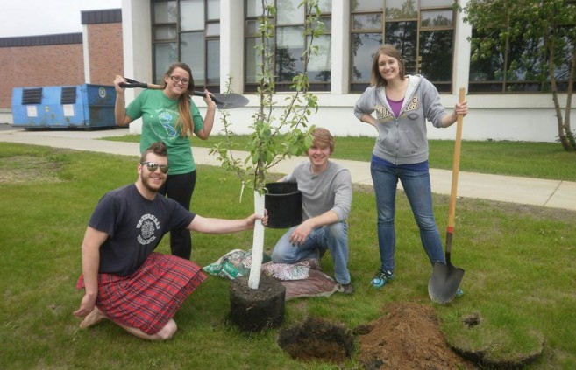
[[IMAGE REF 0005]] Image reference -- not directly editable; the original page reference is preserved automatically. Source: https://www.bemidjistate.edu/offices/sustainability/wp-content/uploads/sites/59/2015/03/76-657x423.jpg
Sustainability Office staff planting fruit trees as a part of our edible landscaping project.
Here in the Sustainability Office, we’re always working on something!
The projects we engage with on campus are guided by our climate action plan and typically fit within our six action areas of:
- Energy Conservation & Efficiency
- Waste & Recycling
- Transportation
- Renewable Energy
- Water Quality & Conservation
- Native Vegetation
However we also engage with a range of projects that more broadly fit within our overall effort to be good stewards of the earth such as:
- Transitioning green space around campus to native and pollinator friendly vegetation
- Maintaining a campus garden for members of the campus and community
- Divesting from fossil fuels
- Limiting pesticide use on campus
- Repurposing wood from trees taken from campus grounds
- Creating a responsible Bottled Water policy on campus
“Working together, we have proven that sustainable development is possible; that reforestation of degraded land is possible; and that exemplary governance is possible when ordinary citizens are informed, sensitized, mobilized and involved in direct action for the environment.”
~ Wangari Maathai (Assistant Minister for Natural Resources)

