Title | Bemidji Resiliency Planning
Meta Description
— Page content begins below. Please do not edit the table above. —

Additional Background about Resilience Planning
Resilience Planning and Bemidji State
Explore the full Climate Action & Resilience Report or read the Climate Action & Resilience Report’s Executive Summary to prepare to participate in strategic planning conversations scheduled for spring semester 2024.
Join in the North Conference Room (lower HMU) from either 11:30-1:00pm or 4:00-5:30pm on the following Wednesdays:
January 17th – Energy (read the energy section (v. 1-5-2024) here!)
Summary of Agreements & Current Reality – Energy
January 24th – Water (read the water section (v. 1-5-2024) here!)
Summary of Agreements & Current Reality – Water
January 31st – Transportation (read the transportation section (v. 1-5-2024))
Summary of Agreements & Current Reality – Transportation
February 7th – Materials & Waste (read the materials & waste section (v. 1-5-2024))
Summary of Agreements & Current Reality – Materials & Waste
February 14th – Economic Opportunity (read the economic opportunity section (v. 1-5-2024))
Summary of Agreements & Current Reality – Economic Opportunity
February 21st – Housing (read the housing section (v. 1-5-2024))
Summary of Agreements & Current Reality – Housing
February 28th – Health & Wellness (read the health & wellness section (v. 1-5-2024))
Summary of Agreements & Current Reality – Health & Wellness
This initiative is led by BSU’s Environmental Advisory Committee – click here to learn more.
Please contact Jordan Lutz if you have questions or comments about Bemidji State’s resilience planning process.
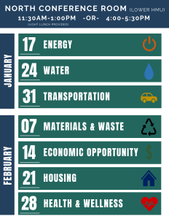
[[IMAGE REF 0000]] Image reference -- not directly editable; the original page reference is preserved automatically. Source: https://www.bemidjistate.edu/offices/sustainability/wp-content/uploads/sites/59/2024/01/CLIMAT1-1-232x300.png

