Title | Landscape Master Plan
Meta Description
— Page content begins below. Please do not edit the table above. —
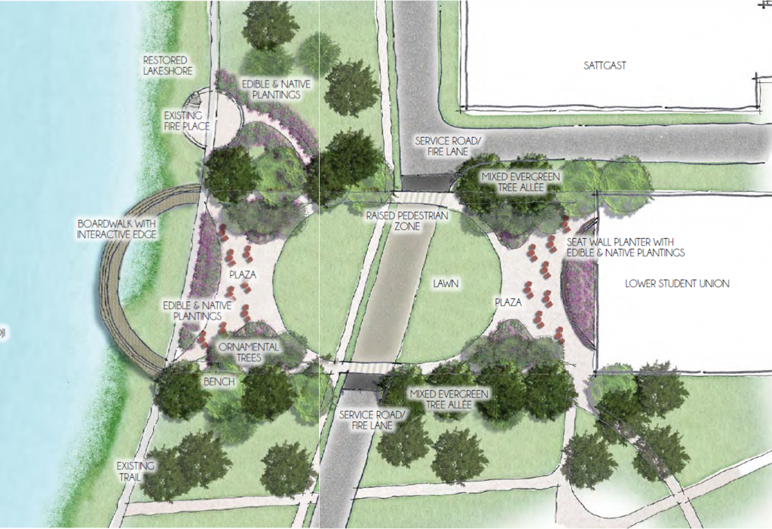
[[IMAGE REF 0000]] Image reference -- not directly editable; the original page reference is preserved automatically. Source: https://www.bemidjistate.edu/offices/sustainability/wp-content/uploads/sites/59/2015/07/122-1024x702.png
Short term landscaping plan​ for BSU’s lakeside lawn.
“The primary goal for this Landscape Master Plan is to express the vision that University students and staff have for their campus landscape. Their aesthetic, social, and environmental values can become part of the physical experience of the campus. And that experience makes a difference in BSU’s success.”
-BSU’s Landscape Master Plan
Little Bluestem (Schizachyrium scoparium) Little Bluestem (Schizachyrium scoparium) | Prairie Smoke (Geum triflorum) Prairie Smoke (Geum triflorum) | Swamp Milkweed (Asclepias incarnata) Swamp Milkweed (Asclepias incarnata)
Landscaping can be beautiful, environmentally responsible, and affordable by using perennial native plants that support pollinators and other wildlife. Native plants require less watering and maintenance than traditional landscaping plants like Kentucky bluegrass.

See full text of BSU’s Landscape Master Plan

