Title | Sustainable Campus Research Award
Meta Description
— Page content begins below. Please do not edit the table above. —
Previous Recipients:
2020 – Edward Haines
2019 – Vernion Cooper
2018 – Camilla Prosise
2017 – Gabriela Lara
2016 – Kari Hovorka, Jordan Morgan, & Abigale Rockis
2014 – Randall Riehl and Hunter Edberg
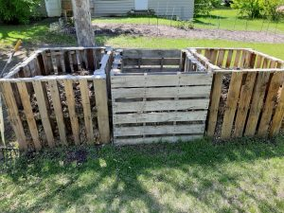
[[IMAGE REF 0002]] Image reference -- not directly editable; the original page reference is preserved automatically. Source: https://www.bemidjistate.edu/offices/sustainability/wp-content/uploads/sites/59/2020/06/Compost-piles-300x225.jpg
Compost piles fashioned of repurposed wood pallets, created by Edward Haines.
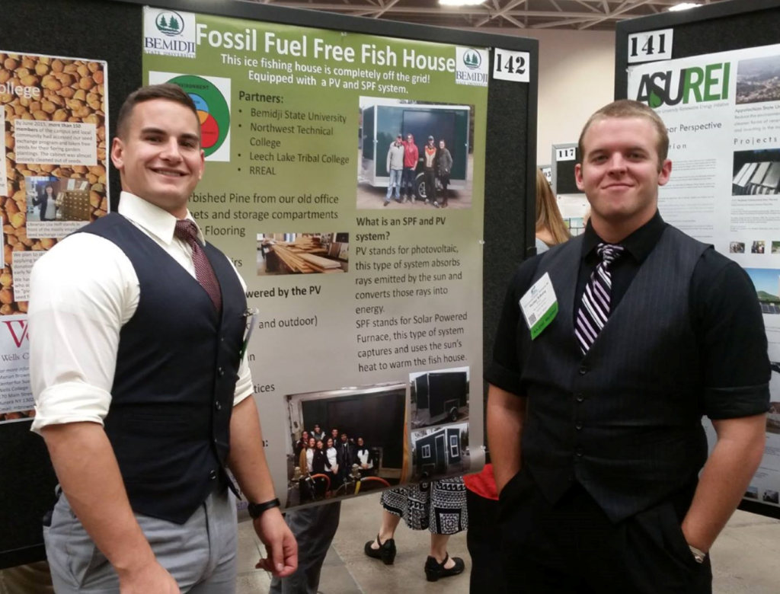
[[IMAGE REF 0000]] Image reference -- not directly editable; the original page reference is preserved automatically. Source: https://www.bemidjistate.edu/offices/sustainability/wp-content/uploads/sites/59/2015/03/FFFH-1024x780.png
Randall and Hunter present their Fossil Fuel-Free Fish House project at the National Association for the Advancement of Sustainability in Higher Education conference (Fall 2015)
“Fossil Fuel-Free Fish House”
The Fish House features three different renewable energy technologies and will be available to rent through the Outdoor Program Center.
- Solar PV
- Solar Thermal
- Biomass (wood) Stove
The Bemidji State University Environmental Advisory Committee accepts and reviews applications for up to $800 through the Sustainable Campus Research and Community Engagement Award.
In 2005, the BSU Sustainable Campus Endowment was established to promote projects by undergraduate and graduate students to improve the environmental responsibility of the campus community and beyond.
As part of an ongoing partnership to promote energy conservation and renewable energy, Otter Tail Power Company made a major contribution to support student projects. An award up to $800 will be awarded annually to returning BSU undergraduate or graduate student(s). These awards will be based on contributions to the campus and/or broader community through research and/or civic engagement related to sustainability.
The goal of this award is to promote academic and personal excellence in the area of sustainability as it pertains to the environment, our campus and our community. This award is seen as one of the many vehicles by which students may continue their academic and professional pursuits with increased awareness of the environment and the role of its citizens in helping to preserve it for generations to come.
Award checks will be distributed at the start of fall semester. The amount of the award(s) will be up to $800.
Stay tuned for application information.
We're sorry, but the applications are closed for this year. They will re-open again in the Spring of next year.
Previous Recipients:
2020 – Edward Haines
2019 – Vernion Cooper
2018 – Camilla Prosise
2017 – Gabriela Lara
2016 – Kari Hovorka, Jordan Morgan, & Abigale Rockis
2014 – Randall Riehl and Hunter Edberg
[[IMAGE REF 0003]] Image reference -- not directly editable; the original page reference is preserved automatically. Source: https://www.bemidjistate.edu/offices/sustainability/wp-content/uploads/sites/59/2020/06/Compost-piles-300x225.jpg
Compost piles fashioned of repurposed wood pallets, created by Edward Haines.
[[IMAGE REF 0001]] Image reference -- not directly editable; the original page reference is preserved automatically. Source: https://www.bemidjistate.edu/offices/sustainability/wp-content/uploads/sites/59/2015/03/FFFH-1024x780.png
Randall and Hunter present their Fossil Fuel-Free Fish House project at the National Association for the Advancement of Sustainability in Higher Education conference (Fall 2015)
“Fossil Fuel-Free Fish House”
The Fish House features three different renewable energy technologies and will be available to rent through the Outdoor Program Center.
- Solar PV
- Solar Thermal
- Biomass (wood) Stove

