Title | Campus Data & Operations
Meta Description
— Page content begins below. Please do not edit the table above. —
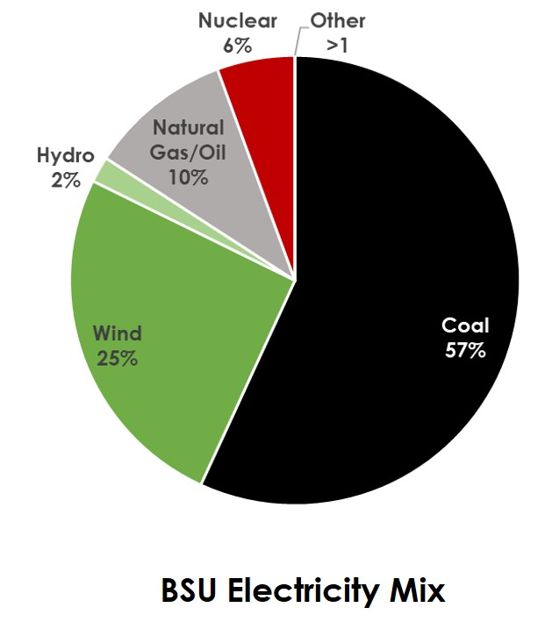
[[IMAGE REF 0000]] Image reference -- not directly editable; the original page reference is preserved automatically. Source: https://www.bemidjistate.edu/offices/sustainability/wp-content/uploads/sites/59/2018/07/BSU-Electricity-Mix-2018.jpg
Bemidji State University currently gets a quarter of its electricity from wind.
Other sources of our electricity are hydro, nuclear, natural gas, and coal. Electricity use on campus is our single biggest contribution to our carbon footprint.
We understand that the most efficient use of energy is to simply use less of it, so we encourage reduction above all else. We are also very committed to reducing our electricity consumption through energy efficiency as well as finding new ways to utilize clean, renewable energy in order to minimize our impact on the earth and reach our goal of carbon neutrality by 2050.

Data Measurement & Tracking Progress
Greenhouse Gas Emissions | Find out more about Bemidji State University’s Carbon Footprint, track our progress, and help us find creative solutions to achieving carbon neutrality! Be sure to check out our CO2-related projects on campus!
92Waste & Recycling | Since 2006, we have decreased our waste generation by almost 30% and have also worked to increase the amount of waste we recycle. The Sustainability Office is continually looking for ways to move our campus towards more sustainable practices. Be sure to check out our waste-related projects on campus!

