Title | Admitted Students
Meta Description
— Page content begins below. Please do not edit the table above. —
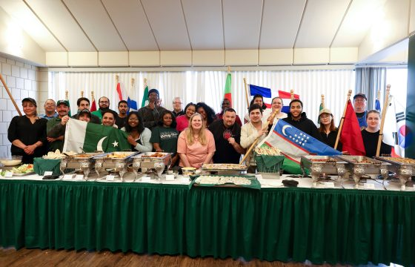
[[IMAGE REF 0000]] Image reference -- not directly editable; the original page reference is preserved automatically. Source: https://www.bemidjistate.edu/services/international/wp-content/uploads/sites/19/2024/05/2K4A7827-560x360.jpg

Long awaited ISO Festival of Nations Returns to Bemidji State University
Juliana Nixon is a BSU international student from Nigeria, she is a third year studying Computer Information Systems and the President of International Student Organization (ISO). When she came to BSU, she came with memories and stories from her aunties, who have graduated BSU, about the Festival of Nations. This grand ISO celebration of different […]
Keep Reading All News

Congratulations and welcome to Bemidji State University!
Now that you have been admitted, it’s time to start focusing on your next steps to becoming a student at Bemidji State University (BSU)! The International Program Center is here to help you make the most of your experience at BSU, offering guidance at every step along the way.

Before You arrive
Once admitted, we will send you your Welcome Packet along with your I-20 or DS-2019 and letter of admission. Once you receive this packet, you will need to:
- Sign your I-20/DS-2019.
- Pay your SEVIS fee. This should be done as soon as possible to ensure that you have enough time to obtain your visa and make travel arrangements.
- Apply for your student visa at the nearest U.S. embassy or consulate.
- Make flight arrangements for travel to Bemidji, Minnesota (airport code is BJI), to arrive BEFORE the orientation program start date (located on admission letter).
- Set up StarID (if you haven’t already done so) and MyBSU e-mail account.
- Sign up for residence hall and dining service through your MyBSU account.You are required to live on campus your first year at BSU, or until you are at least 21 years old. Please note that you are not required to submit the $150 prepayment for housing.
- Bring immunization records with you to take to the BSU Student Center for Health and Counseling once you arrive and fill out the immunization form.

Upon arrival
- Attend the international student orientation program, which includes an Academic American English assessment.
- Purchase the mandatory health insurance. Please see UnitedHealthcare’s website (works best with Chrome browser) for general information. See UHC’s “Bemidji State University” page for more detailed information.
- Have a test for tuberculosis, which is administered by the Student Center for Health and Counseling.
- Payment information: The first two payments for new international students are due the Friday before classes begin. They are: 1) the total amount of your health insurance, and 2) a $300 down payment on tuition and fees OR enrollment in our payment plan. This deadline is meant to give you time to learn about our payment procedures and ask questions. In future semesters, your bills will be due 15 business days prior to the semester start date.

Resources for Admitted Students
Preparing for Travel – Information on obtaining your visa, traveling to Bemidji, and what you’ll need when you arrive.
Health Insurance – Learn more about required health insurance for international students.
Housing – Information about BSU’s residence halls and housing options for international students.
Immunization – Immunization requirements for enrollment.
Orientation – Orientation is mandatory for all new international students, undergraduate and graduate levels.
Sevis Fee – All F-1 and J-1 visa applicants are required to pay this fee.
Visa Information – Points to remember when applying for a non-immigrant visa.
[[IMAGE REF 0001]] Image reference -- not directly editable; the original page reference is preserved automatically. Source: https://www.bemidjistate.edu/services/international/wp-content/uploads/sites/19/2024/05/2K4A7827-560x360.jpg

Long awaited ISO Festival of Nations Returns to Bemidji State University
Juliana Nixon is a BSU international student from Nigeria, she is a third year studying Computer Information Systems and the President of International Student Organization (ISO). When she came to BSU, she came with memories and stories from her aunties, who have graduated BSU, about the Festival of Nations. This grand ISO celebration of different […]
Keep Reading All News

