Title | Eligibility & Expectations
Meta Description
— Page content begins below. Please do not edit the table above. —

Application and Eligibility Information
We’re so excited you’re interested in this enriching opportunity! Upward Bound recruits students in January each year, and the program starts in June.

Eligibility
Here’s how to determine if you’re eligible to apply for the Upward Bound program.
- You are currently in the 8th grade, but have not yet completed the 11th grade.
- You are between the ages of 13-19.
- You want to attend college after high school.
- Your parent(s) or legal guardian(s) have NOT graduated from a four year college/university AND/OR your family meets federal low-income requirements.
- You attend one of the 7 area schools that Upward Bound provides services to: Bagley, Bemidji, Blackduck, Cass Lake, Mahnomen, Park Rapids or Red Lake High School.

How to Apply
Download the Upward Bound participant application. You can also contact the Upward Bound office at (218) 755-3334, and we will send you the application materials.
Turn in the completed application to your high school guidance counselor. Applications are Due February 28, 2023.

What Happens After You Apply
- You will have an interview with UB staff after the application deadline.
- You will receive a letter by the middle of April letting you know if you’ve been accepted.

What Upward Bound Expects of Our Students
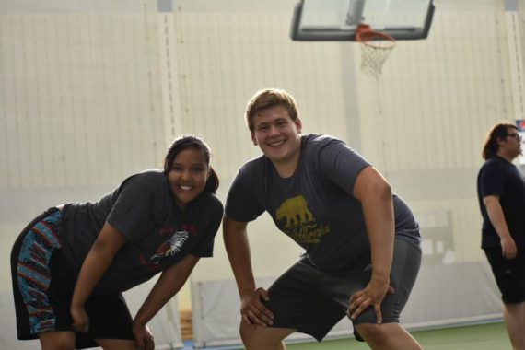
[[IMAGE REF 0000]] Image reference -- not directly editable; the original page reference is preserved automatically. Source: https://www.bemidjistate.edu/services/upward-bound/wp-content/uploads/sites/78/2022/01/summer5-768x512-1-570x380.jpg
IMAGEPLACEHOLDER0001IMAGEPLACEHOLDER0002
Once a student is chosen for Upward Bound, we have high expectations set for your academic and social performance. These expectations include the following:
- Participating in Upward Bound until graduating from high school.
- Participating in Upward Bound activities including attending school visits and tutoring, completing UB assignments and attending UB sponsored activities at Bemidji State.
- Enrolling in high school courses required for admission to higher education programs.
- Maintaining 2.0 GPA (grade point average) throughout the program.
- Achieving satisfactory academic progress in all classes, including GPA (grade point average) improvement each semester and having no incomplete classes.
- Applying for admission to a post-secondary education institution before January of the senior year in high school.
- Maintaining communication with Upward Bound for six years after graduating from high school to report on academic progress and the continuation of education.
- Exhibiting positive, friendly, cooperative and respectful behavior toward Upward Bound staff and fellow students.
- Observing the rules and regulations of Upward Bound.
- Not using tobacco products, alcohol or abusing other substances (legal or illegal).

