Title | InPsyT Program
Meta Description
— Page content begins below. Please do not edit the table above. —
The InPsyT program aims to train and prepare American Indian students for careers in psychology at the undergraduate level. The program focuses on recruiting/enrolling a small cohort (up to 10 students per year) of American Indian students to major in psychology at Bemidji State University. Once accepted, we will utilize culturally-based methods for retention towards graduation and preparation for graduate school and/or the workforce.
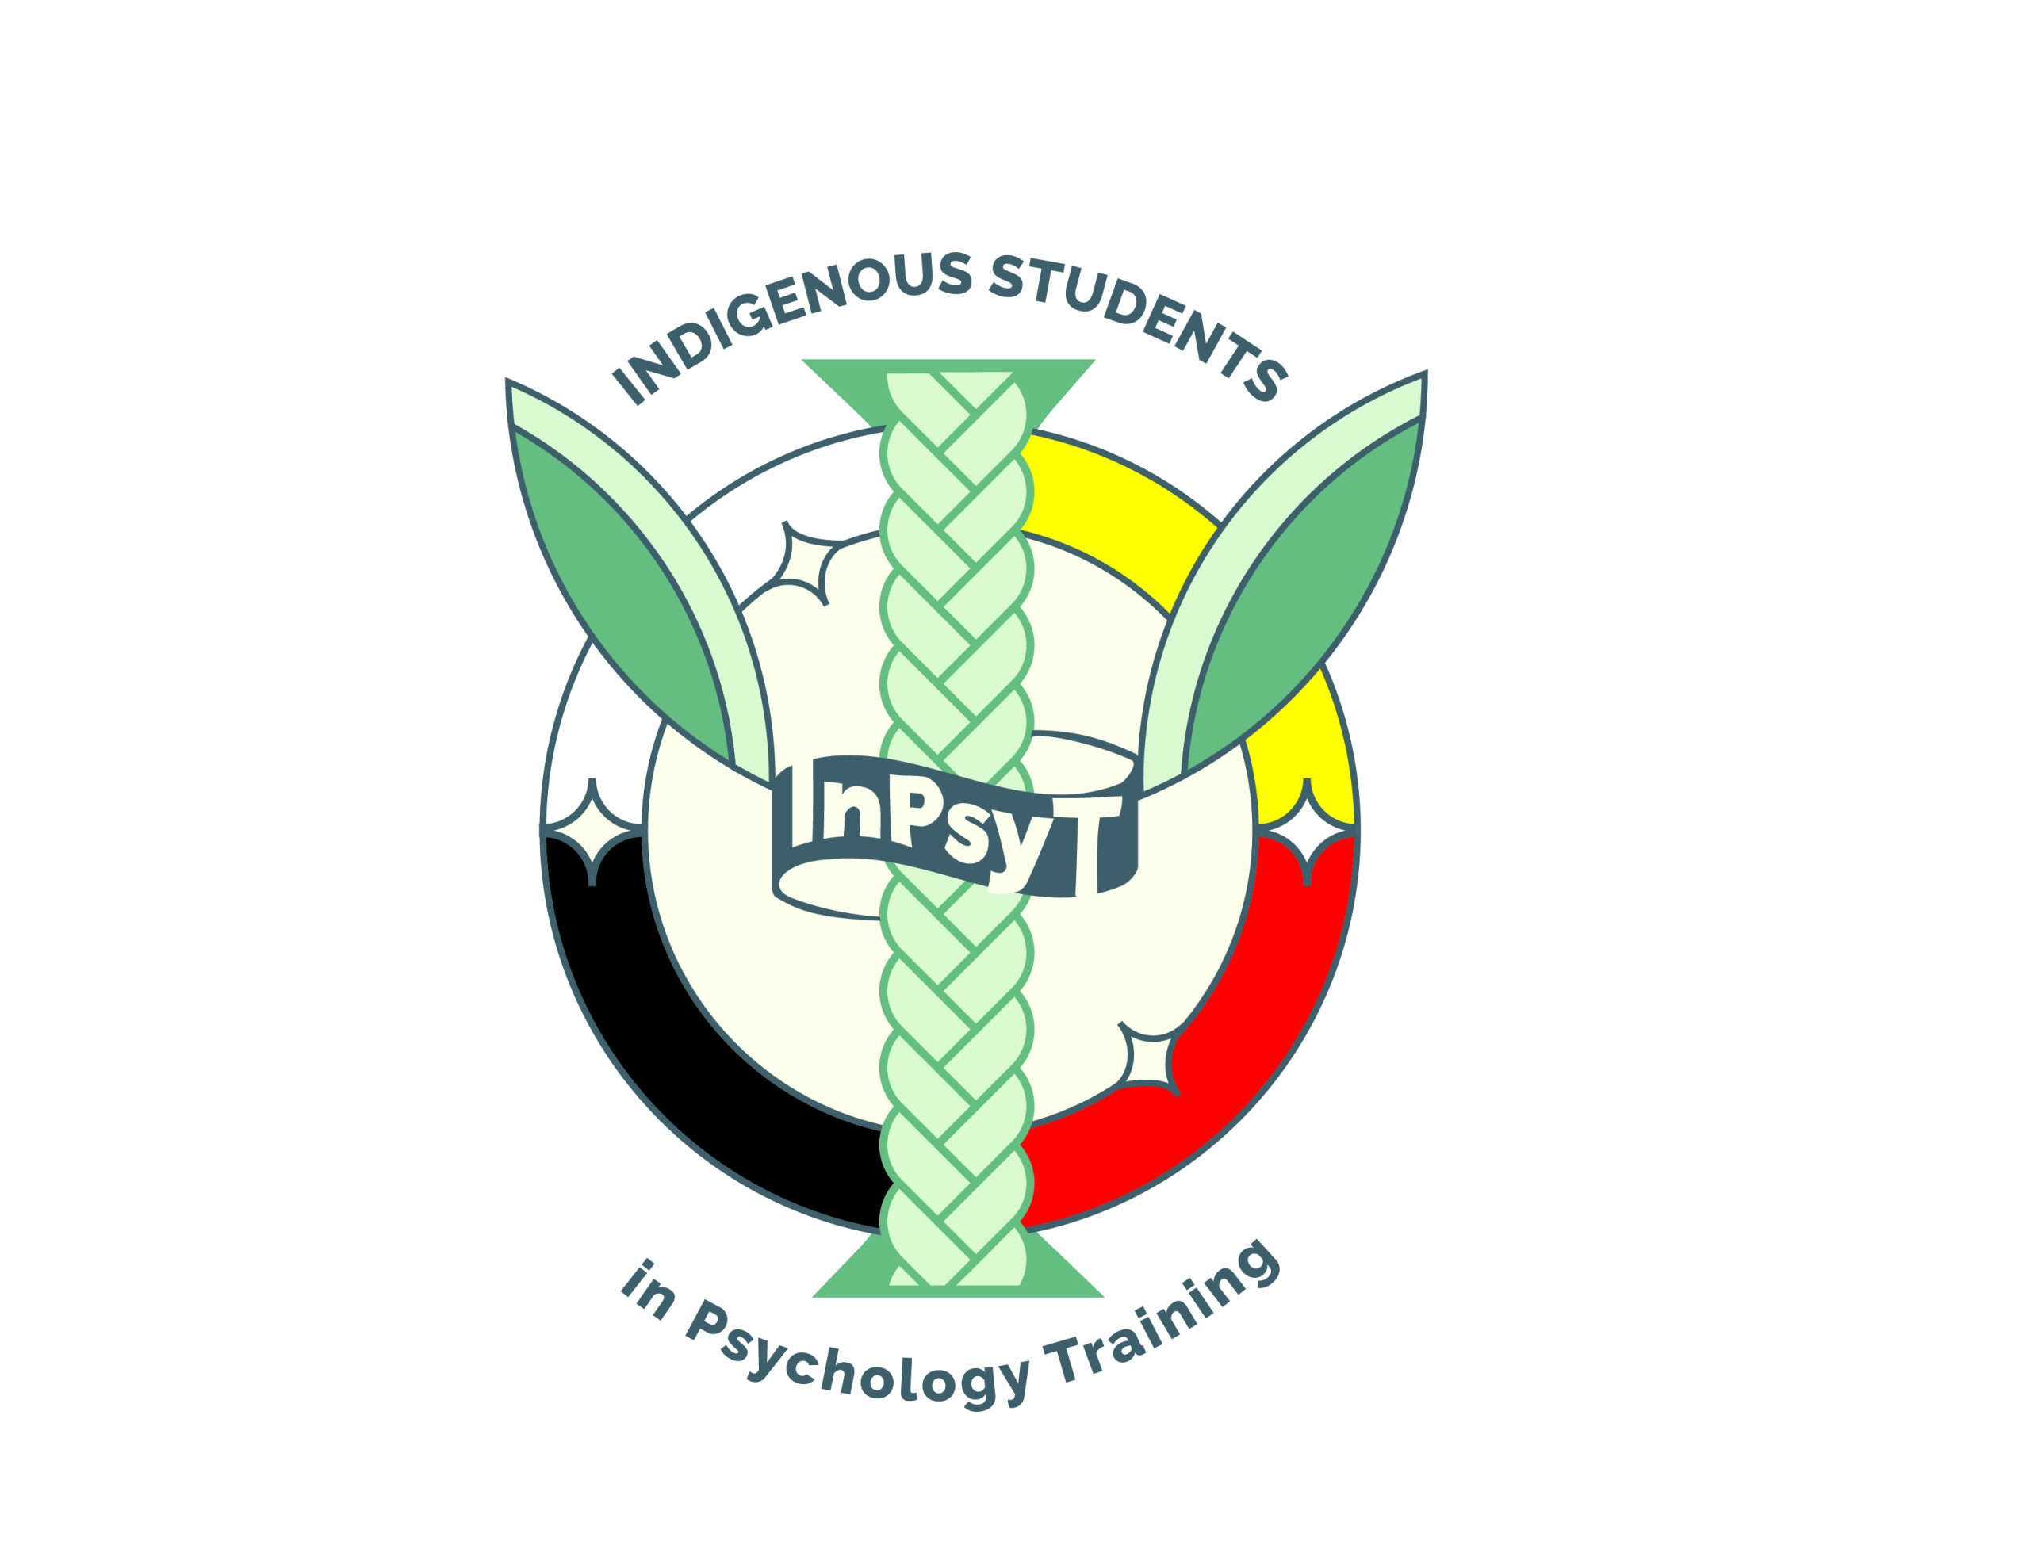
[[IMAGE REF 0000]] Image reference -- not directly editable; the original page reference is preserved automatically. Source: https://www.bemidjistate.edu/academics/psychology/wp-content/uploads/sites/65/2023/03/InPysT-V3_InPsyT-CLR-scaled.jpg
The program is funded through Minnesota State Education Innovations, the Blandin Foundation and the BSU Psychology Department.
The key components of the program include strategies geared towards developing a culturally-supportive community within the Psychology Department for students in the program. We do this by developing and fostering connections amongst students in the cohort; establishing a mentoring and support network for cohort members with American Indian psychologists and mental health professionals; providing culturally-specific departmental (and campus) programming on American Indian psychology and behavioral health; providing research opportunities and training on Indigenous methodologies and providing travel support to attend national conferences, such as the Society of Indian Psychologists conference or the convention of the American Psychological Association.

Program Benefits
The InPsyT program provides social, emotional and academic support to American Indian students majoring in psychology. Students will build connections with other American Indian students, with BSU faculty and with American Indian professionals in the field of psychology. The program aims to support students each semester, with the end goal of completing their degree in psychology and attending graduate school.
- Student Orientation for new cohort members
- Bi-weekly cohort luncheons with BSU psychology faculty members
- American Indian guest speakers
- Mentoring didactics with American Indian psychologists in the region and across the US
- Research opportunities and training through course options and mentored research projects
- Attendance at the Society of Indian Psychologist Conference

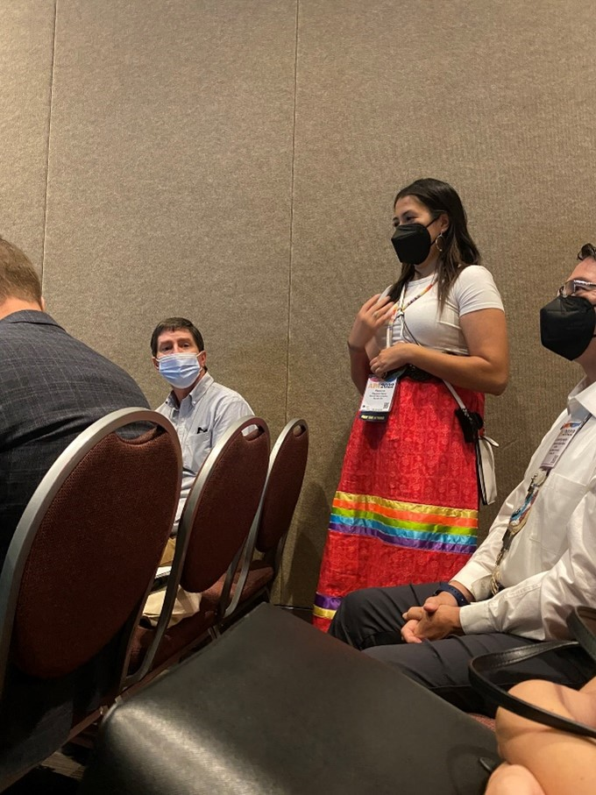
[[IMAGE REF 0001]] Image reference -- not directly editable; the original page reference is preserved automatically. Source: https://www.bemidjistate.edu/academics/psychology/wp-content/uploads/sites/65/2023/04/Raeanne-Henry.jpg
“While at BSU, I became a part of Indigenous Students in Psychology Training and this is where I received all of my training for life after graduation. The faculty involved with InPsyT did an amazing job of preparing me for life after graduation. I was an online student, if I had attended in person I may have received more preparation from other faculty members.”
— Raeanne Henry, Online Psychology Major and InPsyt Program Student
Read more about Raeanne’s Experience

Eligibility
- Declared Psychology Major
- Enrolled member or descendant of an American Indian tribe
- Maintain minimum GPA of 3.0

Contact
Contact the BSU Psychology Department at inpsyt@bemidjistate.edu for more information.

