Title | International Students
Meta Description
— Page content begins below. Please do not edit the table above. —
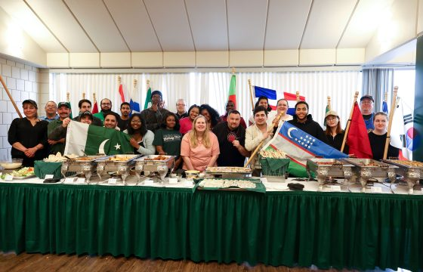
[[IMAGE REF 0000]] Image reference -- not directly editable; the original page reference is preserved automatically. Source: https://www.bemidjistate.edu/services/international/wp-content/uploads/sites/19/2024/05/2K4A7827-560x360.jpg

Long awaited ISO Festival of Nations Returns to Bemidji State University
Juliana Nixon is a BSU international student from Nigeria, she is a third year studying Computer Information Systems and the President of International Student Organization (ISO). When she came to BSU, she came with memories and stories from her aunties, who have graduated BSU, about the Festival of Nations. This grand ISO celebration of different […]
Keep Reading All News
Welcome international students! The staff in the International Program Center truly enjoy getting to know prospective, admitted, new, and current students. Take some time to explore what we have to offer on our website. We hope the provided information will help answer any questions you may have, but you are always welcome to contact us or stop by our office to say hello!
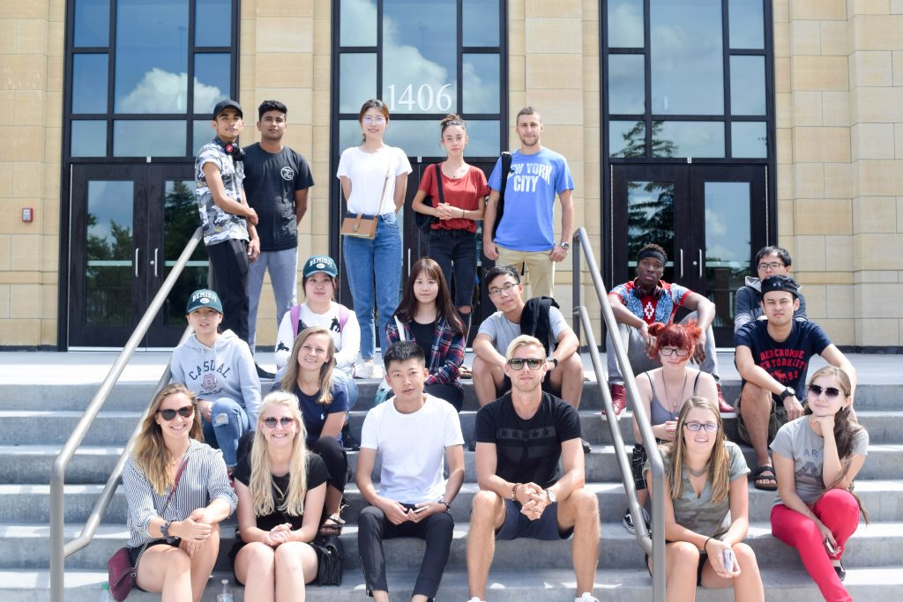
[[IMAGE REF 0001]] Image reference -- not directly editable; the original page reference is preserved automatically. Source: https://www.bemidjistate.edu/services/international/wp-content/uploads/sites/19/2018/05/DSC_0001-1024x683.jpg
When you arrive, you’ll find challenging academic programs coupled with a university and student population committed to environmental stewardship, community service and global understanding. Throughout your stay, the International Program Center will be here to help you with navigating your way in your new home and school.

Interested in attending BSU? Apply Today!
[[IMAGE REF 0002]] Image reference -- not directly editable; the original page reference is preserved automatically. Source: https://www.bemidjistate.edu/services/international/wp-content/uploads/sites/19/2024/05/2K4A7827-560x360.jpg

Long awaited ISO Festival of Nations Returns to Bemidji State University
Juliana Nixon is a BSU international student from Nigeria, she is a third year studying Computer Information Systems and the President of International Student Organization (ISO). When she came to BSU, she came with memories and stories from her aunties, who have graduated BSU, about the Festival of Nations. This grand ISO celebration of different […]
Keep Reading All News

