Title | Faculty & Staff
Meta Description
— Page content begins below. Please do not edit the table above. —

Enokiijig / We Serve
Along with AIRC staff, the center provides office space to Indigenous Studies and Ojibwe Language faculty and is “home away from home” for most of the University’s American Indian faculty and staff.

AIRC Staff
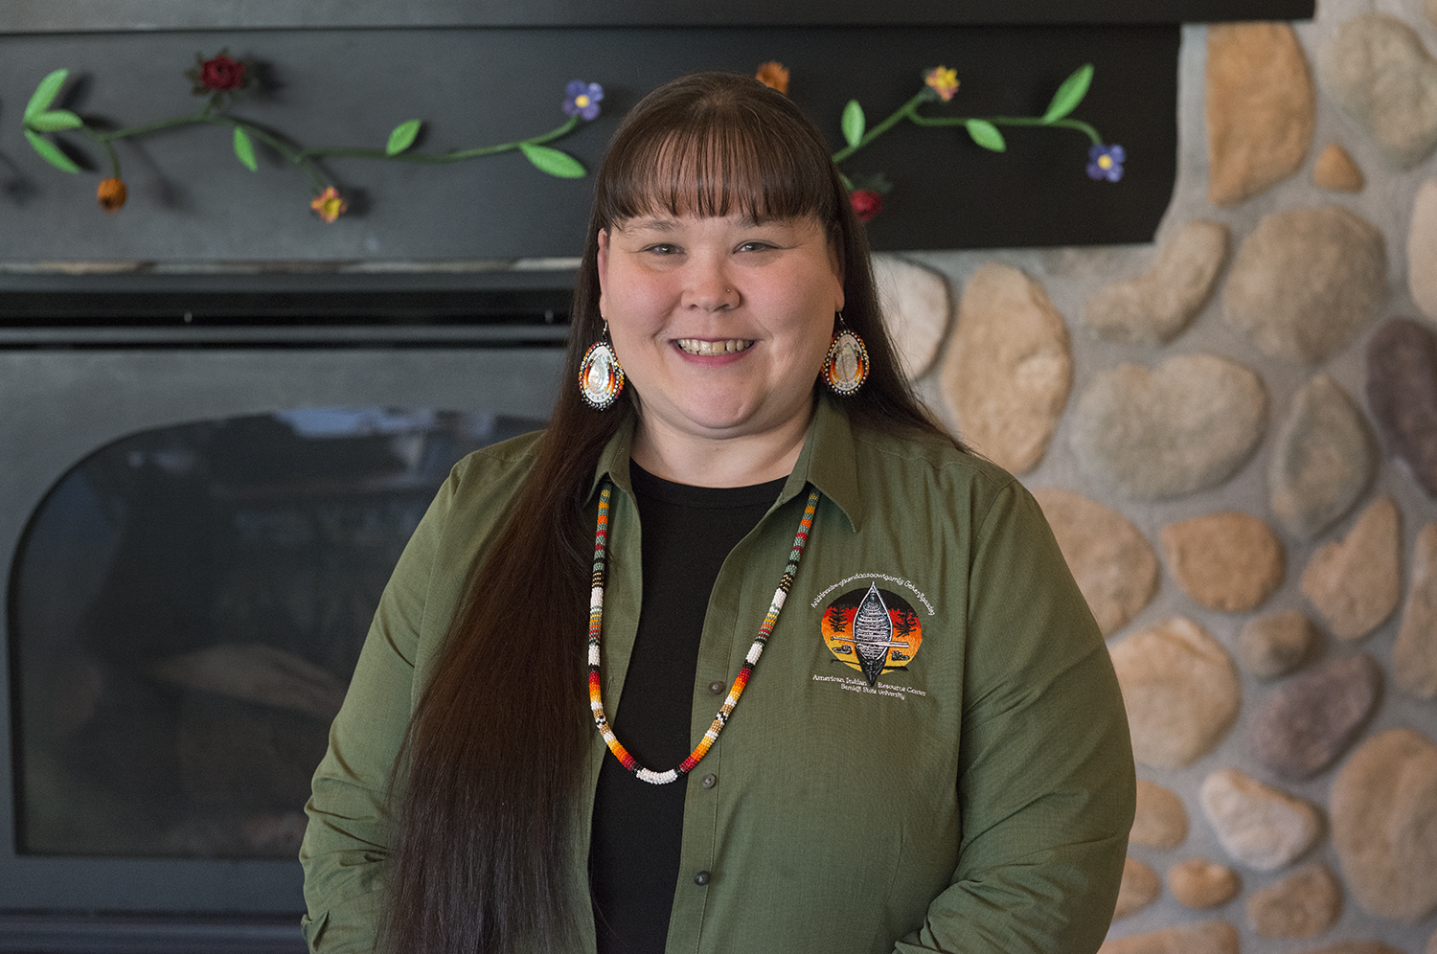
[[IMAGE REF 0000]] Image reference -- not directly editable; the original page reference is preserved automatically. Source: https://www.bemidjistate.edu/airc/wp-content/uploads/sites/85/2020/01/20AIRC_Chrissy_Koch_0016h.jpg
Chrissy Downwind
Vice President of American Indian Student Success and Campus Diversity Officer
American Indian Resource Center 114
Phone: (218) 755-2141
Box #21
chrissy.downwind@bemidjistate.edu

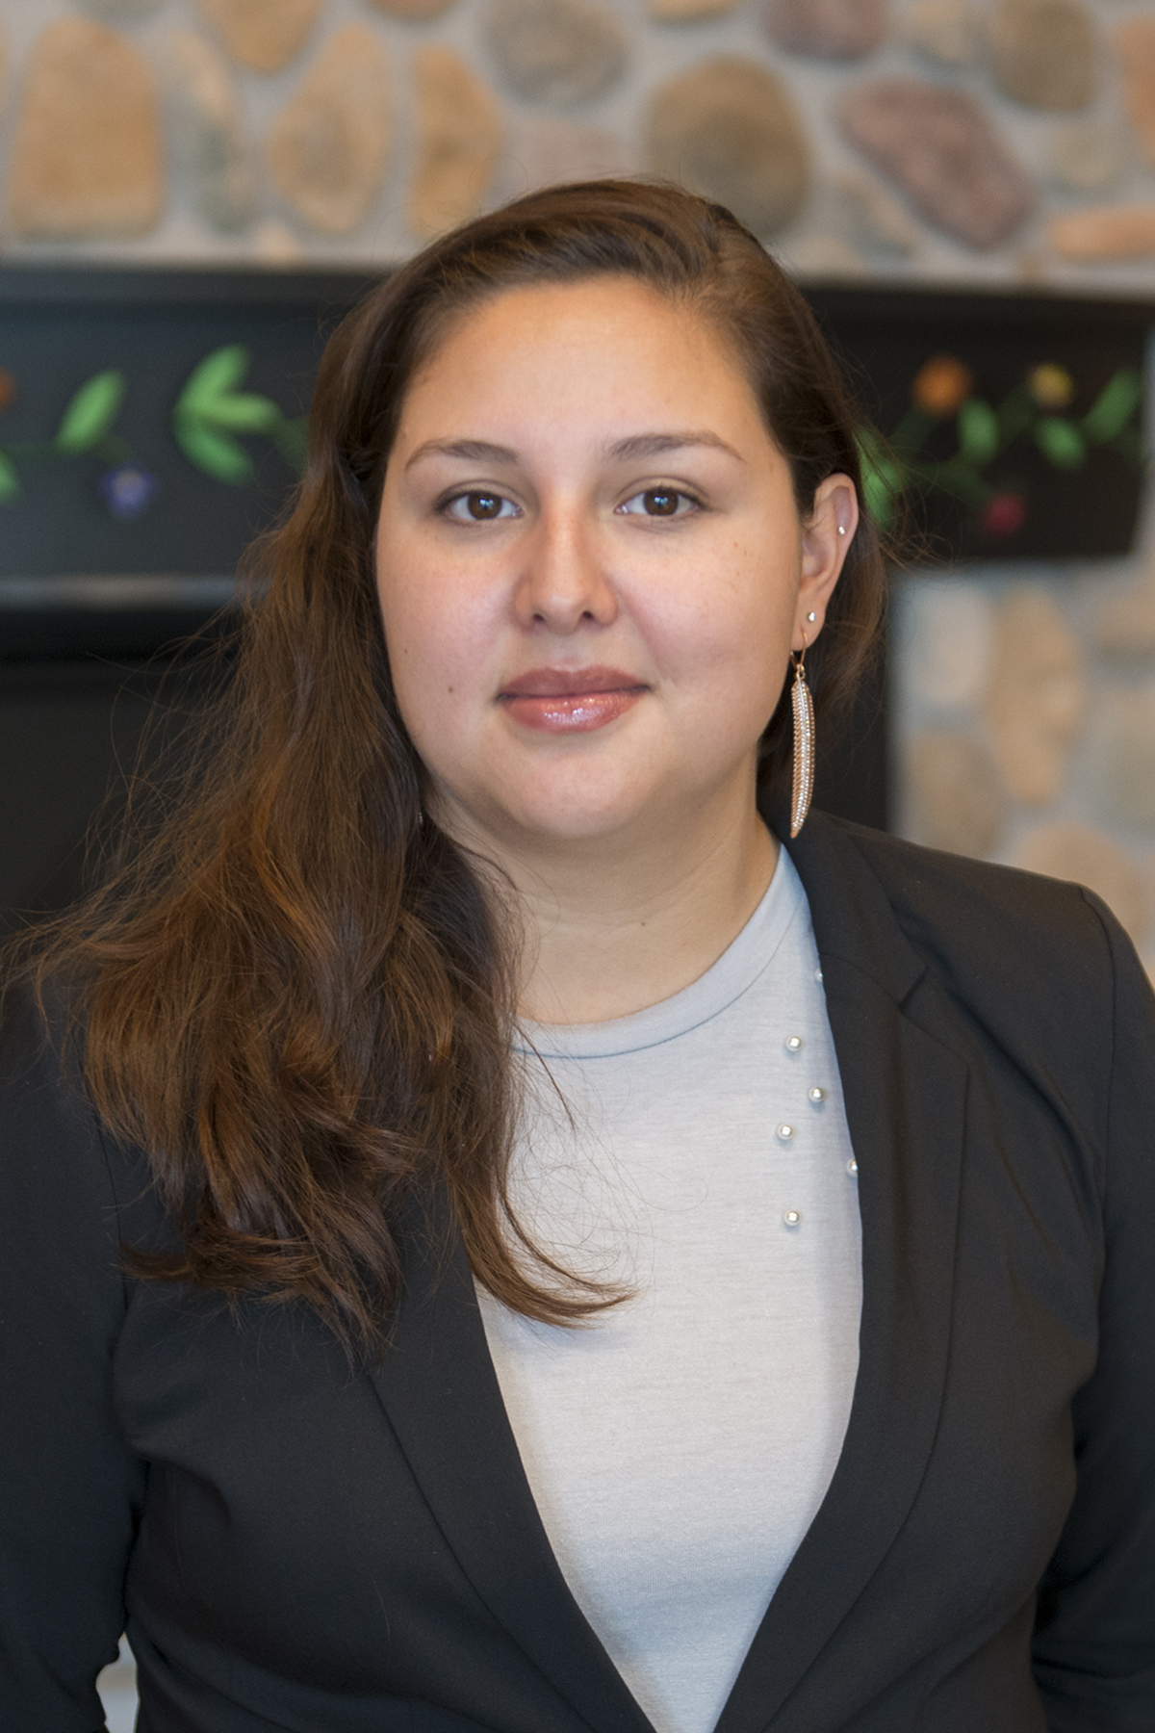
[[IMAGE REF 0001]] Image reference -- not directly editable; the original page reference is preserved automatically. Source: https://www.bemidjistate.edu/airc/wp-content/uploads/sites/85/2018/08/19AIRCstaff_Ann_Humphrey_0019.jpg
Ann Humphrey
AIRC Associate Director
American Indian Resource Center 109a
Phone: (218) 755-3353
Box #21
Email: ann.humphrey@bemidjistate.edu

Ron Wilson
AIRC Associate Director for Outreach
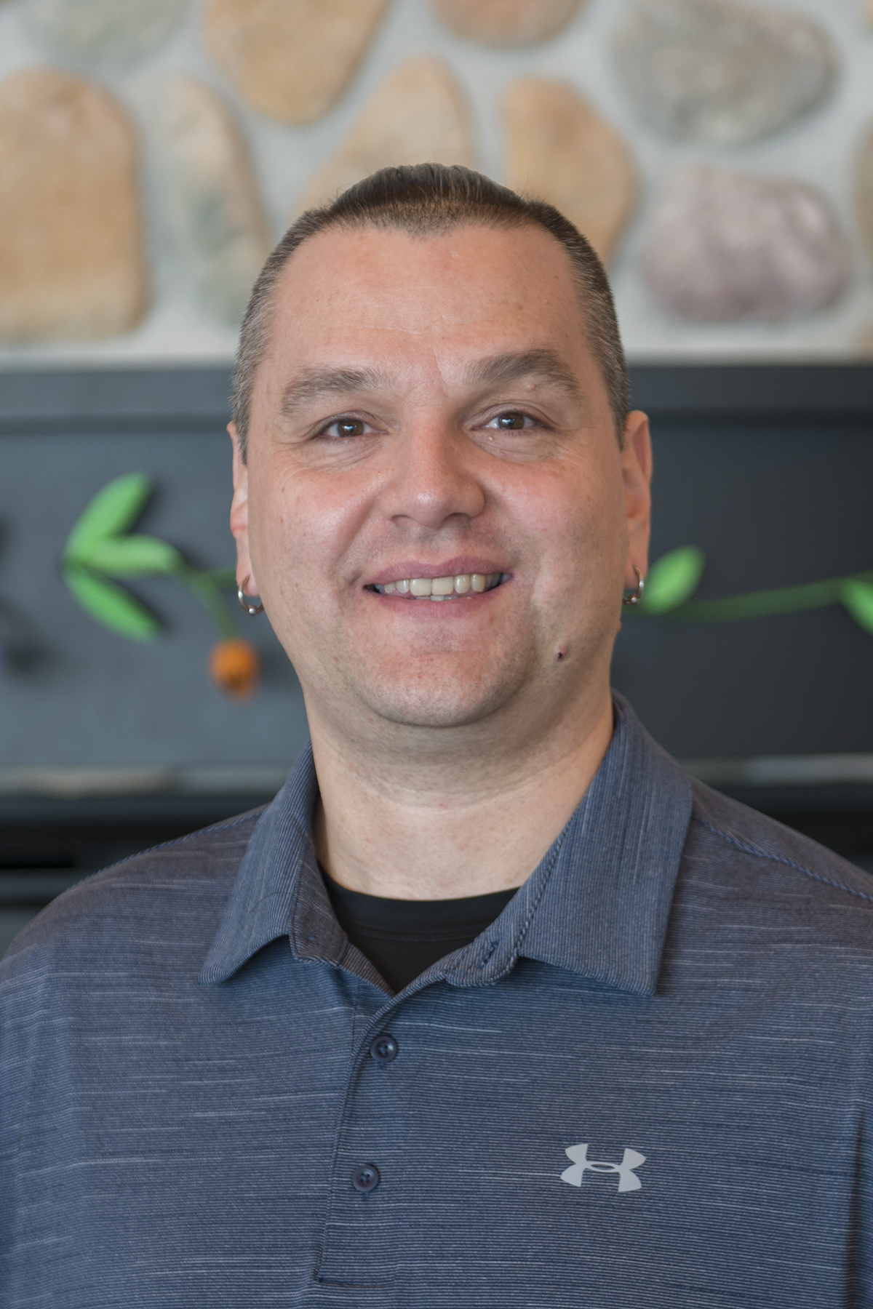
[[IMAGE REF 0002]] Image reference -- not directly editable; the original page reference is preserved automatically. Source: https://www.bemidjistate.edu/airc/wp-content/uploads/sites/85/2020/02/20BSU_AIRC_Ron_Wilson.jpg
American Indian Resource Center 110a
Phone: (218) 755-4210
Box #21
ron.wilson@bemidjistate.edu

Also on AIRC Staff
We have two new Staff at the American Indian Resource Center! These Student Success Coordinators will help students navigate the higher education landscape through various modes.

Ashley Jones
AIRC Student Success Coordinator
Room 113
Email: ashley.jones@bemidjistate.edu
Phone: (218) 755 – 2151

Jack Warren
AIRC Student Success Coordinator
Room 109
Email: jack.warren@bemidjistate.edu
Phone: (218) 755 – 2615

Languages & Indigenous Studies Faculty
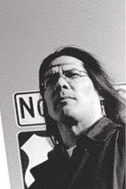
Dr. Shaawano Uran

Professor of Indigenous Studies
American Indian Resource Center Room 111
Phone: (218) 755- 2590
Email: shaawano@bemidjistate.edu

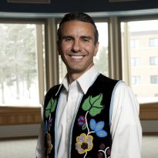
[[IMAGE REF 0003]] Image reference -- not directly editable; the original page reference is preserved automatically. Source: https://www.bemidjistate.edu/airc/wp-content/uploads/sites/85/2018/08/AST-Vest-Crop-e1535744029480.jpg
Dr. Anton Treuer
Professor of Languages Studies
American Indian Resource Center 112
Phone: (218) 755-3968
Box #21
anton.treuer@bemidjistate.edu
Website: Anton Treuer
Schedule an appointment

