Title | Neetus Grant
Meta Description
— Page content begins below. Please do not edit the table above. —
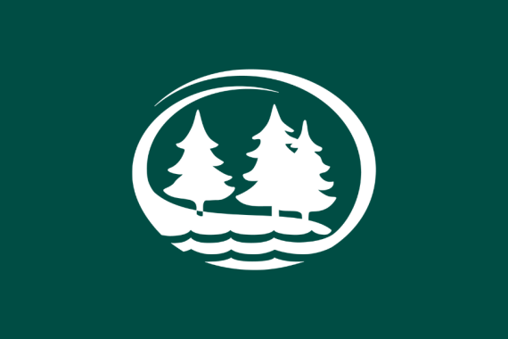
Bemidji State University and Northwest Technical College have been awarded nearly $500,000 through the Governor’s Emergency Educational Relief grant funding for a project to deliver technology for distance learning to students in need.
Chrissy Koch, executive director of BSU’s American Indian Resource Center, says the Northwoods Equity in Education and Technology for Underserved Students project will address a critical need to provide the technology necessary for underserved students to continue receiving access to educational services during the COVID-19 pandemic.
“We focused on how we could best support our American Indian and other underrepresented students during these uncertain times,” Koch said. “We want to provide technological support for those who may not have the means necessary to successfully remain in a distance learning or online platform. This program is an opportunity for us to open the door to these students — whether it was in the form of material items like laptops or assuring they have sufficient Wi-Fi services to accommodate their courses.”
The three-year, $499,932 grant was written and submitted by Koch; BSU Chief Information Officer Dr. Sherry Lawdermilt, and Grant Writer Jenna Trisko. The grant is part of a U.S. Department of Education program that awarded a total of $5.3 million to Minnesota’s Governor Tim Walz for the purpose of providing the state’s colleges and universities and other education‐related entities with emergency assistance due to COVID‐19.
“The GEER grant will also serve as a pilot project to assess if diminishing technology barriers impact student retention and persistence,” Trisko said. “It was a highly competitive grant, but with the assistance and input from a few dozen individuals we put together a compelling project that will benefit some of our most in-need students over the next few years.”

Contact
- Chrissy Koch, director of the American Indian Resource Center; christine.koch@bemidjistate.edu

Links

  - Governor’s Emergency Education Relief Fund
  - Apply for NEETUS Funding
2021-B-020

