Title | Arts & Culture
Meta Description
— Page content begins below. Please do not edit the table above. —
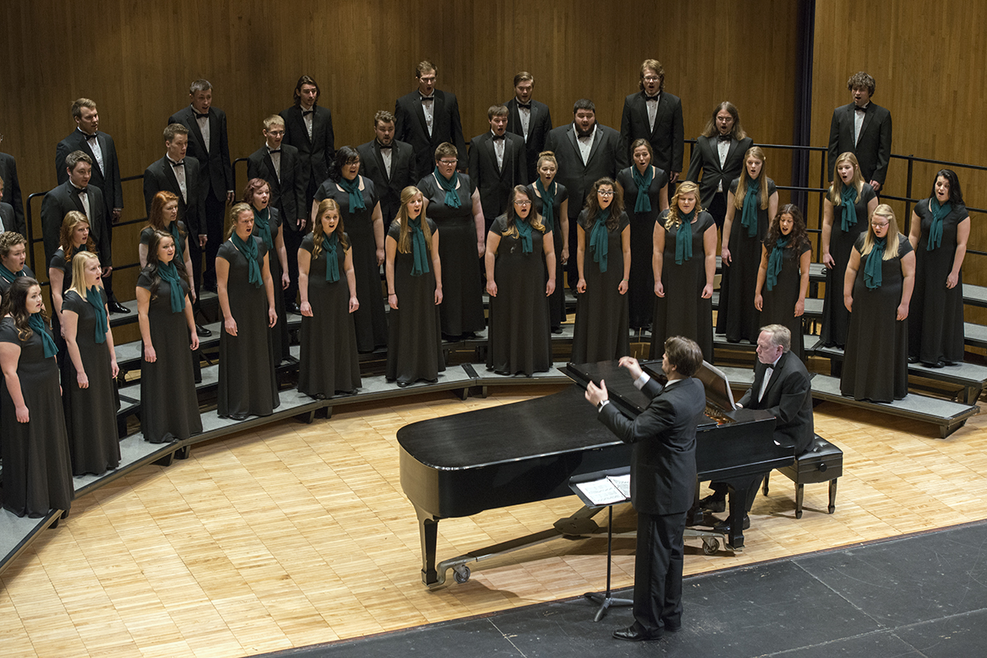
[[IMAGE REF 0000]] Image reference -- not directly editable; the original page reference is preserved automatically. Source: https://www.bemidjistate.edu/campus-life/wp-content/uploads/sites/17/2021/04/16Thompson_Concert_0030.jpg
The Bemidji Choir under the direction of Dr. Dwight Jilek
Take in a student art exhibit at the Talley Gallery. Take a walk around downtown Bemidji and find the yearly rotating sculptures by the Bemidji Sculpture Walk. Check out the historic Paul Bunyan Playhouse. On or off-campus, BSU is a haven for arts and culture.
The Bangsberg Fine Arts Complex houses Thompson Recital Hall, a venue where you might hear the big band sounds of the jazz band or the enchanting tunes of the chamber singers. Read the poems and short stories showcased in our student publications, or even submit something yourself. Marry a passion for art and design in our nationally-renown exhibit design program.
If your passion for the arts is academic, we have majors in music, creative & professional writing and art & design. Follow your creativity and build your skills with our talented faculty.
With our diversity of venues, it’s easy to be both a patron and participant at Bemidji State.

