Title | Main Stage Theater
Meta Description
— Page content begins below. Please do not edit the table above. —

General Info
- Seating Capacity: 261
- Seating Type: Fixed tables and chairs
- Internet: Wireless

Equipment
- Blu-ray/DVD Player
- Ceiling Projector (1920x1080 WUXGA)
- Document Camera
- Sound System
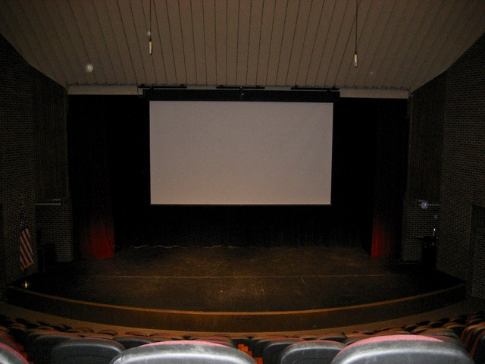
[[IMAGE REF 0000]] Image reference -- not directly editable; the original page reference is preserved automatically. Source: https://www.bemidjistate.edu/offices/its/wp-content/uploads/sites/60/2025/01/bangsberg-200-theater.jpg

