Title | Campus Activities Board
Meta Description
— Page content begins below. Please do not edit the table above. —

Campus Activities Board
Campus Activities Board provides students with fun and free entertainment on campus. We bring hypnotists, comedians, coffeehouses, concerts, magicians, giveaways and much much more! Interested in planning these events on campus? Come talk to one of us at any of our events or stop by at a meeting.
In Spring 2026, we hold meetings in Hobson Leadership Center on Tuesdays at 1 p.m.
Membership is open to all students at both BSU and NTC.
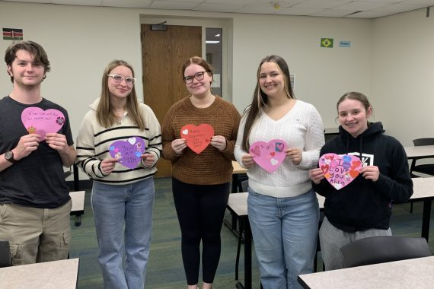
[[IMAGE REF 0000]] Image reference -- not directly editable; the original page reference is preserved automatically. Source: https://www.bemidjistate.edu/services/student-activities/wp-content/uploads/sites/29/2026/05/CAB-Palentines-2025-Kyle-Meadow-Maggie-Jackie-and-Taylor-570x380.jpg
IMAGEPLACEHOLDER0001

Contact Information
bsuclubandorg@bemidjistate.edu
(218) 755-3763

