Title | Orientation & Welcome Week
Meta Description
— Page content begins below. Please do not edit the table above. —
Experience the ultimate kick-off to your college journey at Bemidji State University’s New Student Orientation and Welcome Week.

Orientation Weekend Schedule
New Student Orientation groups are led by students who are involved on campus and ready to show you the ropes!
Whether you’re able to join the festivities in person or not, we encourage you to log into D2L through MyBSU and checkout Beaver Blueprint, our online orientation. The online course is full of great resources and you’ll be able to access them any time you’ll need them this semester. Most new students are already enrolled and will find Beaver Blueprint in your course list. If you don’t see it, search for it under Discover and then can enroll by clicking the “Enroll yourself” button!
This experience is required for all new fall students — both first-time and transfer — and is designed to help you make a smooth transition to college life. From mid-August to the first week of classes, you’ll have the chance to explore the campus, connect with fellow students and learn everything you need to know to succeed at BSU. All of our new fall students are expected to participate.
- Thursday, August 20 — Beaver Move-In
- August 20-23 — 2026 New Student Orientation
- August 24-30 — Welcome Week
- Thursday, September 3 — Beaver Organization Bash
- Wednesday, September 9 — On-Campus Employment Fair
- September, 21-26 — BSU Homecoming
- October 2-4 — Beaver Family Weekend
Welcome back flyer
On move-in day, you’ll start off by settling into your residence hall and then dive into a jam-packed schedule of orientation activities. Off-campus students should check in for orientation at the Hobson Memorial Union Ballroom entrance.
You’ll be grouped with 30-40 students and guided by student orientation leaders, who will show you the ins and outs of campus life. You’ll discover the resources available to you both on campus and in the Bemidji community, and learn how to take advantage of them. You’ll also find out how to get involved in campus activities and where to find academic and personal support when you need it.
And, of course, you’ll learn about our time-honored campus traditions!
Check out the New Student Orientation BeaverLink page for a full list of events and mark your calendars for BSU Family Weekend in late September!
Download the Orientation Schedule
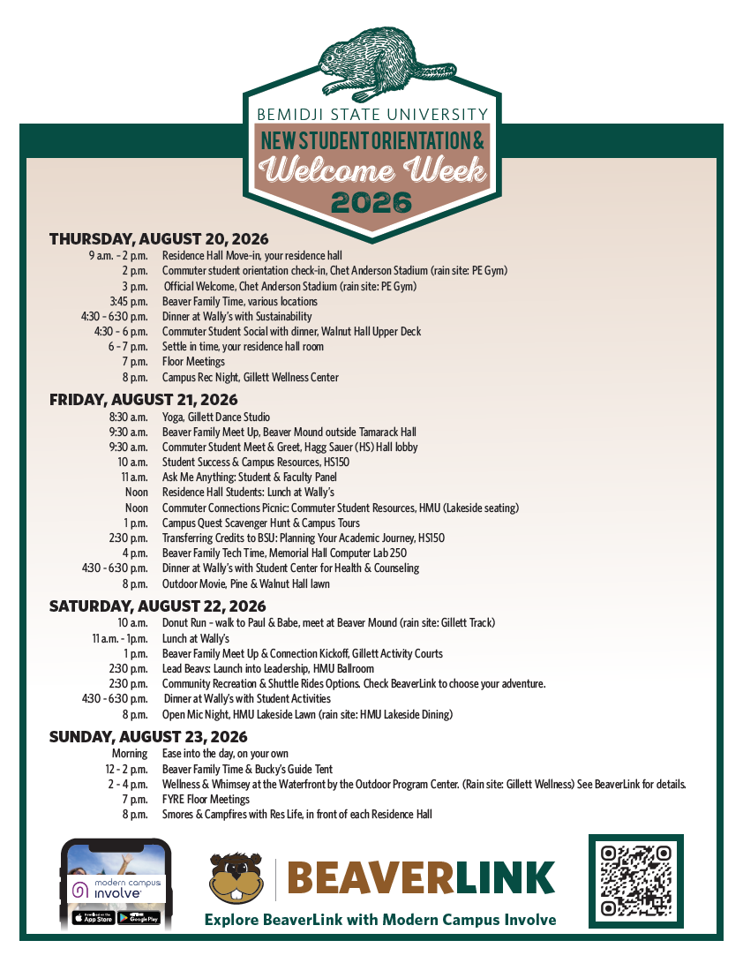
[[IMAGE REF 0002]] Image reference -- not directly editable; the original page reference is preserved automatically. Source: https://www.bemidjistate.edu/services/student-activities/wp-content/uploads/sites/29/2026/07/Orientation-Schedule-pg-1.png
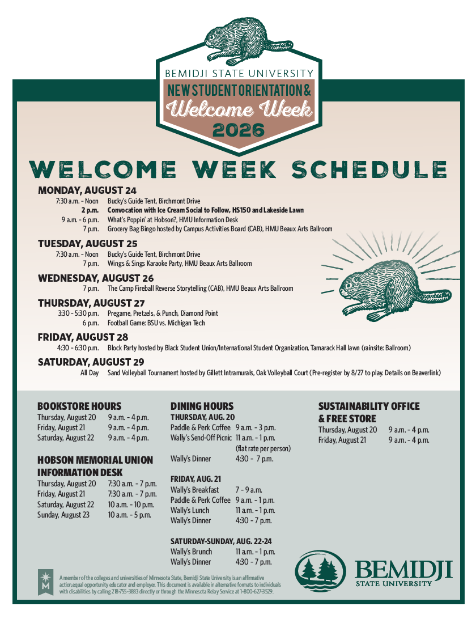
[[IMAGE REF 0003]] Image reference -- not directly editable; the original page reference is preserved automatically. Source: https://www.bemidjistate.edu/services/student-activities/wp-content/uploads/sites/29/2026/07/Orientation-Schedule-pg-2.png

Contact Us
Questions? Call us at (218) 755-3760 or send us an email at orientation@bemidjistate.edu.

[[IMAGE REF 0000]] Image reference -- not directly editable; the original page reference is preserved automatically. Source: https://www.bemidjistate.edu/services/student-activities/wp-content/uploads/sites/29/2023/01/BSU-move-in-2-2022-570x380.jpg
IMAGEPLACEHOLDER0001

