Title | Gillett Wellness Center
Meta Description
— Page content begins below. Please do not edit the table above. —

Get Fit, Stay Active!
At the Gillett Wellness Center, we believe that an active body leads to a healthy and active mind. Our state-of-the-art facilities and equipment provide everything you need to get fit, de-stress and have fun.
As a student meeting minimum enrollment requirements, you have free access to our facilities. We also offer flexible memberships for faculty, staff, alumni and the public. Come visit us and start your journey towards a physically active, healthy way of life.

Contact
Department of Campus Recreation
220 19th Street NE
Mailing Address:
1500 Birchmont Dr. NE #29
Bemidji, MN 56601-2907
Gillett Wellness Center:
Phone: (218) 755-4135
Fax: (218) 755-4363
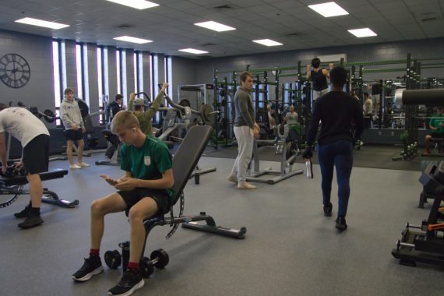
[[IMAGE REF 0000]] Image reference -- not directly editable; the original page reference is preserved automatically. Source: https://www.bemidjistate.edu/services/campus-recreation/wp-content/uploads/sites/31/2022/11/BSU-Weight-Room-Group-2022-570x380.jpg
IMAGEPLACEHOLDER0001IMAGEPLACEHOLDER0002

