Title | Swim Lessons
Meta Description
— Page content begins below. Please do not edit the table above. —

Youth Swim Lessons
Looking to teach your child to swim? Our BSU Swim Program has you covered. With a focus on drowning prevention and water safety, our instructors will teach your child the skills they need to stay safe in and around the water.
Class sizes are small and we offer two instructors per class to ensure safety and individual attention. Plus, your child will have a great time learning these important skills and developing a healthy, lifelong recreational habit. We recently completed our summer swim lessons. At this time we do not have any fall lessons planned but hope to offer lessons again this coming winter. Please check back for updated information. Once posted please log on to the following link to enroll https://bsuwellnesscenter.totalcamps.com/shop/EVENT
For additional information, please contact Duane Biehn at 218-755-4140 or duane.biehn@bemidjistate.edu
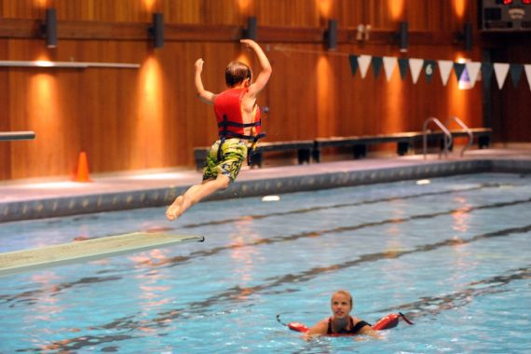
[[IMAGE REF 0000]] Image reference -- not directly editable; the original page reference is preserved automatically. Source: https://www.bemidjistate.edu/services/campus-recreation/wp-content/uploads/sites/31/2022/11/BSU-Pool-Swim-Lessons-2016-570x380.jpeg
IMAGEPLACEHOLDER0001

