Title | Intramural Sports
Meta Description
— Page content begins below. Please do not edit the table above. —

Fitness, Friends and Fun
Join our recreational sport leagues at Bemidji State University. We offer a variety of sports for BSU and NTC students, including flag football, sand volleyball, spike ball, indoor volleyball, basketball, softball, indoor soccer, wiffleball, dodgeball and golf.

Registration
To register your team, visit IM Leagues.

Fall 2026 Intramural Offerings
- Sand Volleyball Tournament – Registration closes 8/27/26
- Spike Ball – Registration closes 8/27/26
- Flag Football – Registration closes 9/3/26
- Coed 4 on 4 League Sand Volleyball – Registration closes 9/3/26
- Indoor Volleyball – Registration closes 10/15/26
- Golf Tournament (Simulator) – Registration closes 11/5/26
- 3 on 3 Basketball – Registration closes 11/26/26

Spring 2027 Intramural Offerings
- 5 on 5 Basketball – TBA
- Spring Volleyball – TBA
- Golf Tournament (Simulator) – TBA
- Wiffle Ball Tournament – TBD
- Dodgeball Tournament -TBD
- Softball Tournament – TBD
Fees will vary from league to league and are due when enrolling your team.
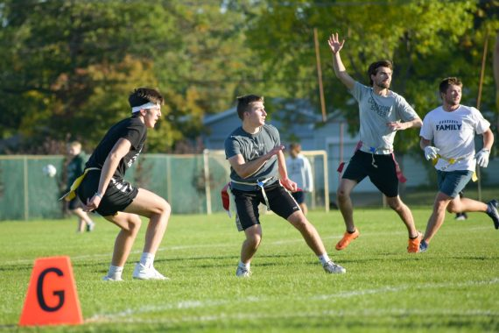
[[IMAGE REF 0000]] Image reference -- not directly editable; the original page reference is preserved automatically. Source: https://www.bemidjistate.edu/services/campus-recreation/wp-content/uploads/sites/31/2022/11/BSU-Flag-Football-2022-570x380.jpg
IMAGEPLACEHOLDER0001

Registration
To register your team, visit IM Leagues. All team members will need to sign waivers, pay team fees (if required) and check out team schedules and standings. Be sure to read through the general rules, too.

Questions and Suggestions
If you have suggestions for sports or you wish to become involved with intramurals but are not sure where to start, please contact Morgan Whitford Intramural Coordinator for the Department of Campus Recreation – office 110, (218) 755-4141, morgan.whitford@bemidjistate.edu
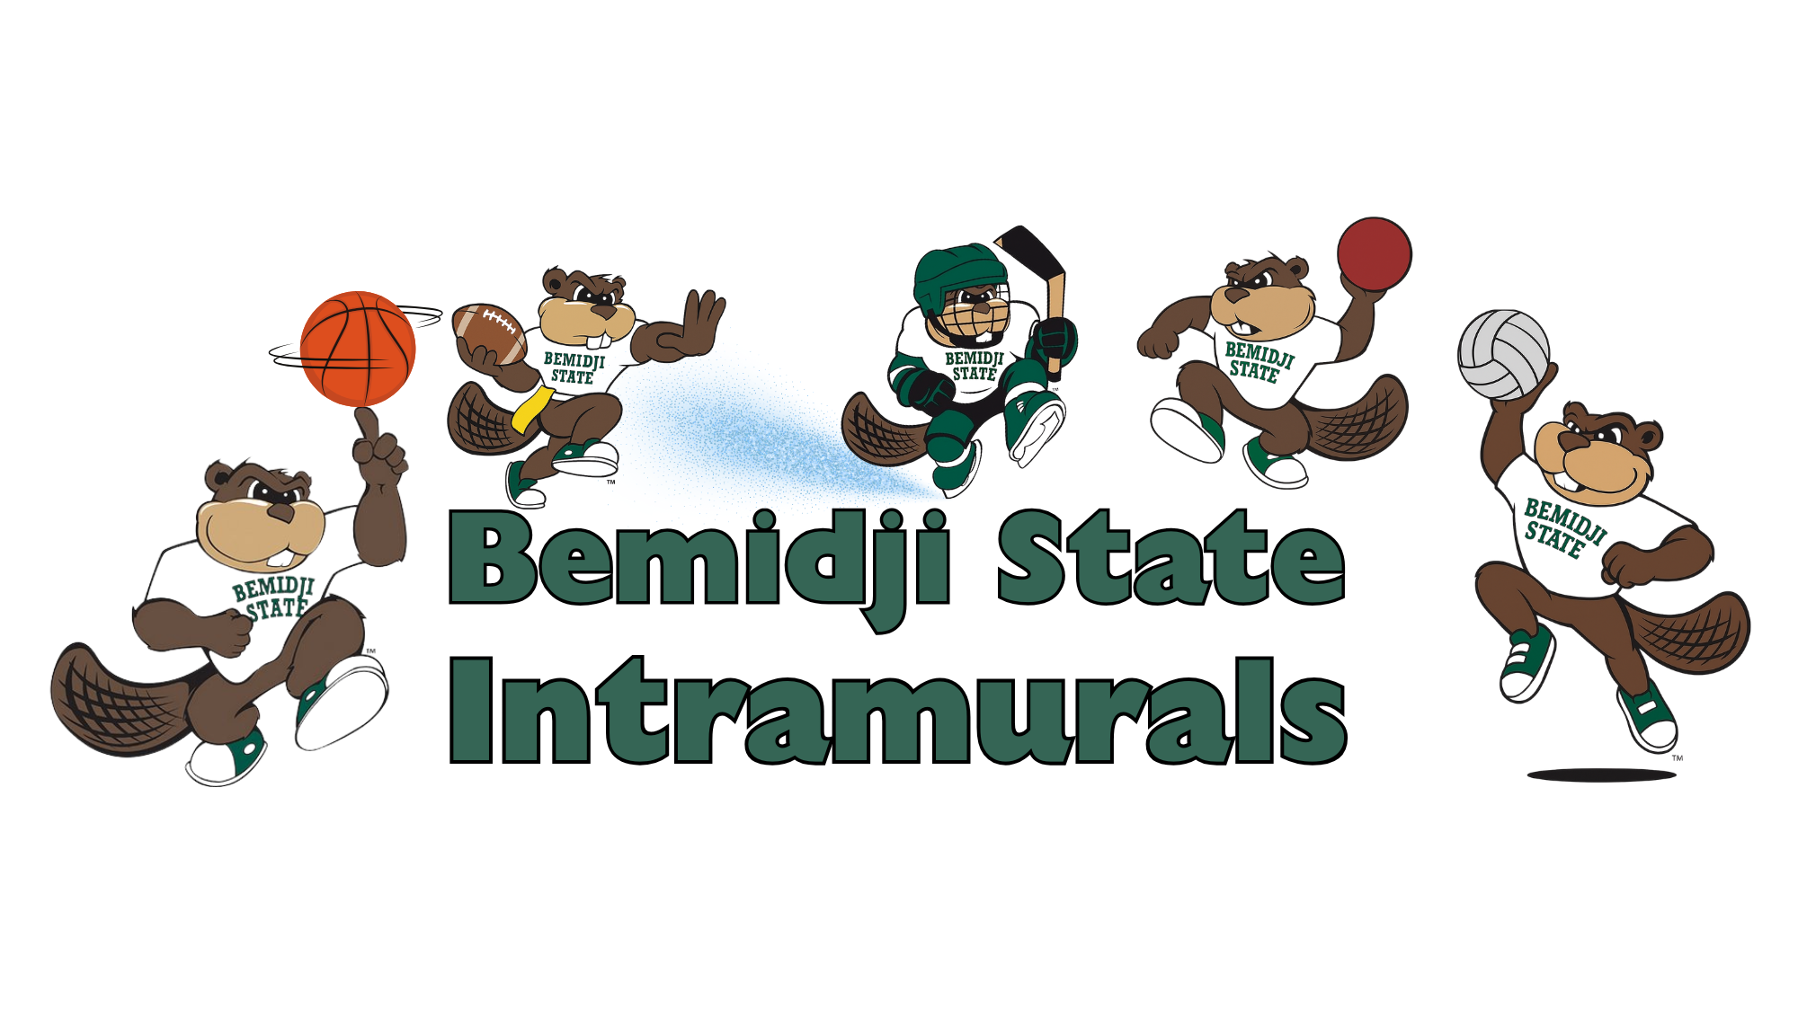
[[IMAGE REF 0002]] Image reference -- not directly editable; the original page reference is preserved automatically. Source: https://www.bemidjistate.edu/services/campus-recreation/wp-content/uploads/sites/31/2025/08/Cover-Image-1.png

