Title | Facilities
Meta Description
— Page content begins below. Please do not edit the table above. —

Gillett Wellness Center Facilities
Our facilities are available for students, faculty, staff, alumni and community members with a paid membership. They can also be reserved for private parties or groups.

Swimming Pool
The BSU pool is located between the Wellness Center and the Physical Education complex. Our 6-lane, 25-yard pool has a depth ranging from 3.5 to 12 feet, and features two 3-meter diving boards. If you have a valid membership to the fitness center, you can access our lap and open swim times.
Sign up for swimming lessons, reserve the pool for your own private party or group and check out today’s lap and open swim hours

Resistance Training Rooms
If you want to build and tone muscle, the Gillett Wellness Center offers two resistance training rooms. The Discovery™ Series features a wide range of equipment that caters to both first-time users and seasoned athletes. Both weight rooms are open seven days a week during the regular academic year.
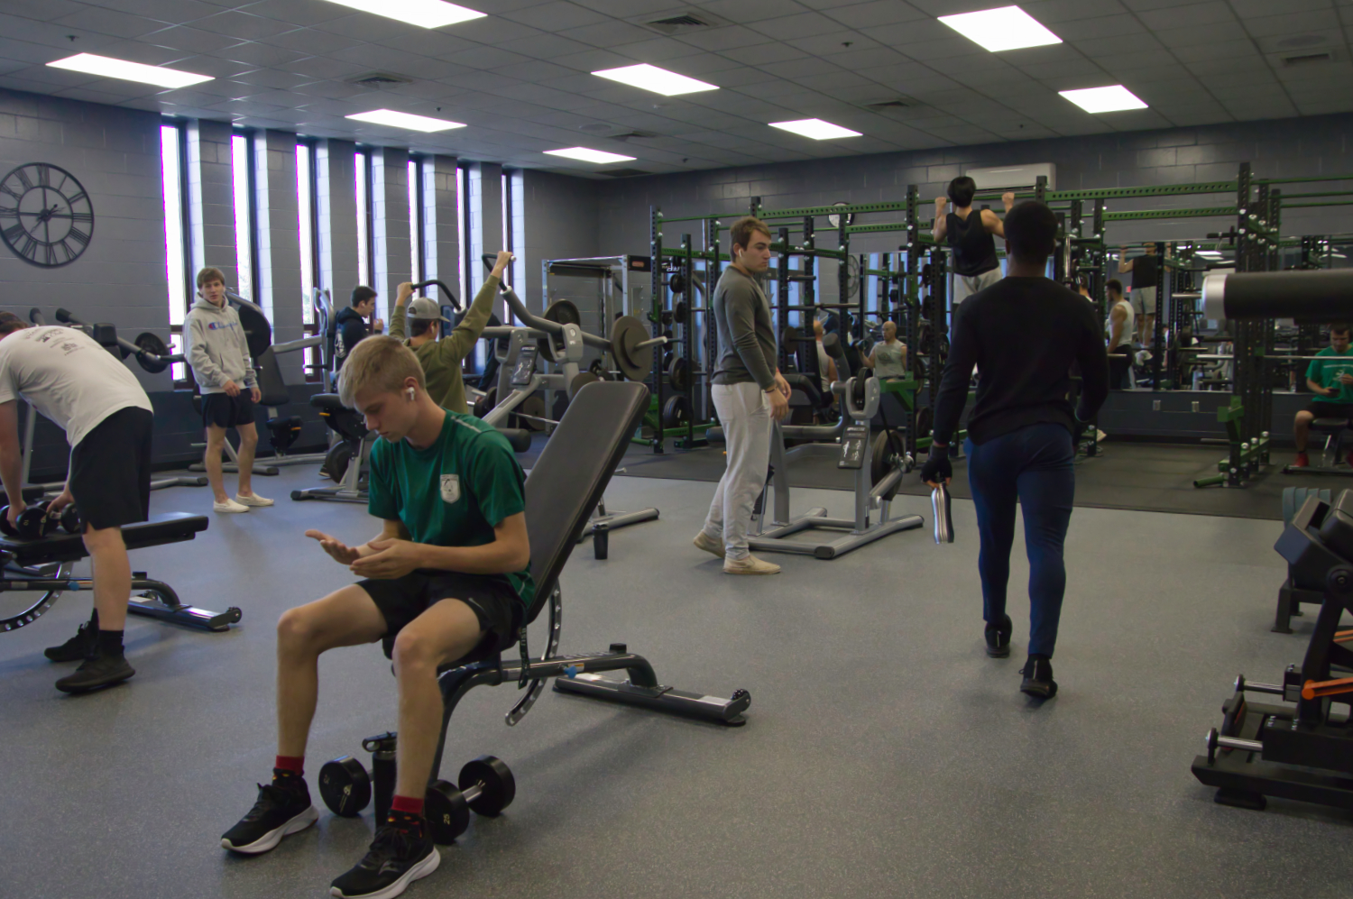
[[IMAGE REF 0000]] Image reference -- not directly editable; the original page reference is preserved automatically. Source: https://www.bemidjistate.edu/services/campus-recreation/wp-content/uploads/sites/31/2022/11/BSU-Weight-Room-Group-2022.jpg

Activity Spaces
The Gillett Wellness Center has four activity courts that can be used for basketball, tennis, volleyball, pickleball, badminton and other sports. When not in use for classes, practices, athletic events or special events, the activity spaces are open for general use. They can also be rented for group use. The activity spaces are surrounded by a six-lane, 200-meter indoor track.
During the regular academic year, the activity spaces are open seven days a week.
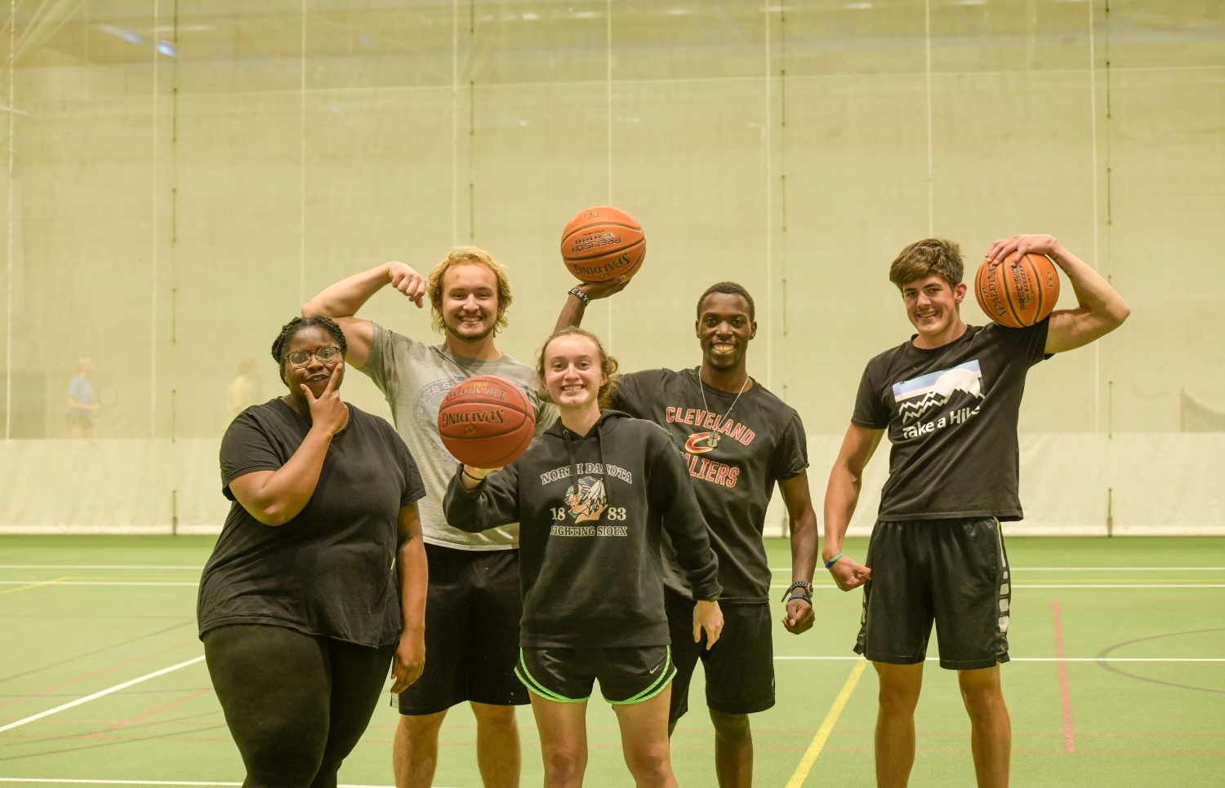
[[IMAGE REF 0001]] Image reference -- not directly editable; the original page reference is preserved automatically. Source: https://www.bemidjistate.edu/services/campus-recreation/wp-content/uploads/sites/31/2022/11/BSU-Rec-Basketball-2022.jpg

Cardio Equipment
On the balcony overlooking the activity spaces and on the main level of the Gillett Wellness Center, you’ll find numerous pieces of cardiovascular equipment available to students and fitness center members. Most of our equipment is from Precor, including treadmills, ellipticals, AMT’s, upright and recumbent bikes, stair steppers, rowers and a NuStep.

Climbing Wall
Come try out our premier rock climbing wall! Located in the Gillett Wellness Center, our 30-foot-tall wall has routes for climbers of all skill levels. You can top rope or lead your way up the cracks, corners and crimpers. We offer instructional clinics, open climbing times and group rentals. The wall is open three days a week during the academic year. For more information, contact the Wellness Center at (218) 755-4135
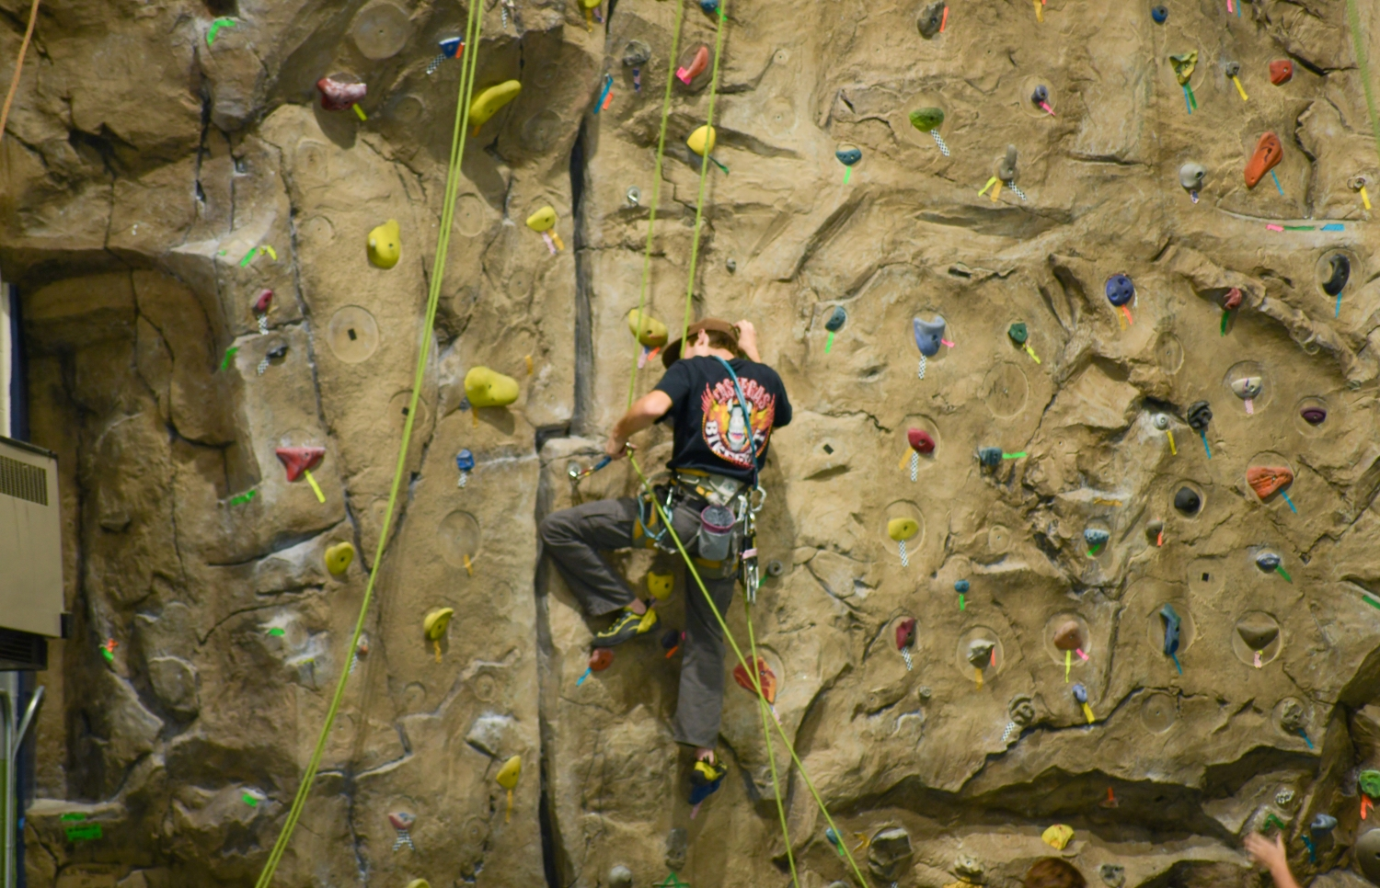
[[IMAGE REF 0002]] Image reference -- not directly editable; the original page reference is preserved automatically. Source: https://www.bemidjistate.edu/services/campus-recreation/wp-content/uploads/sites/31/2022/11/BSU-rec-rockclimbing-2022.jpg

CrossFit Rooms
Looking for a new workout challenge? Our CrossFit rooms offer a variety of exercises that mimic everyday movements like squatting, pulling and pushing. Workouts often feature variations of squats, push-ups and weight lifting that last for a predetermined time, helping you build muscle. This is different from traditional workouts that might give you a specific number of reps to do. Break out of your routine with CrossFit!

Dance Studio
The Gillett Wellness Center also has a professional dance studio with a high-quality dance floor, wall-to-wall mirrors and an observation and lounge area. The studio hosts Physical Education classes throughout the day and a variety of BSU Clubs and Organizations.
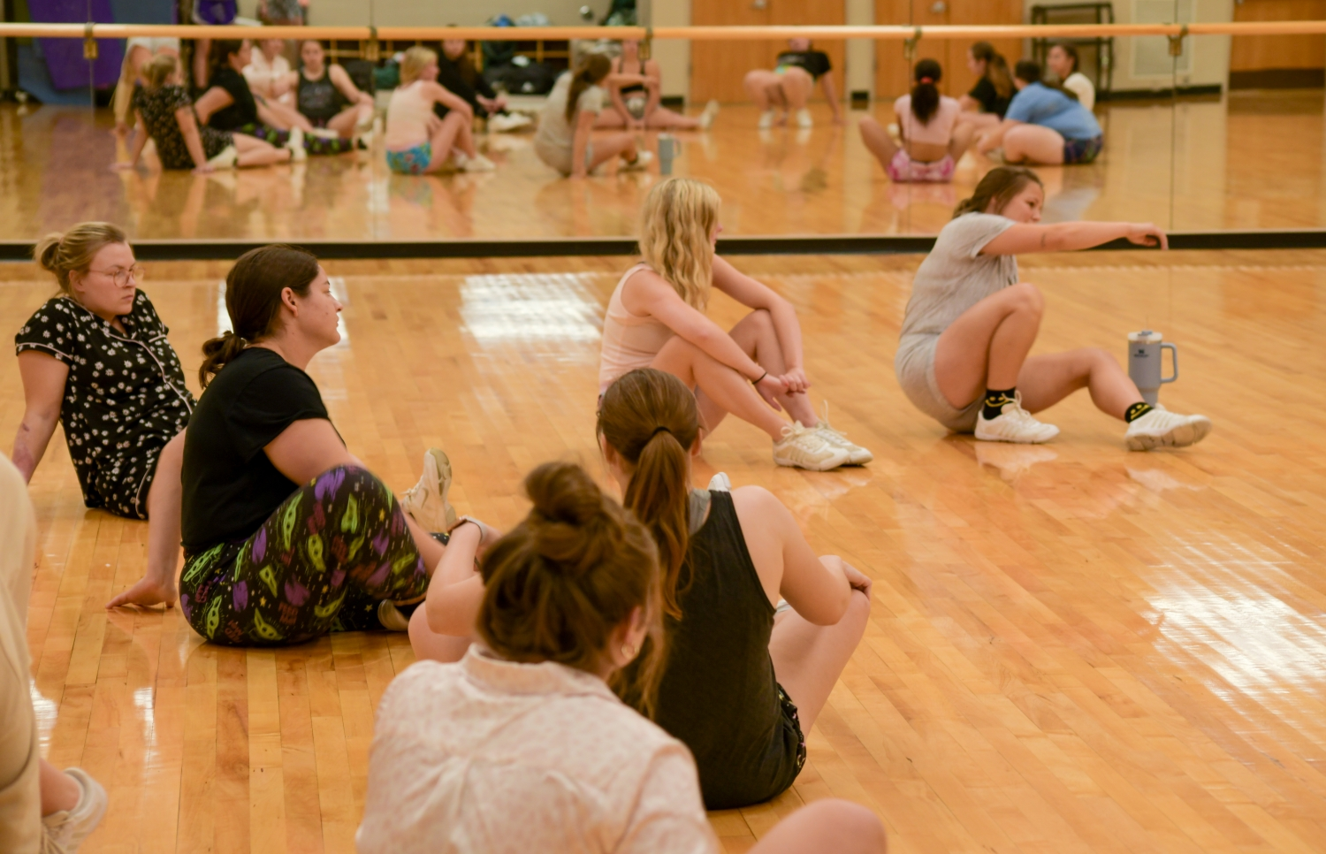
[[IMAGE REF 0003]] Image reference -- not directly editable; the original page reference is preserved automatically. Source: https://www.bemidjistate.edu/services/campus-recreation/wp-content/uploads/sites/31/2022/11/BSU-dance-practice-2022.jpg

Indoor Track
Take a walk or run on our 200-meter indoor six-lane track, which surrounds the activity spaces. The track is open for general use when not in use for classes, practices, athletic events or special events. The track and activity spaces are available for group rentals. During the regular academic year, the activity spaces are open seven days a week.
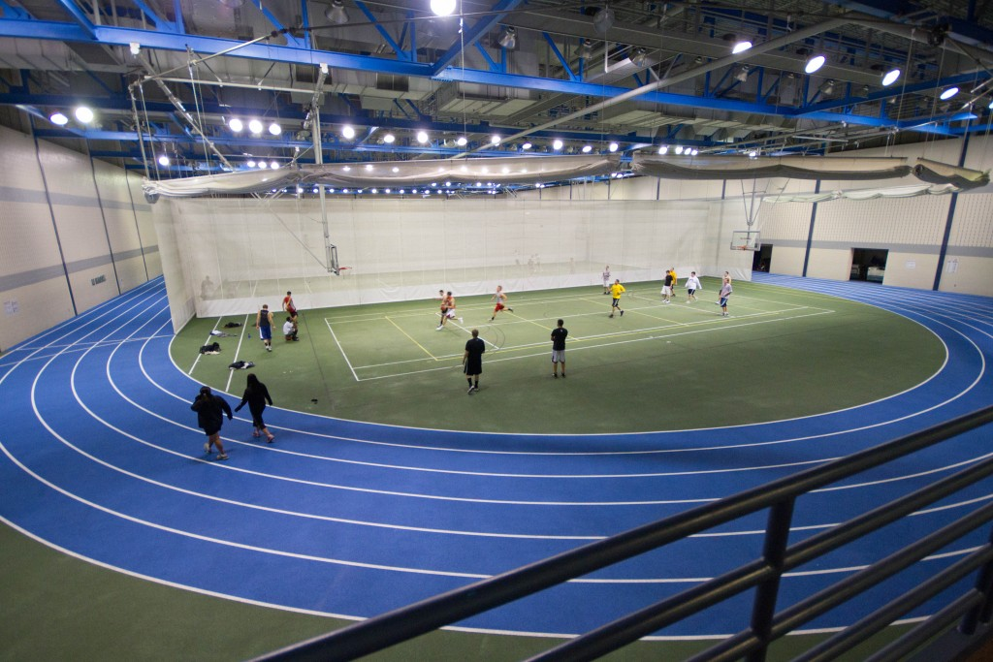
[[IMAGE REF 0004]] Image reference -- not directly editable; the original page reference is preserved automatically. Source: https://www.bemidjistate.edu/services/campus-recreation/wp-content/uploads/sites/31/2022/11/BSU-Track-2015.jpeg

Racquetball Courts
Play a game of racquetball or handball on one of our three courts, which can also accommodate walleyball. All courts are open seven days a week during the regular academic year, with the exception of scheduled classes.

