Title | Our Facilities
Meta Description
— Page content begins below. Please do not edit the table above. —
We are able to host large gatherings of up to 600 people in our Ballroom or intimate gatherings in our smaller rooms. Our other larger scale rooms are the East Ballroom, Crying Wolf Room, Scandinavian Room, Viking Room and Ozawindib Room. For smaller gathering the North Conference Room, South Conference Room and Bridgeview Room offer a perfect space for your next meeting or event.
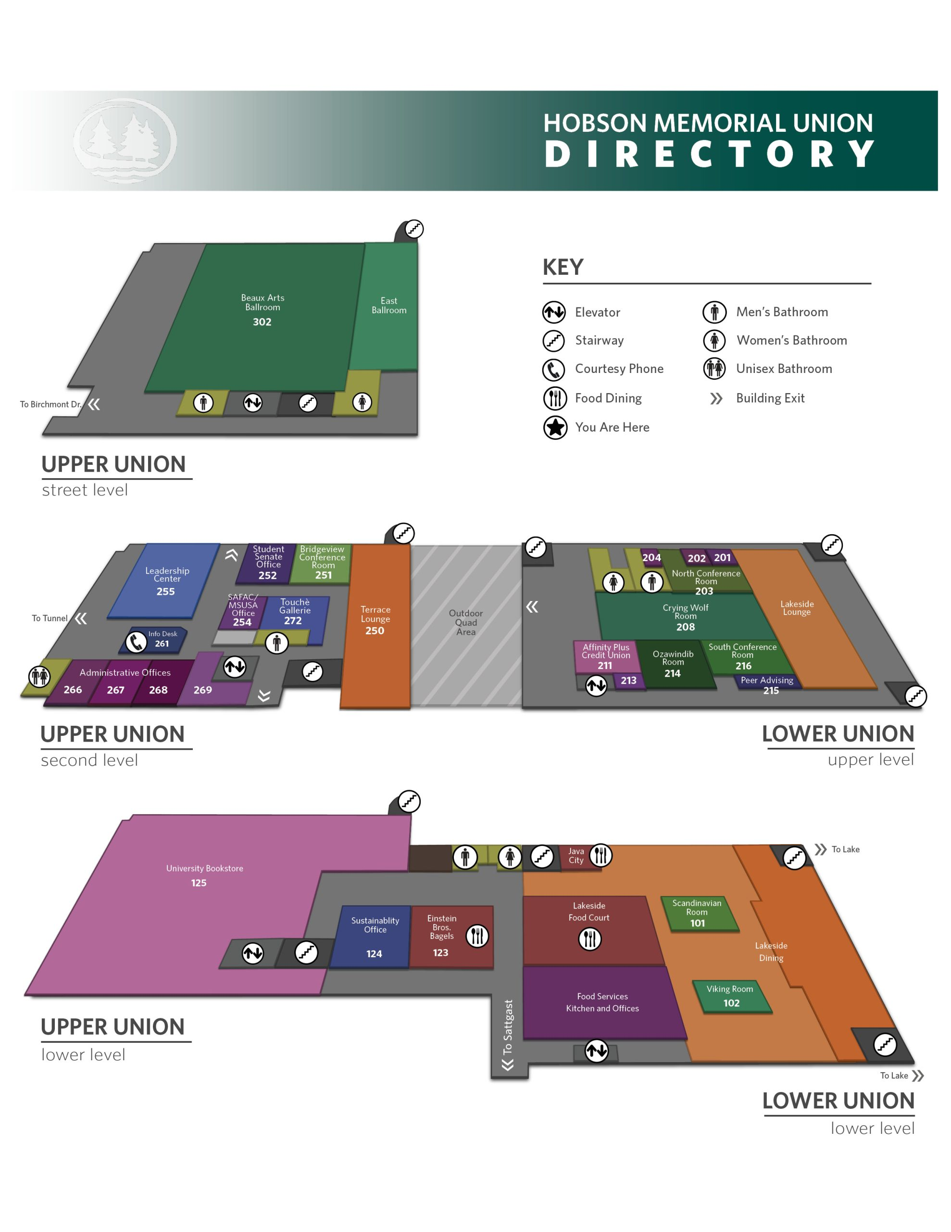
[[IMAGE REF 0000]] Image reference -- not directly editable; the original page reference is preserved automatically. Source: https://www.bemidjistate.edu/hobson-union/wp-content/uploads/sites/28/2022/10/HMU-Building-Map-scaled.jpg

Included Below Are the Capacities and Additional Room Features
 | Ballroom | East Ballroom | Bridgeview Room
Capacity | 600 | 130 | 12
Instruction Microphone | Yes | No | No
Projector | Yes | No | No
Sound System | Yes | No | Yes
Flat Screen Display | No | No | Yes
Wireless Presentation | Yes | No | Yes
Stage | Yes | No | No
Whiteboard | No | No | No
 | Crying Wolf Room | North Conference Room | South Conference Room
Capacity | 150 | 20+ | 12
Instruction Microphone | Yes | No | No
Projector | Yes | Yes | No
Sound System | No | Yes | No
Flat Screen Display | No | No | Yes
Wireless Presentation | Yes | Yes | Yes
Stage | No | No | No
Whiteboard | Yes | Yes | Yes
 | Ozawindib Room | Scandinavian Room | Viking Room
Capacity | 20+ | 44 | 36
Instruction Microphone | No | No | No
Projector | Yes | No | No
Sound System | Yes | No | No
Flat Screen Display | No | Yes | Yes
Wireless Presentation | Yes | No | No
Stage | No | No | No
Whiteboard | Yes | No | No

