Title | Leadership Positions
Meta Description
— Page content begins below. Please do not edit the table above. —

Join Our Team
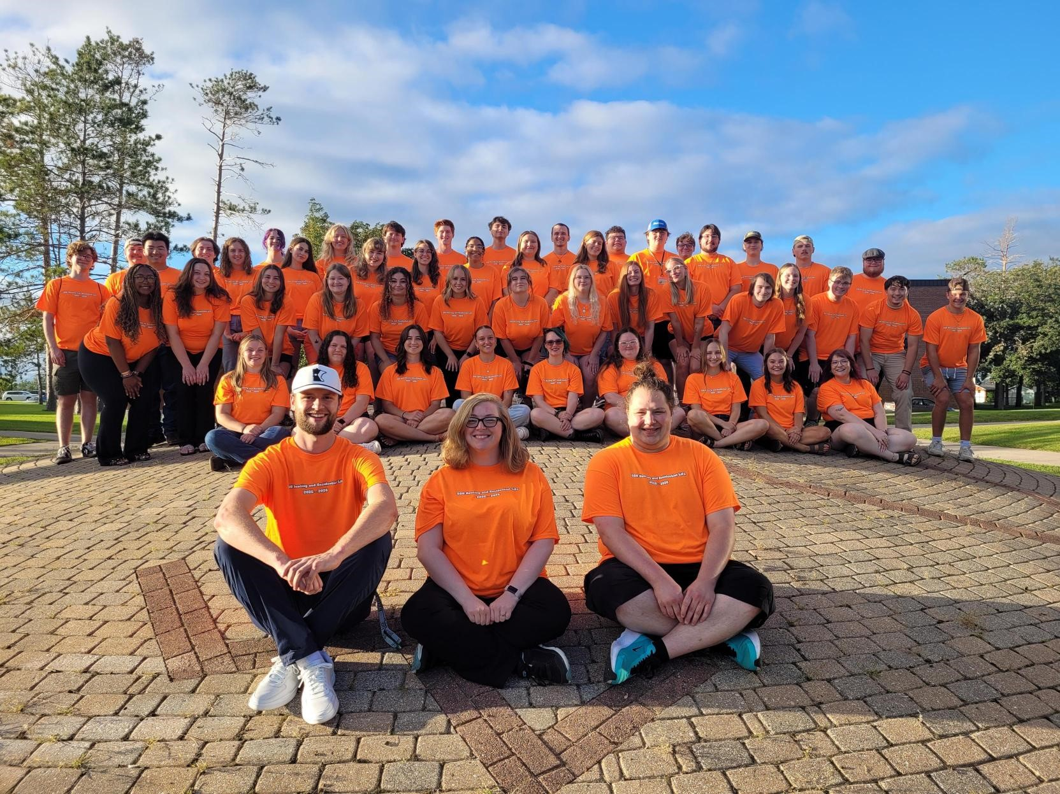
[[IMAGE REF 0000]] Image reference -- not directly editable; the original page reference is preserved automatically. Source: https://www.bemidjistate.edu/services/reslife/wp-content/uploads/sites/20/2025/09/All-Staff.jpg

Apply Here
ARHD/SARHD Position Application
RA/PAA/SH Position Application

Position Descriptions
We are still working on the 2026-2027 position descriptions. Check back later for updates!
- Resident Assistant (RA)
- Peer Academic Assistant (PAA)
- Assistant Residence Hall Director (ARHD)
- Summer Host (SH)
- Summer Assistant Residence Hall Director (SARHD)

Information Nights
Learn more about the RA/PAA/SH positions and get your questions answered.
- Wednesday, Dec. 3 at 5:30 PM at the Linden Fire Pit
- Thursday, Dec. 4 at 8:00 PM in the Tamarack 12th Floor Lounge
Additional Information Nights are still being planned.
If you need an accommodation for this program/event, please contact the Accessibility Services Office (Decker Hall 202) at (218) 755-3883. If an interpreter is needed, two weeks’ notice is requested.

You Can Also Connect With One of Our Area Directors
Adam Berg
Area Director: Birch & Linden Hall
Linden Phone: (218) 755-2077
adam.berg@bemidjistate.edu
Joscelin Eischens
Area Director: Oak Hall & Cedar Hall
Oak Office Phone: (218) 755-2292
Email: Joscelin.Eischens@bemidjistate.edu
**Col’Lette Gauvin**Area Director: Tamarack Hall
Tamarack Office Phone: (218) 755-2131
Email: collette.gauvin@bemidjistate.edu

Application Information
- Applications are online.
  - You can apply for one or multiple leadership positions.
- Be sure to submit your application before the deadline.
  - ARHD & SARHD: Online applications are due January 9, 2026 @ 11:59 PM.
  - RA, PAA, & SH: Online applications are due January 26, 2026 @ 11:59 PM.
- Interview information will be emailed to your student BSU/NTC email.
  - We will communicate with you through your student BSU/NTC email regarding updates or reminders.

Interview Information

Dates
- Interviews will take place during the following dates, depending on the position(s) you apply for:
  - ARHD/SARHD Interviews: Monday, January 12, 2026 – Friday, January 16, 2026
  - RA/PAA/SH Interviews: Saturday, January 31, 2026 – Sunday, February 1, 2026

Interview Format
- Interviews will be conducted in person.
- ARHD/SARHD Interviews will last about one hour. RA/PAA/SH Interviews will take several hours and consist of various formal interviews and group activities.

Interview Sign-Up Process
- Interview date preferences will be asked in the application.
- ARHD/SARHD interview information about your specific date, time and location will be sent to your student BSU/NTC email in early January.
- RA/PAA/SH interview information about your specific date, time and location will be sent to your student BSU/NTC email by January 28, 2026. If you have not heard by noon on January 29, 2026, please contact adam.berg@bemidjistate.edu.

Interview Preparation
- Make sure you get plenty of rest the night before your interview.
- Plan on wearing nicer clothes to your interview.
- Practice interviewing beforehand, either with someone else or using common interviewing questions found online.
- Be yourself! We hire all types of personalities for our positions.

Hiring Decisions
- RA/PAA/SH candidates will know their status in early March.
- ARHD/SARHD candidates will know their status in late January/Early February.

Leadership Positions Frequently Asked Questions Expand All

Are we able to apply for multiple positions?
Yes, you are able to apply for as many positions as you are interested in, even if they are positions that fall within the same time frame. For example, you can apply for both the Resident Assistant (RA) and Peer Academic Assistant (PAA) positions.

Are we able to take time off if we get a position?
Yes, you are able to take time off if you are hired for a position. There may be some times we will need everyone to work (e.g. Move-In Weekend, Closing Weekend, Carousel Weekend, etc.). A couple of our positions have a maximum number of nights they can have off. For example, RAs have a maximum of 12 nights off per semester, PAAs have a maximum of 16 nights off per semester, and SHs have around 12 nights off per summer.

Do I get a say in what type of community I would like to work with?
Yes, after your interview each candidate will receive a preference form where you can rank your various community preferences (e.g. First Year Residential Experience (FYRE) or Upperclass/Upper Division Community, Academics, and Networking (CAN) communities). Please understand that we try our best to grant candidates their top community preference, but sometimes we may not have enough openings in that area at the moment.

Do PAAs only work in the FYRE communities?
Peer Academic Assistants (PAAs) only work in the FYRE community since their main focus is to help first-year students adjust from high school to college courses. In rare occasions, we may have a PAA work in the CAN community if one is needed.

How many people do you end up hiring?
The number of positions we hire each year varies. It depends on how many current staff members want to return for the following year and the number of projected students that will be living in our residence halls. We usually do not know this number until we are conducting interviews.

I have not lived on campus before, can I still apply?
Absolutely! Please apply if you are interested in any of these positions even though you may have never lived on campus before. We also encourage those that have lived on campus before to apply. The only position that we prefer to have candidates with on campus living experience is our Assistant Residence Hall Directors (ARHDs).

If I get a position, do I get a room to myself or do I have to share with a roommate?
Our student staff members receive a bedroom to themselves in a particular building and/or floor that they will help oversee.

Should I apply to live on-campus next year before I know the results of my interview?
Yes! It is easier for our office to switch your housing assignment if you get a position when you have already applied to live on campus. If you do not get a position or are an alternate, you will still have housing all arranged and do not have to worry about not getting the on-campus room you wanted because they are all picked over. Also, it is easier for you to get out of our housing contract than breaking an off-campus lease.

What are the different buildings & floor types that we could possibly be working with?
We hire staff for all of our residence hall buildings: Birch, Cedar, Linden, Oak, and Tamarack.
Community Breakdown by Buildings:
- Our first year (FYRE) communities are located in Oak and Tamarack Halls
- The upperclass/upper division (CAN) communities are located in Birch, Cedar, Linden, and Oak Halls
Position Breakdown by Buildings:
- RAs work in Birch, Cedar, Linden, Oak, and Tamarack Halls
- PAAs work in Oak and Tamarack Halls
- ARHDs work in Birch, Cedar, Linden, Oak, and Tamarack
- SHs & SARHDs work in Birch, Cedar, Linden, Oak, Pine and Tamarack

What are the different interview results?
We have 3 different interview results:
- Hired – we are offering you a position you applied to
- Alternate – we want to hire you but we do not have an opening at this time. If one becomes available we will consider you when filling it
- Not At This Time – we do not have a position for you

What are you looking for in a candidate?
We are looking to hire a diverse group of individuals and personalities since our communities within the residence halls are diverse in many ways. Because of this, we ask that you be yourself in the interview. There is not a certain “type” of person we are looking for in a candidate.

What does it mean to be in good standings with the BSU Conduct System?
To be in good standings with the BSU Conduct System means that you are not on Conduct Probation or Conduct Suspension status. If you were ever written up and placed on Conduct Warning status, you can still apply.

What does it mean to be on duty rotation?
Being on duty means that you carry a duty cell phone and go on rounds throughout the building(s) at certain times for a duration of time (i.e. overnight, 24 hours, or more depending on your position). If a resident needs to contact someone, they can contact the duty phone to help get their questions answered or the assistance they need (i.e. if they are locked out of their room). For rounds, this means that you walk the building(s) and floors to make sure no policies are being broken and no major facilities issues are occurring.

What if I get a position but I already signed up for another room on campus?
We will make the adjustments on our end such as getting you placed in the room where your position is for and removing you from the room you signed up for earlier. If you already made the $150 prepayment, we will work on reimbursing you since our student staff members do not have to pay the $150 prepayment for their staff room.

What is a stipend?
A stipend is similar to a paycheck. The total stipend amount is spread throughout the term into smaller biweekly paycheck amounts.

What is the difference between FYRE and CAN communities?
FYRE stands for First Year Residential Experience. Staff members that work in the FYRE communities work with first-year or freshmen level students.
CAN stands for Community, Academics and Networking. The CAN community staff members work with upperclass or sophomore-graduate level students.
Since each student is in a different level of their collegiate journey, the staff members in these communities focus on different areas to help their residents be successful both in the classroom and within the community. For example, FYRE communities focus on the transition of living on your own and adjusting to college level courses. Whereas, CAN communities focus on skills to help you work towards your career and being a positive community member.

What is the difference between RAs and PAAs?
RAs focus more on the social aspect of the floor whereas PAAs focus more on the academic side. They both go through the same training, so if a resident has a question either the RA or PAA can help. However, the conversations and other initiatives that occur on the floor will be geared towards the RAs helping with social interactions and the PAAs with academics.
The meal plans and the academic stipends also vary between the RA and PAA positions.
RAs work a weekly Front Desk shift and the PAAs work a weekly Academic Resource Center (ARC) shift.
RAs work on a duty rotation with other RAs in the building(s). PAAs do not.
RAs receive 12 nights off per semester. PAAs receive 16 nights off per semester.

What type of training would I get?
Before you begin your role, we will provide mandatory training opportunities. For the academic year staff, training occurs at the beginning of August along with another training at the beginning of January. Those that work with us for the summer have training at the end of April/early May. During these trainings, we cover policies, procedures and how to handle different situations. Sometimes we ask outside guests to help us with various training topics. Even though these training sessions can be long, afterwards we hope you feel more prepared in your skills and abilities to help others effectively.

When will I find out if I got a position or not?
We will communicate the results of your interview via your student BSU/NTC email account. Please refer to the above Selection Timeline chart of the position(s) you applied for regarding the date range of the latest you should hear back. If you do not receive an email with your interview results after the latest date, first check your ‘Junk’ folder. If there is no email in your ‘Junk’ folder then email us at ResLife@bemidjistate.edu.

Would I be able to go home on breaks?
During the academic year, you are able to either go home or take a break from your job duties during Fall, Winter and Spring breaks. However, we still have the residence halls open during those breaks so if you are interested in making additional money, we do have break staff shifts you can work.

Would I be able to work another job?
You are able to work an outside job but only up to 10 hours a week. The Housing & Residential Life job comes first. If you do plan on getting another job, make sure you communicate with your Area Director first.

