Title | Move-In Map
Meta Description
— Page content begins below. Please do not edit the table above. —
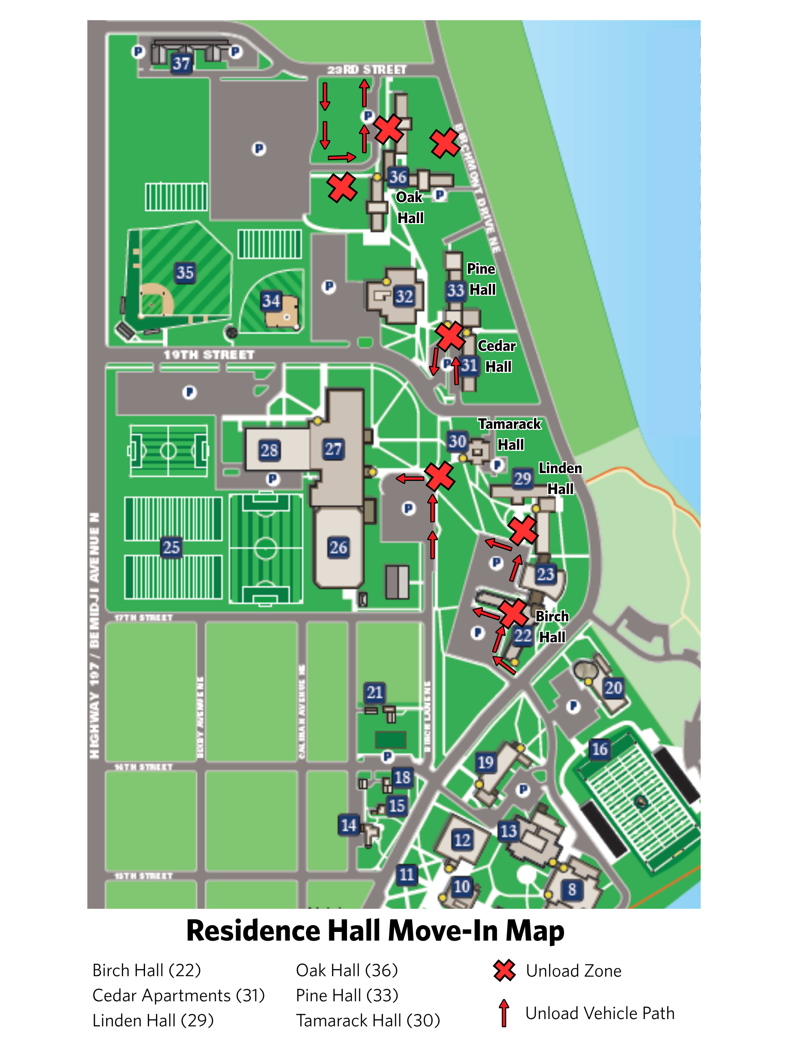
[[IMAGE REF 0000]] Image reference -- not directly editable; the original page reference is preserved automatically. Source: https://www.bemidjistate.edu/services/reslife/wp-content/uploads/sites/20/2026/07/Move-In-Map.png

