Title | Move-Out Checklist
Meta Description
— Page content begins below. Please do not edit the table above. —
As you prepare to move out at the end of your stay, be sure you complete the following items before you leave.

Move Out Checklist
Downloadable checklist
A proper check-out consists of:
- Cleaning your room
  - Dust and wipe down surfaces & drawers
  - Clean your floor
    - Vacuum if you have carpet
    - Sweep and mop if you do not have carpet
  - Clean under desk and radiator (Oak & Tamarack Rooms)
  - Clean any shared common areas (Linden Suites)
  - Move furniture back to its original place
  - Remove personal items from walls & doors and remove any tape residue
  - Make sure all window panes and screens are in place and closed
  - Take out the garbage to the dumpster
- Remove ALL your belongings
  - Be sure to double-check drawers, shelves and behind your room door
  - Even if you are in the same room in the future, you cannot store your belongings in your room until then or over the summer (see Pine Storage Lockers below)
  - If you have a weapon storage locker, please empty it and turn in the locker key to the Housing & Residential Life Office in Walnut Hall. Our office hours are Monday-Friday, 8:00 AM to 4:30 PM. If you check out of your locker outside of our office hours, please turn in your locker key with your room key at check-out
- Completing check-out paperwork with your RA/PAA
  - Sign up for a time to check out of your room with your RA/PAA (Must sign up at least 24 hours in advance)
  - Check-out paperwork includes
    - Completing the check-out portion of your Room Inventory
    - Returning your room key
    - Submitting your forwarding address information
If you need cleaning supplies, check your floor’s kitchen or front desk to see if they have any.

Other Move Out Information Expand All

Abandoned Property
If belongings are left in your room after you move out, we consider it to be abandoned property. Each Area Director/Residence Hall Director will designate a storage area in their residence halls. Residents who leave possessions in their room will be assessed a $100 fee for the removal of these items. Abandoned property will be disposed of in the manner prescribed in Minnesota Statute – Tenant’s Personal Property Remaining in Premises 504B.271.
504B.271 TENANT’S PERSONAL PROPERTY REMAINING IN PREMISES
Subdivision 1. Abandoned property. (a) If a tenant abandons rented premises, the landlord may take possession of the tenant’s personal property remaining on the premises, and shall store and care for the property. The landlord has a claim against the tenant for reasonable costs and expenses incurred in removing the tenant’s property and in storing and caring for the property.
(b) The landlord may sell or otherwise dispose of the property 28 days after the landlord receives actual notice of the abandonment, or 28 days after it reasonably appears to the landlord that the tenant has abandoned the premises, whichever occurs last.
(c) The landlord may apply a reasonable amount of the proceeds of a sale to the removal, care, and storage costs and expenses or to any claims authorized pursuant to section 504B.178, subdivision 3, paragraphs (a) and (b). Any remaining proceeds of any sale shall be paid to the tenant upon written demand.
(d) Prior to a sale, the landlord shall make reasonable efforts to notify the tenant of the sale at least 14 days prior to the sale, by personal service in writing or sending written notification of the sale by first class and certified mail to the tenant’s last known address or usual place of abode, if known by the landlord, and by posting notice of the sale in a conspicuous place on the premises at least two weeks prior to the sale. If notification by mail is used, the 14-day period shall be deemed to start on the day the notices are deposited in the United States mail.
Subdivision 2. Landlord’s punitive damages. If a landlord, an agent, or other person acting under the landlord’s direction or control, in possession of a tenant’s personal property, fails to allow the tenant to retake possession of the property within 24 hours after written demand by the tenant or the tenant’s duly authorized representative or within 48 hours, exclusive of weekends and holidays, after written demand by the tenant or a duly authorized representative when the landlord, the landlord’s agent or person acting under the landlord’s direction or control has removed and stored the personal property in accordance with subdivision 1 in a location other than the premises, the tenant shall recover from the landlord punitive damages in an amount not to exceed twice the actual damages or $1,000, whichever is greater, in addition to actual damages and reasonable attorney’s fees.
In determining the amount of punitive damages the court shall consider (1) the nature and value of the property; (2) the effect the deprivation of the property has had on the tenant; (3) if the landlord, an agent, or other person acting under the landlord’s direction or control unlawfully took possession of the tenant’s property; and (4) if the landlord, an agent, or other person under the landlord’s direction or control acted in bad faith in failing to allow the tenant to retake possession of the property.
The provisions of this subdivision do not apply to personal property which has been sold or otherwise disposed of by the landlord in accordance with subdivision 1, or to landlords who are housing authorities, created, or authorized to be created by sections 469.001 to 469.047, and their agents and employees, in possession of a tenant’s personal property, except that housing authorities must allow the tenant to retake possession of the property in accordance with this subdivision.
Subdivision 3. **Storage.**If the landlord, an agent, or other person acting under the landlord’s direction or control has unlawfully taken possession of a tenant’s personal property the landlord shall be responsible for paying the cost and expenses relating to the removal, storage, or care of the property.
Subdivision 4. Remedies additional. The remedies provided in this section are in addition to and shall not limit other rights or remedies available to landlords and tenants. Any provision, whether oral or written, of any lease or other agreement, whereby any provision of this section is waived by a tenant, is contrary to public policy and void. The provisions of this section also apply to occupants and owners of residential real property which is the subject of a mortgage foreclosure or contract for deed cancellation and as to which the period for redemption or reinstatement of the contract has expired.
History: 1999 c 199 art 1 s 35; 2010 c 315 s 8,9

Beds, Bed Lofts, & University Room Furniture
Beds & University Room Furniture
At move-out, there needs to be the same number of University beds in the room as there are students assigned to the room. For example, two (2) beds for a Double room and one (1) bed for Single, Double-as-Single, and Suite rooms. Beds, frames, and mattresses must never be left in the hallway. Any stored University beds and other University room furniture (e.g. chair, desk, etc.) must be returned to your room in their original condition before checking out of the residence hall.
Bed Loft Parts
If you lofted or bunked your bed, please keep all loft and bunk parts in your room.
Other University Furniture
Furniture in the lounge area is meant to be used by all residents of the hall and therefore, is not to be removed. There is a $25.00 per item charge for having furniture moved back to the public area by University personnel.

Damages & Charges
Damage Charges
You must leave their room in the same condition which it was noted on the Room Inventory form. Upon vacating the room, you must check out of your assigned room with a Housing & Residential Life staff member (RA/PAA). Failure to follow these procedures may result in an improper checkout charge. You are financially responsible for keeping the room, its furnishings, windows, window screens and doors clean and free from damage. When two (2) or more students occupy the same room and responsibility for damages to the room or contents cannot be ascertained, the damage will be assessed equally among students.
You are financially accountable for the replacement of, or repair to, furnishings in the residence halls because of the damage attributed to your behavior or the behavior of your guests. The minimum charge is $10.00. Some common damage charges for residence hall furnishings are listed here. The damage charges listed are minimum charges and may not necessarily reflect additional labor charges. Damage charges may change without notice due to the cost of parts and labor. Damage that requires non-University labor to repair will be billed to the student at the cost to the University. Students wishing to appeal damage charges must do so by contacting Housing & Residential Life or the designee within 30 days of receiving the damage charge bill.
Improper & Late Check Out Charges
Failure to check out and/or vacate the residence hall by NOON on the closing dates will result in a $25 late charge for a late check out. Failure to complete any part of the check-out process with a Housing & Residential Life staff member (RA/PAA) may result in a $25 improper check-out fee.

Donate Don't Dumpster
Located in the Sustainability Office (across from the Bookstore), the FreeStore is a place for students to find and claim clean, usable items free of charge.
You may donate items you no longer need or want to the FreeStore through the Donate Don’t Dumpster program – simply place clean, usable items in the green cylindrical bins located in the lobbies of Birch, Linden, Oak & Tamarack Halls during finals week.
Please follow these Do’s and Don’ts:
- Wash and fold all clothing, bedding, etc. before placing them in the bin
- Do not donate perishable foods
- Do not donate broken or inoperable items
- Do not donate used underwear
- If the green bin is full, please bring your donation to the Sustainability Office
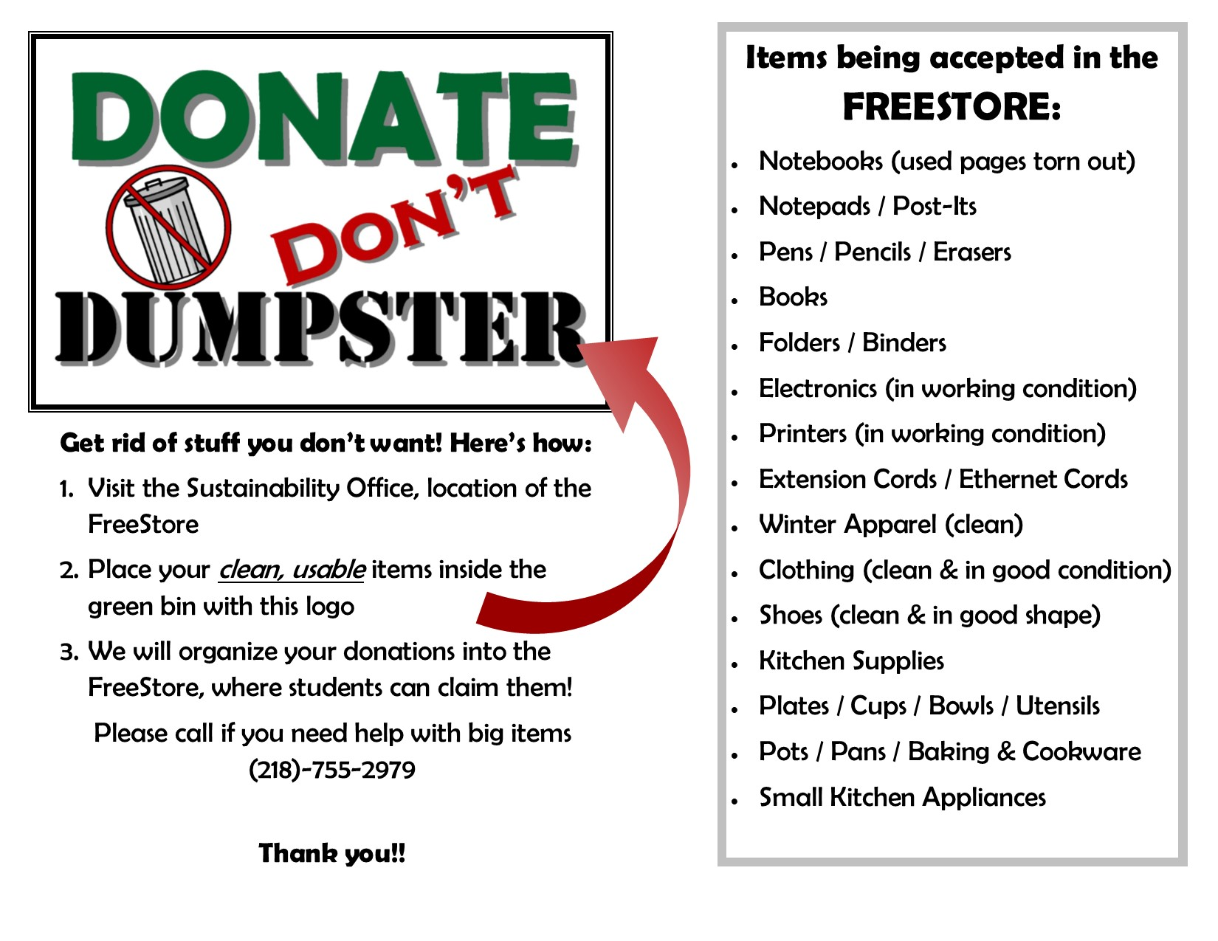
[[IMAGE REF 0000]] Image reference -- not directly editable; the original page reference is preserved automatically. Source: https://www.bemidjistate.edu/services/reslife/wp-content/uploads/sites/20/2023/02/Donate-Dont-Dumpster.png

Dumpsters, Trash, & Carts
Dumpsters & Trash
You are responsible for taking out your room garbage to the outside dumpster near your residence hall. Most dumpsters are behind a tan fence. Daily trash goes into the green dumpsters, recycling in the blue dumpsters, and at the end of the spring semester, there will be additional dumpsters for large items. We encourage residents to break down their boxes and place them in the dumpster, not on the ground beside it. Dumpsters and recycling containers located around the residence hall buildings are for on-campus resident use only.
Carts
We will have a limited number of carts available in the lobby or at the front desk. Carts are used on a first-come, first-serve basis. We ask that after you are done using the cart that you return it back to the lobby or front desk. If you have your own dolly/cart please label it with your name and phone number.

Mail Forwarding Address
You can update your mail forwarding address in your BSU e-Services account under the Housing and Dining tab. Enter in what address you would like us to forward your mail in the event we receive mail for you and you are not currently living in our residence halls.
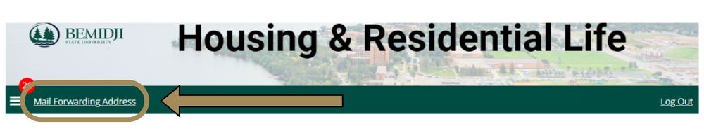
[[IMAGE REF 0001]] Image reference -- not directly editable; the original page reference is preserved automatically. Source: https://www.bemidjistate.edu/services/reslife/wp-content/uploads/sites/20/2024/04/Housing-Portal-Application-Locations.png

Parking Permits
If you moving out during the academic year, you may return your parking permit to the Cashier’s Office, 2nd Floor Deputy Hall. Only residence hall students are permitted to park in Birch, Cedar, Linden, Pine, Oak, Tamarack and Walnut parking lots. You may be eligible to have a portion of the purchase price refunded*.
*This does not apply if you are moving out at the end of the spring semester or during the summer semester.

Pine Storage Lockers
A limited number of storage lockers are available in the basement of Pine Hall for current residents. Students must provide their own locks. Approximate size: 21 in. wide, 33 in. deep, 7.5 ft. high. Sign up and access is available through Housing & Residential Life in Walnut Hall during office hours. Summer semester storage is available to residents that have either an active summer housing contract or a fall assignment.

