Title | Gender-Inclusive Housing
Meta Description
— Page content begins below. Please do not edit the table above. —
New and returning students can choose both a room and potential roommates, including 2SLGBTQIPA+-friendly roommates.
Housing & Residential Life respects and affirms a student’s identity and expression, prioritizes our students’ physical and emotional safety and will find the best match between the student’s needs and the options available.
Linden Hall has gender-inclusive two- and three-person suites. Learn more about our gender-inclusive Linden Hall suite option in the FAQ below. Birch Hall has gender-inclusive floor bathrooms with private toilet and shower rooms. Oak Hall has a limited number of single rooms with private bathrooms.
Oak Hall has a Rainbow Residence floor community for 2SLGBTQIPA+ and allies. This floor is for folks who are action-takers and want to advocate for justice, diversity, equity and inclusion.
To support current and incoming transgender and non-binary students, we invite you to contact us with any questions or concerns so we may help you meet your needs.

Gender Inclusive Housing Questions
Preferred Name
First
Last
Email(Required)
Enter Email
Confirm Email
What Type of Student Are You?(Required)
Let us know what your status is as a BSU student.
Prospective Student
Admitted Student
Transfer Student
Current/Returning BSU Student
Question about Gender Inclusive Housing(Required)
Please ask us any questions you have about our gender inclusive housing.
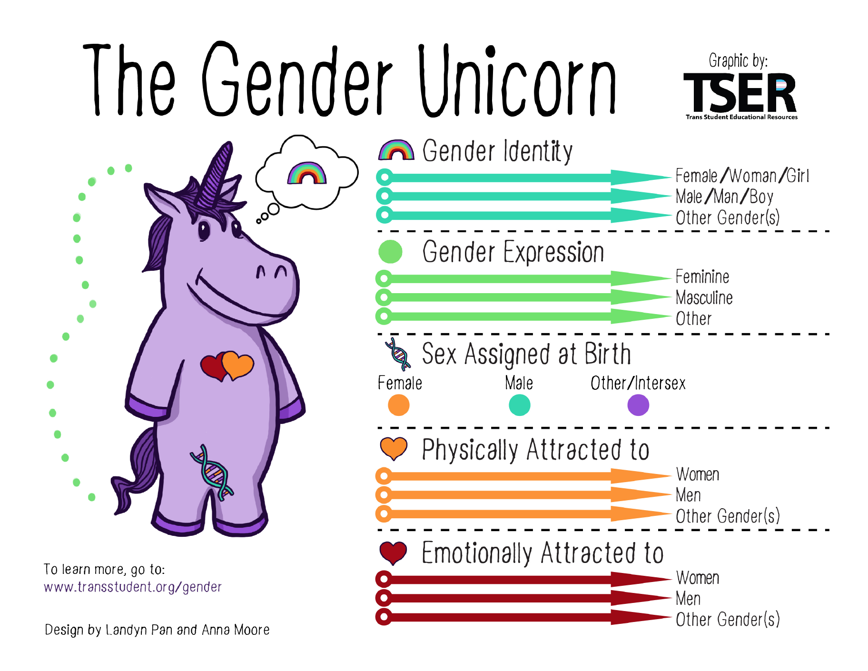
[[IMAGE REF 0000]] Image reference -- not directly editable; the original page reference is preserved automatically. Source: https://www.bemidjistate.edu/services/reslife/wp-content/uploads/sites/20/2022/08/Screen-Shot-2022-08-29-at-8.21.11-AM.png

Linden Hall Gender-Inclusive Housing FAQ Expand All

What Is Gender-Inclusive Housing in Linden Hall?
Gender-inclusive housing in Linden Hall is an intentional living environment where all gender identities are welcomed and where student housing is not restricted to traditional limitations of the gender binary (male/female). Instead, gender-inclusive housing is based on the notion that more than two genders — in fact, an infinite amount exist. This is a Departmental and University commitment to establish more inclusive and affirming housing for students with diverse gender identities and expressions. Gender-inclusive housing means that students from all gender identities and expressions may choose to live together.

What Contributed to the Creation of Gender-Inclusive Housing at BSU in Linden Hall?
As we strive to create a welcoming, inclusive and safe residential experience, offering gender-inclusive housing both accommodates and respects the complexities of gender identity. Knowing that traditional, same-sex room assignments are not always comfortable and/or appropriate for all students, we found gender-inclusive housing to be more welcoming for all our students and truly demonstrate our commitment to our mission and values.
Out of respect for the uniqueness and validity of the self-perceptions and identities of our students, we are establishing gender-inclusive housing options for our residential communities. Living in a suite that is not based on one’s biological sex can further support the safety and comfort of our students who do not fit into others’ expectations of gender presentations, expressions or identity.

Is Gender-Inclusive Housing in Linden Hall Just for 2SLGBTQIPA+ Students?
Gender-inclusive housing is not just for two-sprit, lesbian, gay, bisexual, transgender, queer, questioning, intersex, pansexual, asexual, plus (2SLGBTQIPA+) people; it is for anyone who wants to live with people with whom they feel comfortable — no matter their gender. Students who elect this option must be open to living with a person of any gender. Students are interested in gender-inclusive housing for a variety of reasons. It is our hope that you make the best decision for you.

Who Can Participate in Gender-Inclusive Housing in Linden Hall?
This option is available for continuing students through the housing sign-up process. Incoming students who believe that this housing option will best support their personal needs as they transition to the BSU community may contact the Housing & Residential Life assignments coordinator to discuss what options may be possible.

What if a Student Does Not Want to Live in Gender-Inclusive Housing in Linden Hall?
A student must identify that they are interested in gender-inclusive housing in order to be considered. Students who do not identify an interest will not be considered and will remain eligible for same-sex housing assignments.

What if Parents/Legal Guardians Do Not Want Their Student to Live in a Gender-Inclusive Housing Room/Suite?
We encourage all students to maintain an open dialogue with their families regarding housing decisions. Students over the age of 18 are legally able to make decisions about their housing agreements without parental consent. Students under 18 should discuss housing plans with their families, as they will be required to have parental consent.

Can People Who, Regardless of Sexual Orientation and/or Gender Identity and Expression, Are Romantically Involved Live Together?
Neither gender-specific nor gender-inclusive housing is intended for people in romantic relationships. As a general rule, we would advise against doing so. We respect and honor the privacy of our students, so current procedures do not require students to disclose their reason for roommate requests. However, please note that the Department of Housing and Residential Life encourages students to reconsider living with a person with whom they are romantically involved, regardless of whether it is a same-sex or different-sex relationship. Some relationships are ready for this step while others are not, and there can be serious challenges for both students should the relationship end.

