Title | New Students
Meta Description
— Page content begins below. Please do not edit the table above. —
It’s a big step to come to college and move into your own place. Moving on campus makes that transition a lot easier. Here you’ll find future friends waiting, meal options for everyone and a host of services and amenities to make life less hectic. You will also receive support that has proven to improve personal and academic success through our FYRE program.
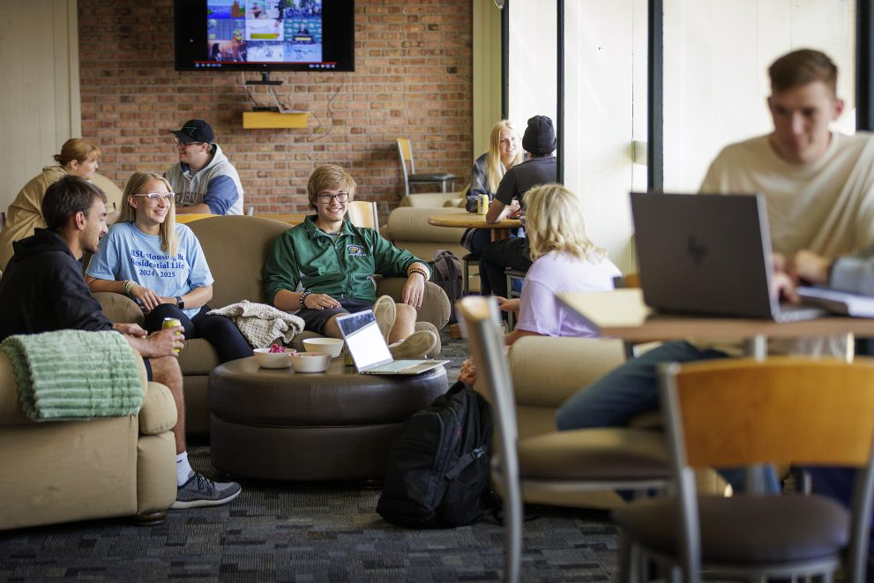
[[IMAGE REF 0000]] Image reference -- not directly editable; the original page reference is preserved automatically. Source: https://www.bemidjistate.edu/services/reslife/wp-content/uploads/sites/20/2025/03/Student-Lounge-1-991x661.jpg

New Student Registration & Summer Webinar Series Presentation
Housing & Residential Life staff will be present at the New Student Registration (NSR) days. We will provide housing application assistance, answer questions and give a presentation to friends, families and supporters while the students are busy registering for classes. Over the summer, we will go in-depth on all things housing during the Summer Webinar Series.

Residence Halls
Our residential community comprises seven residence halls that house over 1,200 students and single-parent families. Located in the heart of the BSU campus, they are a short walk to academic buildings and connected to other campus buildings by a system of underground walkways and tunnels.
First-year students will live in a double or double-as-single room in either Oak or Tamarack Hall. Upper-division students may live in Birch, Linden or Oak where room options include doubles, double-as-singles, singles or suites. All room options are limited, and waiting lists are maintained for those that may not be immediately available.

Services and Amenities
Living on campus is about so much more than a bed to sleep in. You’ll have access to a living room, game room, TV lounge, kitchen, wireless internet, academic resources, a computer lab and plenty more services.

Student Dining
A huge part of living on campus is the food. Student Dining has many options, like the buffet-style cafeteria located in Walnut Hall, affectionately known as Wallyís, Lakeside in the Hobson Memorial Union and the Northwoods Markets. Read more about dining options and meal plans.

Single-Parent & Family Apartments
Cedar Apartments features two- and three-bedroom apartments for family and single-parent students. There is lots for kids to do here, including a playroom downstairs and playground equipment in the backyard.

ADA Compliant Rooms
For students with accessibility needs, ADA-compliant rooms are located in Birch and Linden. Contact the Accessibility Services office for assistance.

Learning Communities
Learn about the FYRE, special interest and Living Learning Communities of BSU residence halls on the Community Living page.

