Title | Summer Housing
Meta Description
— Page content begins below. Please do not edit the table above. —
The Summer 2026 housing application is available beginning March 1, 2026. Please apply using the online application located in e-Services.
Summer housing in Linden Hall will be available from May 9, 2026, through August 7, 2026. The Summer 2026 rate is $195 per week.
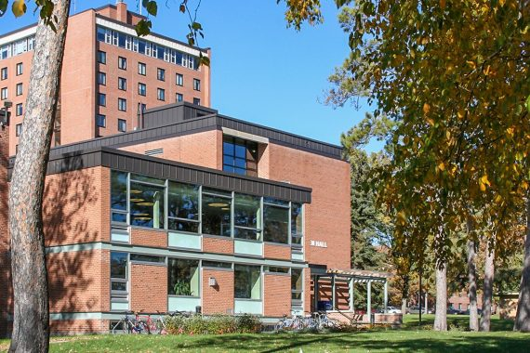
[[IMAGE REF 0000]] Image reference -- not directly editable; the original page reference is preserved automatically. Source: https://www.bemidjistate.edu/services/reslife/wp-content/uploads/sites/20/2023/07/Linden-Hall-Street-Side-570x380.jpg
IMAGEPLACEHOLDER0001

Eligibility
In order to be eligible for summer housing, you must:
- be enrolled for three (3) or more summer semester credits at BSU/NTC OR
- have lived in the residence halls spring semester OR
- have a 2026-2027 Application/Contract on file for fall semester OR
- have another approved academic reason to live on campus.

Application
The summer housing application will be located through your BSU e-Services account under the Housing and Dining tab.

