Title | Cedar Apartments
Meta Description
— Page content begins below. Please do not edit the table above. —
Cedar is reserved for single-parent students and family housing, featuring two- and three-bedroom apartments. In addition to a secure playground and a play space in the basement, the building features an adjacent parking lot and access to on-campus facilities via underground walkways.
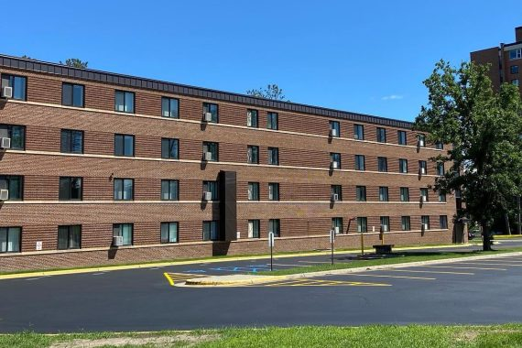
[[IMAGE REF 0000]] Image reference -- not directly editable; the original page reference is preserved automatically. Source: https://www.bemidjistate.edu/services/reslife/wp-content/uploads/sites/20/2024/10/Cedar-Hall-e1729797371894-570x380.jpg
IMAGEPLACEHOLDER0001IMAGEPLACEHOLDER0002IMAGEPLACEHOLDER0003IMAGEPLACEHOLDER0004IMAGEPLACEHOLDER0005IMAGEPLACEHOLDER0006IMAGEPLACEHOLDER0007IMAGEPLACEHOLDER0008IMAGEPLACEHOLDER0009

Family & Single-Parent Housing at the Heart of Campus
Cedar Apartments provide single parents and families a unique opportunity to enroll and complete a degree at Bemidji State University or Northwest Technical College while meeting their parental responsibilities.
Our 21 apartments provide quality housing at a low cost in a supportive and sharing environment. Two and three-bedroom apartments are available. They are just a short walk to campus buildings and have access to our tunnel system.
Cedar offers a fenced outdoor playground and an indoor play area for children.

Cedar Apartment Application
The Cedar Apartment Application is located in BSU e-Services under the Housing and Dining tab. Cedar Apartment Application information is available on the Apply for Housing page.

FAQ's Expand All

How Much Do Cedar Apartments Cost?
Our Cedar Apartment and other residence hall housing rates can be found on our Rates page. Rates for unfurnished units in the Cedar Apartments will be added to your student bill in e-Services per semester.
Cedar Apartment Semester Breakdown:
- Summer: June & July
- Fall: August, September, October, November, & December
- Spring: January, February, March, April, & May

How is the Building Set up?
Floors: 4 Floors + Basement
- Cedar 1st Floor = Student Center for Health & Counseling
- Cedar 2nd – 4th Floors = Cedar single-parent and family apartments
Room Types: 2- & 3-Bedroom Apartments
- 2 Bedroom Apartments are approximately 705 sq. ft.
- 3 Bedroom Apartments are approximately 1010 sq. ft.

What Communities are there?
Communities: Cedar Hall houses single-parent students and students with families (i.e., first-year to graduate students) and is part of the Community, Academics & Networking (CAN) Program.

Where is the Front Desk?
Housing & Residential Life Office: The Housing & Residential Life office in Walnut Hall doubles as the Cedar front desk. The Housing & Residential Life office is located in the lower level of Walnut Hall. Residents can also pick up their packages from the Housing & Residential Life office if they do not fit into their Cedar mailbox. If a resident gets locked out of their room or loses their room key, they can check out a spare tag key at the Housing & Residential Life office. Otherwise, stop by the Housing & Residential Life office if you have any questions!
Housing & Residential Life Phone Number: (218) 755-3750

Where is the Garbage & Dumpsters?
Cedar Garbage & Dumpsters: Cedar residents are responsible for taking out their own room garbage to the outside dumpster. Please use the dumpsters either behind Walnut Hall on the softball field side of the building or the dumpsters by Oak Hall B Wing. The dumpster will be behind a fence. We encourage residents to break down their boxes and place them in the dumpster, not on the ground beside it.
GMW staff routinely take out the garbage and recycling in the shared community spaces.
Dumpsters and recycling containers located around the residence hall buildings are for resident use only.

Where is the Laundry Room?
Laundry: Each floor in Cedar Hall has a Laundry Room is located about halfway down the hallway. Residents use their Cedar Hall room keys to access the Laundry Room. Laundry is free and is connected through the CSC Go App. Residents need to provide their own high-efficiency laundry detergent.

Where is the Lobby?
Lobby: The Cedar Hall 1st Floor Lobby connects to the entrance of the Jack & Jill Preschool, located between Cedar & Pine Halls, and contains the Cedar resident mailboxes.

How do I get my Mail & Packages?
Mail & Packages: Each apartment has its own mailbox located in the Cedar Hall Lobby. If items are too large to fit in the mailbox, residents can pick up their packages at Walnut Hall in the Housing & Residential Life Office. Residents will receive an email to their BSU student email address when a package has arrived and is ready to be picked up.
Mailing Address:(Student Name)
Cedar Hall (apartment number)
1925 Birchmont Dr NE
Bemidji, MN 56601

Is there an On-Site Staff Member?
Cedar Hall has an on-site Housing & Residential Life Staff Member, the Cedar Hall Apartment Building Manager (ABM). The ABM’s role is to help residents with any questions they may have, provide activities to build community within Cedar, enforce policies and procedures, and keep residents updated on pertinent information.

What Outdoor Spaces are there?
**Playground:**Located on the lakeside of Cedar Hall, a playground where parents can let their children play. The playground contains slides, monkey bars, a jungle gym, and picnic tables. Parents must supervise their child(ren) while using the playground.
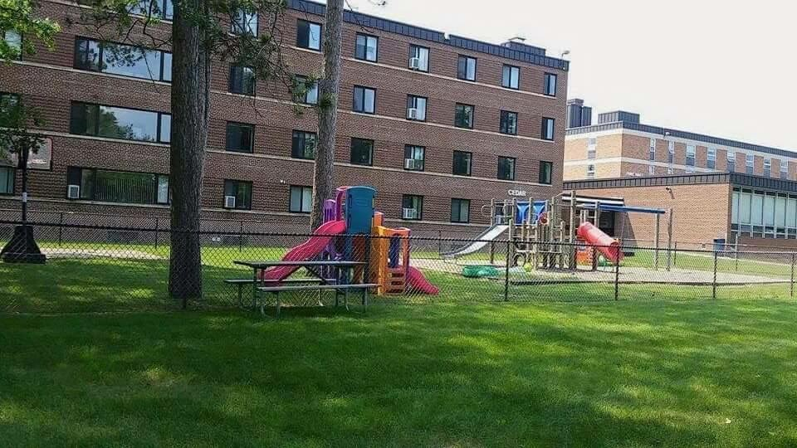
[[IMAGE REF 0010]] Image reference -- not directly editable; the original page reference is preserved automatically. Source: https://www.bemidjistate.edu/services/reslife/wp-content/uploads/sites/20/2022/01/Cedar-Playground.jpg
**Sand Volleyball Court:**Next to the playground is a sand volleyball court. Volleyballs can be checked out at the Tamarack Hall Front Desk with a valid student ID.
Grills & Bike Rack: Pine has an outdoor gathering space with grills and bike racks. Residents will need to bring their own bike lock if they wish to store their bike on the bike rack.

Where can I park?
Parking permits are required year-round in the Cedar Hall Parking Lot. The other parking lots do not require parking permits during the summer. Cedar Parking Lot requires a black parking permit. They are available first to Cedar Apartments residents, but depending on demand, may be available to other residence-hall students. Limited availability. To pre-register for a parking permit, you can do so online at: BSU Parking Permit Online Pre-Registration Form.
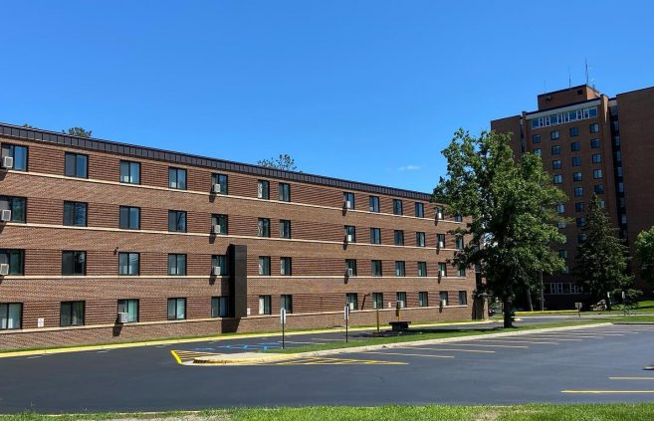
[[IMAGE REF 0011]] Image reference -- not directly editable; the original page reference is preserved automatically. Source: https://www.bemidjistate.edu/services/reslife/wp-content/uploads/sites/20/2022/01/Cedar-Parking-Lot-657x423-1.jpg

Where can our children play?
**Romper Room:**Located in the basement of Cedar Hall, this play area is great for kids. The Romper Room contains various play sets, books, toys, and a table with chairs. Parents must supervise their child(ren) while using the Romper Room.
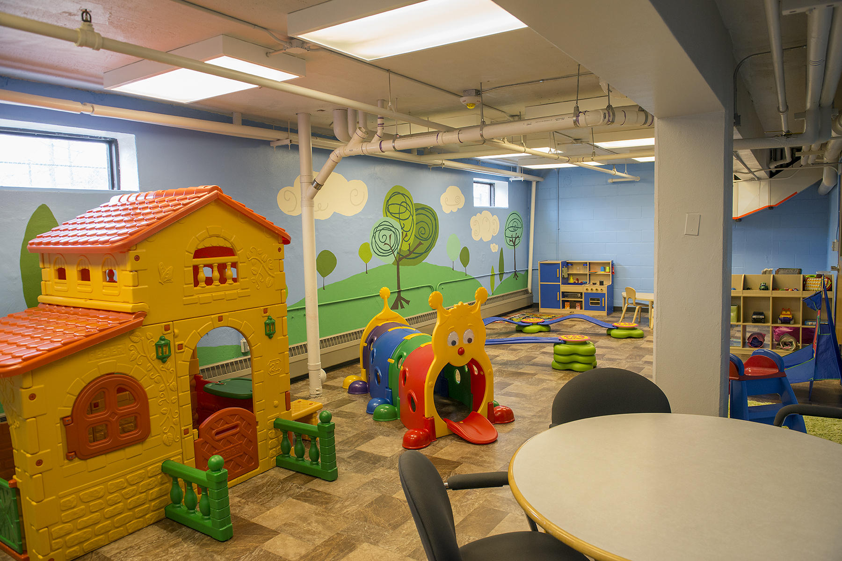
[[IMAGE REF 0012]] Image reference -- not directly editable; the original page reference is preserved automatically. Source: https://www.bemidjistate.edu/services/reslife/wp-content/uploads/sites/20/2022/01/hi-res-romper-room.jpg
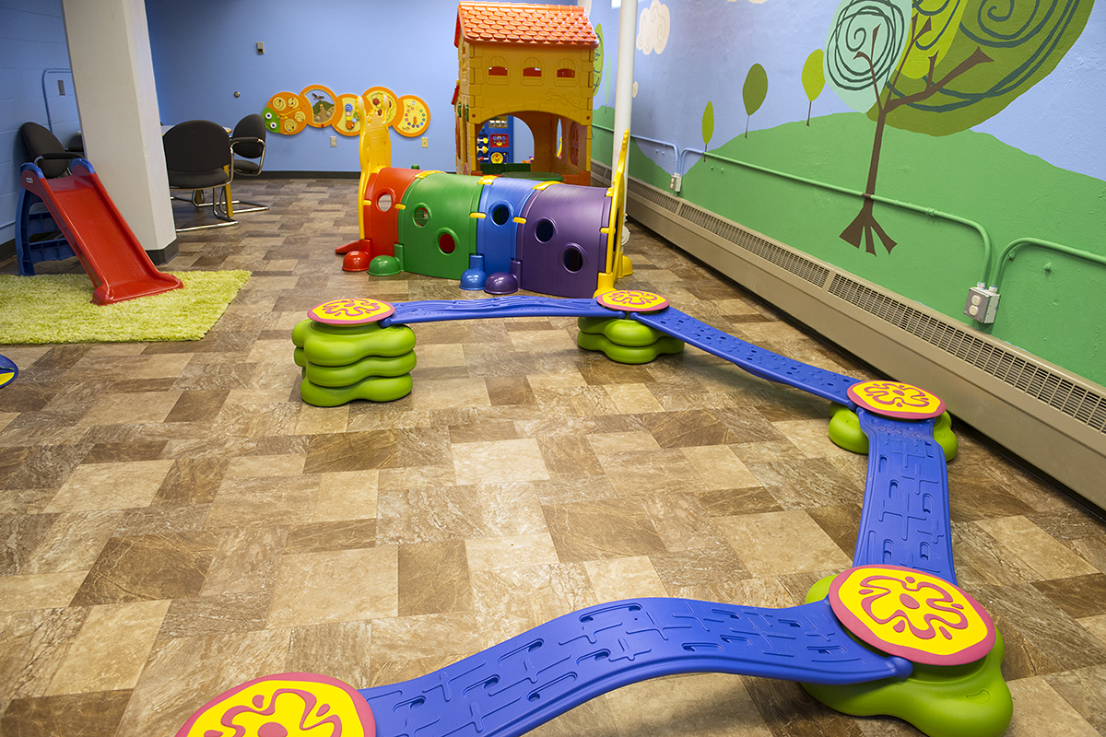
[[IMAGE REF 0013]] Image reference -- not directly editable; the original page reference is preserved automatically. Source: https://www.bemidjistate.edu/services/reslife/wp-content/uploads/sites/20/2022/01/Romper-room-balance.jpg
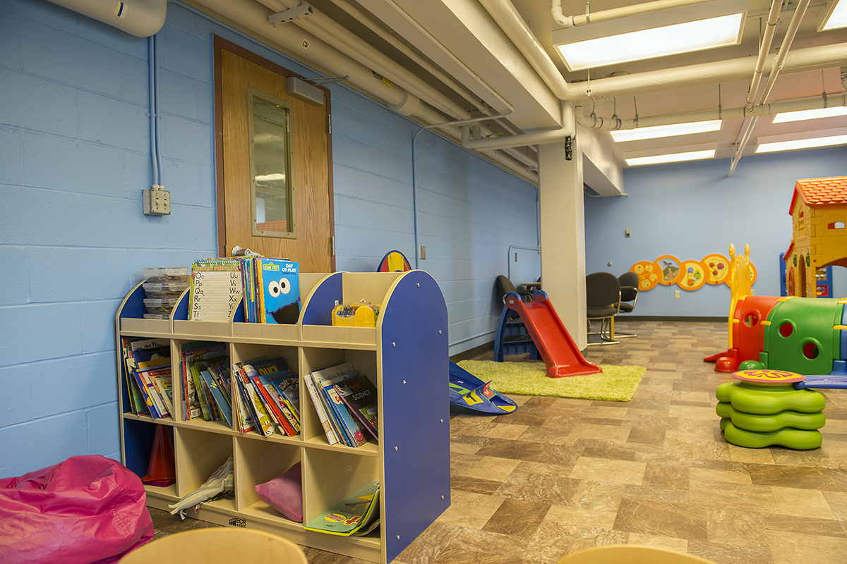
[[IMAGE REF 0014]] Image reference -- not directly editable; the original page reference is preserved automatically. Source: https://www.bemidjistate.edu/services/reslife/wp-content/uploads/sites/20/2022/01/romper-room-books.jpg

Is this building secure?
**Building Security:**To enter Cedar Hall, residents must use their student IDs to scan in. Each resident is also given an apartment key. BSU Public Safety is given a list of individuals who are approved to enter Cedar Hall if someone becomes locked out.
**BSU Public Safety:**Open 24/7 and located in Walnut Hall, the BSU Public Safety office monitors the security cameras around campus & in the residence halls, ensures the buildings remain locked and secure, and enforces parking permits. More about Public Safety can be found on their website.
Public Safety Phone Number: (218)-755-3888

What if I need to store items out of my apartment?
Apartment Storage Lockers: Located in the basement of Cedar Hall, each apartment has a lockable storage locker that can be opened with the apartment room key. There is no additional cost for residents to use their storage locker.
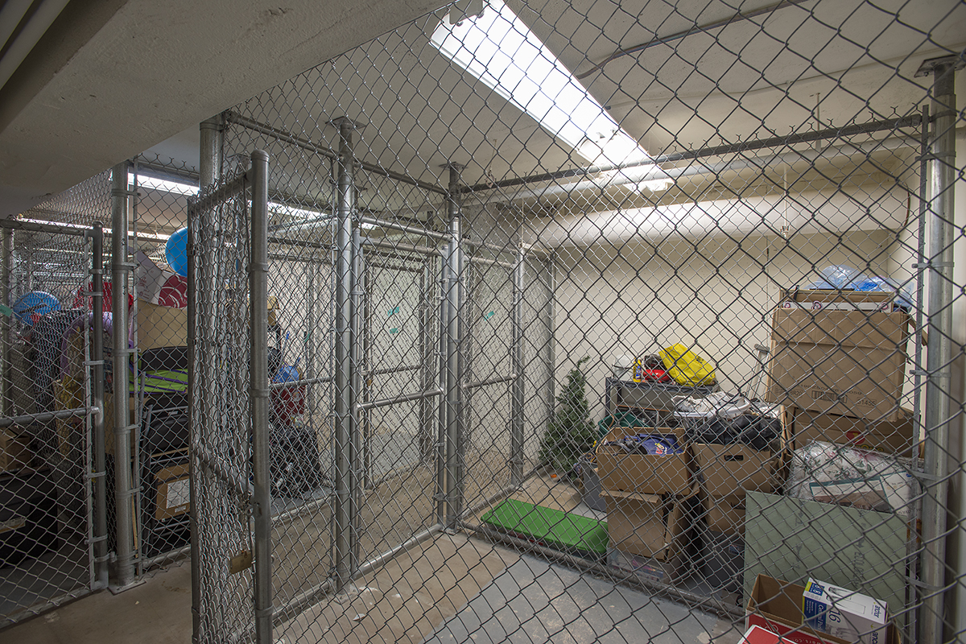
[[IMAGE REF 0015]] Image reference -- not directly editable; the original page reference is preserved automatically. Source: https://www.bemidjistate.edu/services/reslife/wp-content/uploads/sites/20/2022/01/Cedar-Storage.jpg

Do I have to pay for Utilities?
Utilities included are heat, summer air conditioning, electricity, internet, water, sewage, and garbage.

How do I get Wi-Fi & Internet?
Wi-Fi & Internet: Each floor features its own wireless access point, allowing residents to connect to the Wi-Fi. There is an Ethernet port located in each apartment where residents can connect their device with an Ethernet cord.

