Title | Residence Halls
Meta Description
— Page content begins below. Please do not edit the table above. —
Choose from six housing options, each one with its own unique personality, amenities, activities and traditions.

On-Campus Living for First-Year Students
All first-year students live on campus in either Oak or Tamarack Hall and participate in the First Year Residential Experience (FYRE) program.
Residence Hall | Type of Room | Amenities
Oak Hall | Double and double-as-single rooms | Game room, piano rooms, sand volleyball court, basketball court
Tamarack Hall | Double and double-as-single rooms | Game room, basketball court

On-Campus Living for Upper-Division Students
Upper-division students can continue living with a roommate or snag a spacious single to make their own.
Residence Hall | Type of Room | Amenities
Birch Hall | Double, double-as-single and single rooms | Outdoor grills, gender-inclusive private bathrooms
Linden Hall | Two- and three-person suites with a shared bathroom | Lounges with TVs and fireplace, outdoor fire pit, game room
Oak Hall | Double, double-as-single, and single rooms with a private bathroom | Game room, piano rooms, sand volleyball court, basketball court
Pine Hall | Double-as-single rooms | Basement and penthouse lounges, outdoor grills

Oak Hall
Oak is home to 525 residents participating in the First Year Residential Experience (FYRE) program. It has three wings and is alive with a strong sense of tradition and endless activities. Oak encourages academics through large study spaces and resources. There is always something going on here, from volleyball to game nights in the basement lounge.
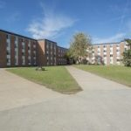
[[IMAGE REF 0000]] Image reference -- not directly editable; the original page reference is preserved automatically. Source: https://www.bemidjistate.edu/services/reslife/wp-content/uploads/sites/20/2022/01/Oak_Exterior-300x200-1-150x150.jpg

Tamarack Hall
Tamarack is home to more than 350 residents across 12 floors and is part of the First Year Residential Experience (FYRE) program. It also has two floors for students interested in outdoor adventure. A fun fact: Tamarack is the tallest building in Bemidji! Upper-floor rooms and the 12th-floor lounges let you view the lake, the city and the beautiful north country. The views are incredible!
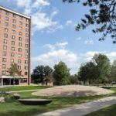
[[IMAGE REF 0001]] Image reference -- not directly editable; the original page reference is preserved automatically. Source: https://www.bemidjistate.edu/services/reslife/wp-content/uploads/sites/20/2022/01/campusscuplture_0147-300x200-1-150x150.jpg

Birch Hall
Birch houses roughly 200 residents in single, double-as-single and double rooms. All floors were designed with inspiration from our Minnesota north woods culture and are designated for upper-division students. Birch offers gender inclusive floor bathrooms with private toilet and shower rooms. Enjoy the views of Lake Bemidji, having the Chet Anderson Stadium across the street and being the closest residence hall to the academic buildings!
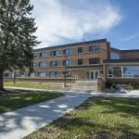
[[IMAGE REF 0002]] Image reference -- not directly editable; the original page reference is preserved automatically. Source: https://www.bemidjistate.edu/services/reslife/wp-content/uploads/sites/20/2022/01/Birch_Exterior-300x200-1-150x150.jpg

Linden Hall
Linden houses approximately 180 upper-division students in two- and three-person suites, each with a shared bathroom. Linden boasts a gaming room, movable furniture, outdoor gathering spaces and spectacular lake views.
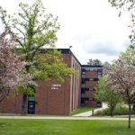
[[IMAGE REF 0003]] Image reference -- not directly editable; the original page reference is preserved automatically. Source: https://www.bemidjistate.edu/services/reslife/wp-content/uploads/sites/20/2022/01/Linden_Exterior-300x200-1-150x150.jpg

Pine Hall
Pine is a welcoming community for upper-division students. It is the smallest hall on campus, housing 107 residents on four floors. Every double-sized room is offered as a single. Though small in size, Pine is big on great amenities. The penthouse lounge offers beautiful views, and the lower level features a spacious game room with a fireplace and a comfortable study lounge. Pine floors are single-gender.
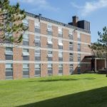
[[IMAGE REF 0004]] Image reference -- not directly editable; the original page reference is preserved automatically. Source: https://www.bemidjistate.edu/services/reslife/wp-content/uploads/sites/20/2022/01/Pine_Exterior-300x200-1-150x150.jpg

Cedar Apartments
Cedar features two- and three-bedroom apartments for families and single-parent students. In addition to a secure playground and a play space in the basement, the building features an adjacent parking lot and access to on-campus facilities via underground walkways.
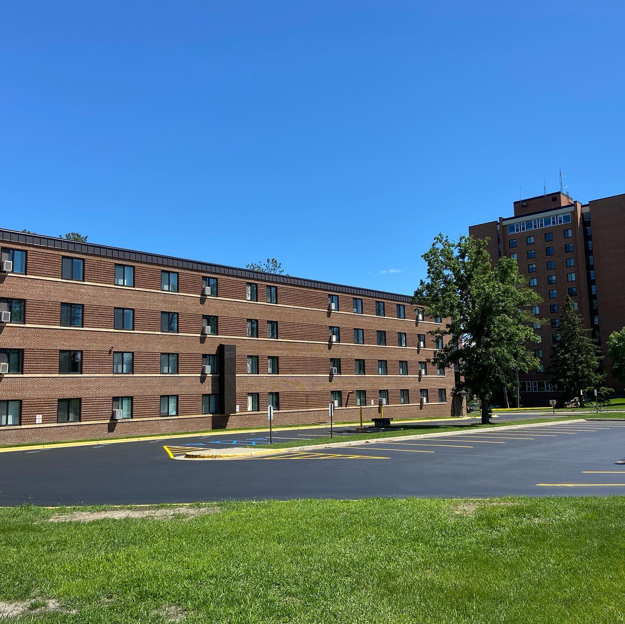
[[IMAGE REF 0005]] Image reference -- not directly editable; the original page reference is preserved automatically. Source: https://www.bemidjistate.edu/services/reslife/wp-content/uploads/sites/20/2024/10/Cedar-Hall.jpg

