Title | Returning Students
Meta Description
— Page content begins below. Please do not edit the table above. —

Welcome Back
The 2026-27 Returning Student Housing Application opens starting December 1, 2025!
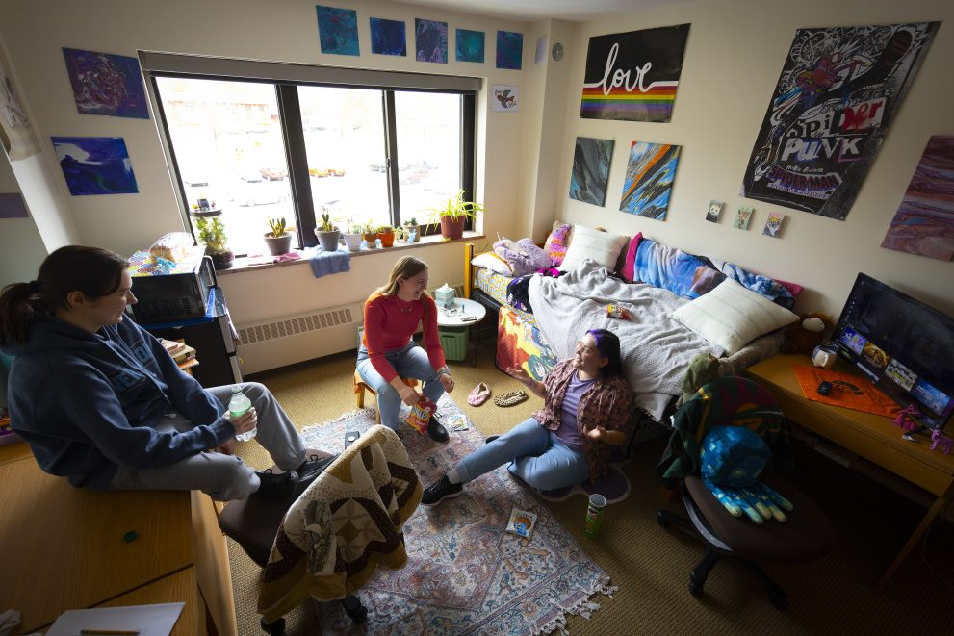
[[IMAGE REF 0000]] Image reference -- not directly editable; the original page reference is preserved automatically. Source: https://www.bemidjistate.edu/services/reslife/wp-content/uploads/sites/20/2025/03/GirlsDorm-2-991x661.jpg

Application & Prepayments
Complete your application and make your prepayment through your BSU e-Services account under the Housing and Dining tab.
- DECEMBER 1: Returning Student Housing Application opens in e-Services
- JANUARY 11: Priority Point Worksheet distribution begins by RA/PAA staff
- JANUARY 23: Priority Point Worksheet due to the Res Life Office
- JANUARY 27-30: Same-Room Selection (Room Renewal)
- FEBRUARY 10-12: Priority Point Participants Room Selection (Watch your BSU email for your room selection start time. Emails should be out by 4:00 PM on Feb 5.)
- FEBRUARY 17+: Room Selection opens to all other returning students, including those living off-campus.
- MARCH 31: HOUSING PREPAYMENT DUE ($150) (This will secure your room selection!)
- APRIL 8: Room Sign-Up Celebration!
Check out the digital version of the Priority Point Worksheet and our on-campus room options!

Floor Plans
Birch Hall
Linden Hall
Oak Hall
All floors in Birch, Linden and Oak are co-ed. Double rooms are single-gender. See the Linden Hall page for details about gender-inclusive housing options in that Hall.

