Title | Faculty & Staff
Meta Description
— Page content begins below. Please do not edit the table above. —
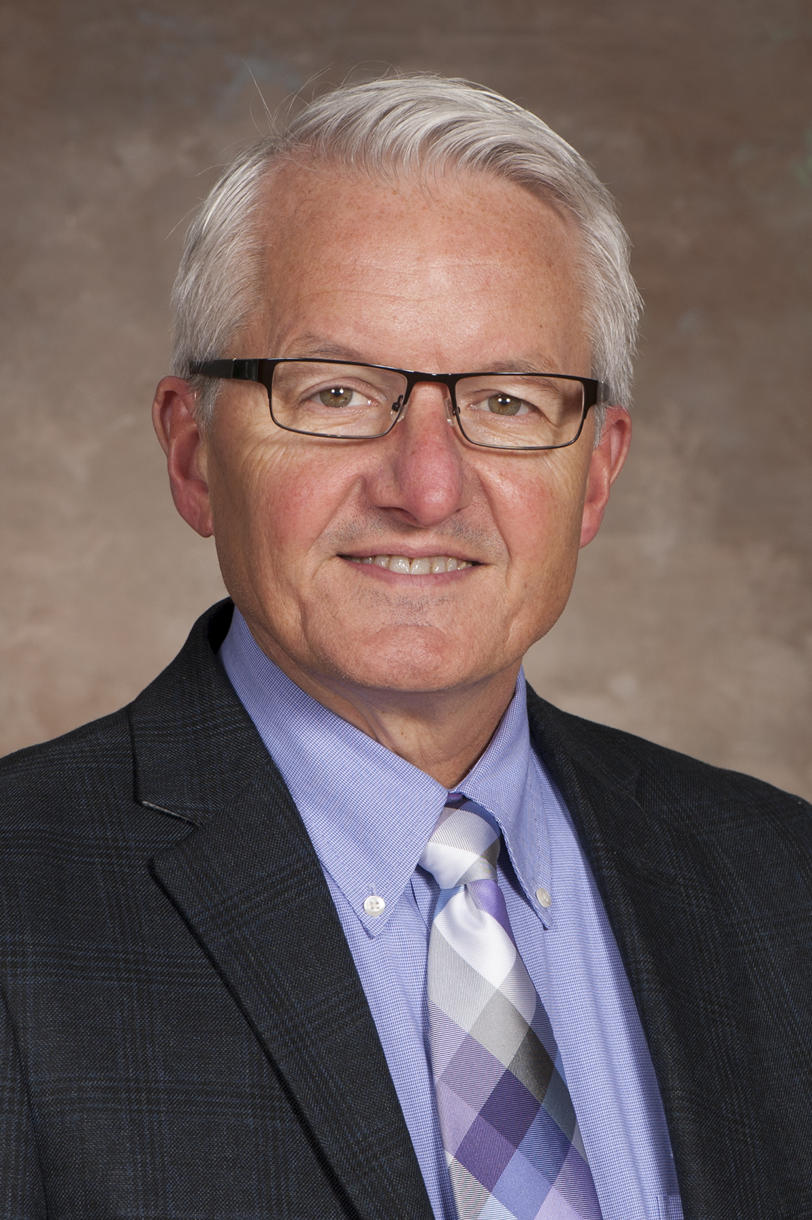
[[IMAGE REF 0000]] Image reference -- not directly editable; the original page reference is preserved automatically. Source: https://www.bemidjistate.edu/academics/accounting/wp-content/uploads/sites/45/2022/03/15BSU__Accounting_William_Graves.jpg
Assistant Professor
Specialty: Accounting Systems
Memorial Hall 160
Phone: (218) 755-3714
Box #30
william.graves@bemidjistate.edu


[[IMAGE REF 0001]] Image reference -- not directly editable; the original page reference is preserved automatically. Source: https://www.bemidjistate.edu/academics/accounting/wp-content/uploads/sites/45/2022/03/Jafar-Al-Saleem-pic.jpg
Adjunct Faculty
Specialty: Advanced Accounting
Memorial Hall 165
Phone: (218) 755-2515
Box #30
jafar.alsaleem@bemidjistate.edu

Dr. Mary DuBois
Adjunct Faculty
Specialty: Government
Memorial Hall
Phone: (218) 428-0254
Box #30
mary.dubois@bemidjistate.edu


[[IMAGE REF 0002]] Image reference -- not directly editable; the original page reference is preserved automatically. Source: https://www.bemidjistate.edu/academics/accounting/wp-content/uploads/sites/45/2022/03/jeff-Picture.jpeg
Assistant Professor
Specialty: Tax
Memorial Hall 131
Phone: (218) 755-3873
Box #30
jeffrey.everhart@bemidjistate.edu

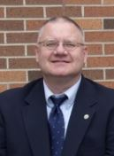
[[IMAGE REF 0003]] Image reference -- not directly editable; the original page reference is preserved automatically. Source: https://www.bemidjistate.edu/academics/accounting/wp-content/uploads/sites/45/2022/03/Bill-Joyce.jpg
Professor
Specialty: Cost
Memorial Hall 163
Phone: (218) 755-2858
Box #30
bill.joyce@bemidjistate.edu

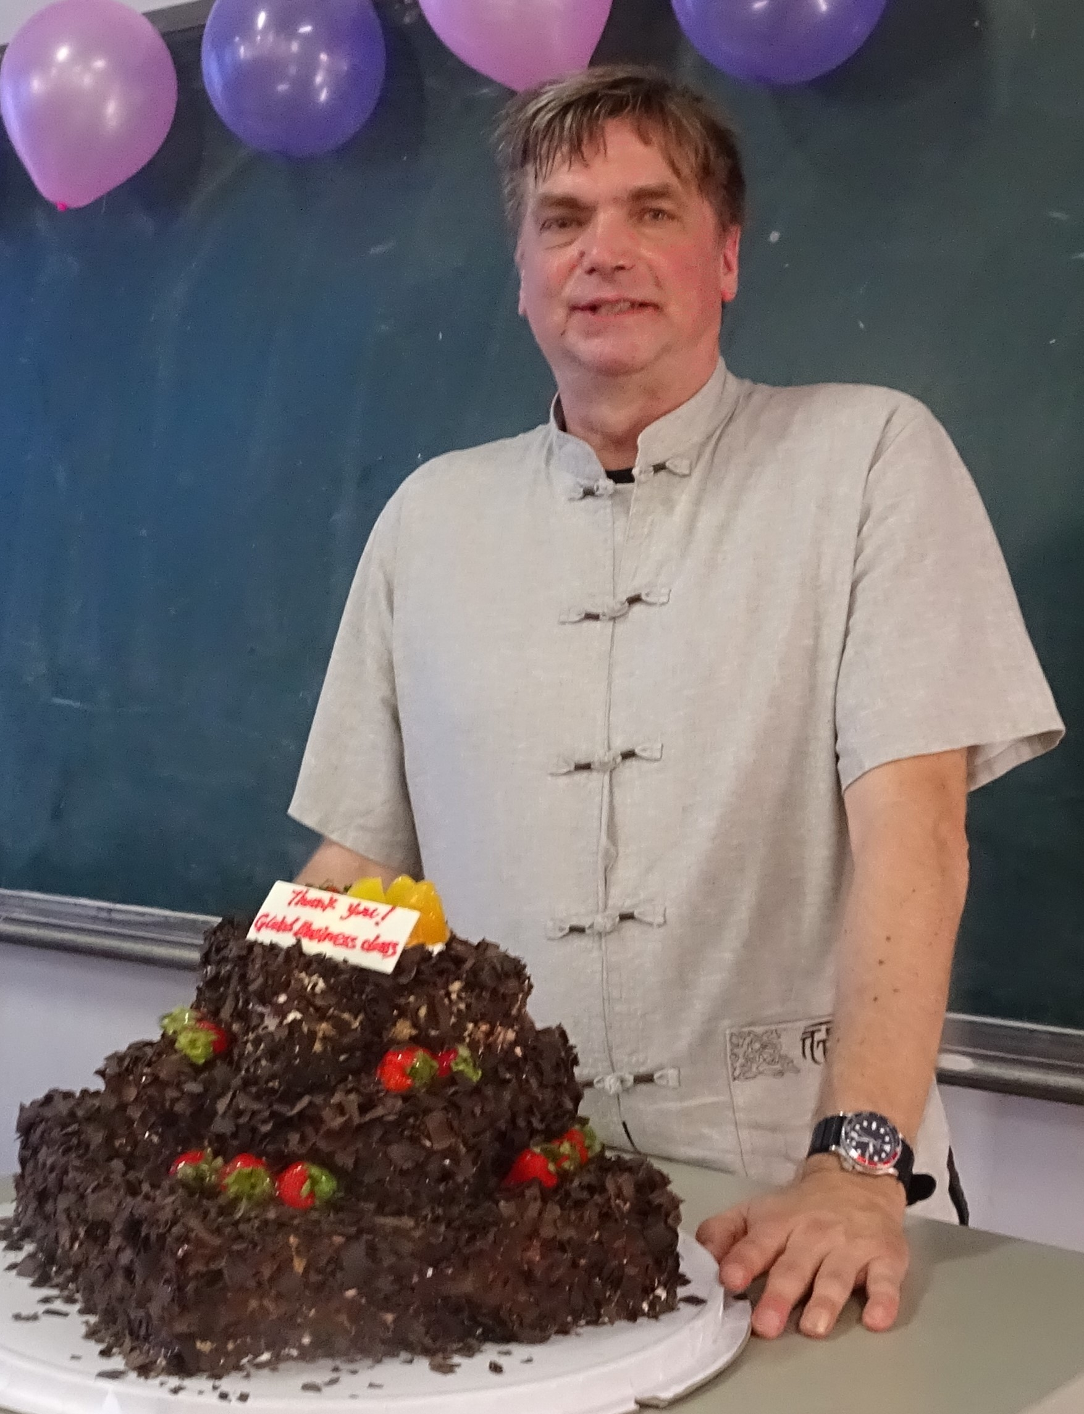
[[IMAGE REF 0004]] Image reference -- not directly editable; the original page reference is preserved automatically. Source: https://www.bemidjistate.edu/academics/accounting/wp-content/uploads/sites/45/2022/03/DSC02427-2.jpg
Associate Professor
Specialty: Intermediate Accounting
Memorial Hall 166
Phone: (218) 755-2906
Box #30
david.massaglia@bemidjistate.edu

Sandra Kranz
Adjunct Faculty
Memorial Hall 157
Phone: (218) 755-3716
Box #30
sandra.kranz@bemidjistate.edu

