Title | Faculty & Staff
Meta Description
— Page content begins below. Please do not edit the table above. —
The faculty of the Department of Chemistry are committed to the intellectual, chemical and social growth of all student chemist who attend Bemidji State University.

Dr. Bob Quandt
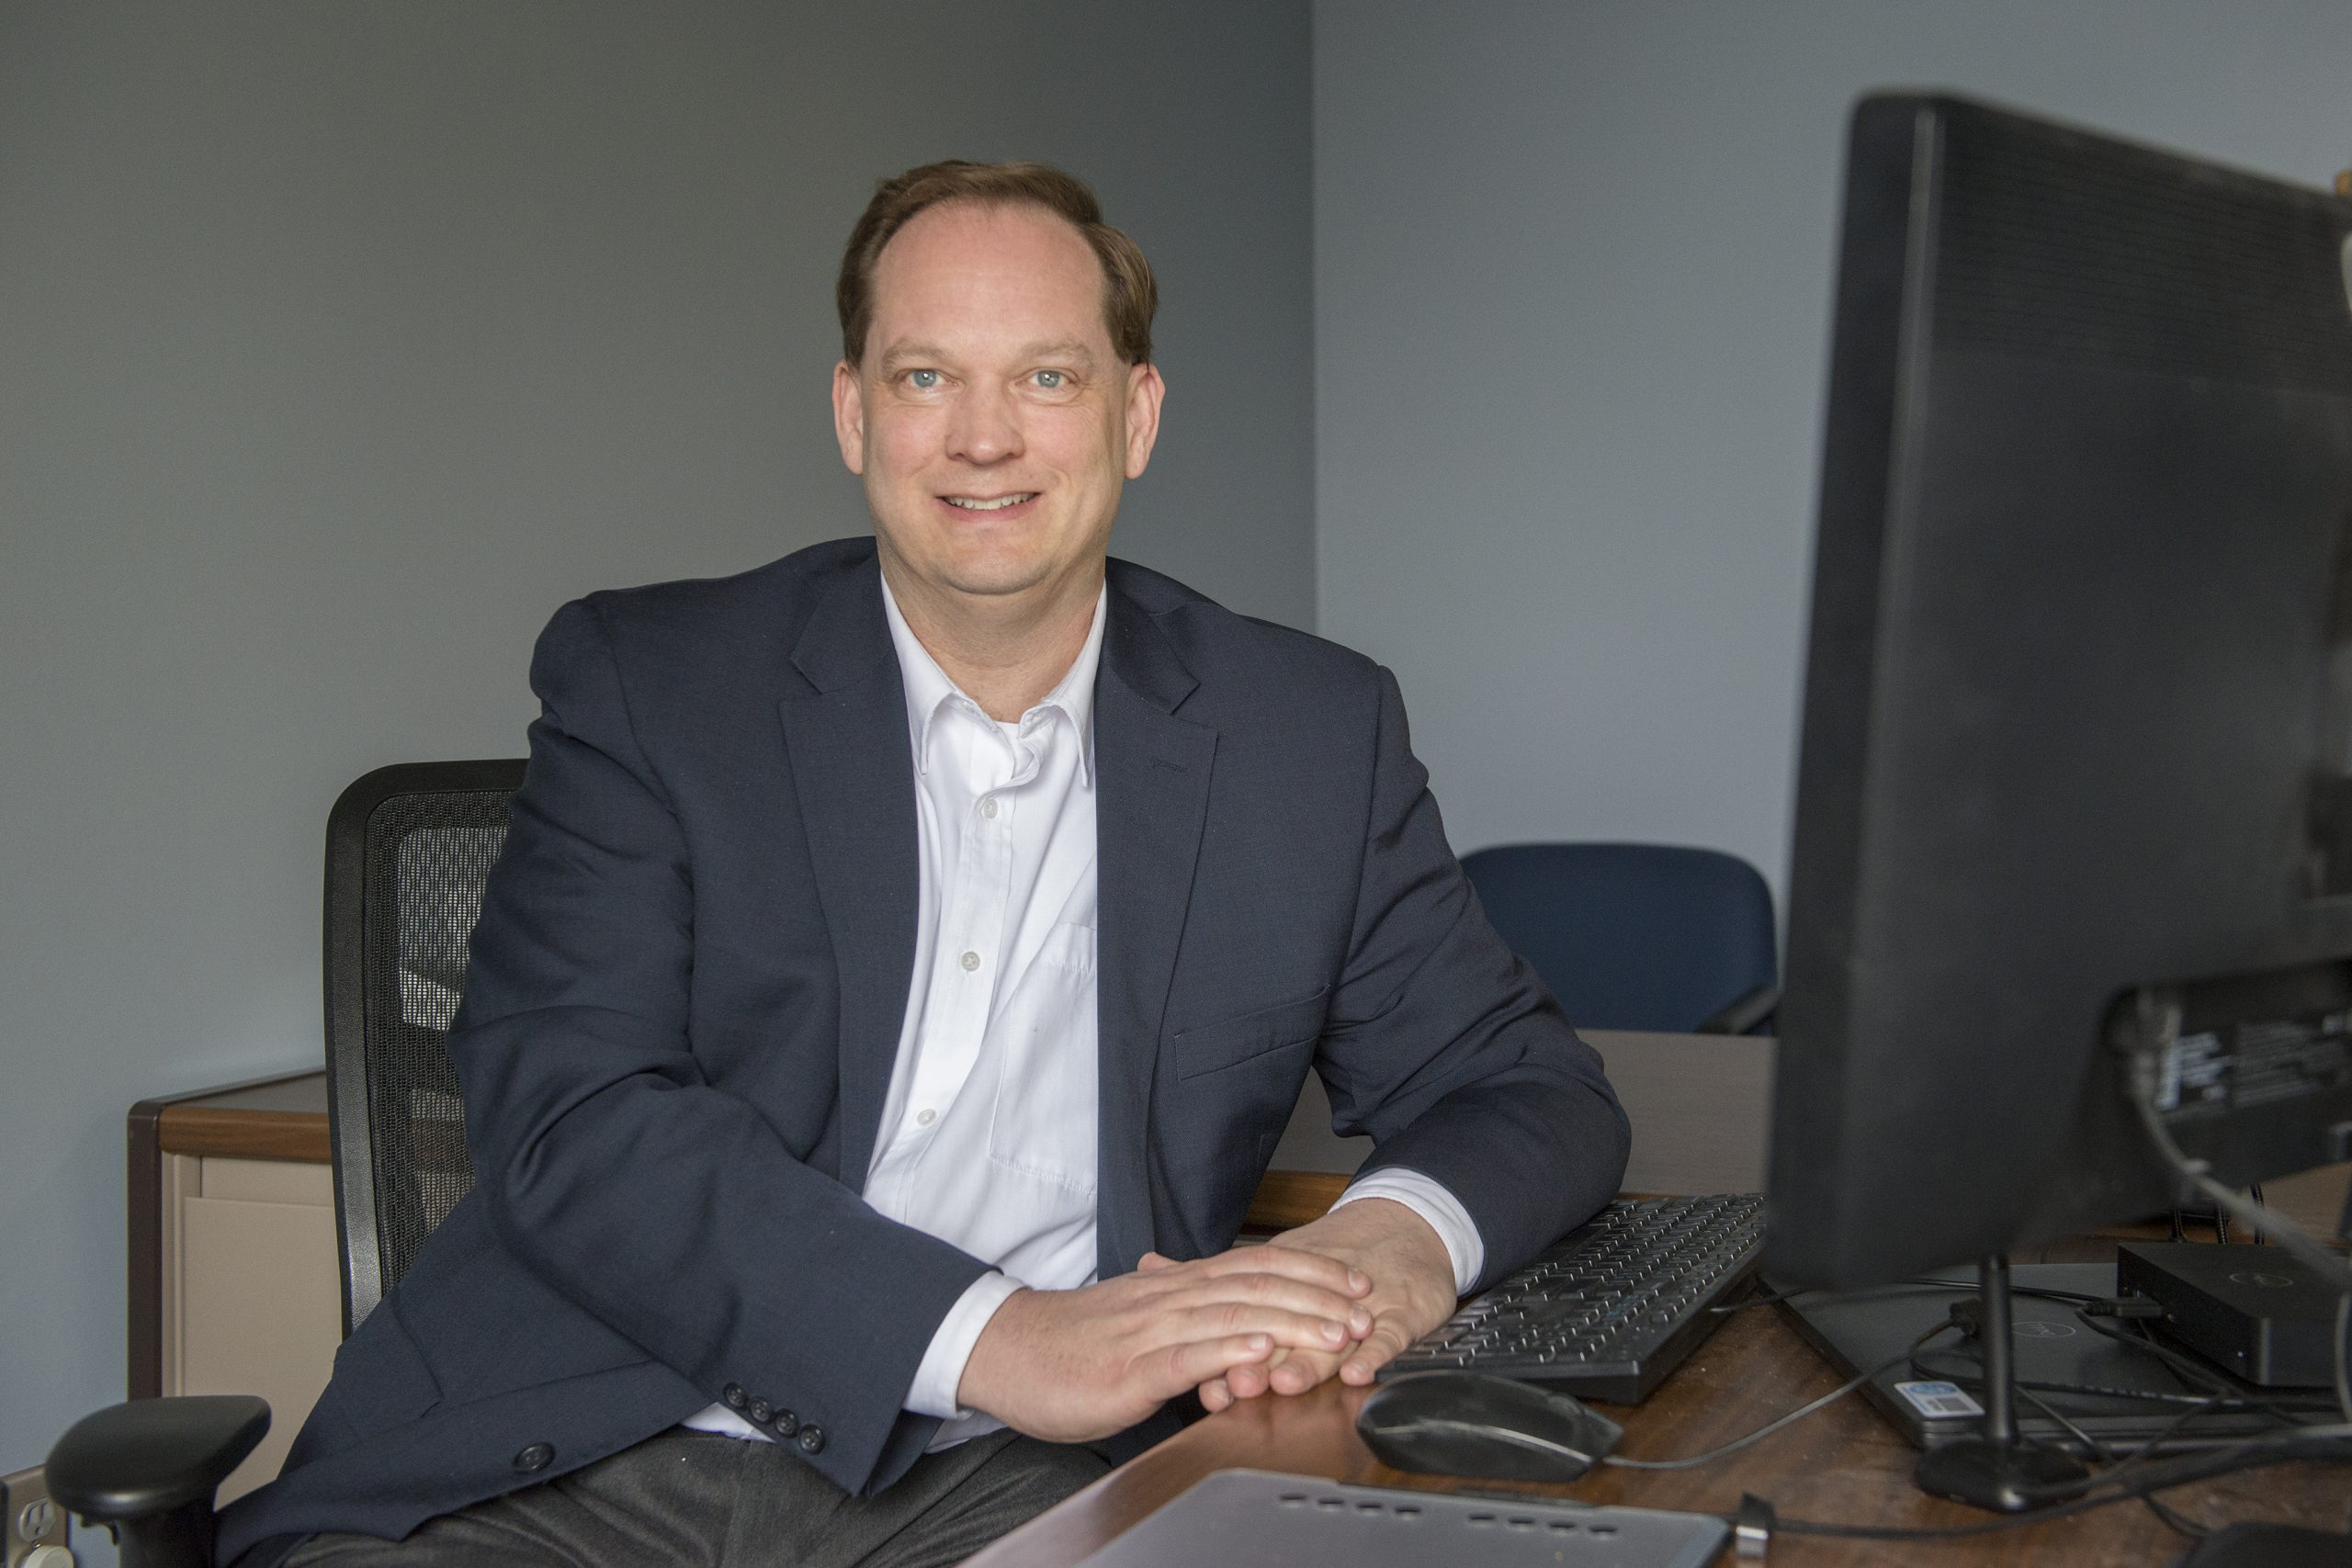
[[IMAGE REF 0000]] Image reference -- not directly editable; the original page reference is preserved automatically. Source: https://www.bemidjistate.edu/academics/chemistry/wp-content/uploads/sites/27/2022/01/21BSU_Chemistry_Dr._Bob_Quandt_0025-scaled.jpg
Chair, Professor
Specialty: Physical Chemistry
Interesting facts:
- Actually likes math!
- Saw Star Wars on its opening night (in 1977).
- Speaks some Klingon.
- Cubs Fan.
- Research interests include using computational chemistry to map potential energy profiles of reactions that are important in both atmospheric and combustion chemistry.
Location: Sattgast Hall 377D
Phone: (218) 755-2792
Box #: 27
Email: bob.quandt@bemidjistate.edu

Dr. Keith Marek
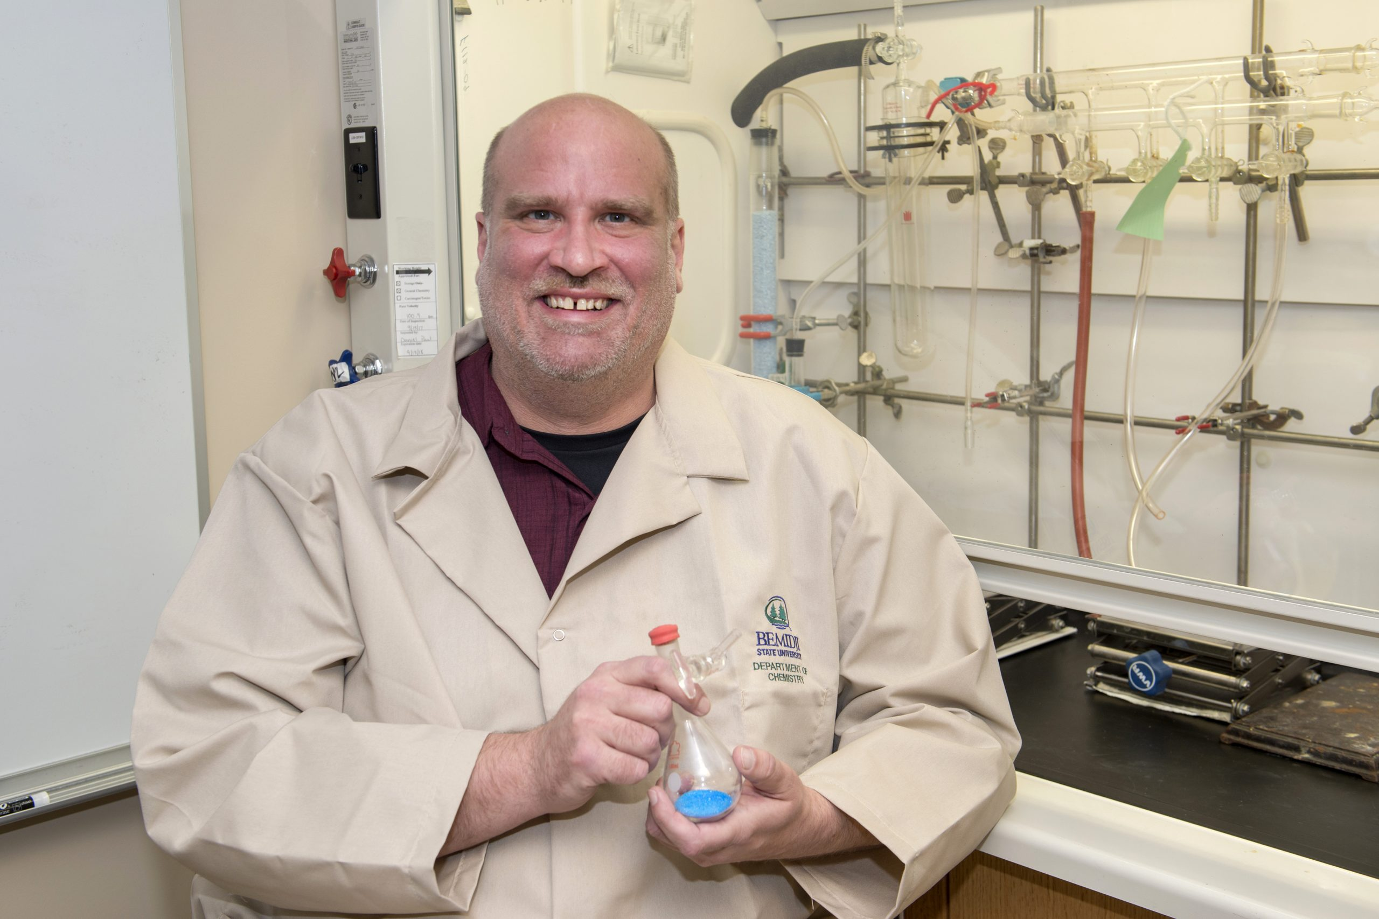
[[IMAGE REF 0001]] Image reference -- not directly editable; the original page reference is preserved automatically. Source: https://www.bemidjistate.edu/academics/chemistry/wp-content/uploads/sites/27/2022/01/21BSU_Chemistry_Dr._Keith_Marek_0047-DESKTOP-9N7I2PC-scaled.jpg
Professor
Specialty: Inorganic Chemistry
Interesting facts:
- Trivia winner with Team name “Chemically Enhanced.”
- Has the periodic table memorized.
- High School graduating class with 34 members.
Location: Sattgast Hall 377B
Phone: (218) 755-2788
Email: keith.marek@bemidjistate.edu

Dr. Julie Larson
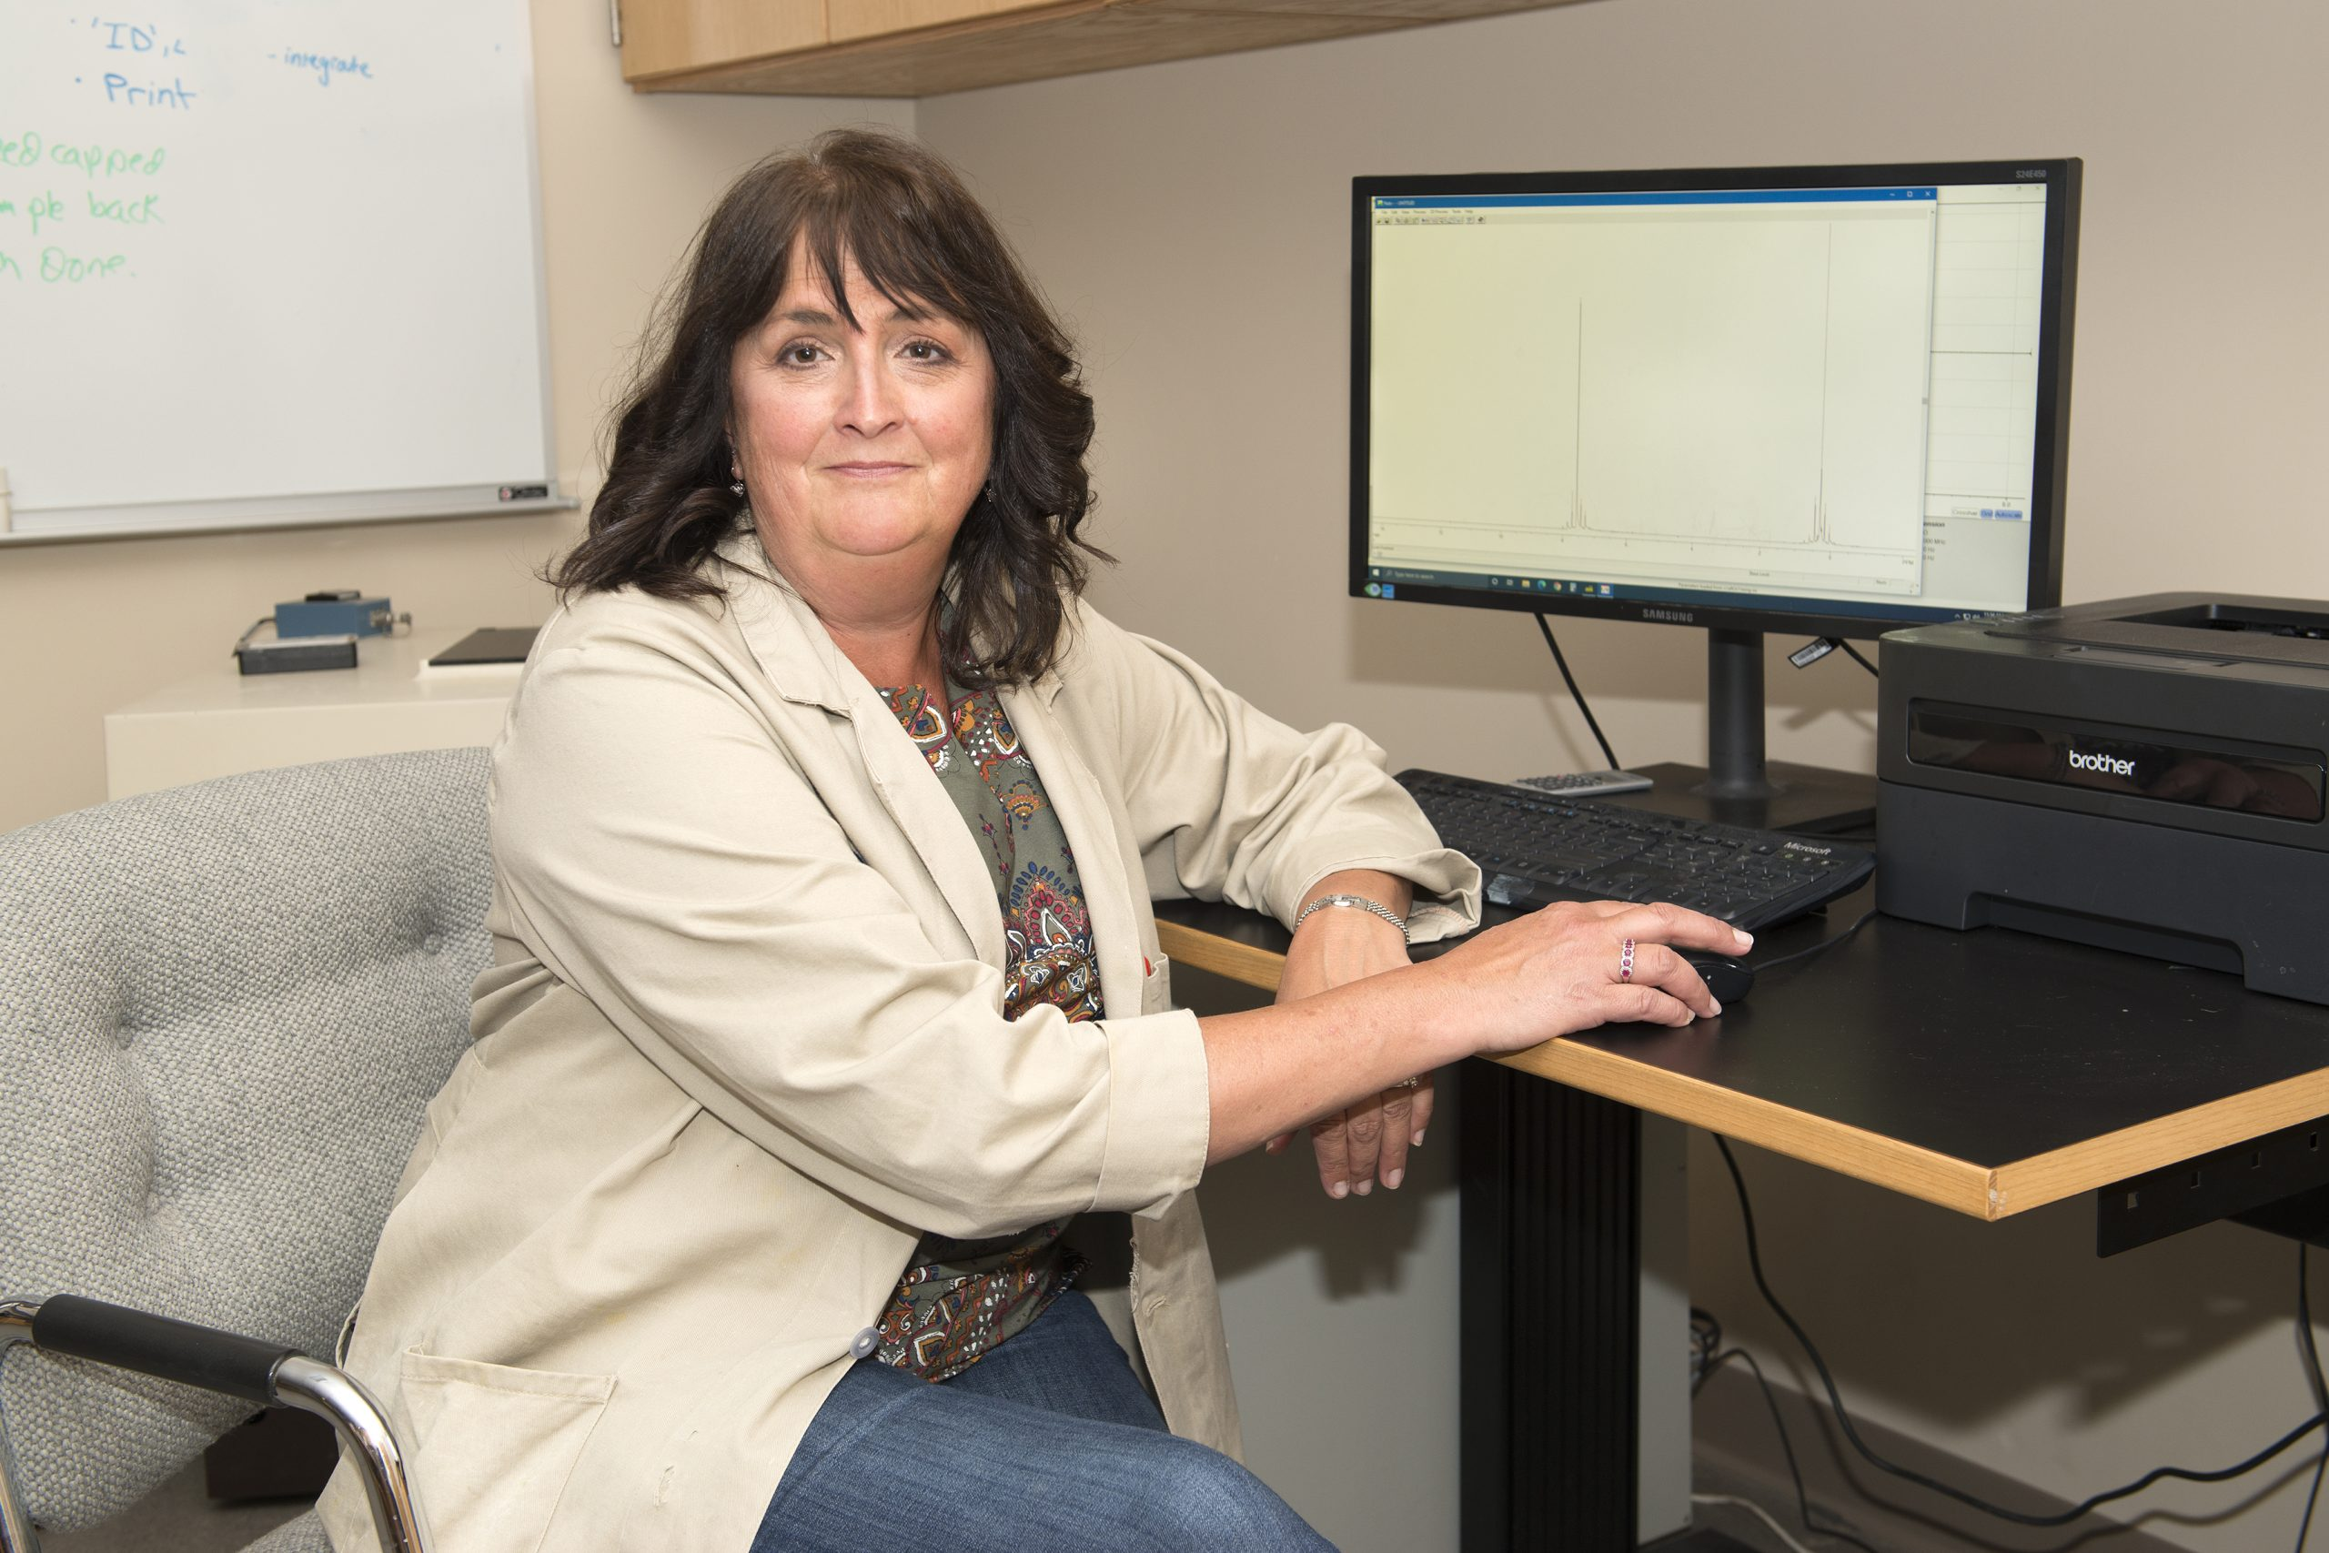
[[IMAGE REF 0002]] Image reference -- not directly editable; the original page reference is preserved automatically. Source: https://www.bemidjistate.edu/academics/chemistry/wp-content/uploads/sites/27/2022/01/21BSU_Chemistry_Dr._Julie_Larson_0030-DESKTOP-9N7I2PC-scaled.jpg
Professor
Specialty: Organic Chemistry
Interesting facts:
- Can draw a perfect hexagon, chair too!
- Mother of seven.
Location: Sattgast Hall 377A
Phone: (218) 755-2791
Email: julie.larson@bemidjistate.edu

Dr. Katie Peterson
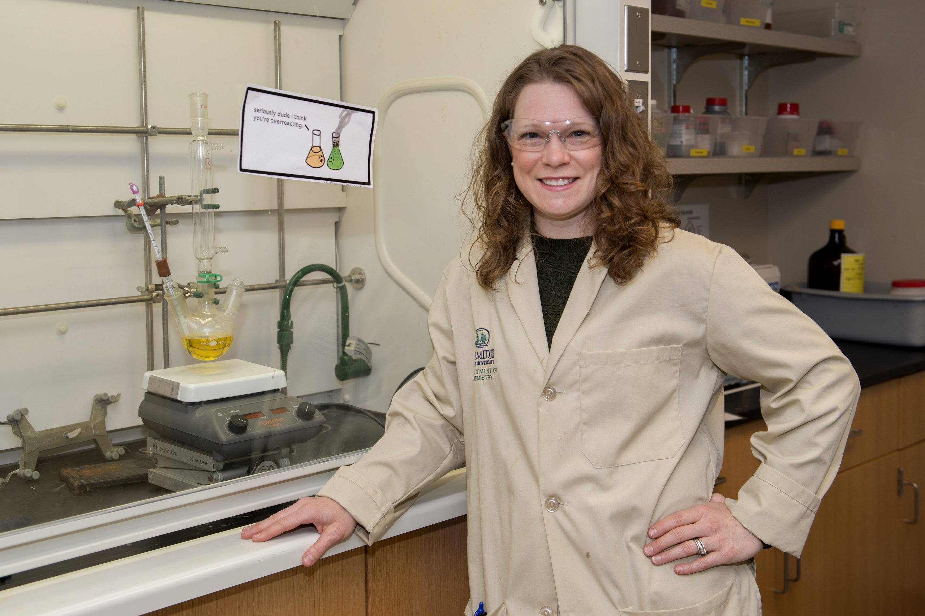
[[IMAGE REF 0003]] Image reference -- not directly editable; the original page reference is preserved automatically. Source: https://www.bemidjistate.edu/academics/chemistry/wp-content/uploads/sites/27/2022/01/21BSU_Chemistry_Dr.-Katie_Peterson_0041-scaled.jpg
Professor
Specialty: Medicinal Chemistry
Interesting facts:
- Hometown of less than 500 people.
- Research interests include fluorescent probes for hydrogen sulfide and the capture of bicarbonate from water.
- Likes to fish!
Location: Sattgast Hall 377C
Phone: (218) 755-3880
Email: katie.peterson@bemidjistate.edu

Dr. Zach Geeraerts
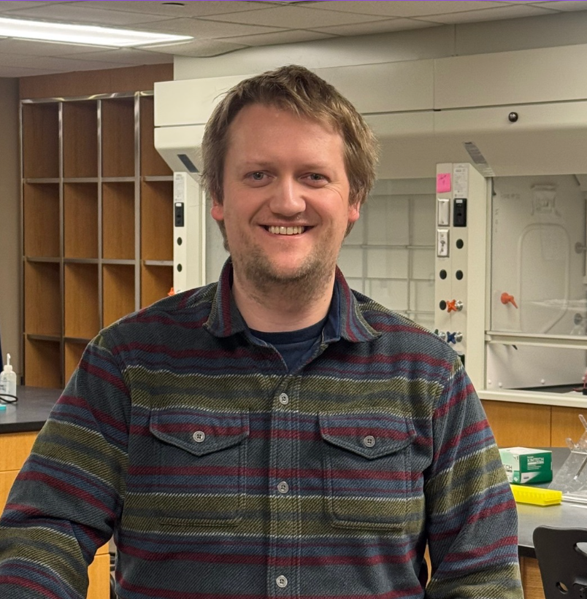
[[IMAGE REF 0004]] Image reference -- not directly editable; the original page reference is preserved automatically. Source: https://www.bemidjistate.edu/academics/chemistry/wp-content/uploads/sites/27/2025/12/Zach.png
College Lab Specialist and Biochemistry Instructor
Interesting facts:

  - Coffee aficionado.
  - First generation American.
  - Heme enzymes are the center of his research interests.
Location: Sattgast Hall 377E
Phone: (218) 755-2784
Email: zachary.geeraerts@bemidjistate.edu

