Title | Faculty & Staff
Meta Description
— Page content begins below. Please do not edit the table above. —
The Criminal Justice Faculty at Bemidji State University have extensive experience with many areas of the Criminal Justice system and can help answer your questions about what Bemidji State University can do for you. Feel free to contact any of the listed faculty below, we would be happy to discuss your future!
Heather Ebbighausen
[Image preview unavailable (UnrecognizedImageError) -- original reference preserved automatically below.]
[[IMAGE REF 0000]] Image reference -- not directly editable; the original page reference is preserved automatically. Source: https://www.bemidjistate.edu/academics/criminal-justice/wp-content/uploads/sites/63/2023/12/Ebbighausen-Heather-Photo.jpeg
Adjunct
Email: heather.ebbighausen@bemidjistate.edu

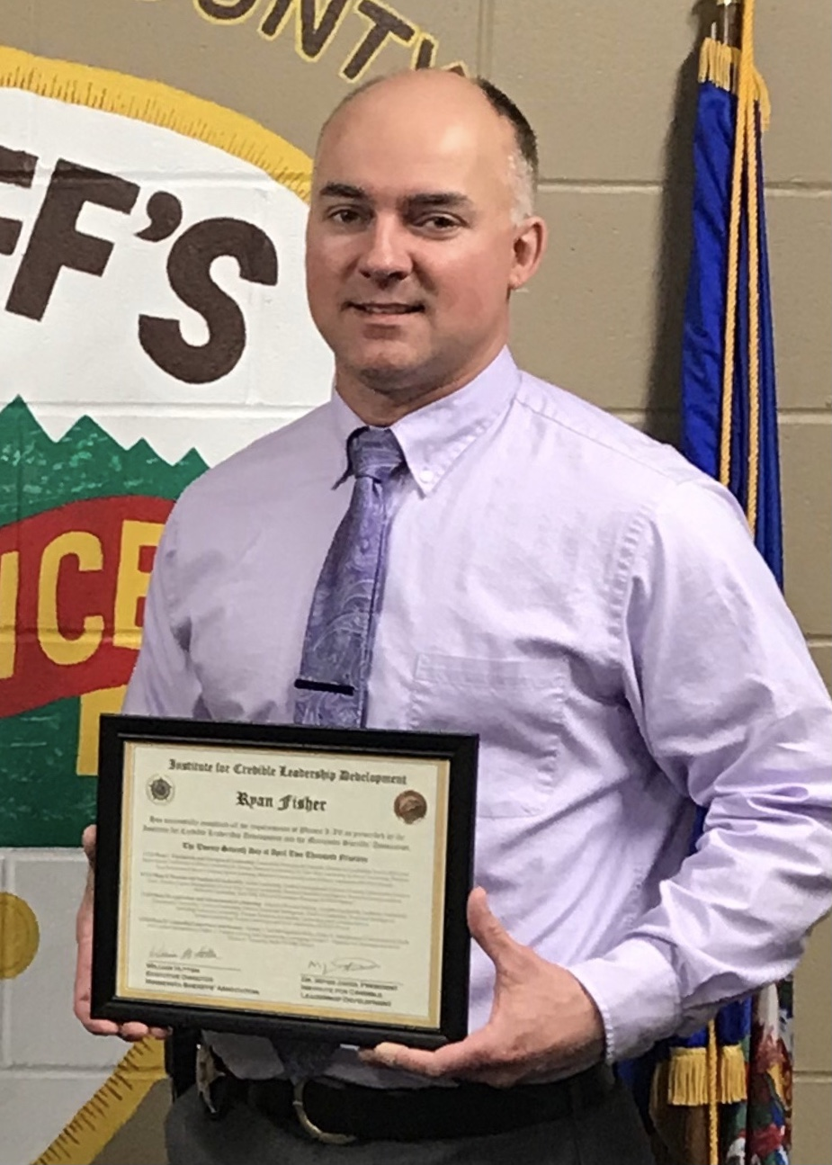
[[IMAGE REF 0001]] Image reference -- not directly editable; the original page reference is preserved automatically. Source: https://www.bemidjistate.edu/academics/criminal-justice-police-science-leadership/wp-content/uploads/sites/63/2022/05/Website-Photo-Fisher-R_.jpg
Instructor of Criminal Justice
Email: ryan.fisher@bemidjistate.edu


[[IMAGE REF 0002]] Image reference -- not directly editable; the original page reference is preserved automatically. Source: https://www.bemidjistate.edu/academics/criminal-justice-police-science-leadership/wp-content/uploads/sites/63/2022/05/Website-Photo-Fraik-R_.jpg
Assistant Professor & POST Coordinator
Office: Bensen Hall 312
Phone: (218) 755-2301
Box #: 35
Email: robert.fraik@bemidjistate.edu

Dr. Michael Herbert
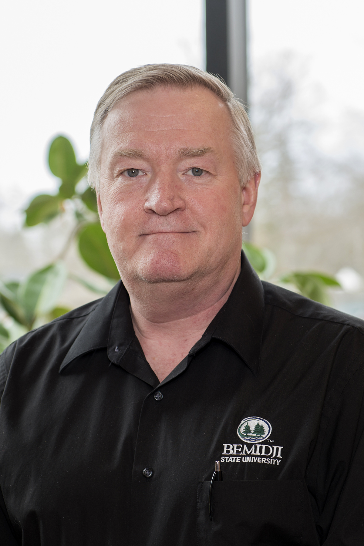
[[IMAGE REF 0003]] Image reference -- not directly editable; the original page reference is preserved automatically. Source: https://www.bemidjistate.edu/academics/criminal-justice-police-science-leadership/wp-content/uploads/sites/63/2022/05/Website-Photo-Herbert-M_.jpg
Emeritus Professor
Office: Bensen Hall 303
Phone: (218) 755-4049
Box #: 35
Email: michael.herbert@bemidjistate.edu

Trisha HansenIMAGEPLACEHOLDER0004
Instructor
Bensen Hall 306
Phone: (218) 755-3748
Box #: 35
Email: trisha.hansen@bemidjistate.edu

Dr. Michael Herbert
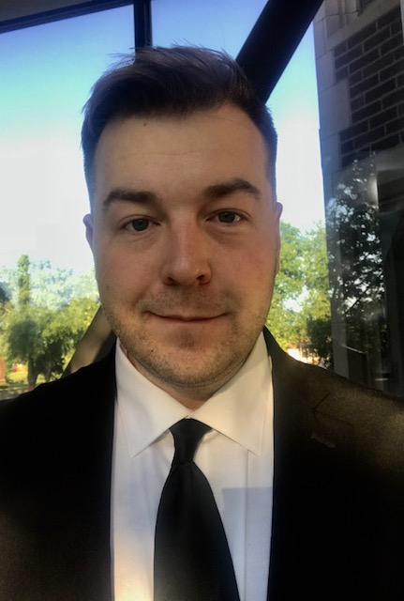
[[IMAGE REF 0005]] Image reference -- not directly editable; the original page reference is preserved automatically. Source: https://www.bemidjistate.edu/academics/criminal-justice-police-science-leadership/wp-content/uploads/sites/63/2022/05/Website-Photo-Herbert-M.-2.jpg
Adjunct
Email: michael.herbert.2@bemidjistate.edu

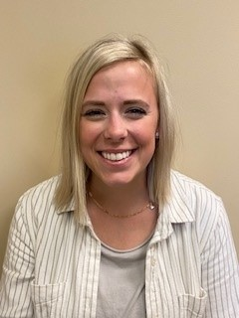
[[IMAGE REF 0006]] Image reference -- not directly editable; the original page reference is preserved automatically. Source: https://www.bemidjistate.edu/academics/criminal-justice/wp-content/uploads/sites/63/2022/05/Website-Photo-Hayft-K_.jpg
Criminal Justice Adjunct
Bensen Hall
Phone: (218) 755-3734
Box #: 35
Email: kaitlyn.hayft@bemidjistate.edu

