Title | Faculty & Staff
Meta Description
— Page content begins below. Please do not edit the table above. —

English Department Faculty
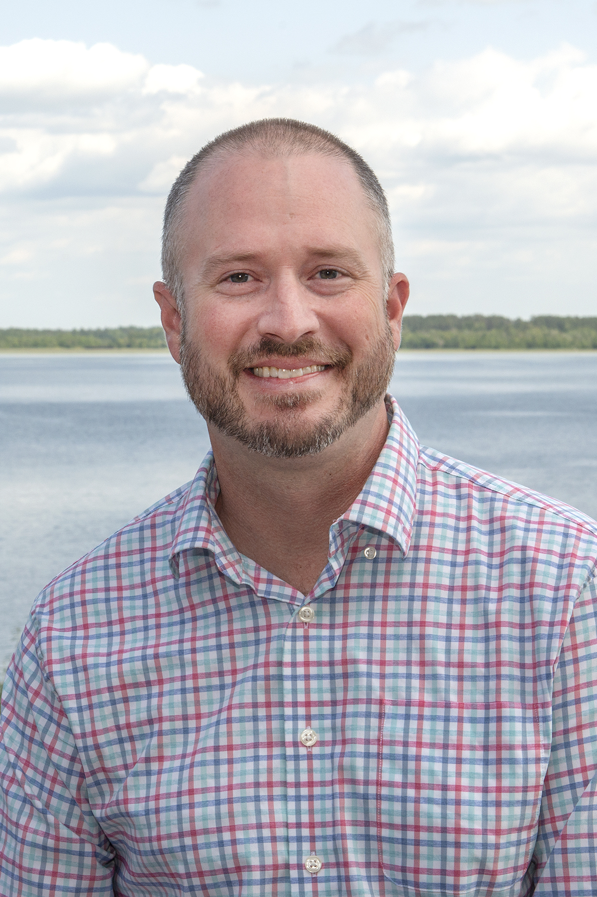
[[IMAGE REF 0000]] Image reference -- not directly editable; the original page reference is preserved automatically. Source: https://www.bemidjistate.edu/academics/english/wp-content/uploads/sites/81/2022/10/Gary-Rees-BSU-English-2023.jpg
Chair and Associate Professor
Bangsberg Hall 213
Phone: (218) 755-2359
Box #16
Email: gary.rees@bemidjistate.edu

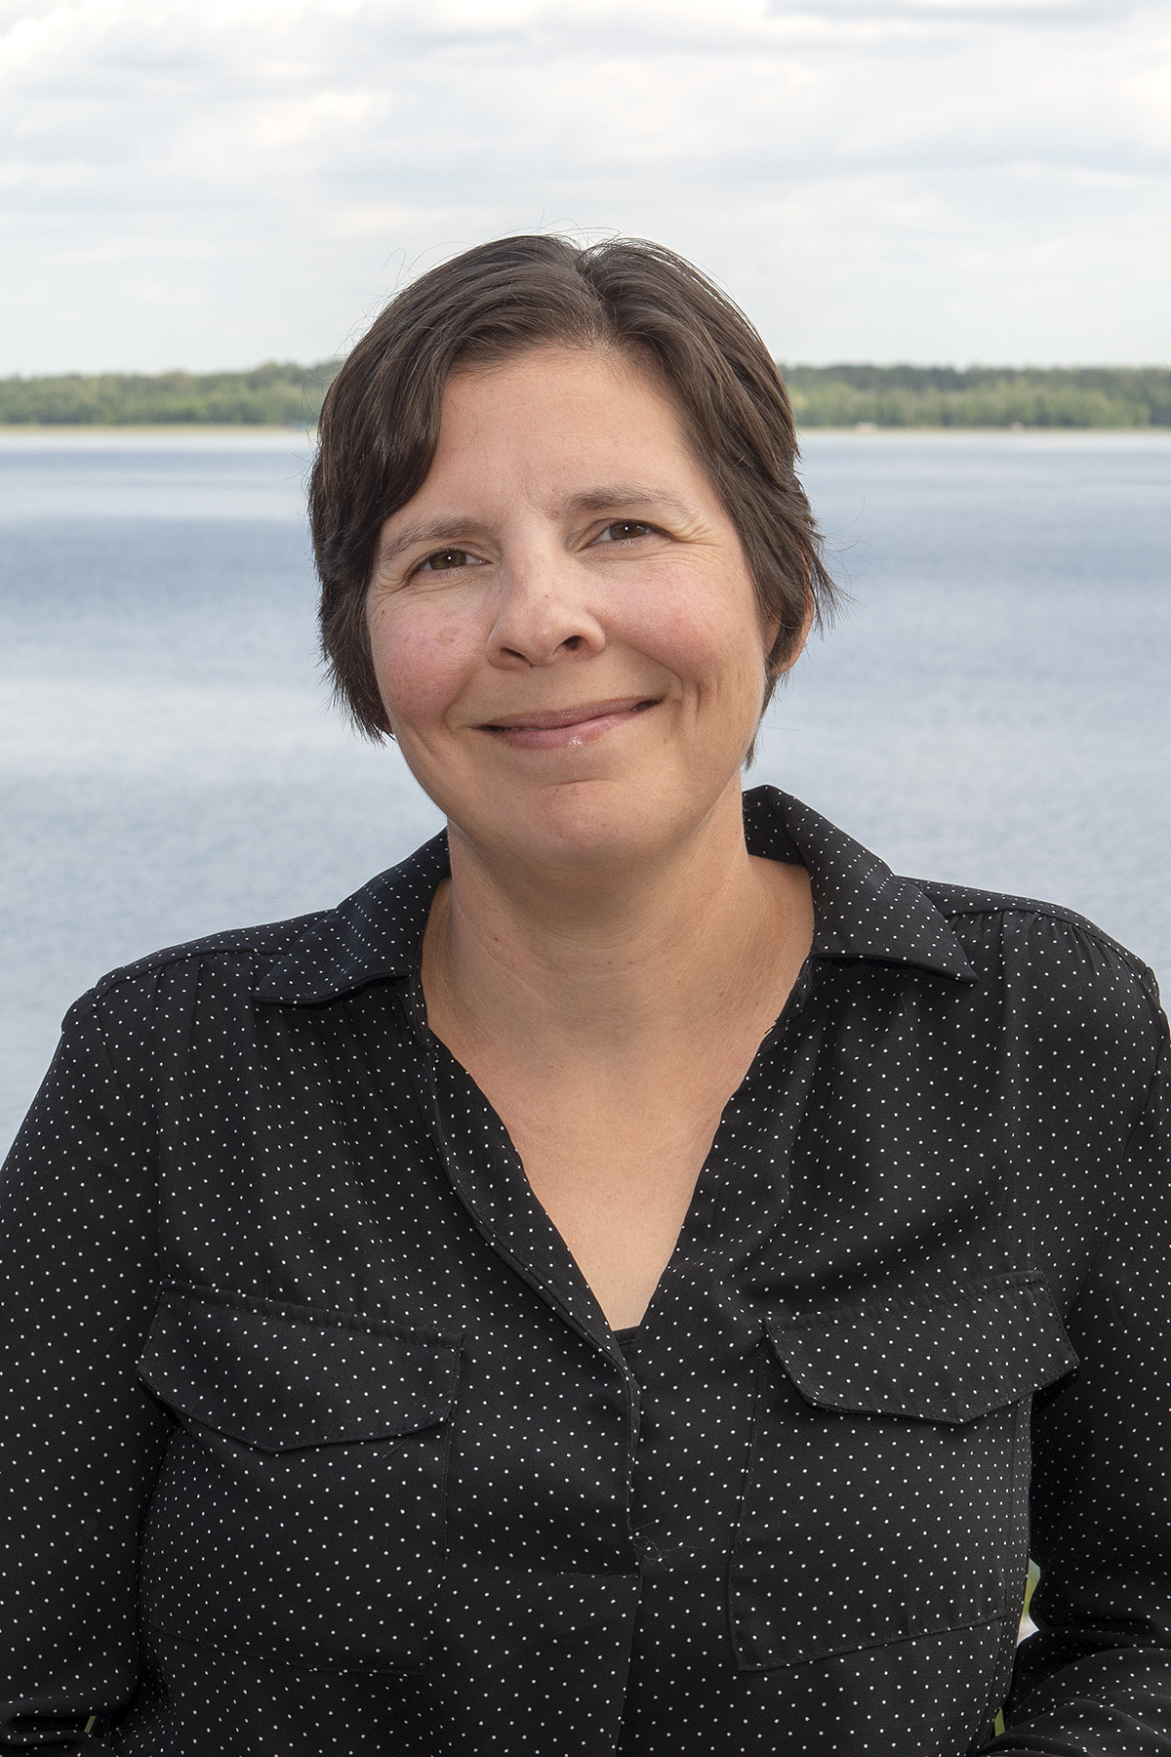
[[IMAGE REF 0001]] Image reference -- not directly editable; the original page reference is preserved automatically. Source: https://www.bemidjistate.edu/academics/english/wp-content/uploads/sites/81/2022/10/Jessica-Durgan-BSU-English-2023.jpg
Professor
Bangsberg Hall 204
Box #16
Phone: (218) 755-2812
Email: jessica.durgan@bemidjistate.edu

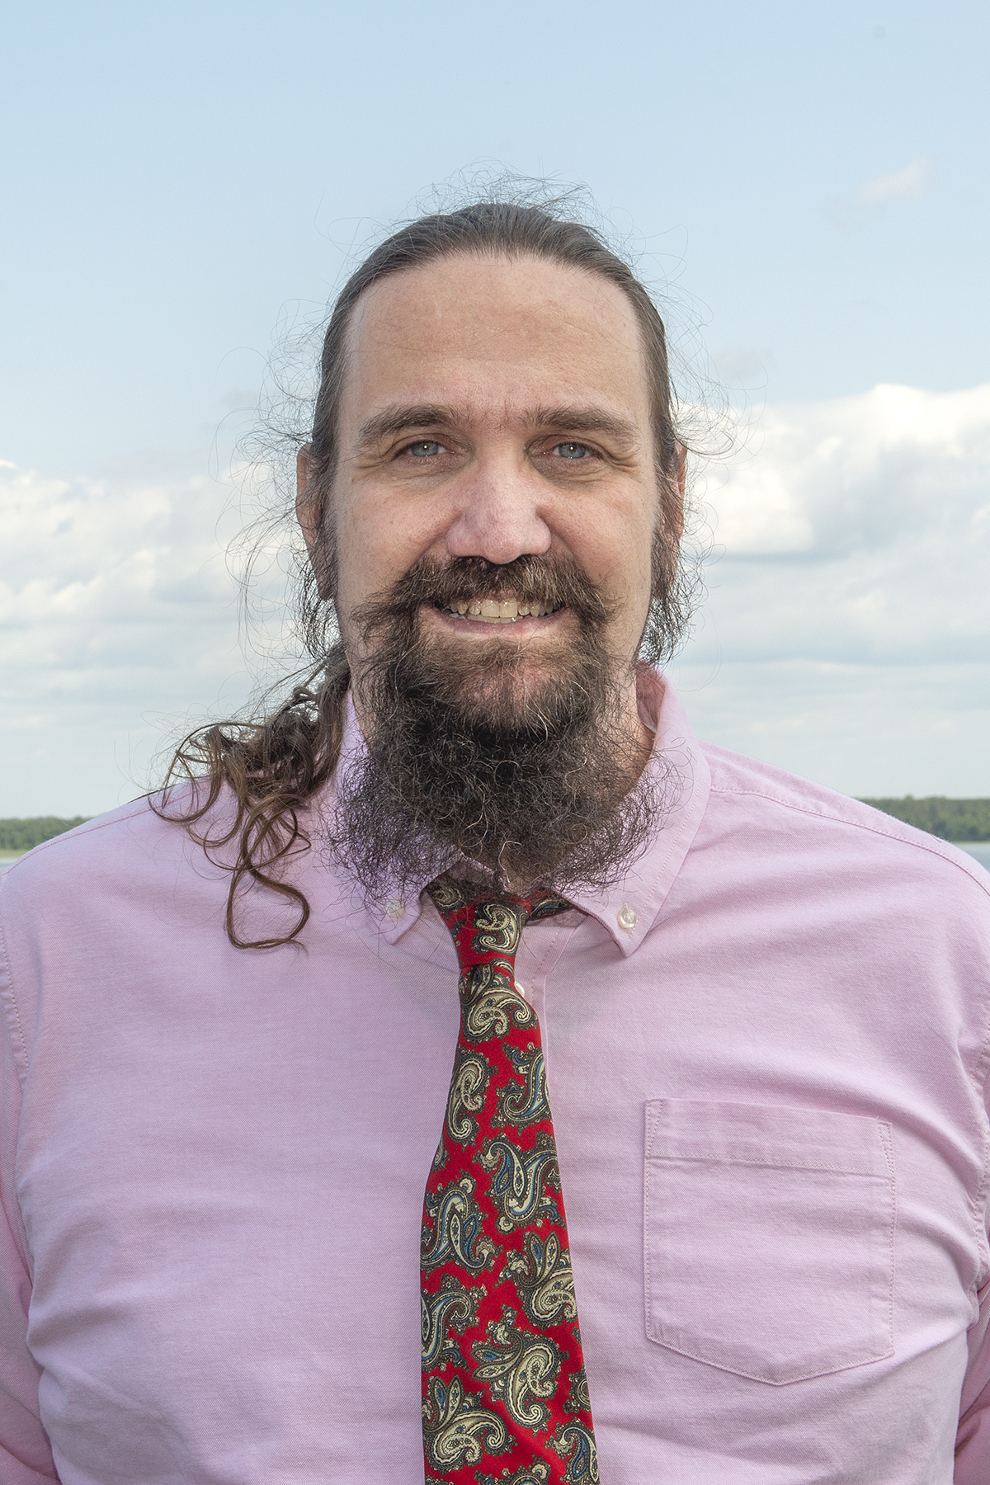
[[IMAGE REF 0002]] Image reference -- not directly editable; the original page reference is preserved automatically. Source: https://www.bemidjistate.edu/academics/english/wp-content/uploads/sites/81/2022/10/Stephen-Hamrick-BSU-English-2023.jpg
Professor
Email: stephen.hamrick@bemidjistate.edu

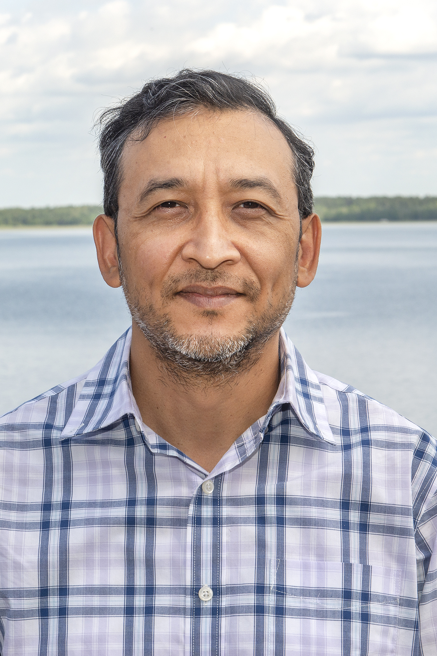
[[IMAGE REF 0003]] Image reference -- not directly editable; the original page reference is preserved automatically. Source: https://www.bemidjistate.edu/academics/english/wp-content/uploads/sites/81/2022/10/Prabin-Lama-BSU-English-2023.jpg
Associate Professor
Bangsberg Hall 206
Phone: (218) 755-2165
Box #: 16
Email: prabin.lama@bemidjistate.edu

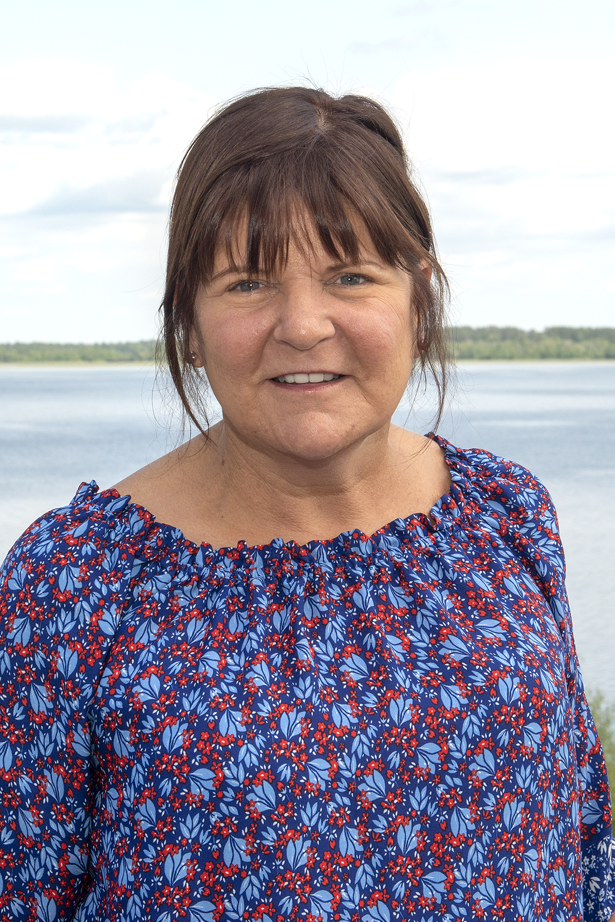
[[IMAGE REF 0004]] Image reference -- not directly editable; the original page reference is preserved automatically. Source: https://www.bemidjistate.edu/academics/english/wp-content/uploads/sites/81/2022/10/Danielle-Sullivan-BSU-English-2023.jpg
Associate Professor
Email: danielle.sullivan@bemidjistate.edu

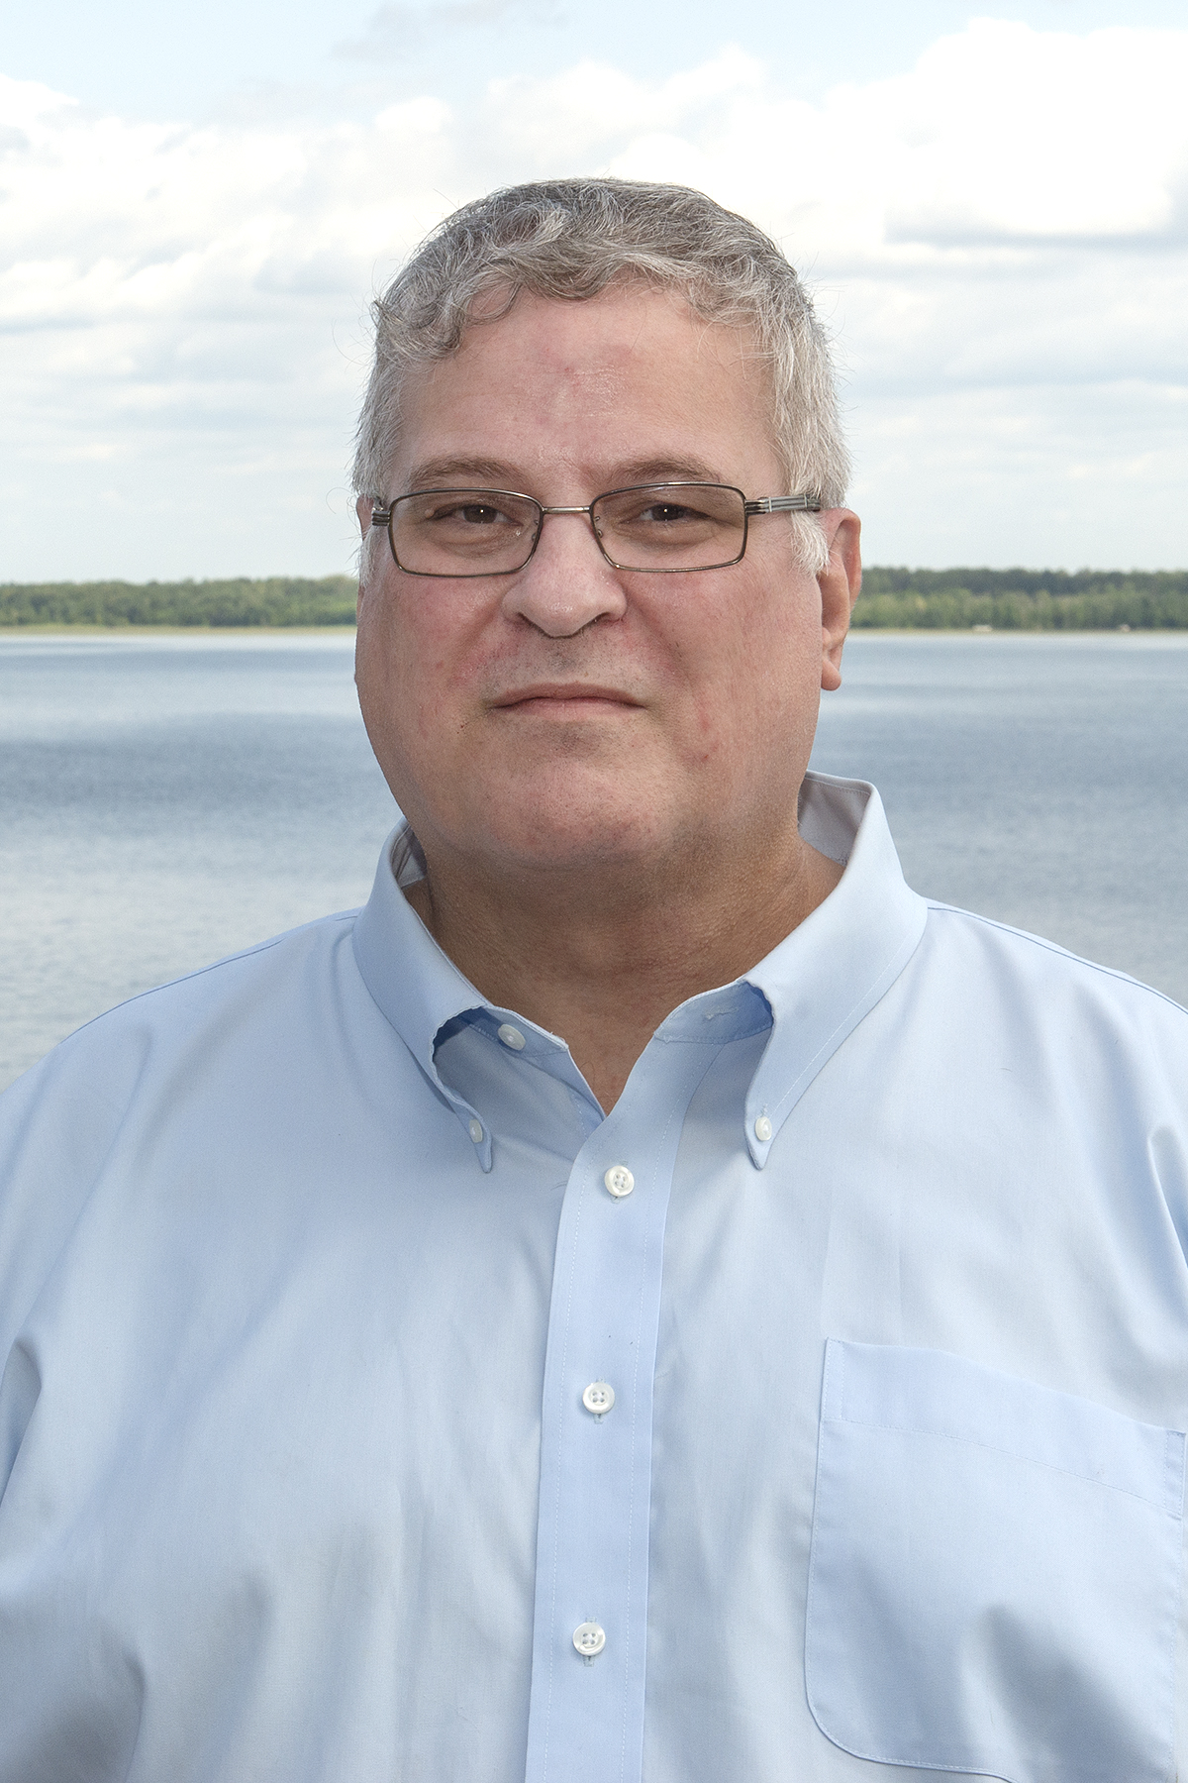
[[IMAGE REF 0005]] Image reference -- not directly editable; the original page reference is preserved automatically. Source: https://www.bemidjistate.edu/academics/english/wp-content/uploads/sites/81/2022/10/Larry-Swain-BSU-English-2023.jpg
Associate Professor
Bangsberg Hall 214
Phone: (218) 755-2484
Box #16
Email: larry.swain@bemidjistate.edu

Emeriti Faculty
Dr. Mark Christensen
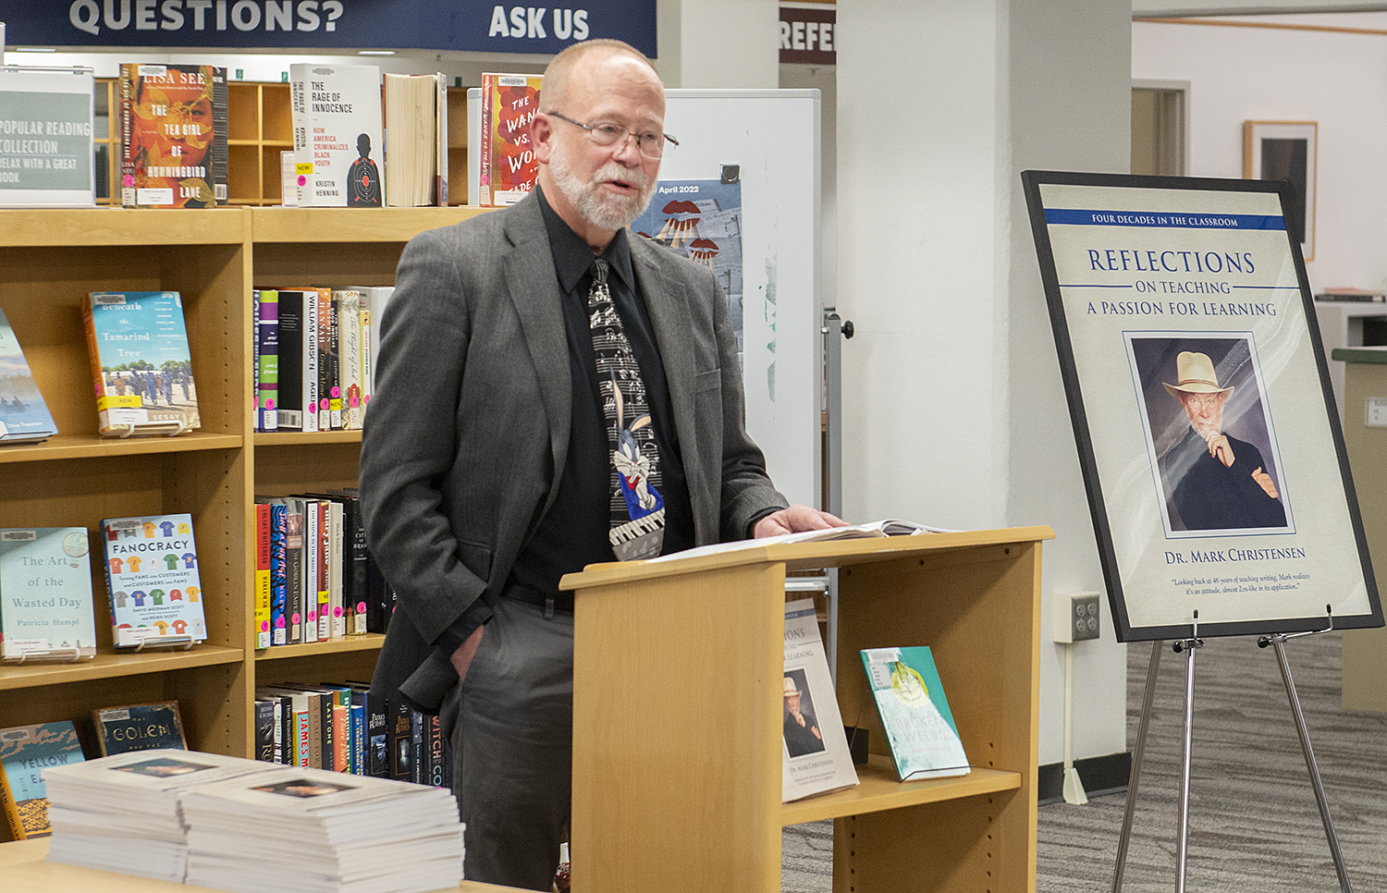
[[IMAGE REF 0006]] Image reference -- not directly editable; the original page reference is preserved automatically. Source: https://www.bemidjistate.edu/academics/english/wp-content/uploads/sites/81/2022/10/Mark-Christensen-2022.jpg
Emeritus Professor

