Title | Faculty & Staff
Meta Description
— Page content begins below. Please do not edit the table above. —

Faculty and Staff of the Department of Environmental Studies
Dr. Anna Carlson
Assistant Professor
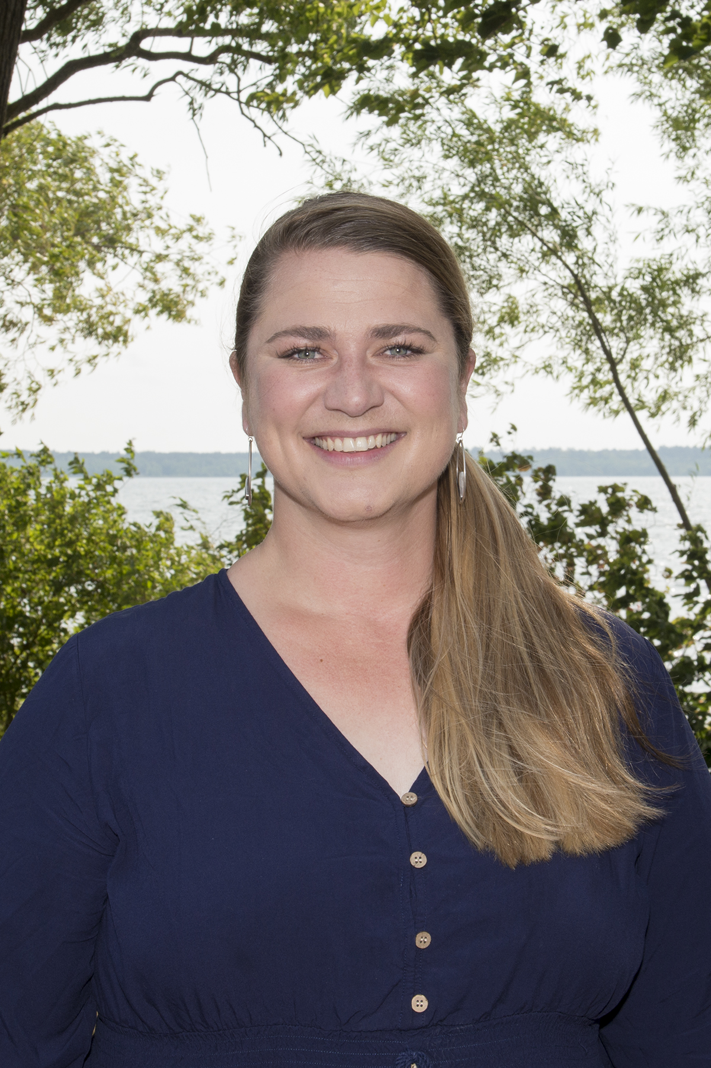
[[IMAGE REF 0000]] Image reference -- not directly editable; the original page reference is preserved automatically. Source: https://www.bemidjistate.edu/academics/css/environmental-studies/wp-content/uploads/sites/68/2022/03/22CSS__Anna_Carlson_ENVR.jpg
Specialty: Sustainability and Systems Analysis
Sattgast Hall 128
Phone: (218) 755-2801
Box #: 27
Email: anna.carlson@bemidjistate.edu

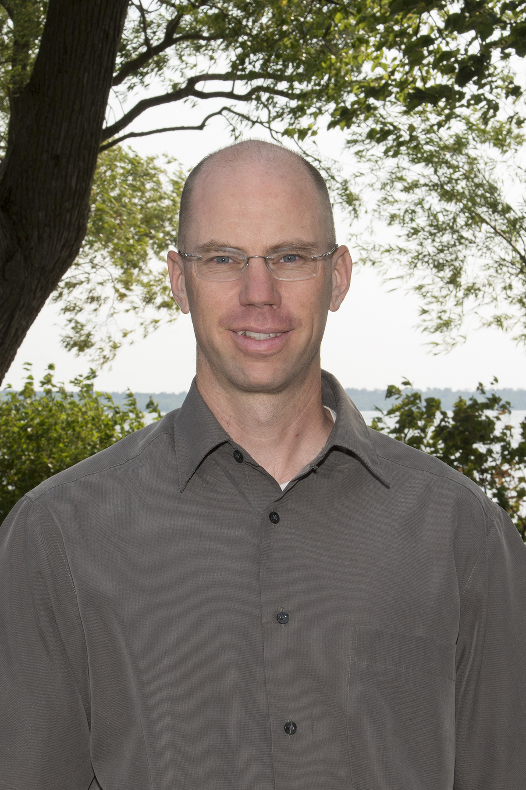
[[IMAGE REF 0001]] Image reference -- not directly editable; the original page reference is preserved automatically. Source: https://www.bemidjistate.edu/academics/css/environmental-studies/wp-content/uploads/sites/68/2022/03/22CSS__Carl-Isaacson2_ENVR.jpg
Chair-Associate Professor
Specialty: Water Quality
Sattgast Hall 109
Phone: (218) 755-4104
Box #: 27
Email: carl.isaacson@bemidjistate.edu

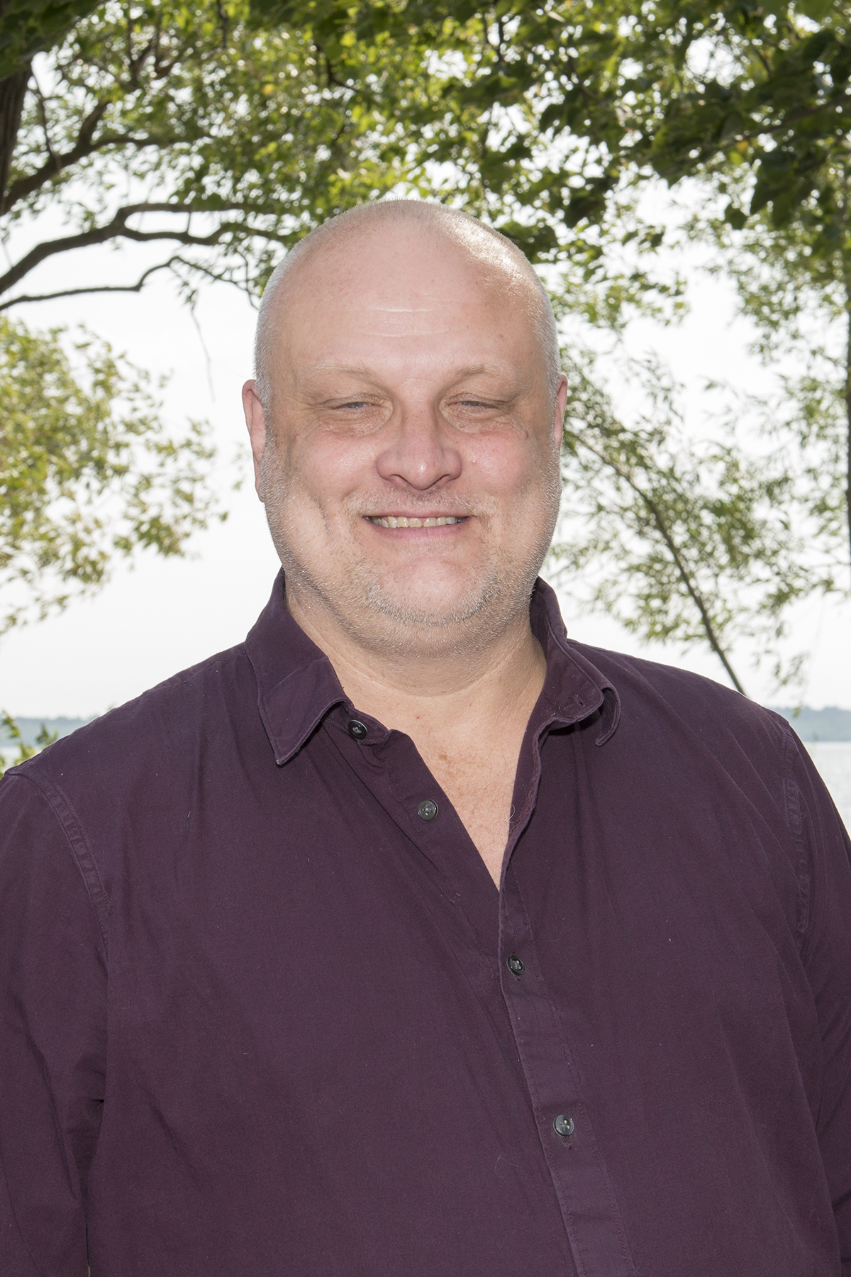
[[IMAGE REF 0002]] Image reference -- not directly editable; the original page reference is preserved automatically. Source: https://www.bemidjistate.edu/academics/css/environmental-studies/wp-content/uploads/sites/68/2022/03/22CSS__Paul_Kivi2_ECON.jpg
Assistant Professor
Specialty: Environmental Economics
Sattgast Hall 108
Phone: (218) 755-4106
Box #: 27
Email: paul.kivi@bemidjistate.edu

Dr. Miriam Rios-Sanchez
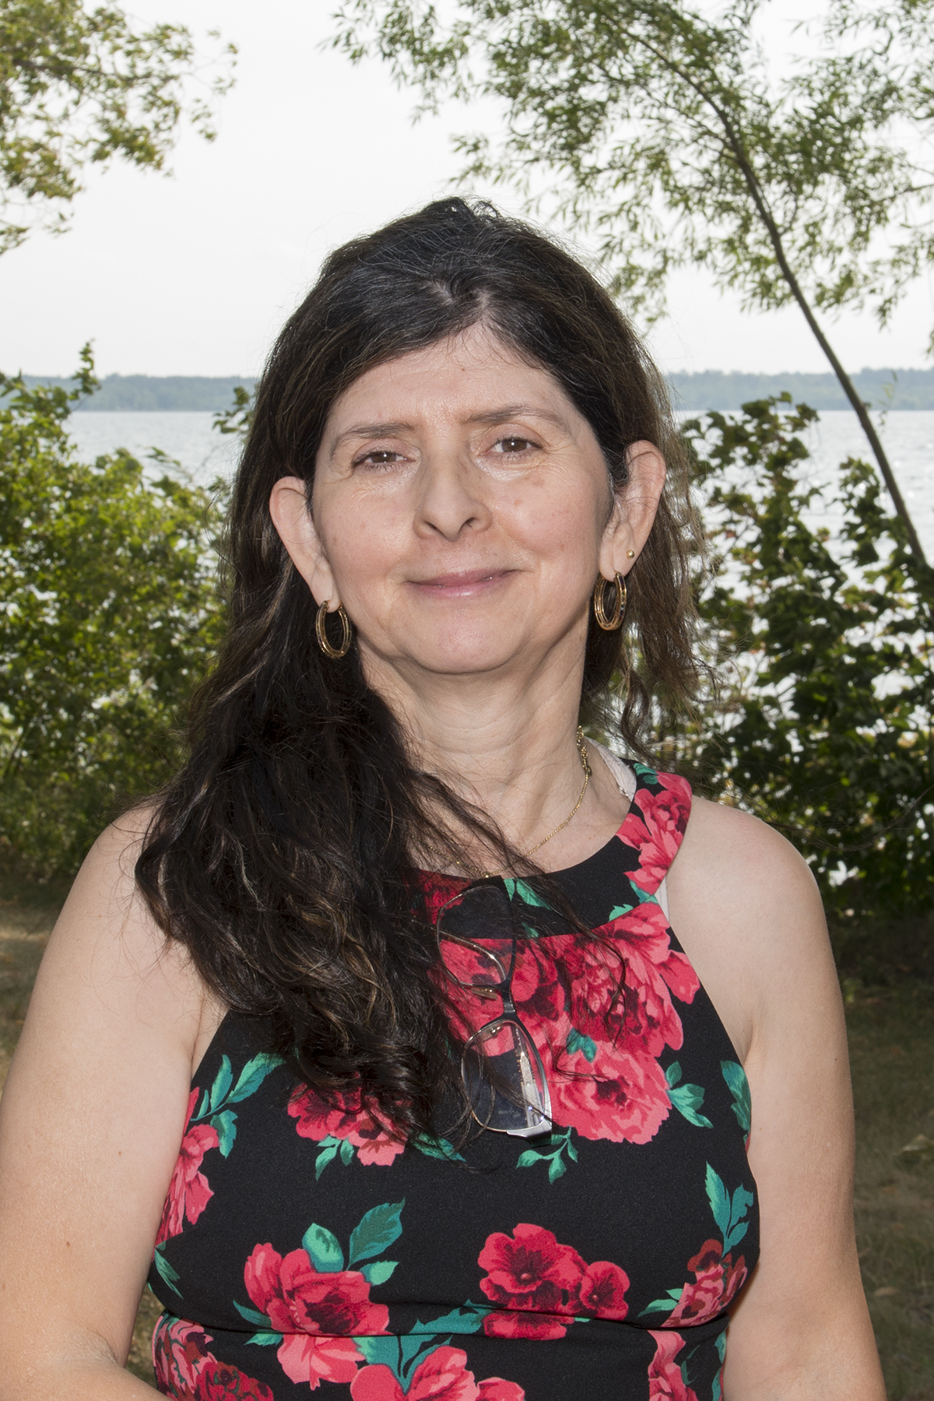
[[IMAGE REF 0003]] Image reference -- not directly editable; the original page reference is preserved automatically. Source: https://www.bemidjistate.edu/academics/css/environmental-studies/wp-content/uploads/sites/68/2022/03/22CSS__Miriam_Rios-Sanchez_Geology.jpg
Associate Professor
Specialty: Geology, Hydrology, & Remote Sensing
Sattgast Hall 106
Phone: (218) 755-2563
Box #: 27
Email: miriam.rios-sanchez@bemidjistate.edu

Dr. William Sea
Associate Professor
Specialty: Environmental Change & Global Ecology
Sattgast Hall 126
Phone: (218) 755-4103
Box #: 27
Email: william.sea@bemidjistate.edu

