Title | Faculty & Staff
Meta Description
— Page content begins below. Please do not edit the table above. —

Faculty
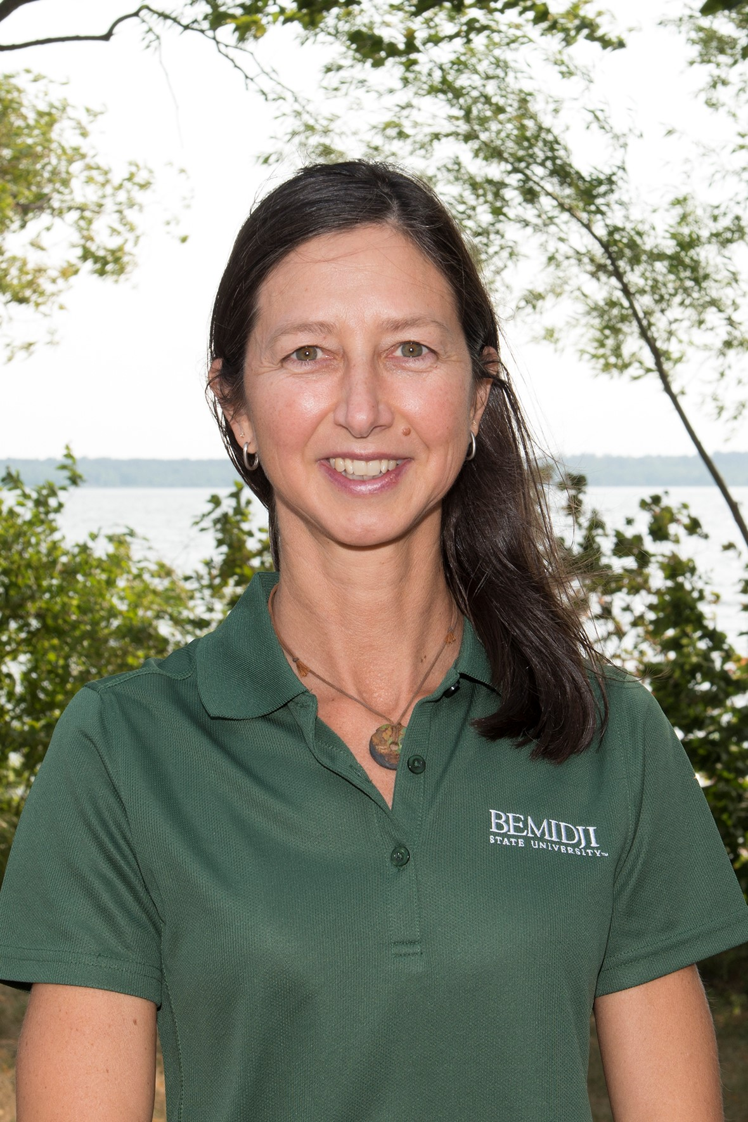
[[IMAGE REF 0000]] Image reference -- not directly editable; the original page reference is preserved automatically. Source: https://www.bemidjistate.edu/academics/geography/wp-content/uploads/sites/26/2022/02/22CSS__Sam_Jones_GEOG.jpg
Assistant Professor
Specialty: GIS applications and Dendroecology
Sattgast Hall 125
Phone: (218) 755-3946
Box #27
samantha.jones@bemidjistate.edu


[[IMAGE REF 0001]] Image reference -- not directly editable; the original page reference is preserved automatically. Source: https://www.bemidjistate.edu/academics/geography/wp-content/uploads/sites/26/2022/03/22CSS__Jerry_Smith_Geog.jpg
Assistant Professor of Geography
Specialty: Applications of GIS
Phone: (218) 755-2805
jerry.smith@bemidjistate.edu

Dr. Jeffrey Ueland
Professor
Specialty: GIS, Spatial Analysis & Machine Learning
Bridgeman Hall 311
Phone: (218) 755-2203
Box #27
jeffrey.ueland@bemidjistate.edu

