Title | Academic Programs
Meta Description
— Page content begins below. Please do not edit the table above. —
Geology is the scientific study of the Earth, its history and the processes that shape it. It encompasses the study of rocks, minerals, fossils, mountains, oceans, earthquakes and many other natural phenomena.
The study of geology has many practical applications, including the exploration and extraction of natural resources such as oil, gas and minerals, as well as the assessment of natural hazards such as earthquakes and landslides.
Geology also plays a crucial role in understanding the impacts of human activities on the Earth’s environment, including climate change, pollution and habitat destruction.

Why Minor in Geology at Bemidji State?
If you’re looking for an exciting and fulfilling career path that allows you to inspire and educate the next generation of earth scientists, look no further than Bemidji State’s geology minor program.
Not only will you learn from professors who are at the forefront of earth science research, but you’ll also gain the expertise needed to become an effective and inspiring high school Earth science teacher. And with a high demand for qualified teachers in this field, your career prospects will be bright and promising.
Plus, by pursuing a minor in geology at Bemidji State, you’ll be well on your way to earning a Master of Arts in Teaching degree in just one additional year. And with a higher salary as a teacher, the financial benefits are hard to ignore.
For more information about the course offerings, visit the course catalog.

Next-Level Exploration with Cutting-Edge Geology Facilities
Our faculty, staff and students work in several fundamental and applied areas important to earth, energy and environment that includes mineral and energy resources, soils, geological hazards and geochemistry, as well as surface and ground water resources.
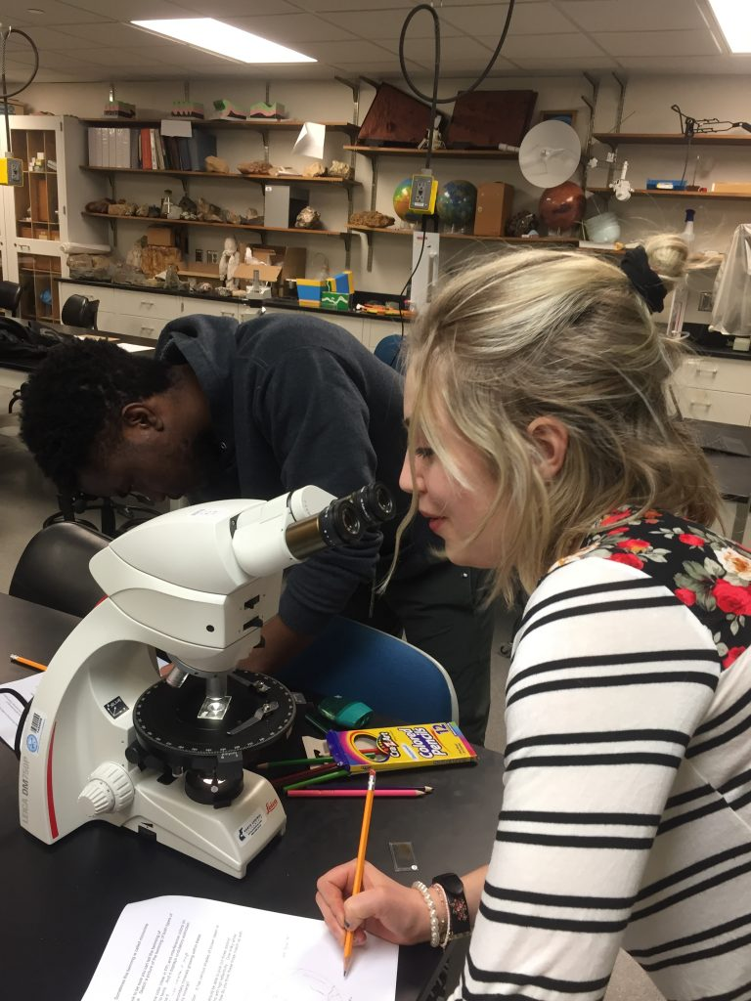
[[IMAGE REF 0000]] Image reference -- not directly editable; the original page reference is preserved automatically. Source: https://www.bemidjistate.edu/academics/css/geology/wp-content/uploads/sites/72/2023/03/IMG_0701-768x1024-1.jpg
The geology instrumentation laboratory at the Bemidji State University is a multi-instrument resource for the geology program. It specializes in surface and elemental analysis as well as petrographic microscopy.
All of this amazing equipment is housed in Sattgast Hall on the BSU campus, so you’ll have easy access to everything you need to take your geology studies to new heights.

Mineralogy & Petrology Equipment
- Polarizing microscopes
- Olympus transmitted and reflected light research microscopes
- Microscope camera systems
- Cathodoluminescence stage
- Selection of rock hand specimen
- Selection of thin sections
- Teaching fossil exhibition
- Research microscopes
Microscope set up for transmitted and reflected light petrographic and photographic work. Microscopes can be used with the available cameras. A dedicated stationery computer runs the image acquisition software.

Geophysical Lab Equipment
- GPS
- XRF
- Philips X-ray powder diffractometer with cobalt tube
- Sub-bottom and side-scan sonar
- Shallow 12-channel seismometer
- RF ground inductance
- Gravimeter
- Total field magnetometer

Hydrology Lab Equipment
- Conductivity meters
- pH meters
- Dissolved oxygen meters
- Related equipment for field water chemistry analyses
- Hydrogeology pumps
- Soft sediment coring equipment

Field Equipment
Our field equipment includes Brunton compasses, hammers, hand lenses, hand-held and base station GPS systems and ground resistivity. And for those deep field deployments, we’ve got you covered with safety equipment such as tents, ropes, harnesses and more.
[Image preview unavailable (UnrecognizedImageError) -- original reference preserved automatically below.]
[[IMAGE REF 0001]] Image reference -- not directly editable; the original page reference is preserved automatically. Source: https://www.bemidjistate.edu/academics/css/geology/wp-content/uploads/sites/72/2023/03/Sudan-Mine-2.jpg

Pioneering Research for Sustainability
With our department’s facilities, distinguished faculty and a strong sense of community, our program is ideally situated to support you through your minor in geology and your prospective professional career.
We take science education seriously and have exceptional teaching and laboratory facilities, as well as access to some of the best field sites in Bemidji, Minnesota and the world.

Geology with a Purpose
Geology is important to many areas important to humanity, from hazards to water and mineral resources to changing climate. We are training outstanding students to be stewards of our earth’s natural resources.

Geology Learning Outcomes
- Students will acquire a solid base of knowledge in the science of geology as a whole as well as earth materials, earth history, sedimentation and stratigraphy, deformational processes and structural features and hydrologic and geophysical processes, soils and landforms.
- Students will develop proficiency in conveying complex geologic concepts in clear, technically correct writing.
- Students will develop proficiency in oral communication of complex geologic concepts.
- Students will develop the aptitudes and dispositions necessary to help democratize society by obtaining and maintaining employment as a professional geologist.

Careers in Geology
With a geology minor, you can get certified to teach Earth sciences at the high school or middle school level. Imagine the thrill of sharing your love for science with the next generation of curious minds!
Add on the minor in geology to BSU’s FasTrack degree to gain greater training and skills to prepare you for your future career.
But teaching isn’t the only path available to you with a geology minor. You can also pursue science-related positions in a variety of other career fields:
- Business
- Communication
- Conservation
- Geospatial science
- Library services
- Meteorology
- Research

Support for Your Job Hunt
Bemidji State University Career Services can help you jump-start your career. They have a list of current openings, tips for preparing your résumé and on-campus interview opportunities.

Graduate Studies
And if you’re interested in furthering your education, our certification path also offers the opportunity to earn a Master of Arts in Teaching degree with just one additional year of study. This degree can even qualify you to teach dual-credit (college-level) classes in high school.
So whether you see yourself as a science teacher, a researcher or something else entirely, a geology minor from Bemidji State University is the perfect place to start.
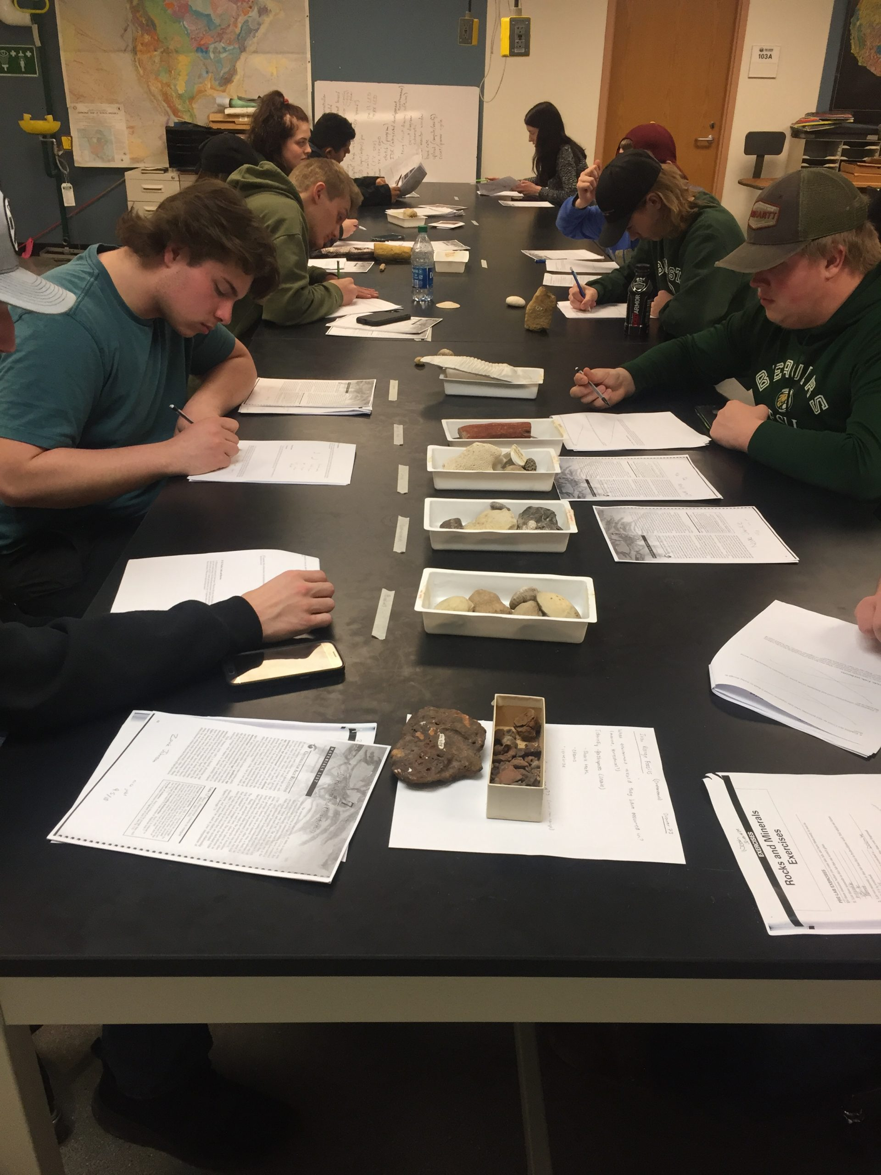
[[IMAGE REF 0002]] Image reference -- not directly editable; the original page reference is preserved automatically. Source: https://www.bemidjistate.edu/academics/css/geology/wp-content/uploads/sites/72/2023/03/IMG_0692-scaled.jpg

