Title | Faculty & Staff
Meta Description
— Page content begins below. Please do not edit the table above. —

Geology Faculty
Dr. Miriam Rios-Sanchez
Associate Professor of Geology
Office/Department: Environmental Studies
Location: Sattgast Hall 106
Phone: (218) 755-2563
Box #: 27
Email: miriam.rios-sanchez@bemidjistate.edu
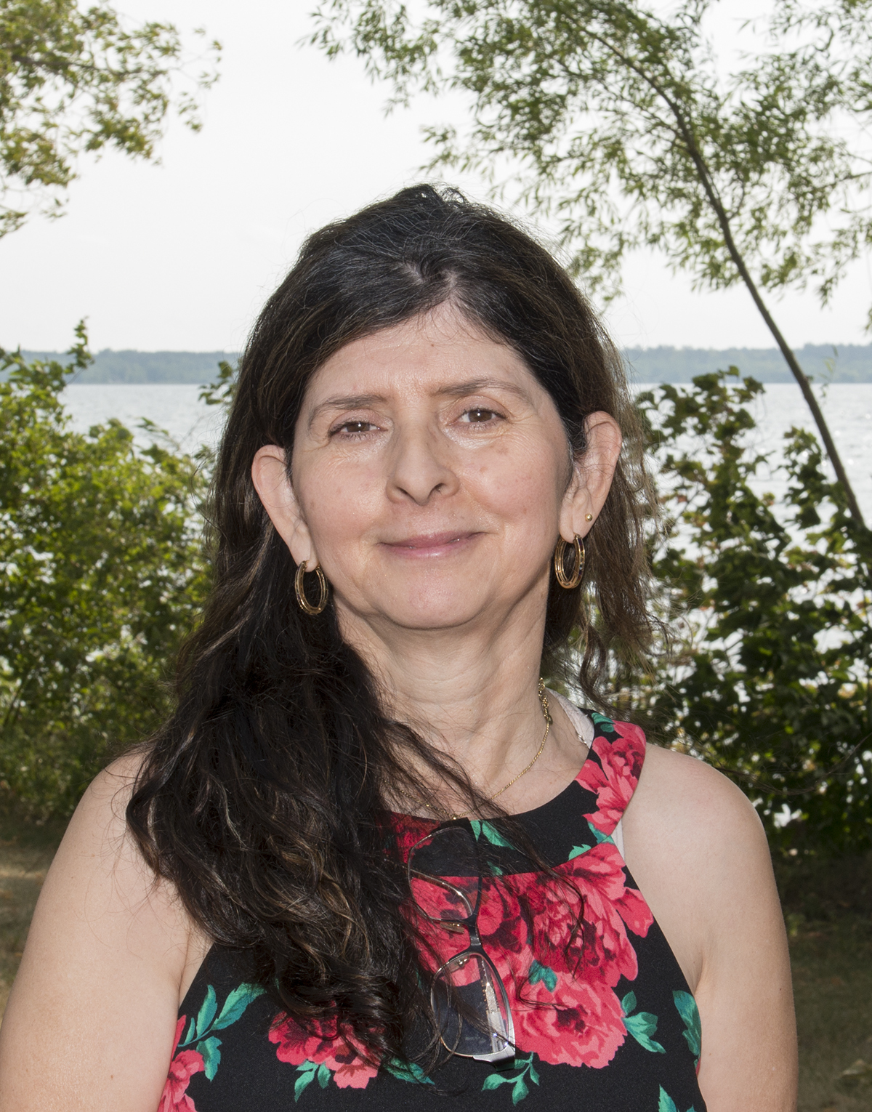
[[IMAGE REF 0000]] Image reference -- not directly editable; the original page reference is preserved automatically. Source: https://www.bemidjistate.edu/directory/wp-content/uploads/sites/16/2023/02/miriam-rios-sanchez.jpg

Dr. William Sea
Associate Professor
Office/Department: Environmental Studies
Location: Sattgast Hall 126
Phone: (218) 755-4103
Box #: 27
Email: william.sea@bemidjistate.edu

