Title | Faculty & Staff
Meta Description
— Page content begins below. Please do not edit the table above. —
The faculty of the Department of Human Performance, Sport & Health is committed to the intellectual, academic and social growth of all students who attend Bemidji State University.

Faculty
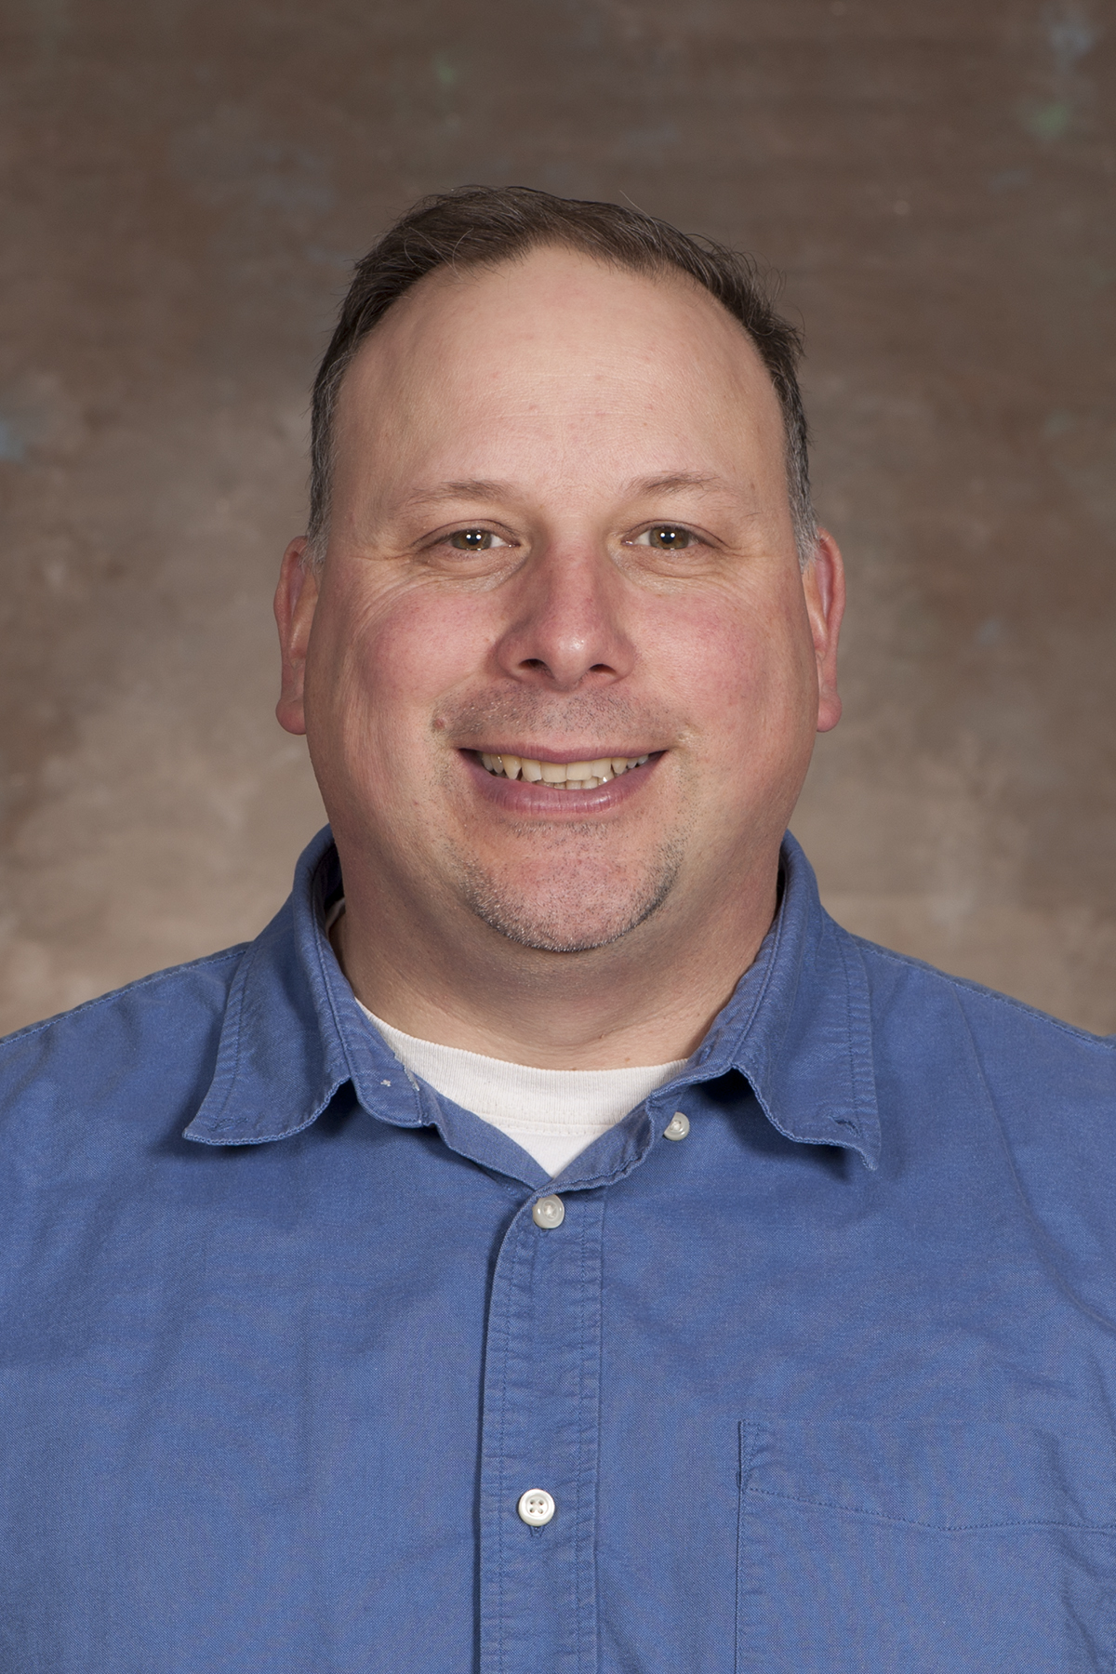
[[IMAGE REF 0000]] Image reference -- not directly editable; the original page reference is preserved automatically. Source: https://www.bemidjistate.edu/academics/human-performance-sport-health/wp-content/uploads/sites/30/2022/05/15BSU__HPSH_Jim_White.jpg
Professor-Chair
Location: Sattgast Hall 319
Phone: (218) 755-3868
Box #: 27
Email: jim.white@bemidjistate.edu

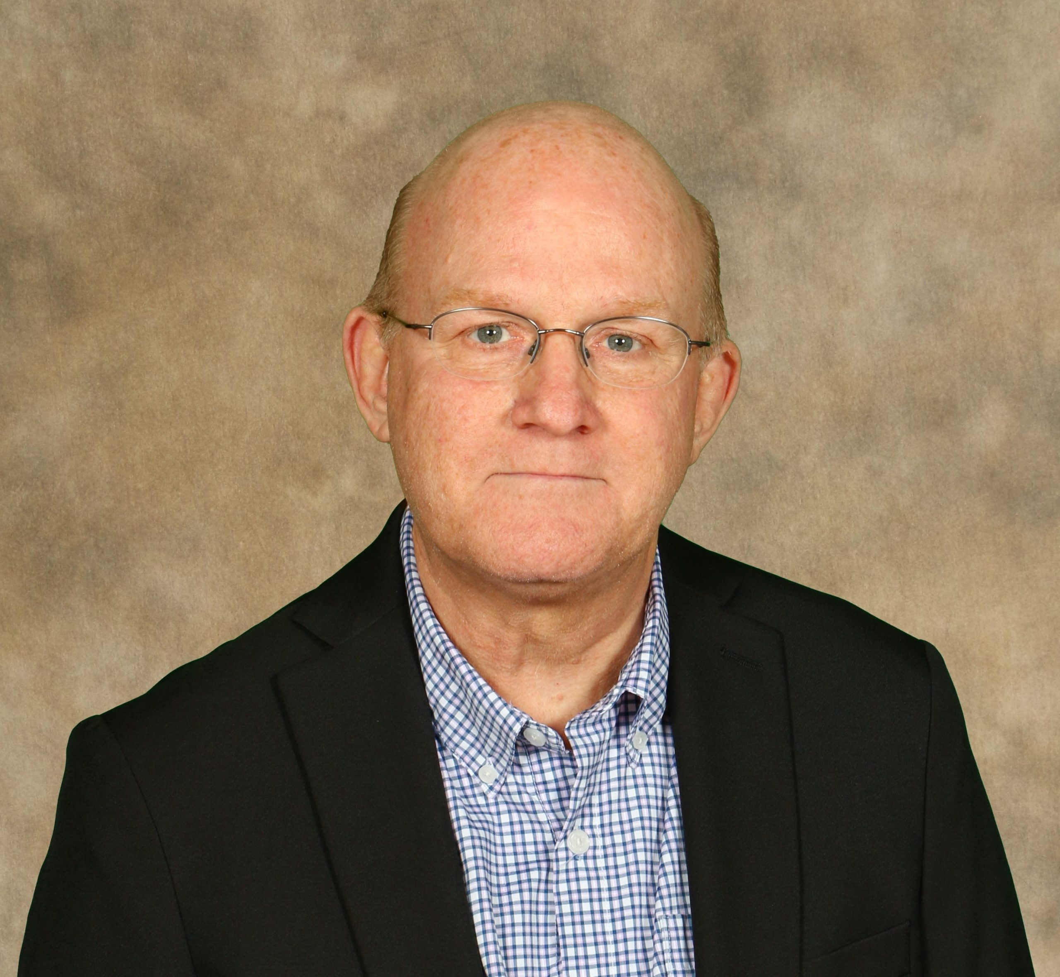
[[IMAGE REF 0001]] Image reference -- not directly editable; the original page reference is preserved automatically. Source: https://www.bemidjistate.edu/academics/human-performance-sport-health/wp-content/uploads/sites/30/2023/09/Eric-Forsyth-scaled.jpg
Professor
Location: Physical Education Complex 224
Phone: (218) 755-2083
Box #: 29
Email: eric.forsyth@bemidjistate.edu

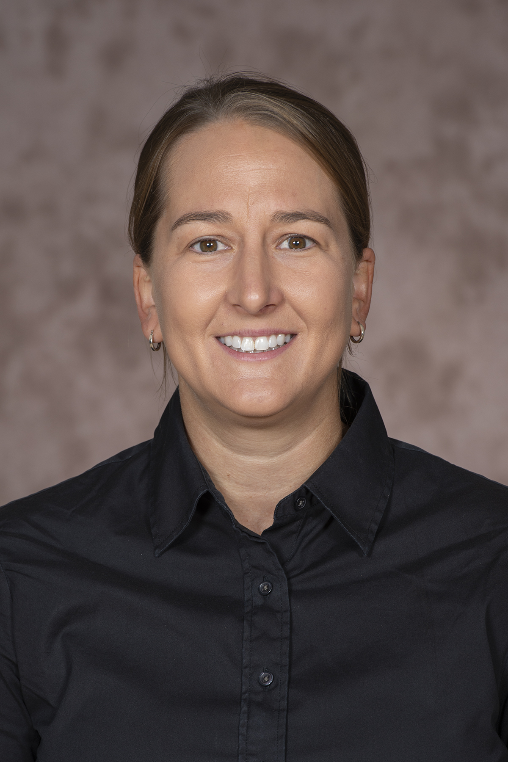
[[IMAGE REF 0002]] Image reference -- not directly editable; the original page reference is preserved automatically. Source: https://www.bemidjistate.edu/academics/human-performance-sport-health/wp-content/uploads/sites/30/2022/12/202021BSUHPSHAmberFryklund.jpg
Assistant Professor of Human Performance, Sport & Health
Location: Physical Education Complex 214
Phone: (218) 755-2771
Box #: 29
Email: amber.fryklund@bemidjistate.edu


[[IMAGE REF 0003]] Image reference -- not directly editable; the original page reference is preserved automatically. Source: https://www.bemidjistate.edu/academics/human-performance-sport-health/wp-content/uploads/sites/30/2022/05/Sherry.jpg
State University Faculty
Location: Physical Education Complex 208
Phone: (218) 755-2223
Box #: 29
Email: sherry.holloway@bemidjistate.edu

Dr. Christel Kippenhan
Professor
Location: Physical Education Complex 219
Phone: (218) 755-2076
Box #: 29
Email: christel.kippenhan@bemidjistate.edu
Website

Dr. Shannon Norman
Associate Professor
Location: Physical Education Complex 204
Phone: (218) 755-4099
Box #: 29
Email: shannon.norman@bemidjistate.edu

[[IMAGE REF 0004]] Image reference -- not directly editable; the original page reference is preserved automatically. Source: https://www.bemidjistate.edu/academics/human-performance-sport-health/wp-content/uploads/sites/30/2022/05/15BSU__HPSH_Shannon_Norman.jpg

Jacob Erickson
Assistant ProfessorLocation: Physical Education Complex
Phone: (218) 755-2043
Box #: 29
Email: jacob.erickson@bemidjistate.edu

Adjunct Faculty
Mr. Benjamin Baird
Assistant Track & Field Coach
Location: Physical Education Complex 242
Phone: (218) 755-2941
Box #: 29
Email: benjamin.baird@bemidjistate.edu

Suzy Langhout
Adjunct Faculty
Location: Physical Education Complex 215
Phone: (218) 755-2964
Box #: 29
Email: suzy.langhout@bemidjistate.edu

Daniel Carlson
Physical Ed Adjunct
Office: Physical Education Complex
Email: daniel.carlson@bemidjistate.edu

