Title | Faculty & Staff
Meta Description
— Page content begins below. Please do not edit the table above. —

Faculty and Staff of the Department of Integrated Media
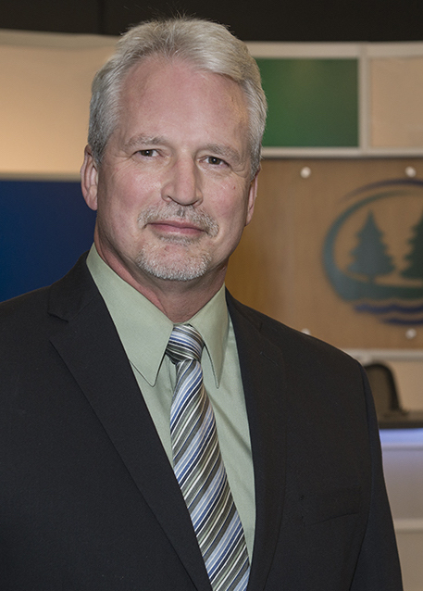
[[IMAGE REF 0000]] Image reference -- not directly editable; the original page reference is preserved automatically. Source: https://www.bemidjistate.edu/academics/integrated-media/wp-content/uploads/sites/34/2022/02/Virgil_Bakken.jpeg
Professor & Chair
Deputy Hall 244
Phone: (218) 755-3370
Box #: 40
Email: virgil.bakken@bemidjistate.edu

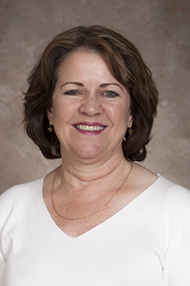
[[IMAGE REF 0001]] Image reference -- not directly editable; the original page reference is preserved automatically. Source: https://www.bemidjistate.edu/academics/integrated-media/wp-content/uploads/sites/34/2022/02/BSU_14CBTC_0107-Valica-Boudry.jpg
Professor
Deputy Hall 246
Phone: (218) 755-3904
Box #: 40
Email: valica.boudry@bemidjistate.edu


[[IMAGE REF 0002]] Image reference -- not directly editable; the original page reference is preserved automatically. Source: https://www.bemidjistate.edu/academics/integrated-media/wp-content/uploads/sites/34/2022/04/thumbnail_20BSU_AVTechShawn_Campbell.jpg
Audio Visual Tech
Deputy Hall 268
Phone: (218) 755-4127
Box #: 40
Email: shawn.campbell@bemidjistate.edu

