Title | Academic Programs
Meta Description
— Page content begins below. Please do not edit the table above. —

Languages and Indigenous Studies Programs
The Department of Languages and Indigenous Studies offers:
- majors in Indigenous Studies, Indigenous Sustainability Studies and Spanish
- minors in Indigenous Studies, Indigenous Sustainability Studies, Ojibwe and Spanish
- certificates in Indigenous Studies and Ojibwe Language Instruction
- courses in German language and culture

German
German language courses at Bemidji State University.

[[IMAGE REF 0000]] Image reference -- not directly editable; the original page reference is preserved automatically. Source: https://www.bemidjistate.edu/academics/languages-indigenous-studies/wp-content/uploads/sites/100/2023/04/cologne-g0b503da0d_1920.jpg
Unlock your potential to communicate with over 95 million German speakers worldwide by enrolling in our dynamic

Indigenous Studies
Indigenous studies courses.
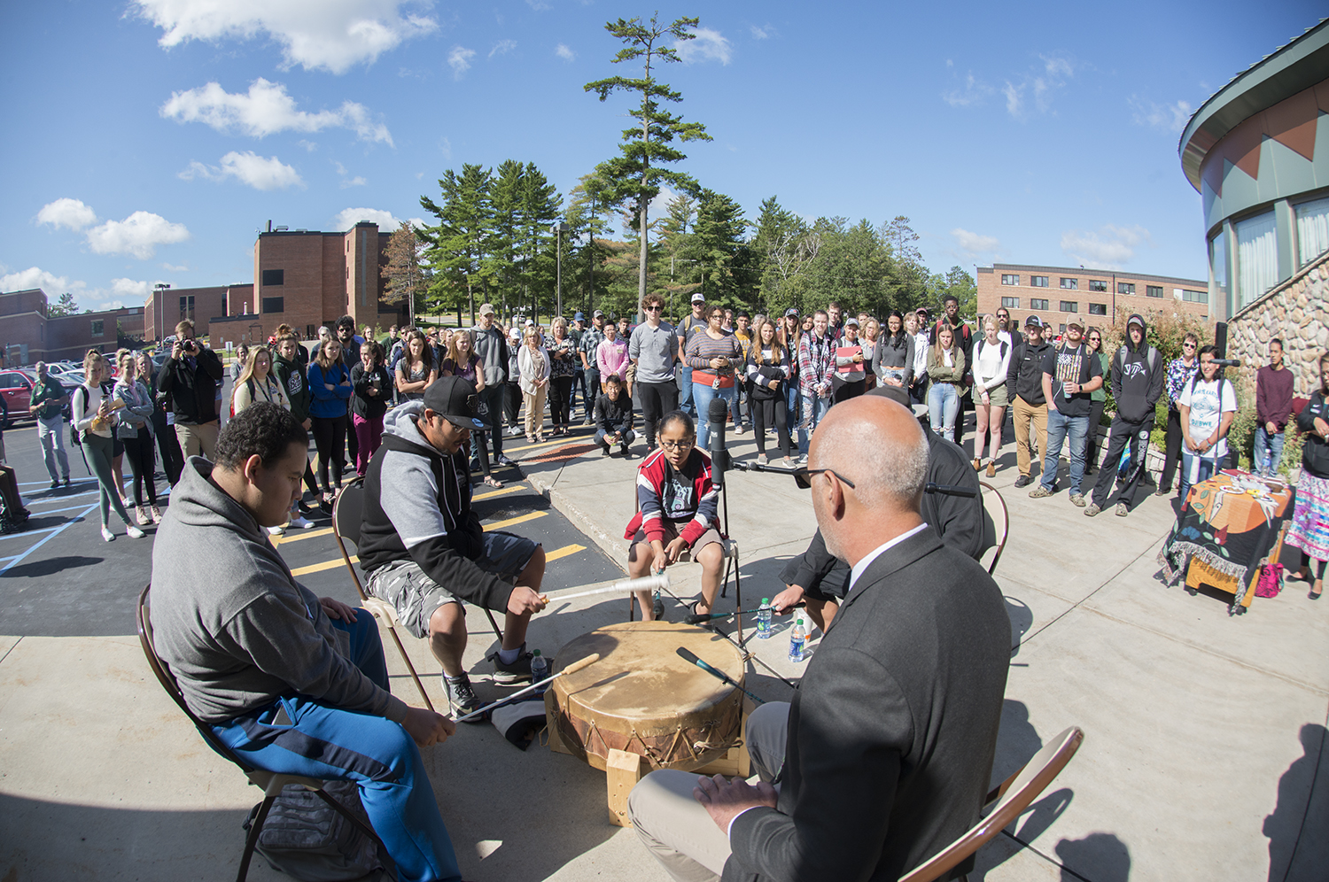
[[IMAGE REF 0001]] Image reference -- not directly editable; the original page reference is preserved automatically. Source: https://www.bemidjistate.edu/academics/languages-indigenous-studies/wp-content/uploads/sites/100/2023/03/AIRC_F19DayOfWelcome_0014.jpg
Discover the rich history and diverse cultures of Indigenous peoples through our thought-provoking

Ojibwe
Ojibwe language and culture courses at Bemidji State University.
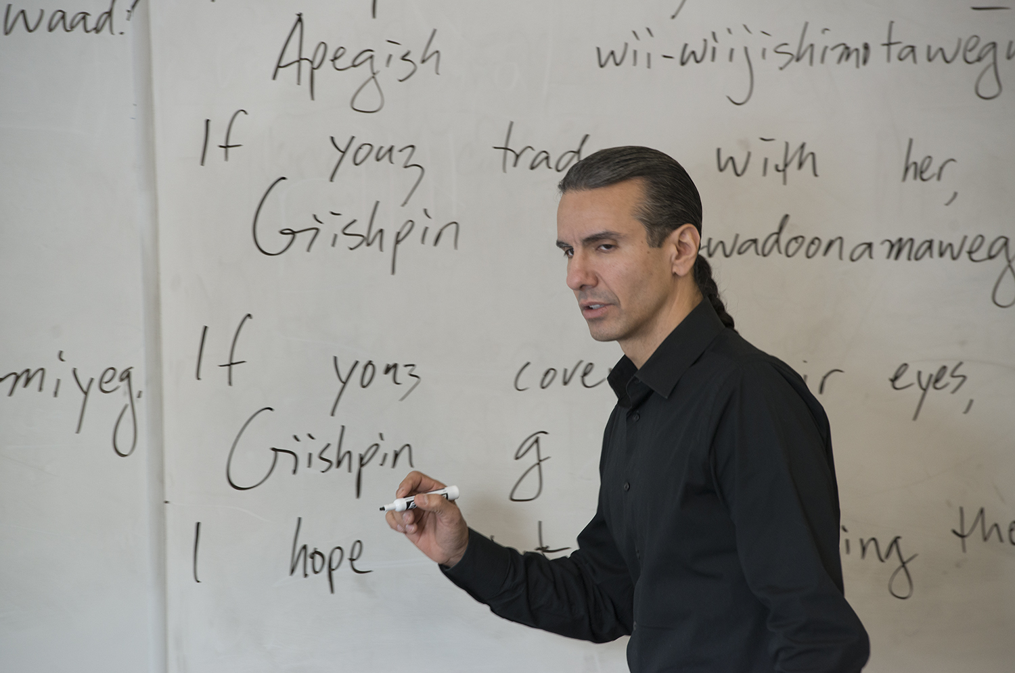
[[IMAGE REF 0002]] Image reference -- not directly editable; the original page reference is preserved automatically. Source: https://www.bemidjistate.edu/academics/languages-indigenous-studies/wp-content/uploads/sites/100/2022/03/Adv_Ojibwe_Treuer_0045.jpg
Immerse yourself in the language and traditions of the Ojibwe people, a vital part of our local community, with our engaging

Spanish
Spanish language through our immersive and engaging program.
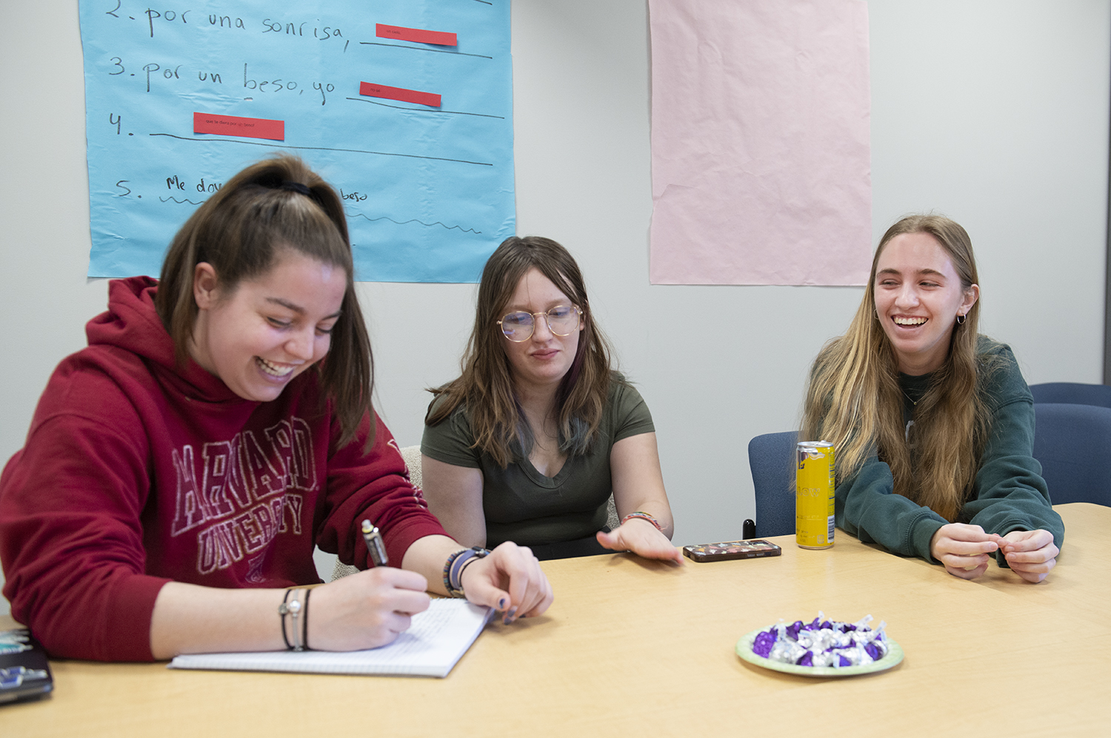
[[IMAGE REF 0003]] Image reference -- not directly editable; the original page reference is preserved automatically. Source: https://www.bemidjistate.edu/academics/languages-indigenous-studies/wp-content/uploads/sites/100/2023/03/Spanish2212_0010.jpg
Open doors to new opportunities and connect with millions of Spanish speakers worldwide by mastering the

For more information on the courses in this department, visit the course catalog.

Contact Information
Languages & Indigenous Studies
AIRC 112
1500 Birchmont Dr NE #21
Bemidji, MN 56601-2699
Office: (218) 755-3968

