Title | Faculty & Staff
Meta Description
— Page content begins below. Please do not edit the table above. —

Languages and Indigenous Studies Faculty and Staff
Dr. Anton Treuer
Professor of Indigenous Studies
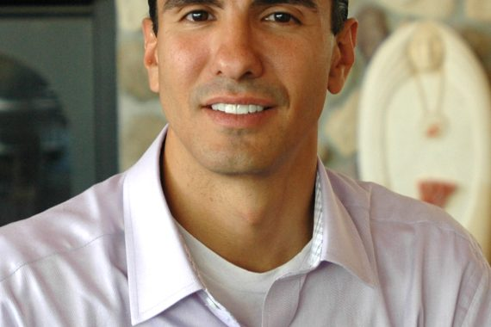
[[IMAGE REF 0000]] Image reference -- not directly editable; the original page reference is preserved automatically. Source: https://www.bemidjistate.edu/academics/languages-indigenous-studies/wp-content/uploads/sites/100/2022/11/BSU_Tony_Treuer_LanguagesIndigenousStudies-570x380.jpg
Office: American Indian Resource Center 112
Phone: (218) 755-3968
Box #21
Email: anton.treuer@bemidjistate.edu

Dr. Shaawano Uran
Associate Professor of Indigenous Studies

[[IMAGE REF 0001]] Image reference -- not directly editable; the original page reference is preserved automatically. Source: https://www.bemidjistate.edu/academics/languages-indigenous-studies/wp-content/uploads/sites/100/2022/11/23BSU_Shaawano_Uran_LanguagesIndigenousStudies-150x150.jpg
Office: American Indian Resource Center 111
Phone: (218) 755-2590
Box # 21
Email: shaawano.uran@bemidjistate.edu

Lisa Christensen Graefe

[[IMAGE REF 0002]] Image reference -- not directly editable; the original page reference is preserved automatically. Source: https://www.bemidjistate.edu/academics/languages-indigenous-studies/wp-content/uploads/sites/100/2022/11/23BSU_Lisa_Christensen_Graefe_LanguagesIndigenousStudies-150x150.jpg
Instructor of German
Office: Benson Hall 311
Phone: (218) 755-2278
Box #35
Email: lisa.graefe@bemidjistate.edu

Tammy Erickson
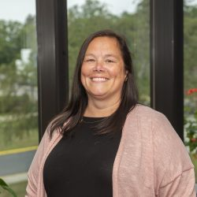
[[IMAGE REF 0003]] Image reference -- not directly editable; the original page reference is preserved automatically. Source: https://www.bemidjistate.edu/academics/languages-indigenous-studies/wp-content/uploads/sites/100/2023/01/23PROFED_Tammy_Erickson-250x250.jpg
Administrative Specialist
Office: Benson Hall 326
Phone: (218) 755-2934
Box #35
Email: tammy.erickson@bemidjistate.edu

