Title | Faculty & Staff
Meta Description
— Page content begins below. Please do not edit the table above. —

Department Chair
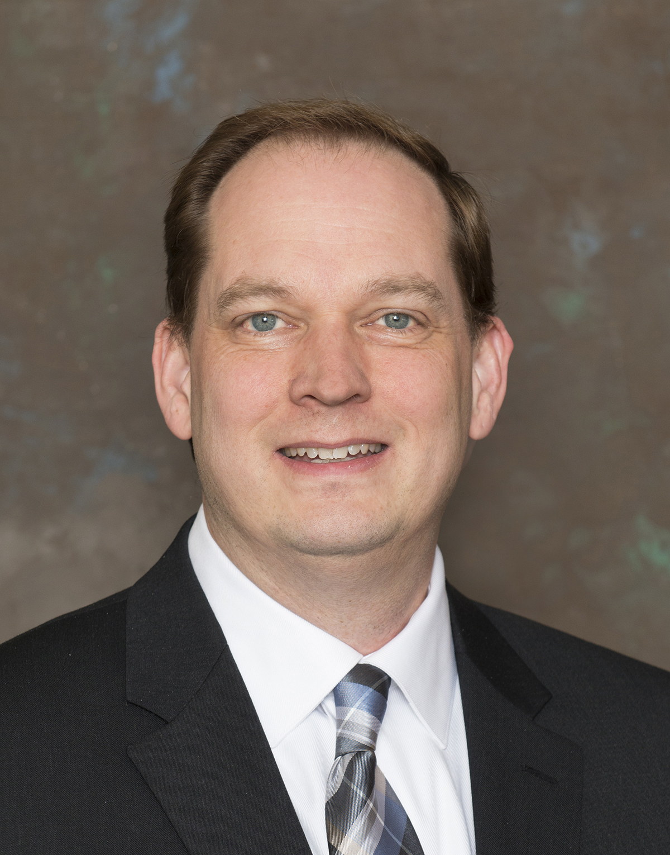
[[IMAGE REF 0000]] Image reference -- not directly editable; the original page reference is preserved automatically. Source: https://www.bemidjistate.edu/academics/mathematics-computer-science/wp-content/uploads/sites/36/2026/04/bob-quandt.jpg
ProfessorSattgast Hall 377D
(218) 755-2792
bob.quandt@bemidjistate.edu

Math Faculty
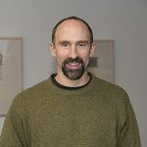
[[IMAGE REF 0001]] Image reference -- not directly editable; the original page reference is preserved automatically. Source: https://www.bemidjistate.edu/academics/mathematics-computer-science/wp-content/uploads/sites/36/2022/03/Todd-Frauenholtz-150x150.jpg
ProfessorSattgast Hall 207G
(218) 755-2817
todd.frauenholtz@bemidjistate.edu
Dr. Frauenholtz’s Homepage

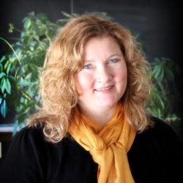
[[IMAGE REF 0002]] Image reference -- not directly editable; the original page reference is preserved automatically. Source: https://www.bemidjistate.edu/academics/mathematics-computer-science/wp-content/uploads/sites/36/2022/03/Heidi-Hansen-picture-scaled-e1777042771108-250x250.jpg
ProfessorSattgast Hall 207J
(218) 755-2820
heidi.hansen@bemidjistate.edu

Dr. Jenna O’Dell
Associate ProfessorSattgast Hall 207E
(218) 755-3943
Box #: 27
jenna.odell@bemidjistate.edu

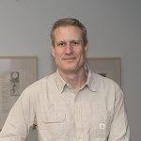
[[IMAGE REF 0003]] Image reference -- not directly editable; the original page reference is preserved automatically. Source: https://www.bemidjistate.edu/academics/mathematics-computer-science/wp-content/uploads/sites/36/2022/03/Derek-Webb-150x150.jpg
ProfessorSattgast Hall 207A
(218) 755-2846
derek.webb@bemidjistate.edu
Dr.Webb’s Homepage

Computer Science Faculty
Dr. Francois Neville
Assistant ProfessorSattgast Hall 207 C
(218) 755-2840
Box #: 27
francois.neville@bemidjistate.edu

Physics Faculty
Dr. Ryan Sayer
Associate ProfessorSattgast Hall, Room 311A
(218) 755-2781
ryan.sayer@bemidjistate.edu

