Title | Faculty & Staff
Meta Description
— Page content begins below. Please do not edit the table above. —
The faculty of the School of Music are committed to the intellectual, musical and social growth of all student musicians who attend Bemidji State University.

Faculty
Stephen Carlson, D.M.A.
Professor & Chair of the School of Music
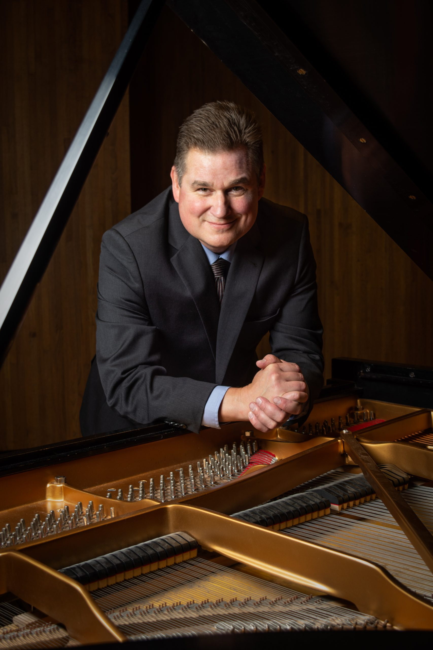
[[IMAGE REF 0001]] Image reference -- not directly editable; the original page reference is preserved automatically. Source: https://www.bemidjistate.edu/academics/music/wp-content/uploads/sites/58/2021/11/Stephen-Carlson-headshot-21-scaled-1.jpeg
Specialty: Piano, Piano Pedagogy, Piano Literature, Music History
Performances:
- Thirty-two Variation on an Original Theme, WoO 80-Beethoven
- Préludes, Livre 2, L. 123: V: Bruyères-Debussy
- L’Isle joyeuse, L. 106-Debussy
- Romanian Dances, Sz. 43: No. 1. Allegro moderato-Bartók
- 2 Légendes, S. 175: II. St. Francis of Paola Walking on the Water-Liszt
Bangsberg 337
Phone: (218) 755-3997
Box #: 16
stephen.carlson@bemidjistate.edu
www.stephencarlsonpianist.com

Isaac Lovdahl, D.M.A.
Assistant Professor
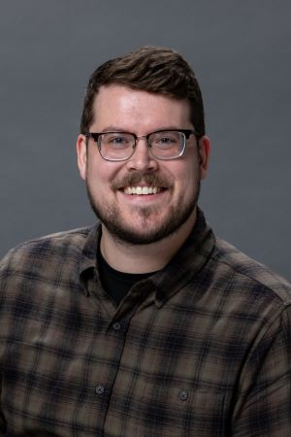
[[IMAGE REF 0002]] Image reference -- not directly editable; the original page reference is preserved automatically. Source: https://www.bemidjistate.edu/academics/music/wp-content/uploads/sites/58/2024/10/Isaac-Lovdahl-headshot.jpg
Specialty: Director of Choral Activities, Conducting, Choral Composition
Website: https://www.isaaclovdahl.com/
Bangsberg 347
Phone: (218) 755-2855
Box #: 16
isaac.lovdahl@bemidjistate.edu

Scott Guidry, M.A.
Associate Professor
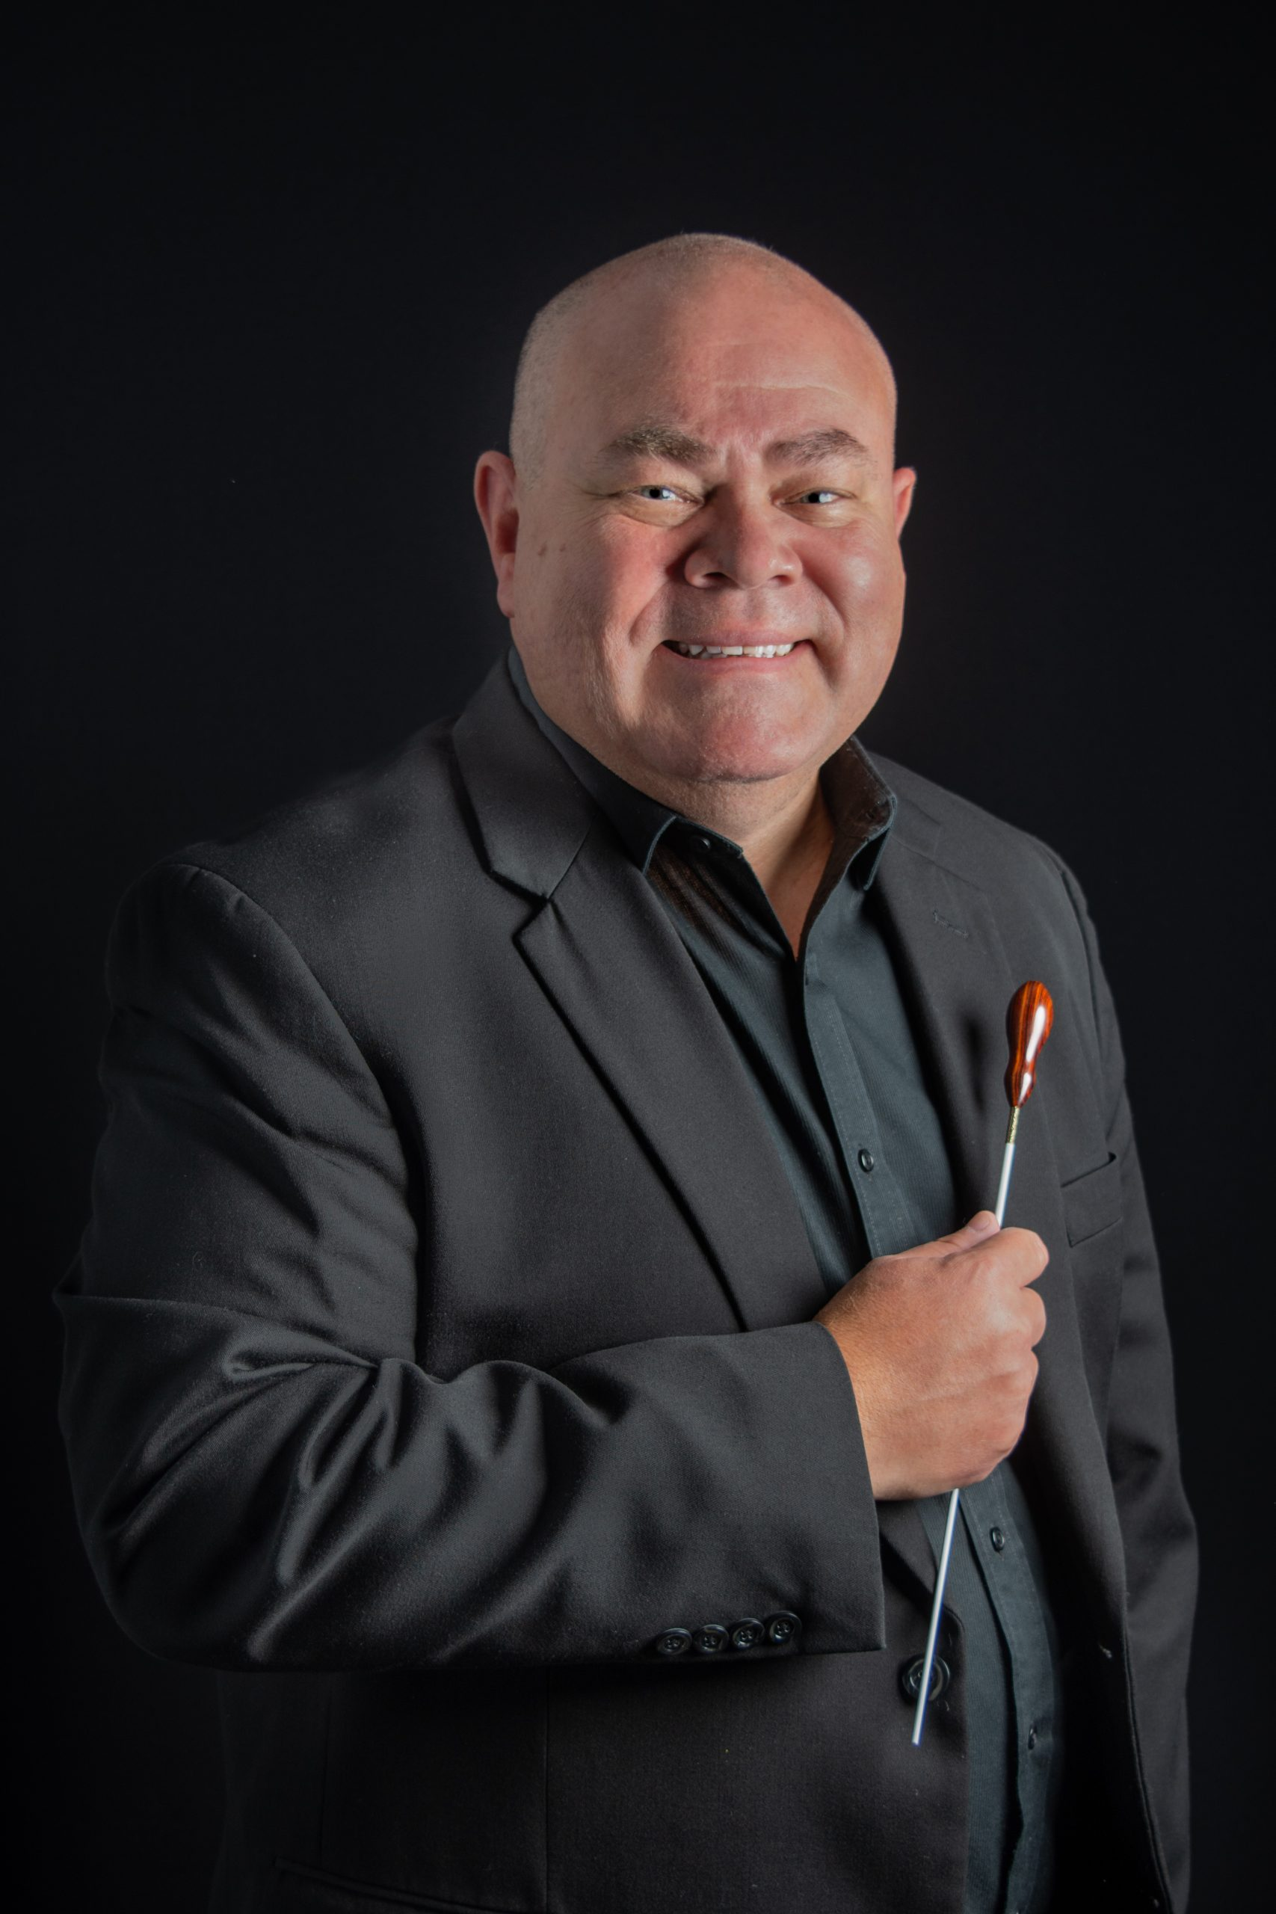
[[IMAGE REF 0003]] Image reference -- not directly editable; the original page reference is preserved automatically. Source: https://www.bemidjistate.edu/academics/music/wp-content/uploads/sites/58/2021/11/Guidry-Head-Shot-21-scaled-1.jpeg
Specialty: Director of Bands, High Brass
Bangsberg Hall 359
Phone: (218) 755-3365
Box #: 16
scott.guidry@bemidjistate.edu

Eric Olson, D.M.A.
Assistant Professor
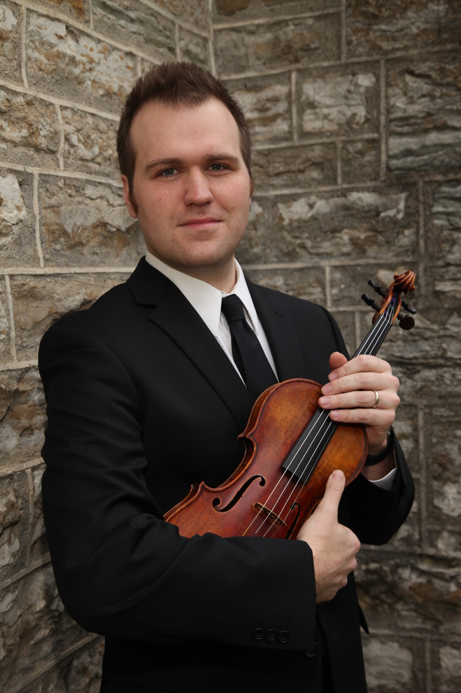
[[IMAGE REF 0004]] Image reference -- not directly editable; the original page reference is preserved automatically. Source: https://www.bemidjistate.edu/academics/music/wp-content/uploads/sites/58/2021/11/Unknown-1.jpeg
Specialty: Strings
Performances:
Franck Sonata in A Major for Violin and Piano
Bangsberg 318
Phone: (218) 755-3941
Box #: 16
eric.olson.2@bemidjistate.edu

Jennifer Olson, D.M.A.
Assistant Professor
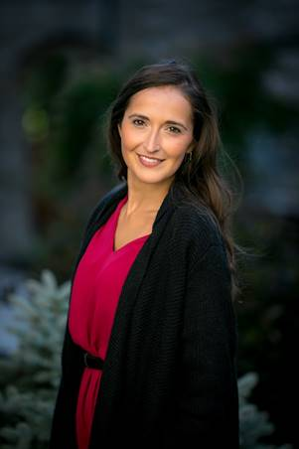
[[IMAGE REF 0005]] Image reference -- not directly editable; the original page reference is preserved automatically. Source: https://www.bemidjistate.edu/academics/music/wp-content/uploads/sites/58/2021/11/Unknown.jpeg
Specialty: Vocal Performance
Performances:
Ernani Braga: Cinco Canções do Folclore Nordestino
Bangsberg 323
Phone: (218) 755-2198
Box #: 16
jennifer.olson@bemidjistate.edu

Cory Renbarger, D.M.A.
Professor

[[IMAGE REF 0006]] Image reference -- not directly editable; the original page reference is preserved automatically. Source: https://www.bemidjistate.edu/academics/music/wp-content/uploads/sites/58/2021/11/Cory-J-Renbarger-Head-1-19-scaled.jpeg
Specialty: Vocal Performance, Opera
Performances:
- Gianni Schicchi – Puccini (Live Performance with Fargo-Moorhead Opera)
- Die Krähe – Schubert (Commercial Release, Winterreise, D. 911)
- Gute Nacht – Schubert (Commercial Release, Winterreise, D. 911)
- Hai già vinta la causa! – Le nozze di Figaro – Mozart (Live in Recital)
- O! du mein holder Abendstern – Tannhäuser – Wagner (Live in Recital)
Bangsberg 349
Phone: (218) 755-2867
Box#: 16
cory.renbarger@bemidjistate.edu

Miriam Webber, Ph.D.
Associate Professor
Honors Program Director
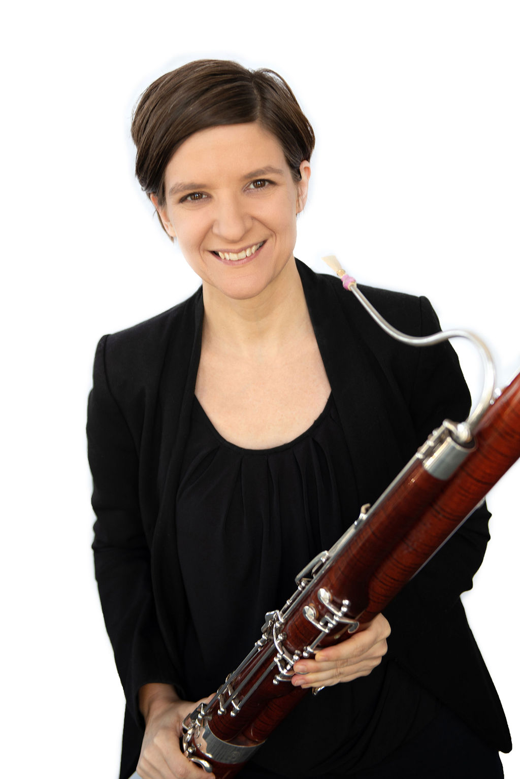
[[IMAGE REF 0007]] Image reference -- not directly editable; the original page reference is preserved automatically. Source: https://www.bemidjistate.edu/academics/music/wp-content/uploads/sites/58/2021/11/Miriam-Webber-Headshot-21.jpeg
Specialty: Music Theory, Bassoon, Honors
Bangsberg 367
Phone: (218) 755-3360
Box #: 16
miriam.webber@bemidjistate.edu

Adjunct Instructors
Ben Bartholomew
Adjunct Instructor
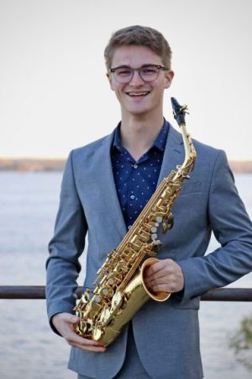
[[IMAGE REF 0008]] Image reference -- not directly editable; the original page reference is preserved automatically. Source: https://www.bemidjistate.edu/academics/music/wp-content/uploads/sites/58/2026/08/Bartholomew1-scaled-e1786671056391.jpeg
Pep Band Director
Bangsberg 362
Box #: 16

Kyle Brown
Adjunct Instructor
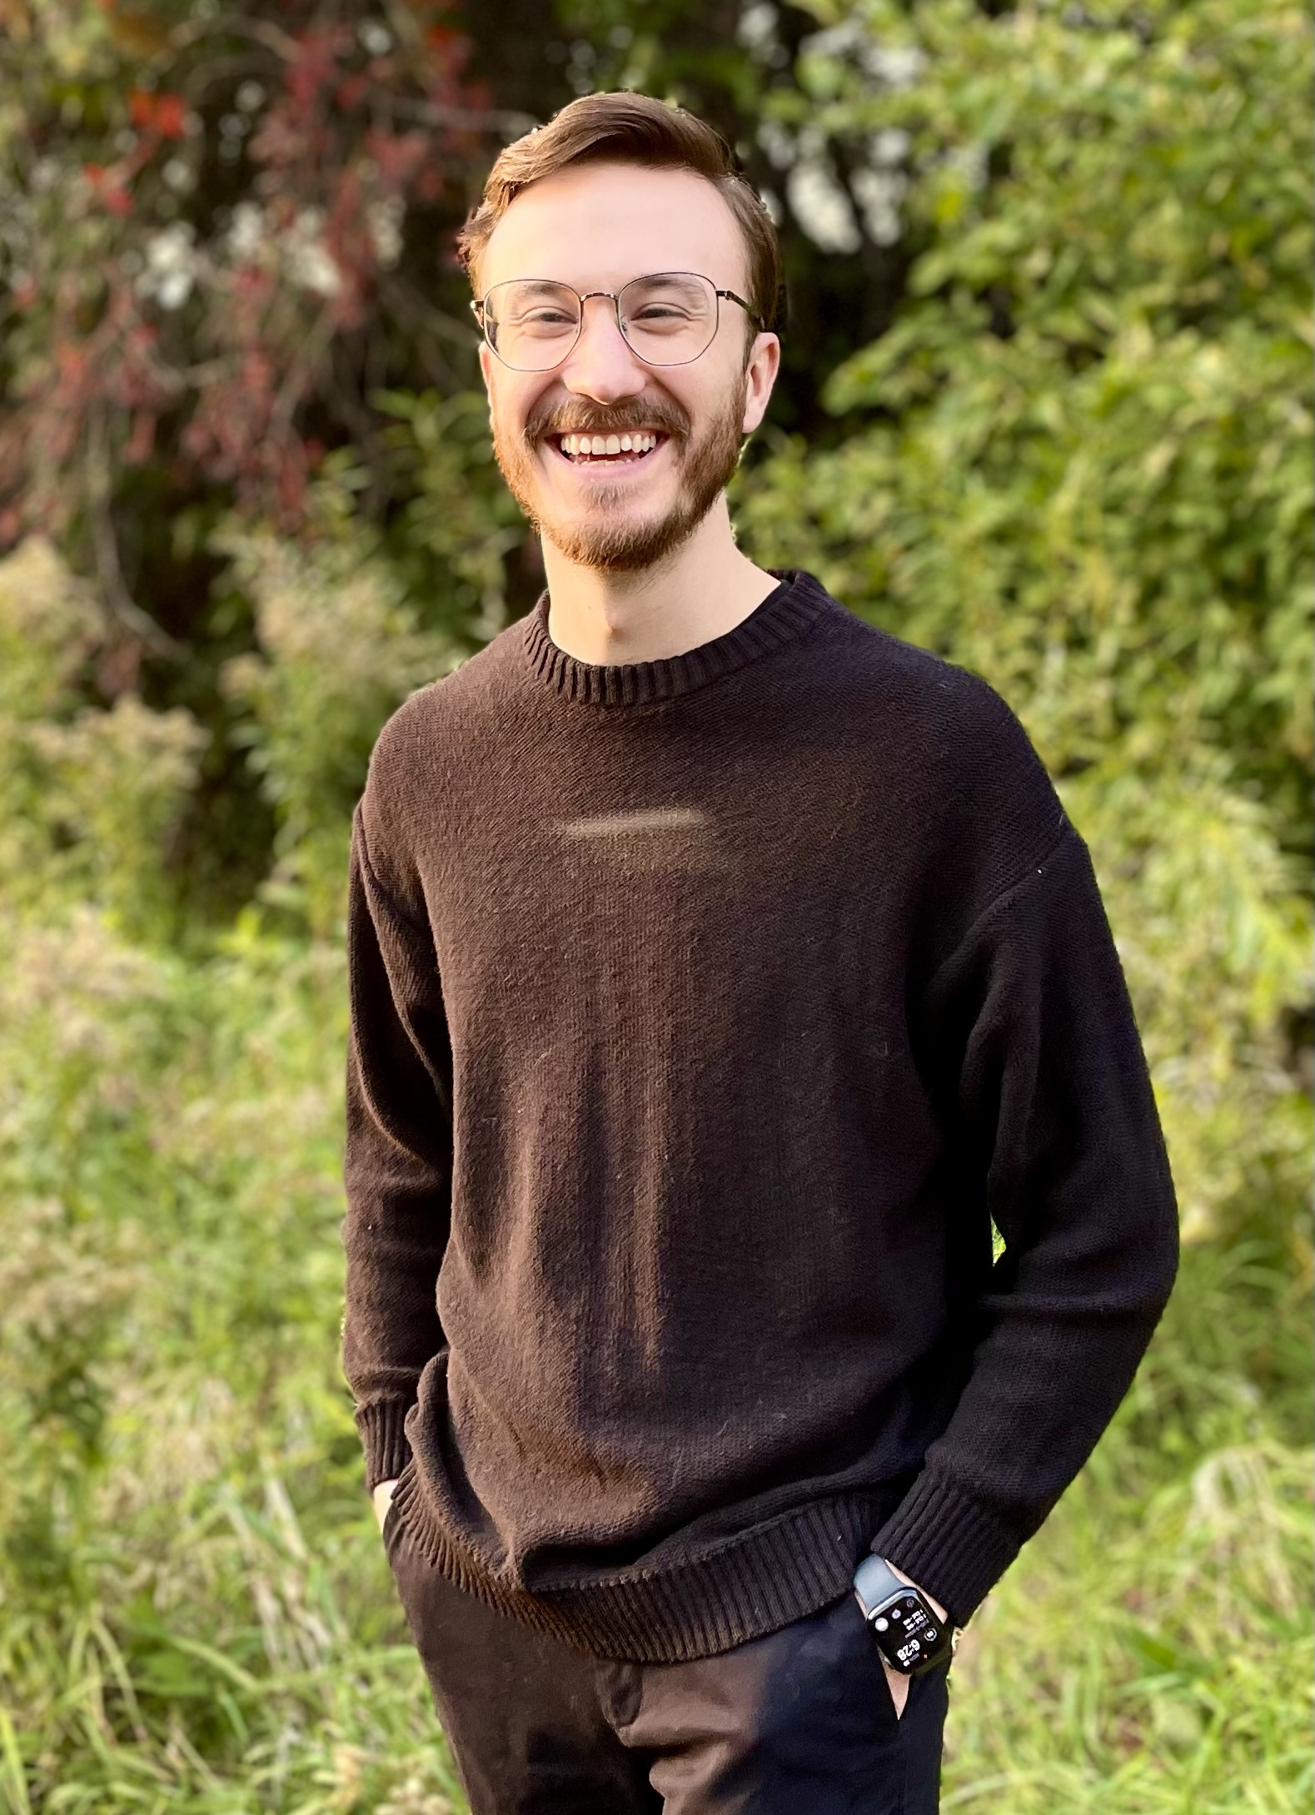
[[IMAGE REF 0009]] Image reference -- not directly editable; the original page reference is preserved automatically. Source: https://www.bemidjistate.edu/academics/music/wp-content/uploads/sites/58/2026/01/BrownHeadshot.jpg
Specialty: Flute, Composition
Bangsberg Hall 318
Box # 16
kyle.brown@clcmn.edu

Sarah Carlson
Adjunct Instructor
Specialty: Collaborative Piano, Organ
sarah.carlson@bemidjistate.edu

Seth Freundschuh
Adjunct Instructor
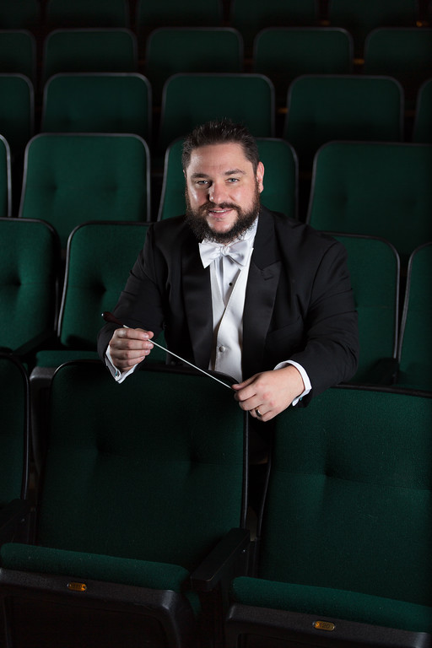
[[IMAGE REF 0010]] Image reference -- not directly editable; the original page reference is preserved automatically. Source: https://www.bemidjistate.edu/academics/music/wp-content/uploads/sites/58/2025/04/seth-freundschuh.jpg
Specialty: Cello
Bangsberg Hall 348
Box # 16
seth.freundschuh@bemidjistate.edu

Greg Gaston
Adjunct Instructor
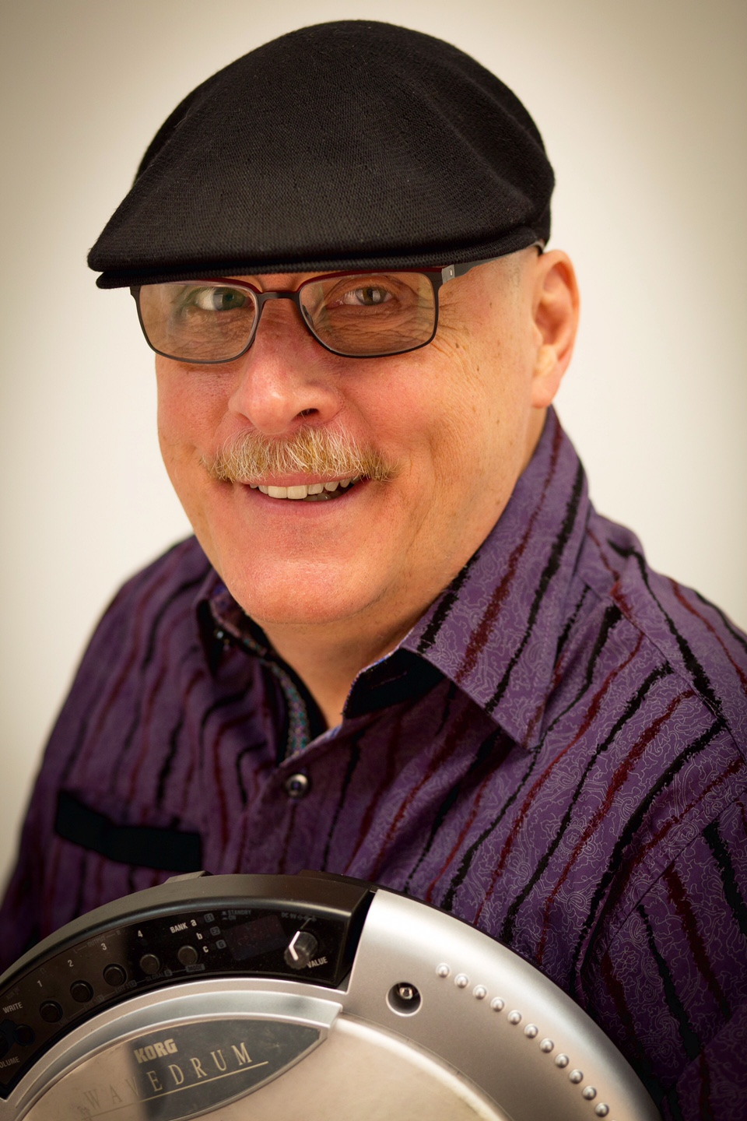
[[IMAGE REF 0011]] Image reference -- not directly editable; the original page reference is preserved automatically. Source: https://www.bemidjistate.edu/academics/music/wp-content/uploads/sites/58/2021/11/image1.jpeg
Bangsberg Hall 360
Box #: 16
greg.gaston@bemidjistate.edu

Heather Guidry, M.M.
Adjunct Instructor
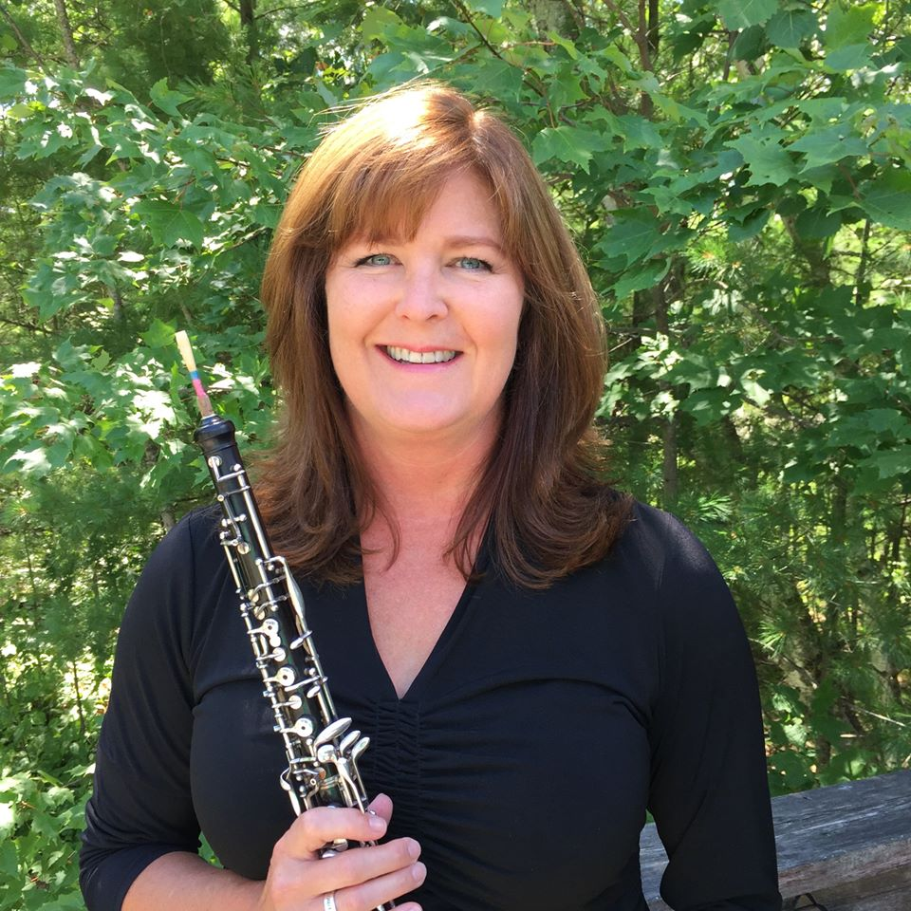
[[IMAGE REF 0012]] Image reference -- not directly editable; the original page reference is preserved automatically. Source: https://www.bemidjistate.edu/academics/music/wp-content/uploads/sites/58/2021/11/Heather-Bio-Pic.jpeg
Specialty: Oboe
Bangsberg Hall 370
Box #: 16
heather.guidry@bemidjistate.edu

Dale Gunderson
Adjunct Instructor
Specialty: Saxophone
Bangsberg Hall 325
Box # 16
dale.gunderson@bemidjistate.edu

Curtis Olson, M.M.
Adjunct Instructor
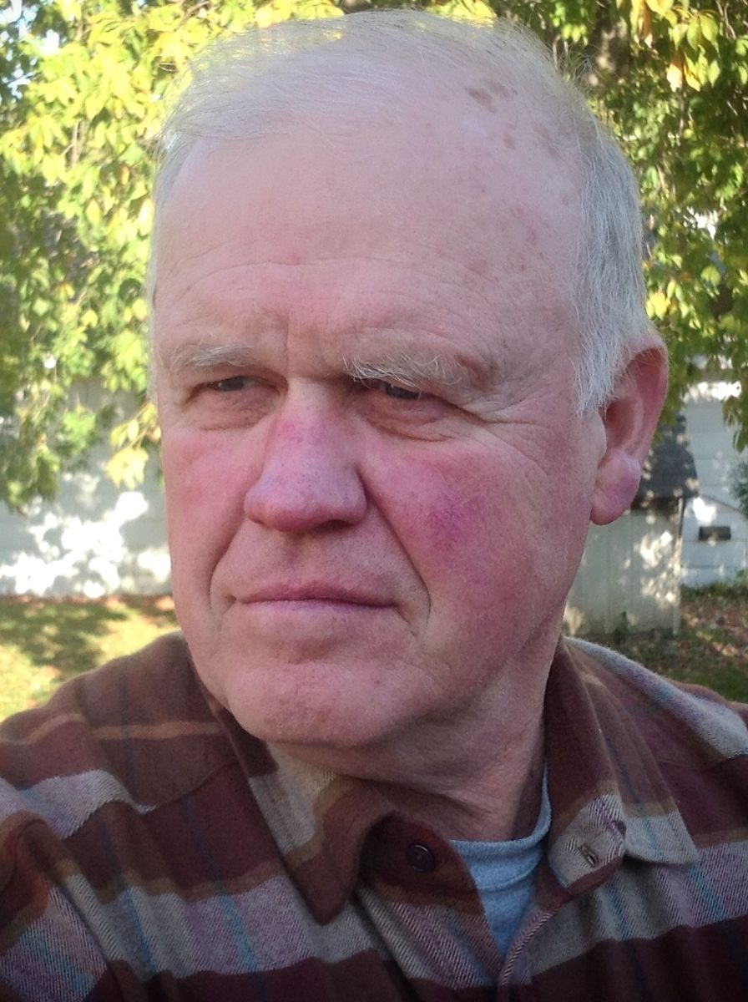
[[IMAGE REF 0013]] Image reference -- not directly editable; the original page reference is preserved automatically. Source: https://www.bemidjistate.edu/academics/music/wp-content/uploads/sites/58/2021/11/Curt14.jpeg
Specialty: Low Brass
Bangsberg 361
Box #: 16
curtis.olson@bemidjistate.edu

Magdalena Sas
Adjunct Instructor
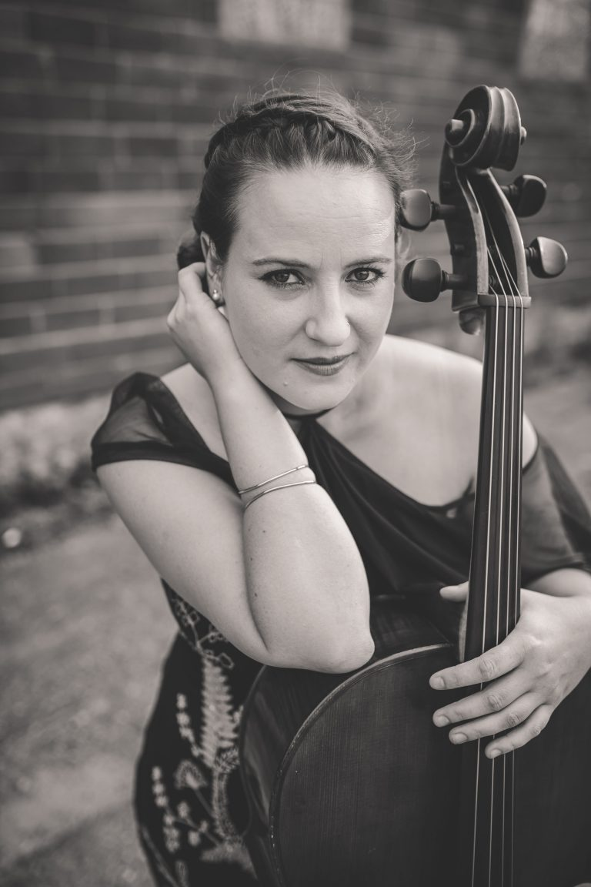
[[IMAGE REF 0014]] Image reference -- not directly editable; the original page reference is preserved automatically. Source: https://www.bemidjistate.edu/academics/music/wp-content/uploads/sites/58/2026/02/Magdaline-Sas-Website-Picture-768x1152-1.jpg
View her performance on YouTube
Bangsberg Hall
Box # 16
magdalena.sas@bemidjistate.edu

Max Sommers
Adjunct Instructor
Specialty: Clarinet
Bangsberg Hall 350
Box # 16
max.sommers@bemidjistate.edu

Eric Sundeen
Adjunct Instructor
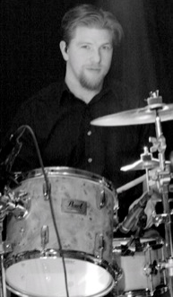
[[IMAGE REF 0000]] Image reference -- not directly editable; the original page reference is preserved automatically. Source: https://www.bemidjistate.edu/academics/music/wp-content/uploads/sites/58/2021/11/eric_sundeen.png
Specialty: Percussion, Percussion Ensemble
Bangsberg 111
Box #: 16
eric.sundeen@bemidjistate.edu

Ryan Webber, M.M.
Adjunct Instructor
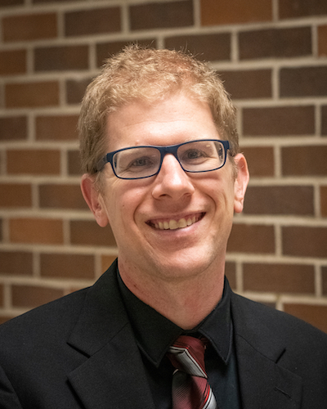
[[IMAGE REF 0015]] Image reference -- not directly editable; the original page reference is preserved automatically. Source: https://www.bemidjistate.edu/academics/music/wp-content/uploads/sites/58/2021/11/Ryan-Webber-Headshot-2020.jpeg
Specialty: Symphonic Band, Low Brass
Bangsberg 361
Box #: 16
ryan.webber@bemidjistate.edu

Dan Will
Staff Accompanist/Coach

[[IMAGE REF 0016]] Image reference -- not directly editable; the original page reference is preserved automatically. Source: https://www.bemidjistate.edu/academics/music/wp-content/uploads/sites/58/2021/11/Dan-Will-Headshot-18-Crop-595x550-1.png
Specialty: Collaborative Piano, Coaching
Bangsberg 368
Box #: 16
daniel.will@bemidjistate.edu

Staff
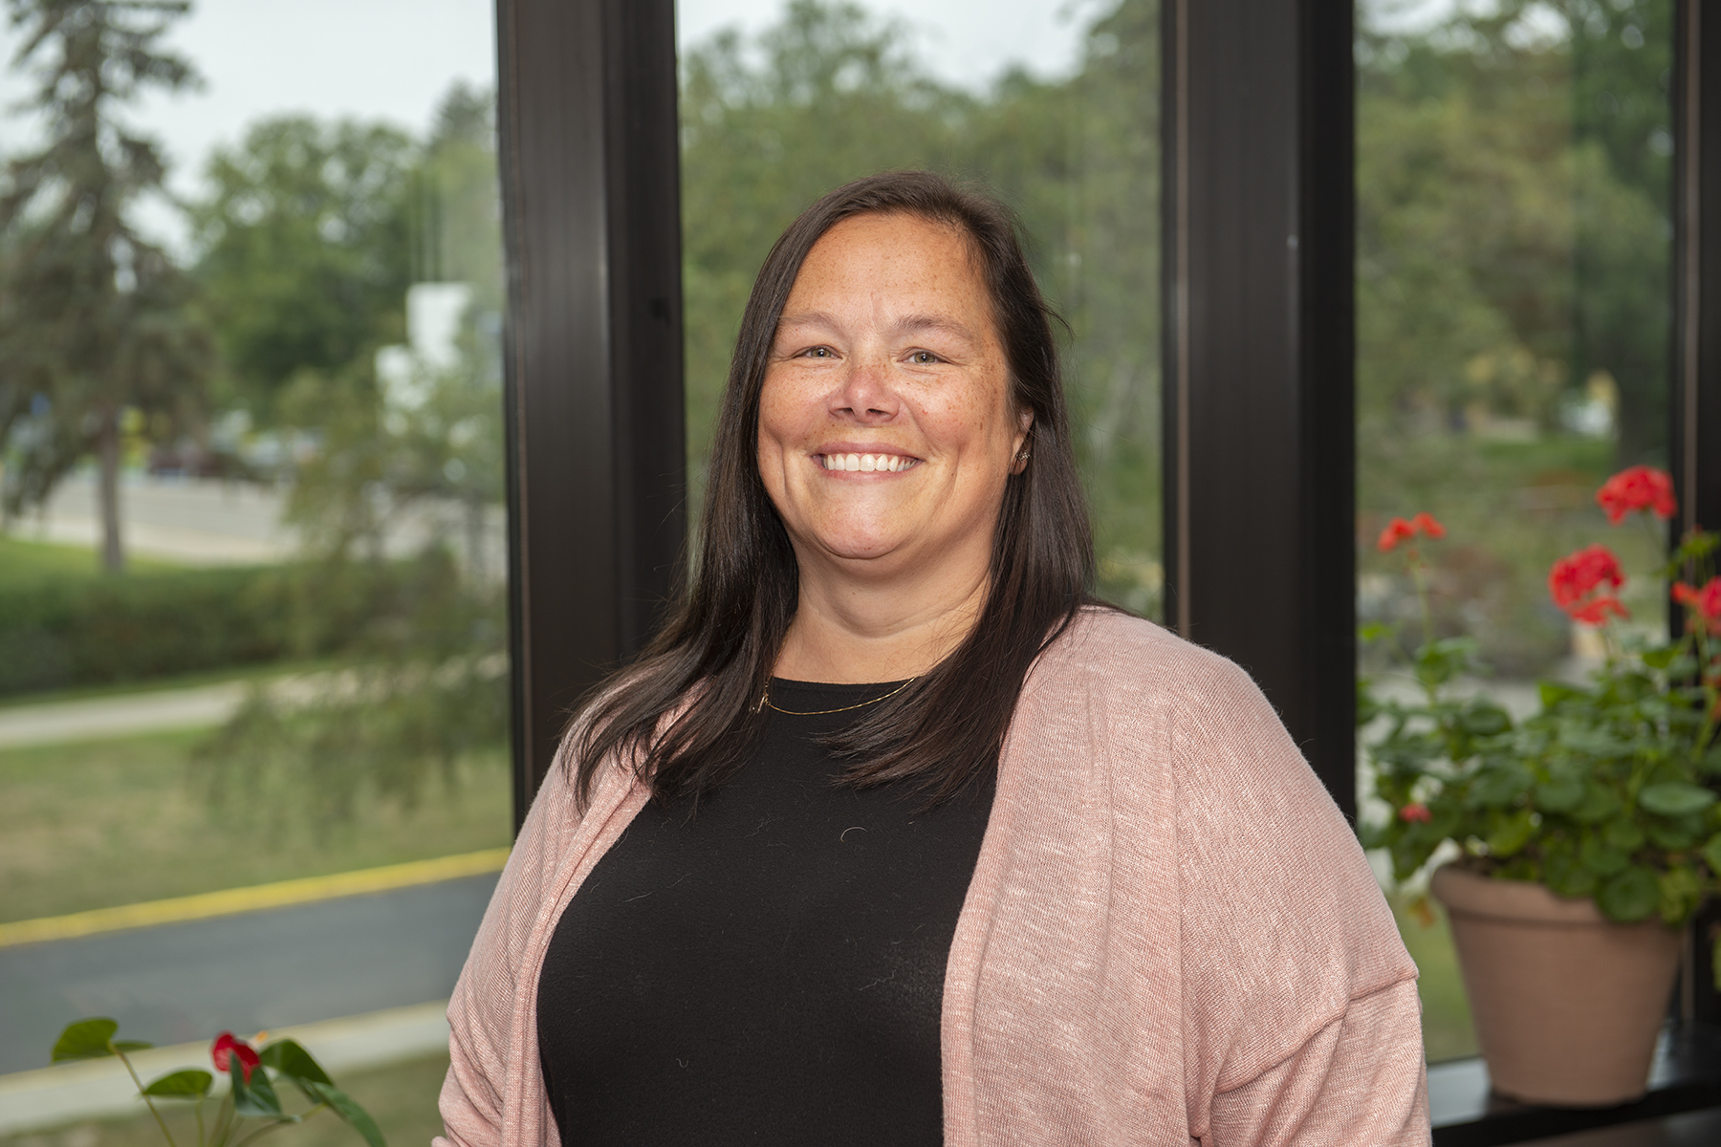
[[IMAGE REF 0017]] Image reference -- not directly editable; the original page reference is preserved automatically. Source: https://www.bemidjistate.edu/directory/wp-content/uploads/sites/16/2023/02/tammy-erickson.jpg
Office Manager
Bensen Hall 326
Phone: (218) 755-2934
Box #: 35
Email: tammy.erickson@bemidjistate.edu

Jeremiah Liend
Technical Coordinator of Performing Arts
Bangsberg 120
Phone: (218) 755-2506
Email: jeremiah.liend@bemidjistate.edu

