Title | Faculty & Staff
Meta Description
— Page content begins below. Please do not edit the table above. —
Bemidji State University has a highly talented and compassionate Nursing faculty whose members are dedicated to teaching, research and service.
Our faculty provide insight to students about the relationship between the theory of the classroom and the reality of nursing practice. Each faculty member is committed to providing leadership in nursing, premier healthcare, innovation and cutting-edge science.

Faculty
Dean of Academic Affairs and Programs
Nicholle Bieberdorf
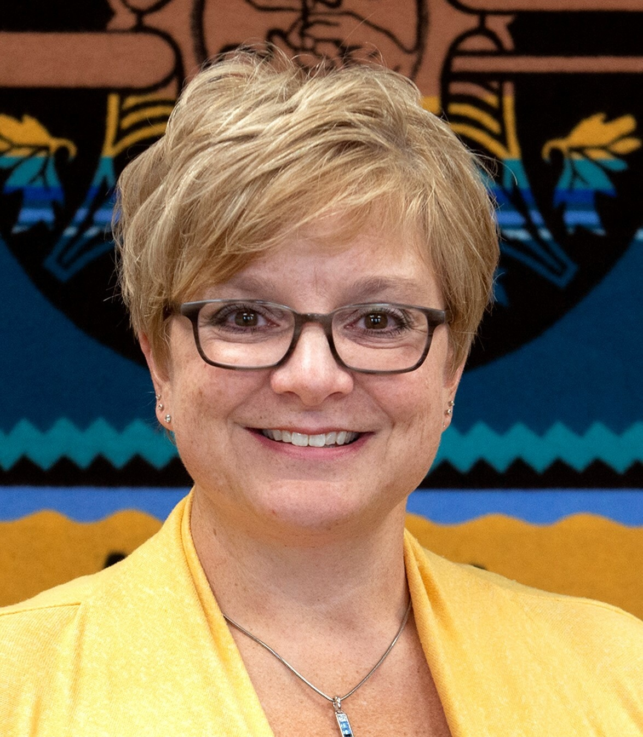
[[IMAGE REF 0001]] Image reference -- not directly editable; the original page reference is preserved automatically. Source: https://www.bemidjistate.edu/academics/nursing/wp-content/uploads/sites/32/2025/09/nicholle-bieberdorf-phto.jpg
Bensen Hall 232/233
Phone: (218) 333-6659Email: nicholle.bieberdorf@bemidjistate.edu

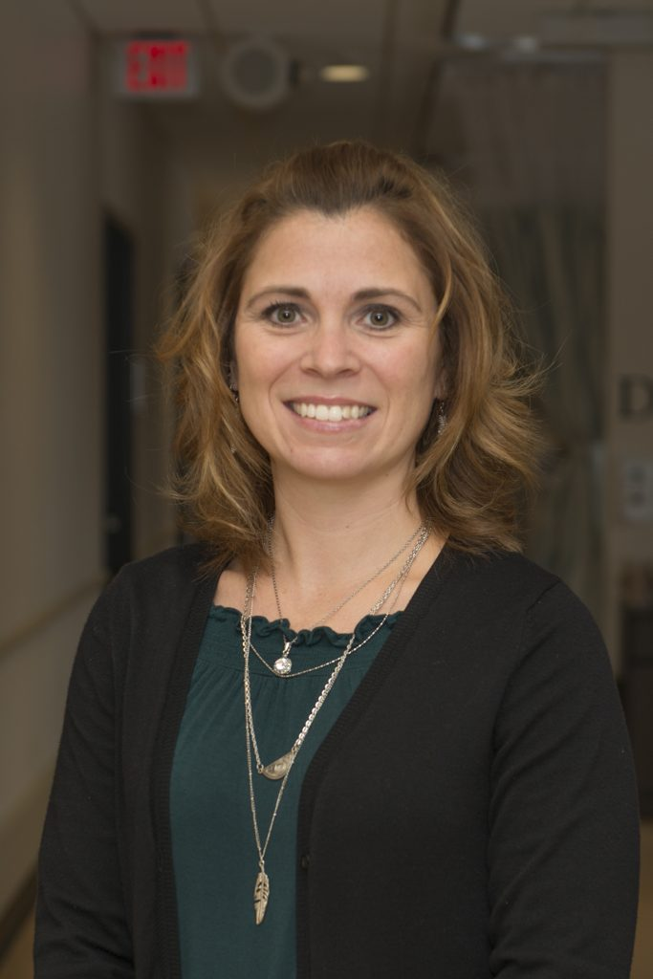
[[IMAGE REF 0002]] Image reference -- not directly editable; the original page reference is preserved automatically. Source: https://www.bemidjistate.edu/academics/nursing/wp-content/uploads/sites/32/2022/05/Christy-Cook.jpg
Professor
Bensen Hall 230
Email: christy.cook@bemidjistate.edu

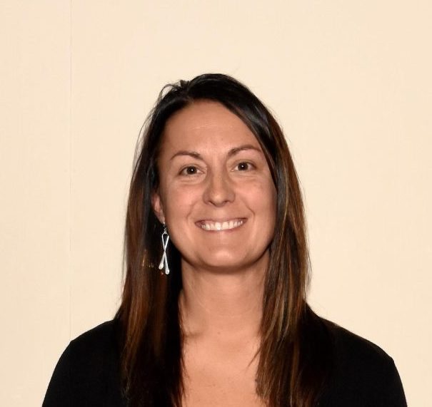
[[IMAGE REF 0003]] Image reference -- not directly editable; the original page reference is preserved automatically. Source: https://www.bemidjistate.edu/academics/nursing/wp-content/uploads/sites/32/2024/10/Megan-Christensen-scaled-e1729533582953.jpg
Megan Christiansen
Assistant Professor
Bensen Hall 109G
Phone: (218) 755-2715

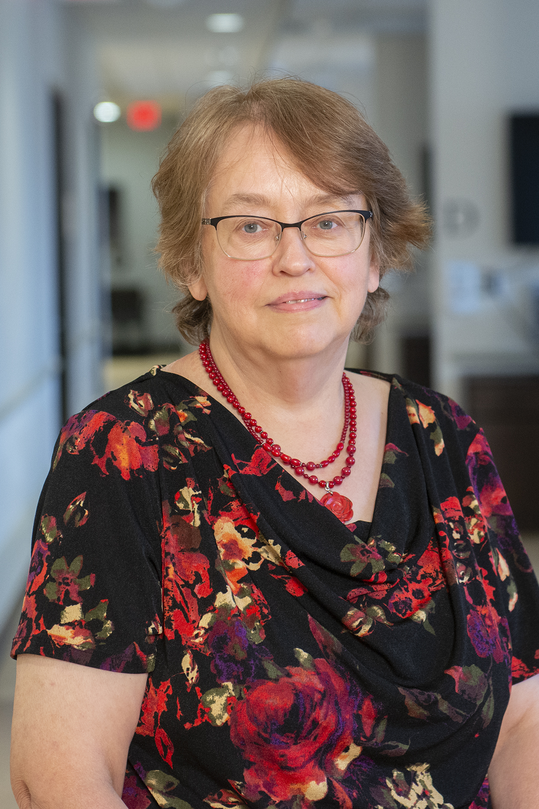
[[IMAGE REF 0004]] Image reference -- not directly editable; the original page reference is preserved automatically. Source: https://www.bemidjistate.edu/academics/nursing/wp-content/uploads/sites/32/2022/09/23Nursing_Ruth_Eckstrom.jpg
Assistant Professor
Bensen Hall 109Q
Phone: (218) 755-2524
Email: ruth.eckstrom@bemidjistate.edu

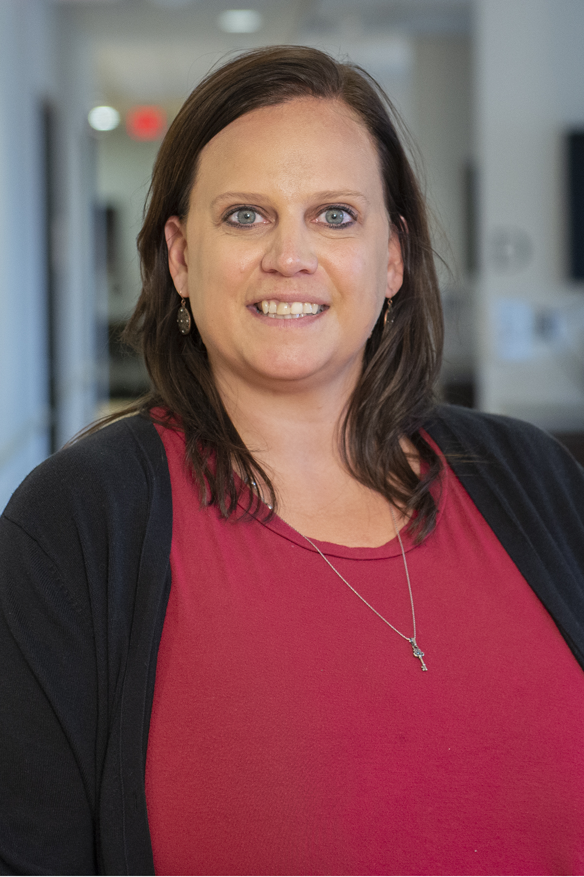
[[IMAGE REF 0005]] Image reference -- not directly editable; the original page reference is preserved automatically. Source: https://www.bemidjistate.edu/academics/nursing/wp-content/uploads/sites/32/2022/09/23Nursing_Angela_Halvorson.jpg
Assistant Professor
Bensen Hall 109D
Phone: (218) 755-2523
Email: angela.halvorson@bemidjistate.edu

Melissa Jenson
Assistant Professor
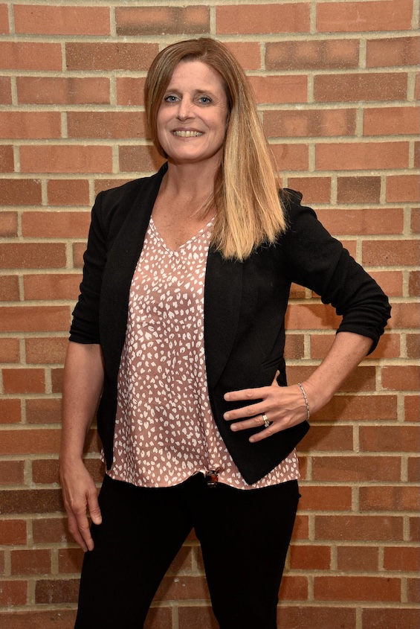
[[IMAGE REF 0000]] Image reference -- not directly editable; the original page reference is preserved automatically. Source: https://www.bemidjistate.edu/academics/nursing/wp-content/uploads/sites/32/2025/06/Melissa-Jenson.jpg
Bensen Hall 225
Phone: (218) 755-2811
Email: melissa.jenson@bemidjistate.edu

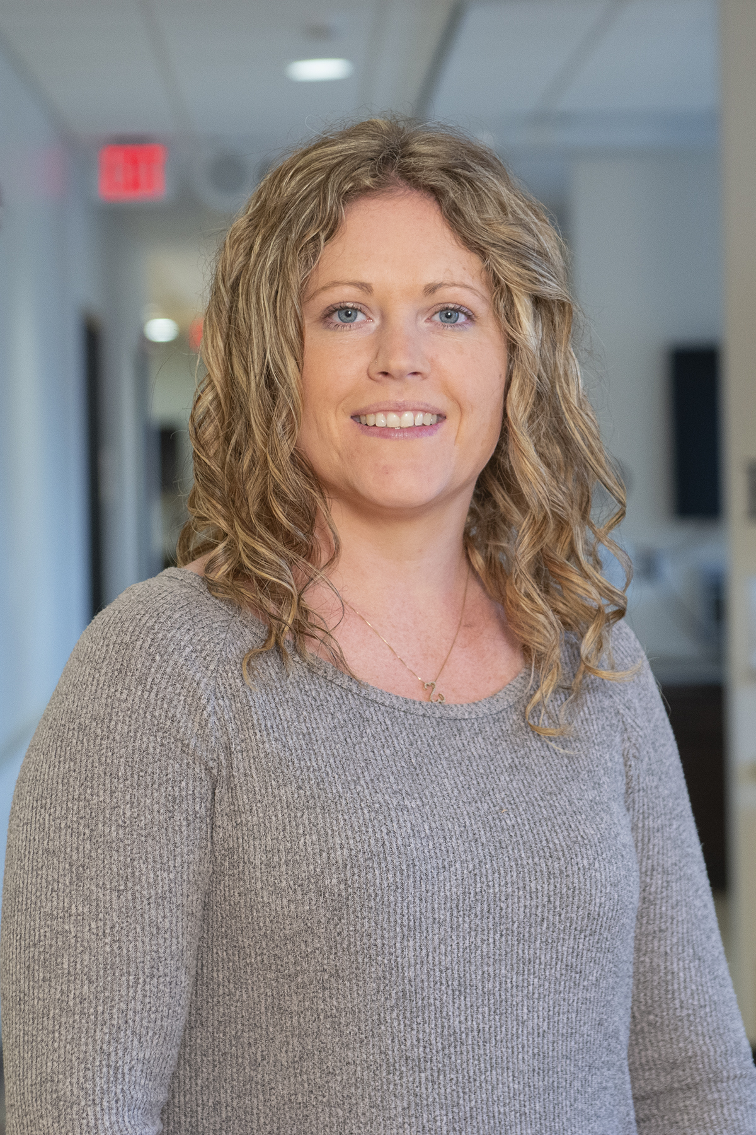
[[IMAGE REF 0006]] Image reference -- not directly editable; the original page reference is preserved automatically. Source: https://www.bemidjistate.edu/academics/nursing/wp-content/uploads/sites/32/2022/09/23Nursing_Nicole_Johnson.jpg
Assistant Professor
Bensen Hall 227
Phone: (218) 755-3870
Email: nicole.johnson@bemidjistate.edu

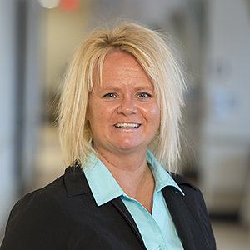
[[IMAGE REF 0007]] Image reference -- not directly editable; the original page reference is preserved automatically. Source: https://www.bemidjistate.edu/academics/nursing/wp-content/uploads/sites/32/2022/05/BSU_Nursing_0056_Marci_Maple.jpg
Professor
Bensen Hall 109L
Phone: (218) 755-4240
Email: marci.maple@bemidjistate.edu

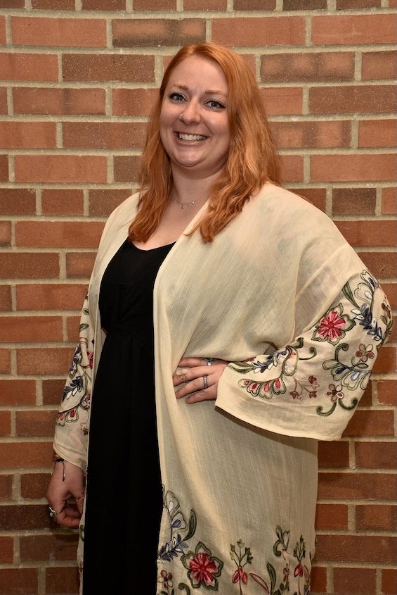
[[IMAGE REF 0008]] Image reference -- not directly editable; the original page reference is preserved automatically. Source: https://www.bemidjistate.edu/academics/nursing/wp-content/uploads/sites/32/2025/06/Robin-Sand.jpg
Assistant Professor
Bensen Hall 109E
Phone: (218) 755-3708
Email: robin.sand@bemidjistate.edu

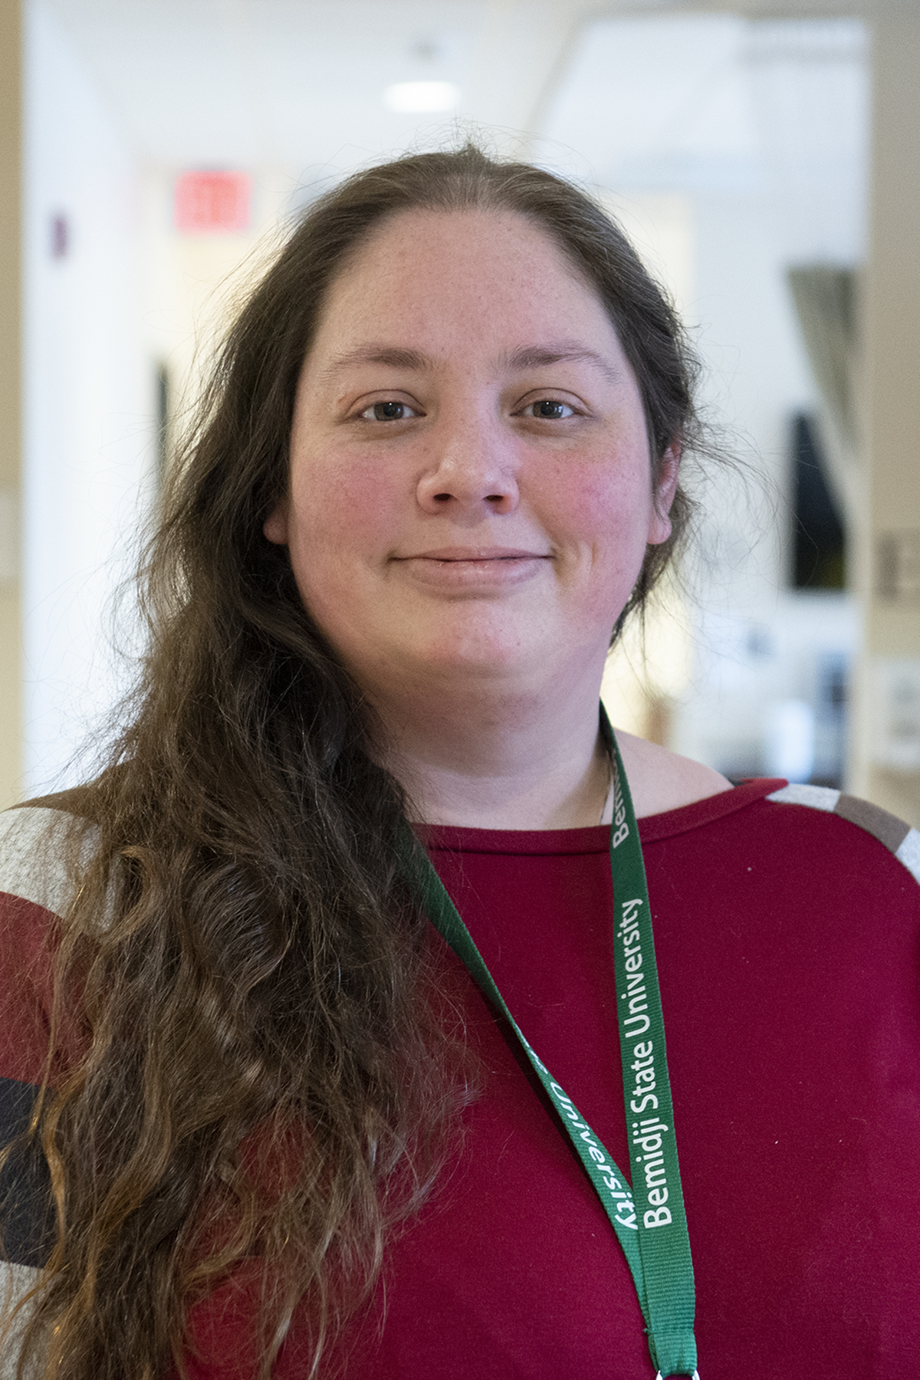
[[IMAGE REF 0009]] Image reference -- not directly editable; the original page reference is preserved automatically. Source: https://www.bemidjistate.edu/academics/nursing/wp-content/uploads/sites/32/2022/05/22BSU_Nursing_Catrina_Welch_0000.jpg
Catrina Welch
Assistant Professor
Bensen Hall 229
Phone: (218) 755-3708
Email: catrina.welch@bemidjistate.edu

Staff
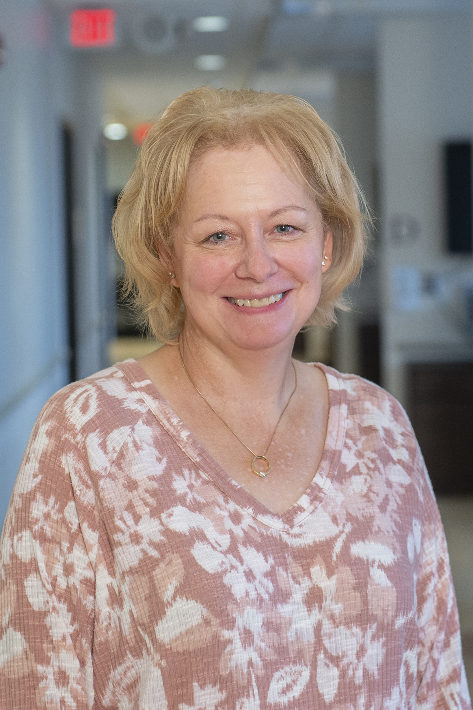
[[IMAGE REF 0010]] Image reference -- not directly editable; the original page reference is preserved automatically. Source: https://www.bemidjistate.edu/academics/nursing/wp-content/uploads/sites/32/2022/09/23Nursing_Lisa_Burlage.jpg
Nursing Lab Coordinator
Bensen Hall 213
Phone: (218): 755-3848
Email: lisa.burlage@bemidjistate.edu

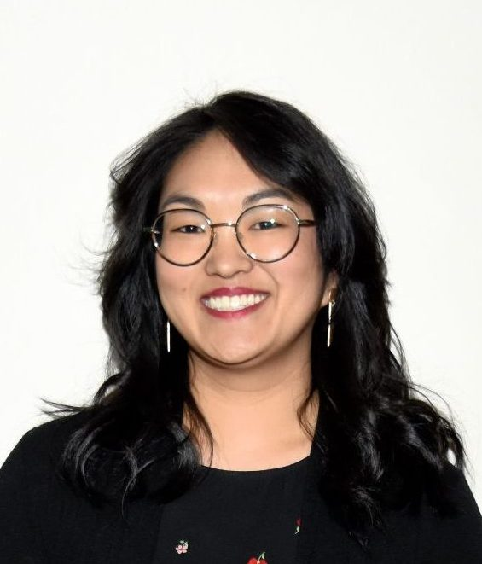
[[IMAGE REF 0011]] Image reference -- not directly editable; the original page reference is preserved automatically. Source: https://www.bemidjistate.edu/academics/nursing/wp-content/uploads/sites/32/2024/10/Reese-Hiller-scaled-e1729533771160-565x661.jpg
Reese Hiller
Nursing Clinical Coordinator
Bensen Hall 224
Phone: (218) 755-3729
Email: reese.hiller@bemidjistate.edu

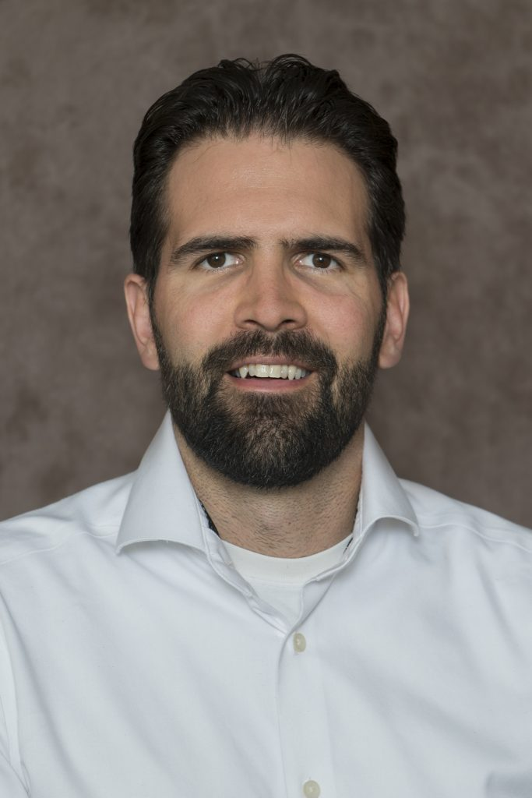
[[IMAGE REF 0012]] Image reference -- not directly editable; the original page reference is preserved automatically. Source: https://www.bemidjistate.edu/academics/nursing/wp-content/uploads/sites/32/2022/05/Mike-Simpson-photo.jpg
Nursing Student Services Coordinator
Bensen Hall 223
Phone: (218) 755-2486
Email: michael.simpson@bemidjistate.edu

