Title | Faculty & Staff
Meta Description
— Page content begins below. Please do not edit the table above. —
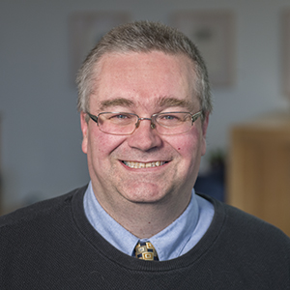
[[IMAGE REF 0000]] Image reference -- not directly editable; the original page reference is preserved automatically. Source: https://www.bemidjistate.edu/academics/political-science/wp-content/uploads/sites/40/2022/03/PolySci_Beech_0005.jpg
Professor
Sattgast Hall 215 G
Phone: (218) 755-3964
Box #: 27
Email: thomas.beech@bemidjistate.edu

Emeriti Faculty
Dr. Patrick Donnay
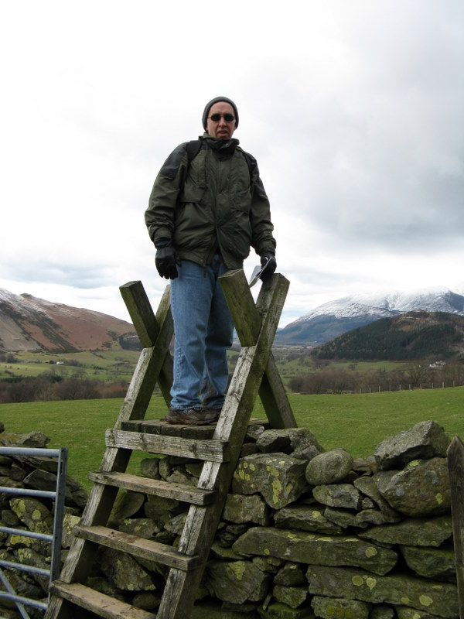
[[IMAGE REF 0001]] Image reference -- not directly editable; the original page reference is preserved automatically. Source: https://www.bemidjistate.edu/academics/political-science/wp-content/uploads/sites/40/2022/03/Donnay2.jpg
Professor
Sattgast Hall 215J
Phone: (218) 755-3899
Box #: 27
Email: patrick.donnay@bemidjistate.edu

