Title | Faculty & Staff
Meta Description
— Page content begins below. Please do not edit the table above. —
Our faculty bring a diverse set of expertise that will provide students with both a broad understanding in psychology and an opportunity to gain experience in specific areas.
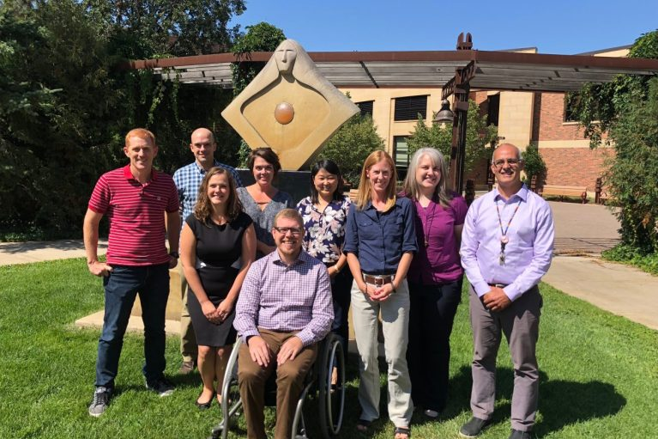
[[IMAGE REF 0000]] Image reference -- not directly editable; the original page reference is preserved automatically. Source: https://www.bemidjistate.edu/academics/psychology/wp-content/uploads/sites/65/2022/04/Psychology_Staf-767x511.jpg

Psychology Faculty
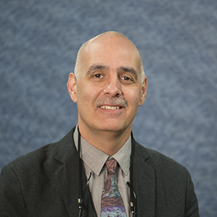
[[IMAGE REF 0001]] Image reference -- not directly editable; the original page reference is preserved automatically. Source: https://www.bemidjistate.edu/academics/psychology/wp-content/uploads/sites/65/2022/04/BSU_Psychology_John_Gonzalez.jpeg
Dr. John Gonzalez
Chair, Professor of Psychology
Office: Bensen Hall 405
Phone: (218) 755-2881
Email: john.gonzalez@bemidjistate.edu


[[IMAGE REF 0002]] Image reference -- not directly editable; the original page reference is preserved automatically. Source: https://www.bemidjistate.edu/academics/psychology/wp-content/uploads/sites/65/2022/04/Psychology_Faculty_Baez.jpg
Dr. Mark. Baez
Assistant Professor of Psychology
Office: Bensen Hall 407
Phone: (218) 755-2870
Email: mark.baez@bemidjistate.edu

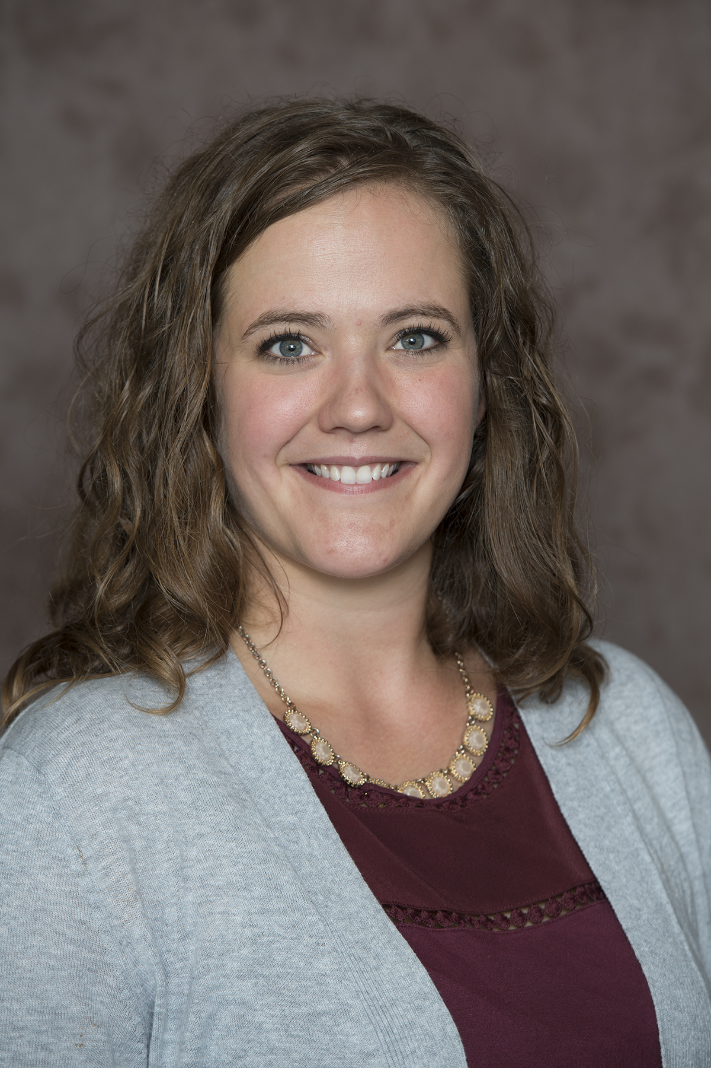
[[IMAGE REF 0003]] Image reference -- not directly editable; the original page reference is preserved automatically. Source: https://www.bemidjistate.edu/academics/psychology/wp-content/uploads/sites/65/2022/04/19BSU_Sarah_Cronin.jpg
Dr. Sarah Cronin
Associate Professor of Psychology
Office: Bensen Hall 406
Phone: (218) 755-2884
Email: sarah.cronin@bemidjistate.edu

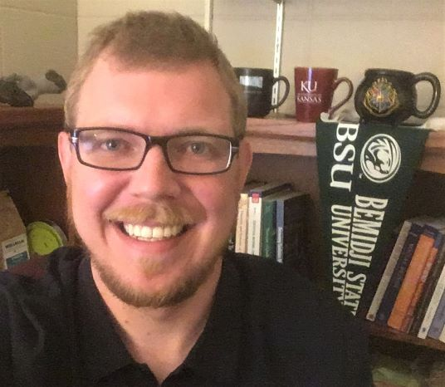
[[IMAGE REF 0004]] Image reference -- not directly editable; the original page reference is preserved automatically. Source: https://www.bemidjistate.edu/academics/psychology/wp-content/uploads/sites/65/2022/04/Dirth_facultypage.jpg
Dr. Thomas Dirth
Associate Professor of Psychology
Office: Bensen Hall 401
Phone: (218) 755-2945
Email: thomas.dirth@bemidjistate.edu

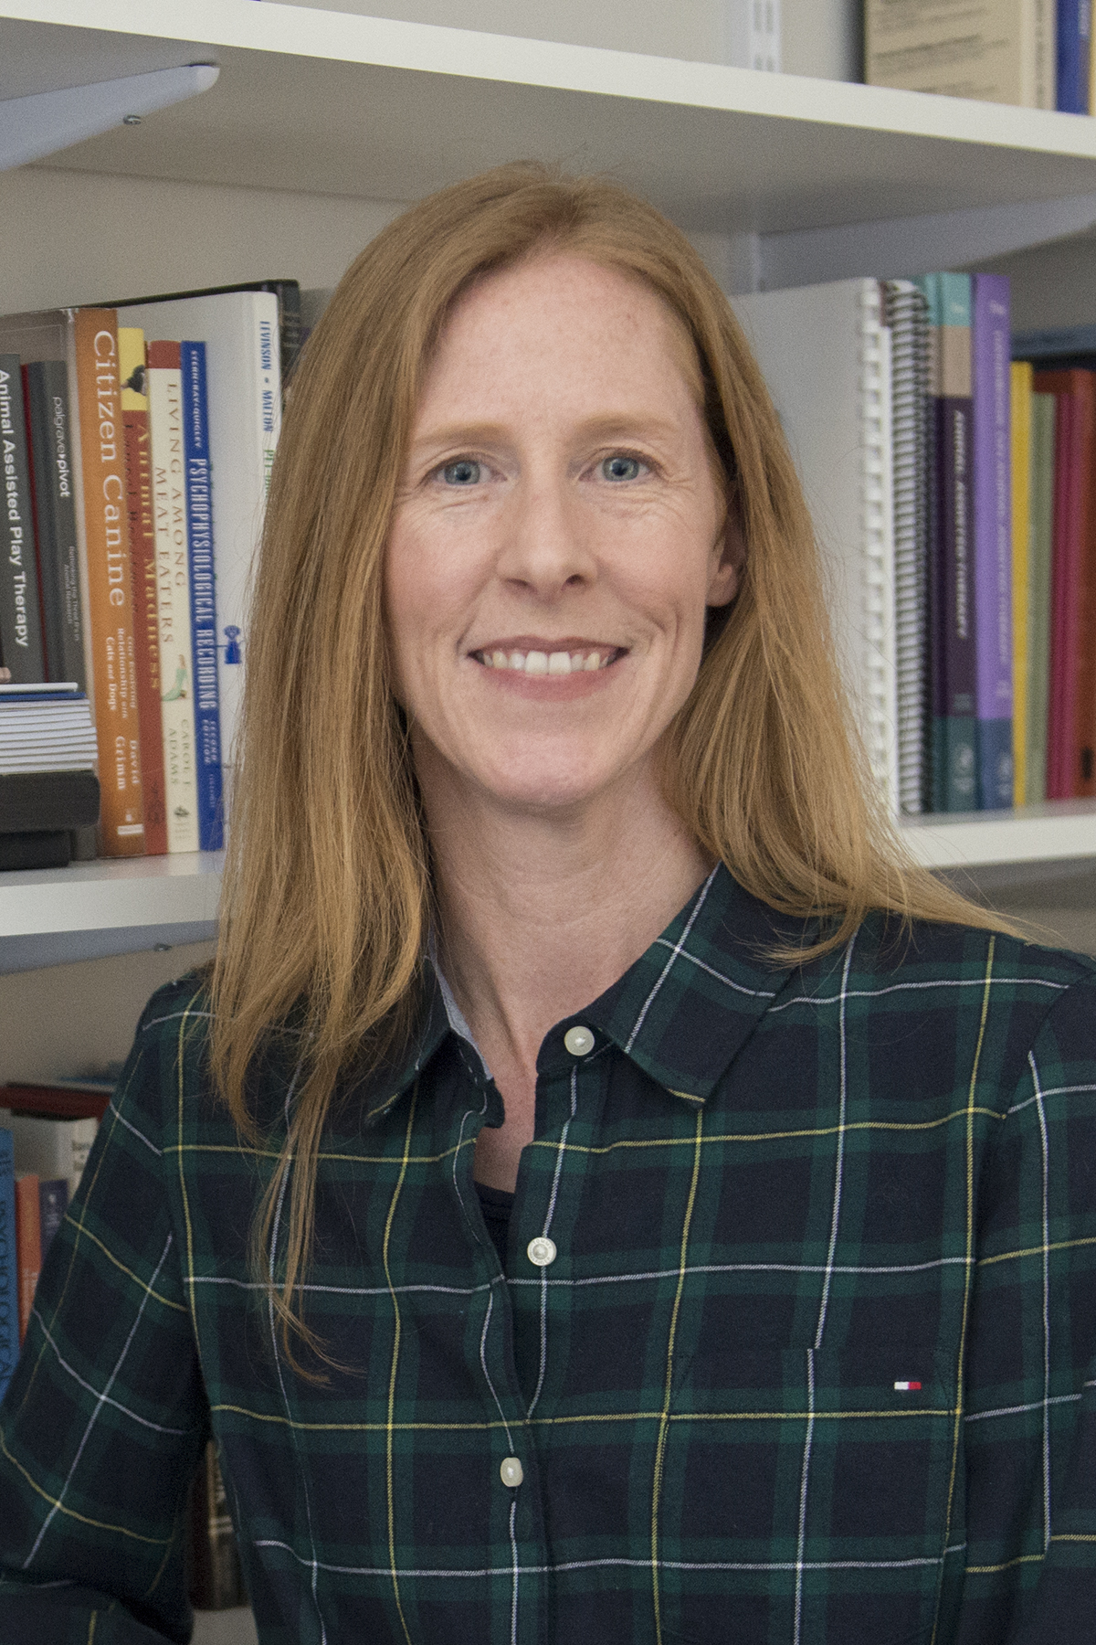
[[IMAGE REF 0005]] Image reference -- not directly editable; the original page reference is preserved automatically. Source: https://www.bemidjistate.edu/academics/psychology/wp-content/uploads/sites/65/2022/04/BSU_Psychology_Angela_Fournier.jpg
Dr. Angela Fournier
Professor of Psychology
Office: Bensen Hall 403
Phone: (218) 755-2530
Email: angela.fournier@bemidjistate.edu

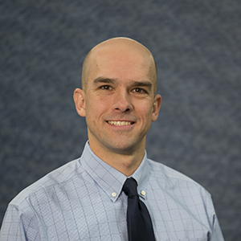
[[IMAGE REF 0006]] Image reference -- not directly editable; the original page reference is preserved automatically. Source: https://www.bemidjistate.edu/academics/psychology/wp-content/uploads/sites/65/2022/04/BSU_Psychology_Keith_Gora.jpg
Dr. Keith Gora
Associate Professor of Psychology
Office: Bensen Hall 402
Phone: (218) 755-2882
Email: keith.gora@bemidjistate.edu

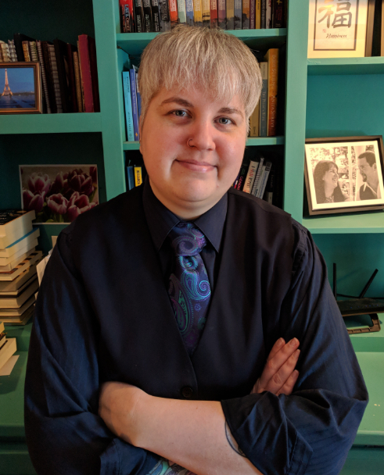
[[IMAGE REF 0007]] Image reference -- not directly editable; the original page reference is preserved automatically. Source: https://www.bemidjistate.edu/academics/psychology/wp-content/uploads/sites/65/2022/04/Kathryn-Klement.png
Dr. Kat Klement
Associate Professor of Psychology
Office: Bensen Hall 410
Phone: (218) 755-2848
Email: kathryn.klement@bemidjistate.edu
Website: Personal Website

[Image preview unavailable (UnrecognizedImageError) -- original reference preserved automatically below.]
[[IMAGE REF 0008]] Image reference -- not directly editable; the original page reference is preserved automatically. Source: https://www.bemidjistate.edu/academics/psychology/wp-content/uploads/sites/65/2026/04/Abe-Jr.webp
Dr. Emma Pasiuk
Adjunct Professor of Psychology
Office: Bensen Hall 427
Email: emma.pasiuk@bemidjistate.edu

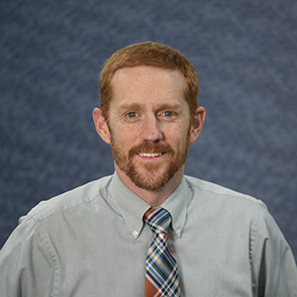
[[IMAGE REF 0009]] Image reference -- not directly editable; the original page reference is preserved automatically. Source: https://www.bemidjistate.edu/academics/psychology/wp-content/uploads/sites/65/2022/04/BSU_Psychology_Travis_Ricks.jpg
Dr. Travis Ricks
Professor of Psychology
Office: Bensen Hall 404
Phone: (218) 755-2106
Email: travis.ricks@bemidjistate.edu

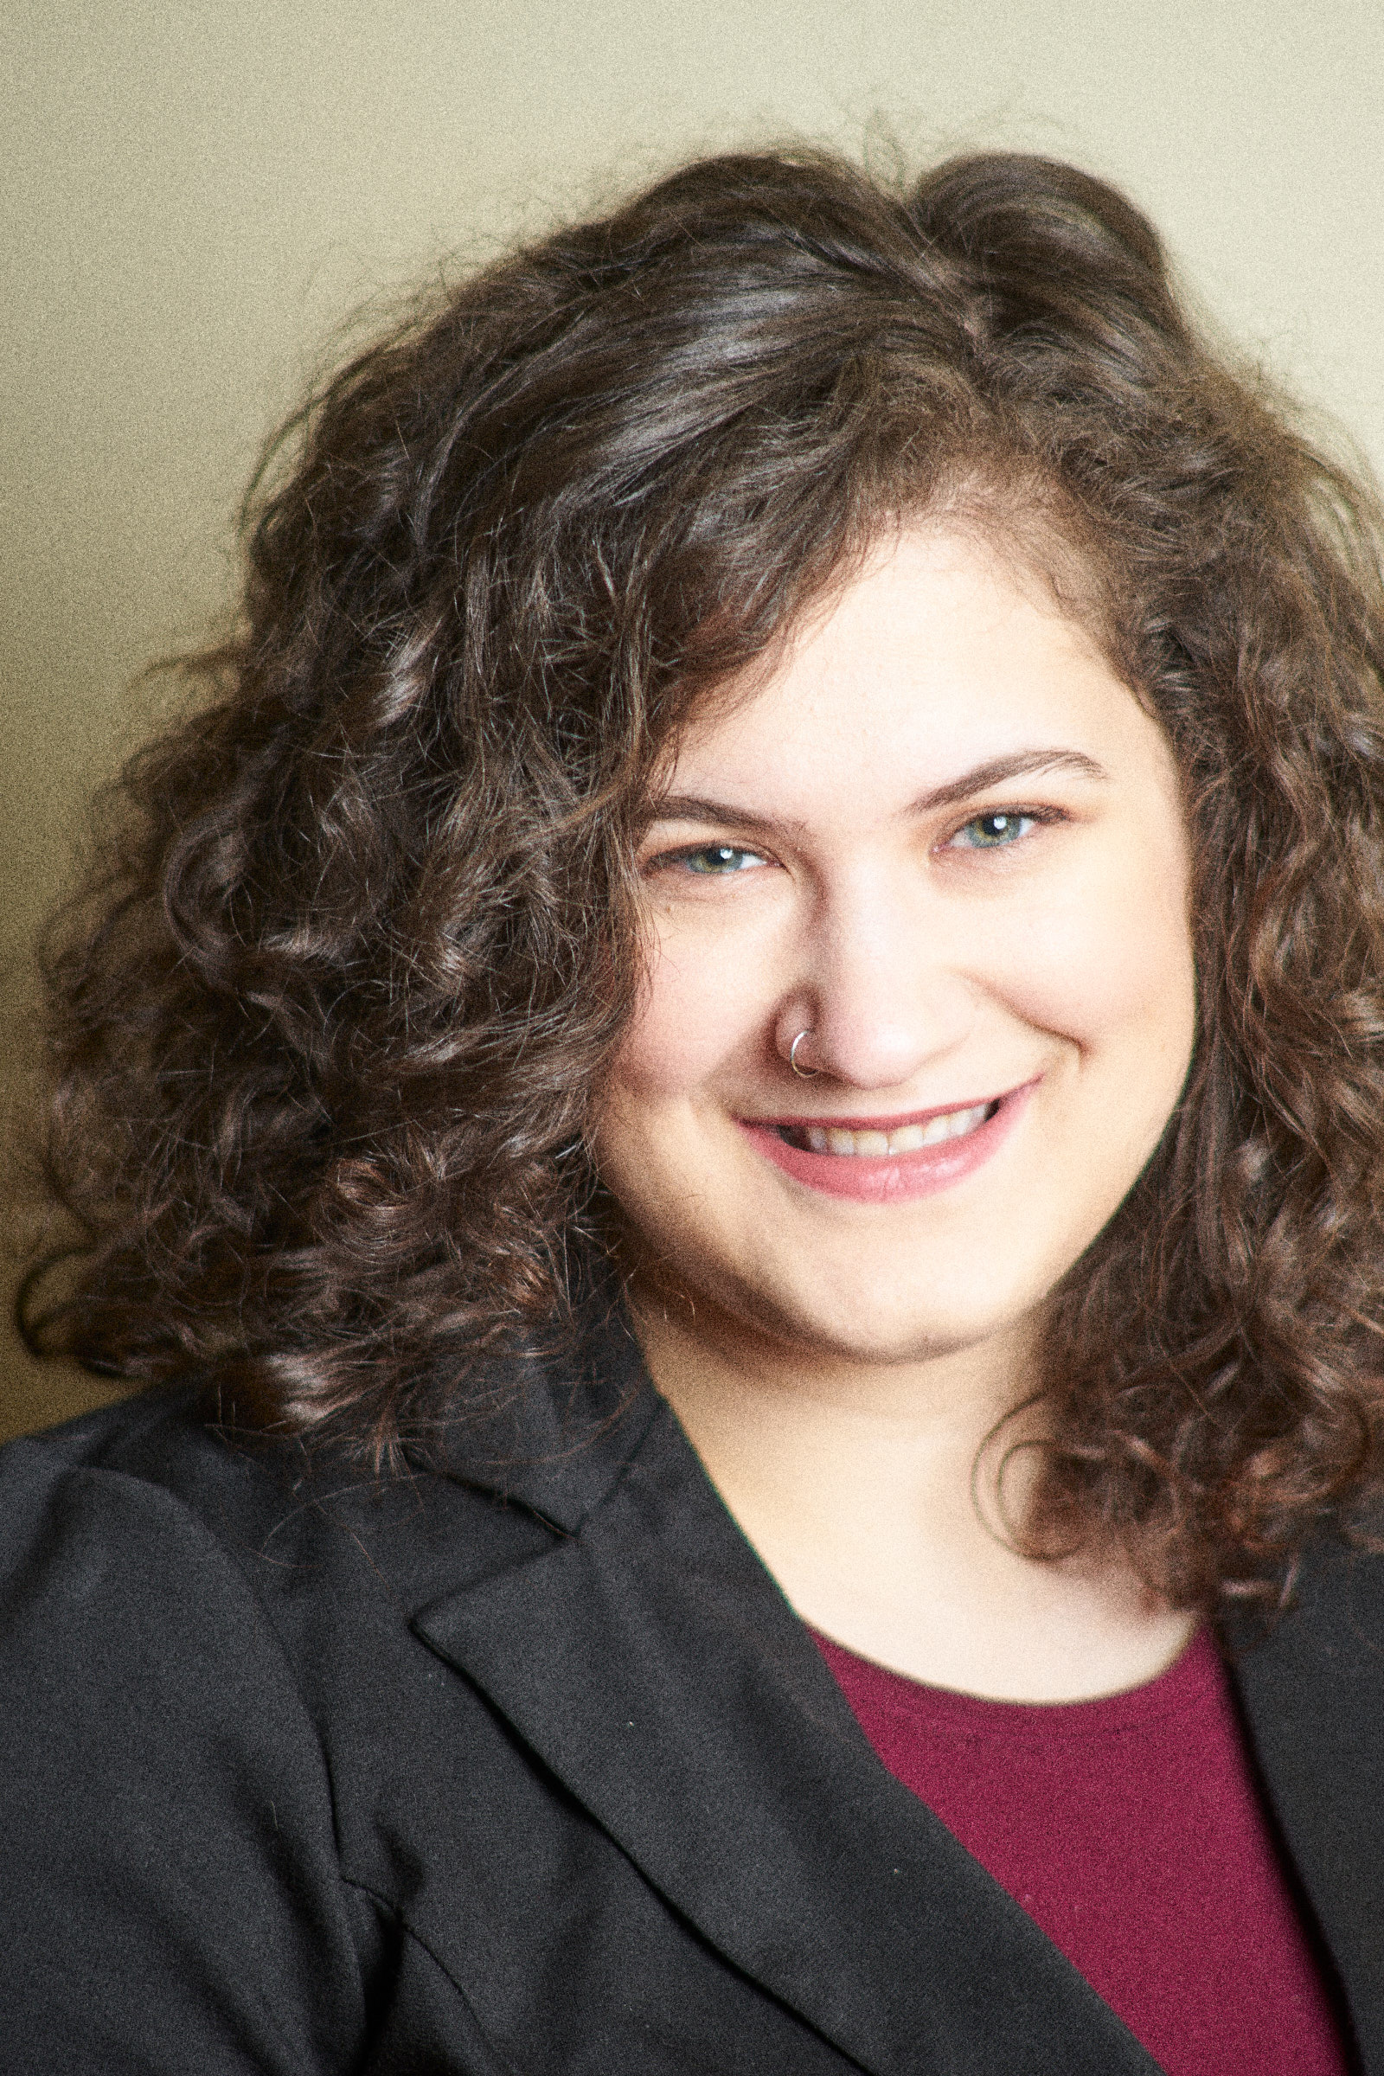
[[IMAGE REF 0010]] Image reference -- not directly editable; the original page reference is preserved automatically. Source: https://www.bemidjistate.edu/academics/psychology/wp-content/uploads/sites/65/2022/04/Judith-Zatkin.jpg
Dr. Judith Zatkin
Assistant Professor of Psychology
Office: Bensen Hall 409
Phone: (218) 755-4112
Email: judith.zatkin@bemidjistate.edu

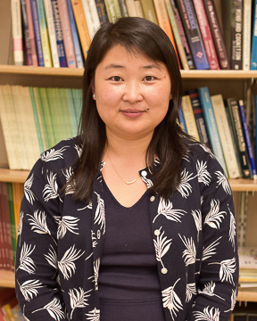
[[IMAGE REF 0011]] Image reference -- not directly editable; the original page reference is preserved automatically. Source: https://www.bemidjistate.edu/academics/psychology/wp-content/uploads/sites/65/2023/01/Dr.-Li-Zhou.jpg
Dr. Li Zhou
Associate Professor of Psychology
Office: Bensen Hall 408
Phone: (218) 755-2485
Email: li.zhou@bemidjistate.edu

