Title | Faculty & Staff
Meta Description
— Page content begins below. Please do not edit the table above. —
The faculty of the Department of Social Work are committed to the intellectual, pedagogical and social growth of all social work students who attend Bemidji State University.
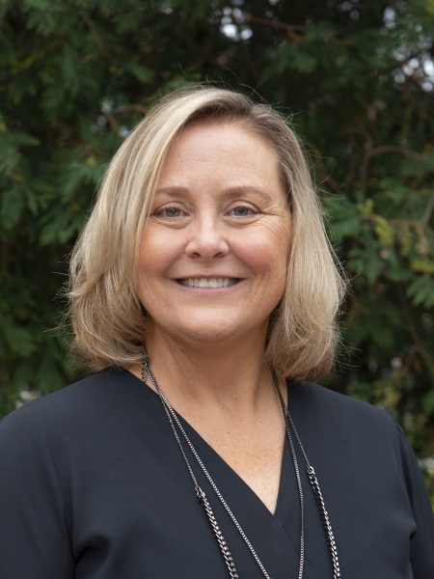
[[IMAGE REF 0000]] Image reference -- not directly editable; the original page reference is preserved automatically. Source: https://www.bemidjistate.edu/academics/social-work/wp-content/uploads/sites/16/2023/02/brenda-mack-450x600.jpg

Brenda Mack – Chair Associate Professor
- Emailbrenda.mack@bemidjistate.edu
- Phone218‑755‑4050
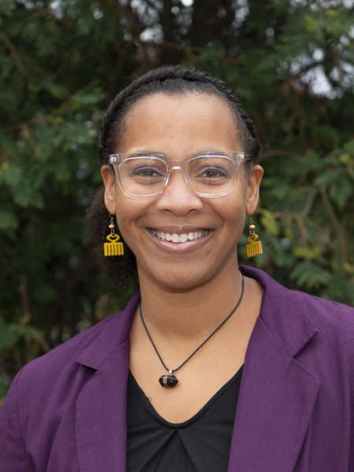
[[IMAGE REF 0001]] Image reference -- not directly editable; the original page reference is preserved automatically. Source: https://www.bemidjistate.edu/academics/social-work/wp-content/uploads/sites/16/2023/02/ashley-charwood-450x600.jpg

Ashley Charwood Associate Professor of Social Work
- Emailashley.charwood@bemidjistate.edu
- Phone218‑755‑2836
- Website
  - Hear from Ashley (opens in a new tab)
Ashley Charwood is an Assistant Professor in the Social Work Department. She lives in Bemidji with her husband and 4 children, where they enjoy camping, roller blading, trivia, and hammocking. Born in Atlanta, Georgia, and a descendant of people from…
Read Ashley’s full bio
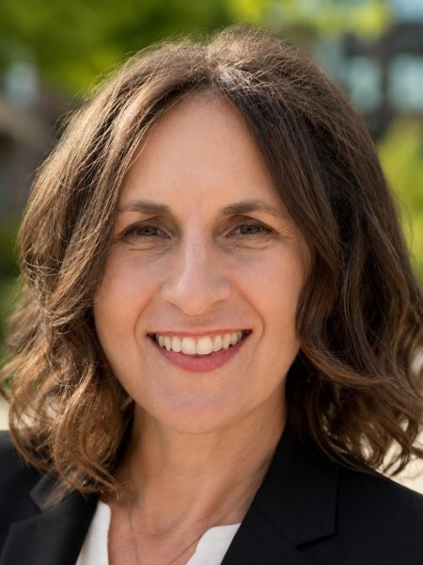
[[IMAGE REF 0002]] Image reference -- not directly editable; the original page reference is preserved automatically. Source: https://www.bemidjistate.edu/academics/social-work/wp-content/uploads/sites/16/2026/06/Dr.-Rebecca-Hoffman-450x600.jpg

Rebecca Hoffman Professor
- Emailrebecca.hoffman@bemidjistate.edu
- Phone218‑755‑2837
- Website
  - Hear from Rebecca (opens in a new tab)
Dr. Rebecca L. Hoffman, DSW, LISW, is a Professor of Social Work at Bemidji State University (BSU) and serves as BSU’s Coordinator of Research, Experiential, and Applied Learning (REAL). Before joining the faculty at Bemidji State in 2014, she spent…
Read Rebecca’s full bio
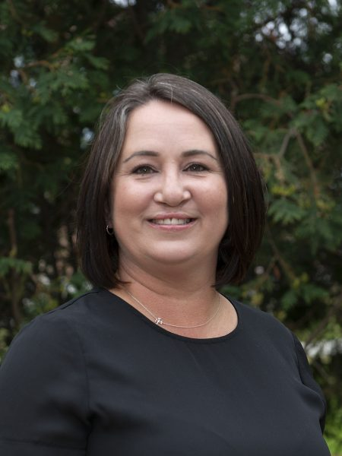
[[IMAGE REF 0003]] Image reference -- not directly editable; the original page reference is preserved automatically. Source: https://www.bemidjistate.edu/academics/social-work/wp-content/uploads/sites/16/2023/02/amanda-longie-450x600.jpg

Amanda Longie Assistant Professor of Social Work
- Emailamanda.longie@bemidjistate.edu
- Phone218‑755‑2058
- Website
  - Hear from Amanda (opens in a new tab)
Amanda Longie is an Assistant Professor of Social Work and the Faculty Liaison for Licensed Alcohol and Drug Counselor (LADC) Internships at Bemidji State University. Ms. Longie began her career in the United States Air Force where she served six…
Read Amanda’s full bio
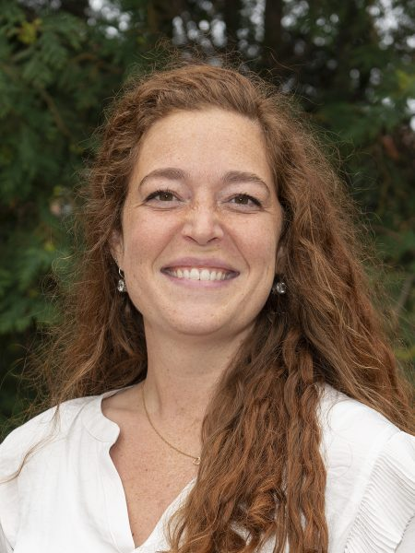
[[IMAGE REF 0004]] Image reference -- not directly editable; the original page reference is preserved automatically. Source: https://www.bemidjistate.edu/academics/social-work/wp-content/uploads/sites/16/2023/02/emily-paine-450x600.jpg

Emily Paine Associate Professor
- Emailemily.paine@bemidjistate.edu
- Phone218‑755‑2849
- Website
  - Hear from Emily (opens in a new tab)
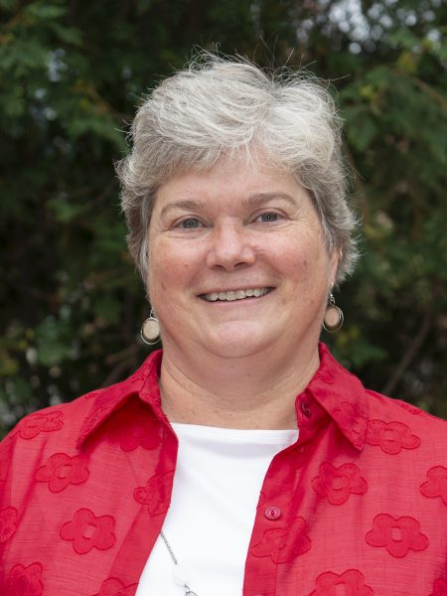
[[IMAGE REF 0005]] Image reference -- not directly editable; the original page reference is preserved automatically. Source: https://www.bemidjistate.edu/academics/social-work/wp-content/uploads/sites/16/2023/02/sue-rickers-450x600.jpg

Susan Rickers Professor
- Emailsue.rickers@bemidjistate.edu
- Phone218‑755‑2835
- Website
  - Hear from Sue (opens in a new tab)
Sue is an Associate Professor and Department Chair in Social Work. She enjoys teaching a variety of courses at BSU and interacting with future social workers. Sue has a range of work experiences working with diverse populations and in a…
Read Susan’s full bio

