Title | Faculty & Staff
Meta Description
— Page content begins below. Please do not edit the table above. —

Communication Studies Faculty
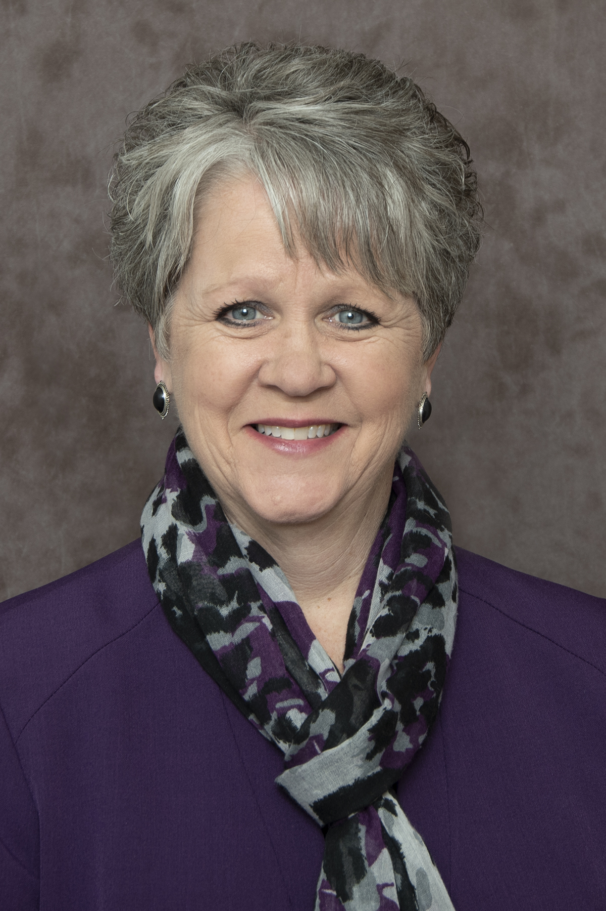
[[IMAGE REF 0000]] Image reference -- not directly editable; the original page reference is preserved automatically. Source: https://www.bemidjistate.edu/academics/sociology/wp-content/uploads/sites/116/2023/04/23BSUDr._Donna_Pawlowski_CommunicationStudies.jpg
Dr. Donna Pawlowski, Chair****Professor of Communication Studies
Sattgast Hall 215E
Phone: (218) 755-2487
Box #27
donna.pawlowski@bemidjistate.edu

Dr. Tim Baird
Assistant Professor of Communication Studies
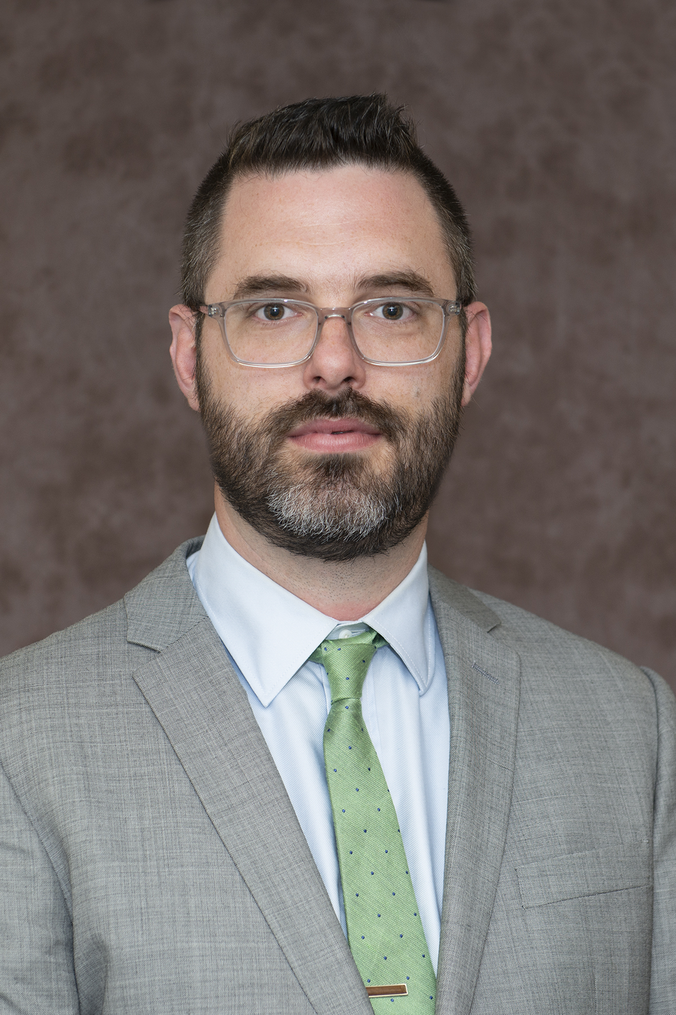
[[IMAGE REF 0001]] Image reference -- not directly editable; the original page reference is preserved automatically. Source: https://www.bemidjistate.edu/academics/sociology/wp-content/uploads/sites/116/2022/09/23BSU_SACS_Tim_Baird.jpg
timothy.baird@bemidjistate.edu

Dr. John Perlich
Professor of Communication Studies
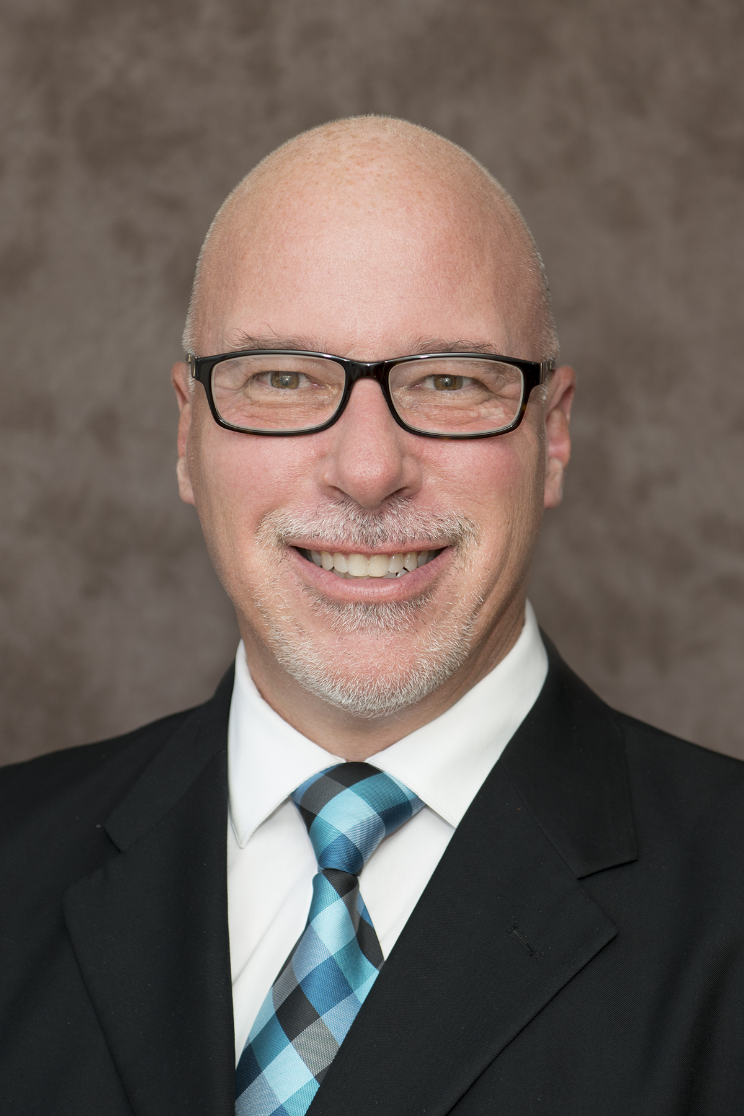
[[IMAGE REF 0002]] Image reference -- not directly editable; the original page reference is preserved automatically. Source: https://www.bemidjistate.edu/academics/sociology/wp-content/uploads/sites/116/2022/03/20BSU_SACS_John_Perlich4.jpg
Sattgast Hall 207K
Phone: (218) 755-2807
Box #27
john.perlich@bemidjistate.edu

Peace and Justice Faculty
Dr. Stacie Jergenson
Associate Professor of Justice Studies
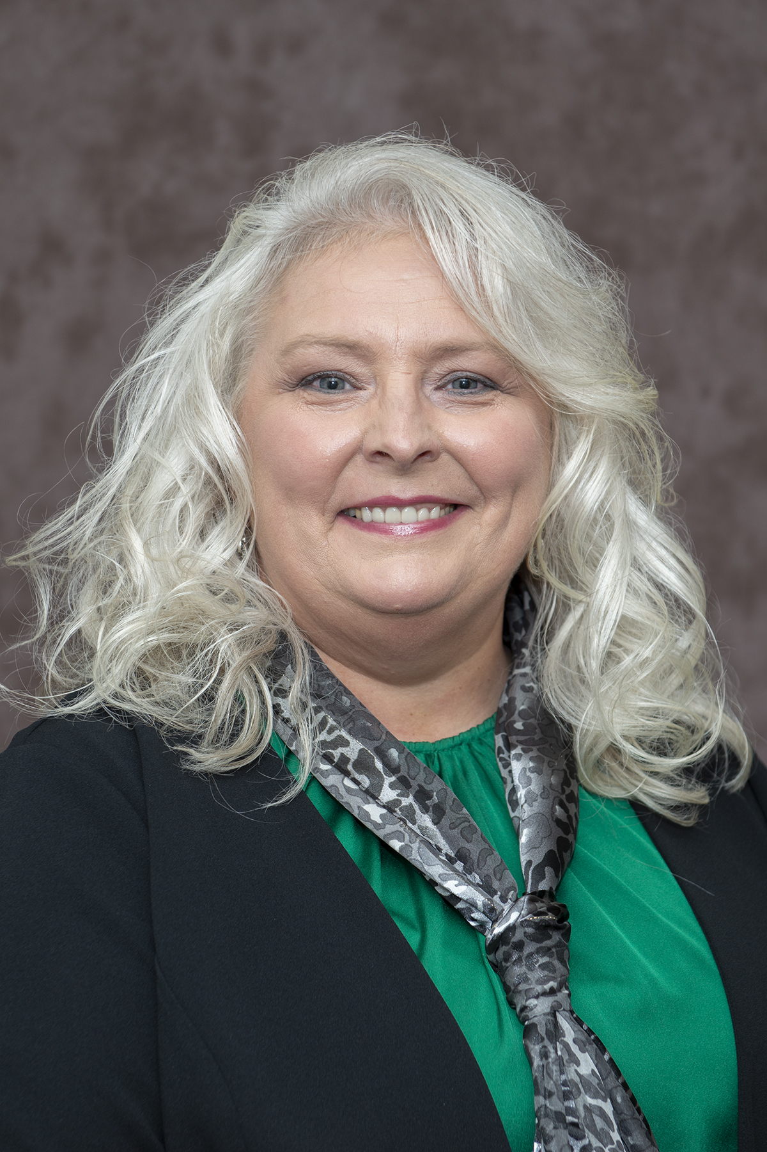
[[IMAGE REF 0003]] Image reference -- not directly editable; the original page reference is preserved automatically. Source: https://www.bemidjistate.edu/academics/sociology/wp-content/uploads/sites/116/2022/09/23BSU_SACS_Stacie_Jergenson.jpg
Sattgast Hall 215H
Box #: 27
stacie.jergenson@bemidjistate.edu

Sociology Faculty
Dr. Rucha Ambikar
Associate Professor of Sociology and Anthropology
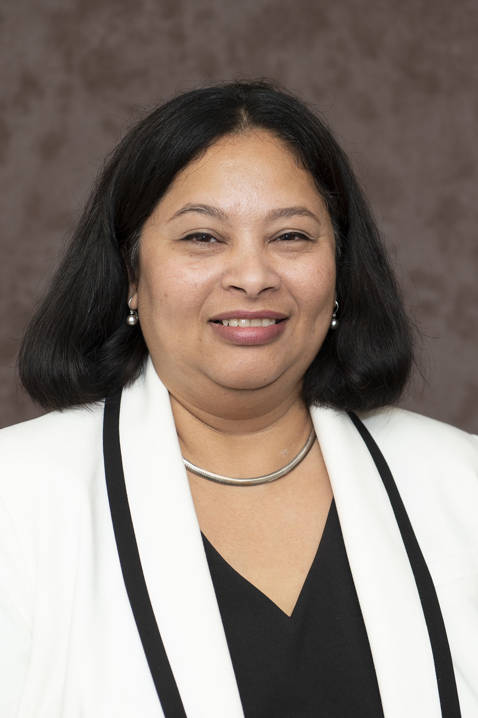
[[IMAGE REF 0004]] Image reference -- not directly editable; the original page reference is preserved automatically. Source: https://www.bemidjistate.edu/academics/sociology/wp-content/uploads/sites/116/2022/09/23BSU_SACS_Rucha_Ambikar.jpg
Sattgast Hall 215D
Box #27
rucha.ambikar@bemidjistate.edu


[[IMAGE REF 0005]] Image reference -- not directly editable; the original page reference is preserved automatically. Source: https://www.bemidjistate.edu/academics/sociology/wp-content/uploads/sites/116/2022/09/23BSU_SACS_Lukas_Szrot.jpg
Associate Professor of Sociology
Currently on sabbatical for the 2025/2026 academic year
Sattgast Hall 215F
Box #27
Email: lukas.szrot@bemidjistate.edu

